3GPP TSG-RAN WG4 Meeting #116 R4-2512558
Bangalore, India, August 25th – August 29th, 2025

Source: MediaTek,[ Huawei,] BT
Title: pCR on TR 38.753 Section 6.3 Channel Properties
Agenda item: 7.12.2
Document for: Endorsement

- Introduction
During RAN4#116 the introduction of Section 6.3 to TR 38.753 was agreed. This contribution provides corresponding text proposal introducing Sections 6.3 and 6.4.
- Text Proposal

<Start of Change 1>

6.3 Channel Properties
Spatial channel properties were analysed qualitatively across TDL and CDL models in reference to provided field measurements, including angular distribution in Tx and Rx directions (stability and diversity) and spatial layer properties. Measurement results provided to this study are included in Annex A.

6.3.1 CDL
Following observations can be drawn:
- The spatial properties of TR 38.753 CDLC match well to measured typical deployment MIMO characteristics.
- For CDL models, both spatial and temporal properties are drawn from a common ray-based framework that resembles physical environments.
- CDL (link level) models are based on the same paradigm that is extensively used for system-level simulations by RAN1 and regularly used for link-level simulations by RAN1 to develop MIMO related features.
- Each tabulated CDL model corresponds to a single possible physical environment example with static long-term spatial properties, with the realization chosen by RAN1 to match the median of the system level environment distribution.
- In this study item, RAN4 contributors spent considerable effort to clarify and align the understanding of the many practical details of CDL models.

6.3.1.1 Spatial properties
Estimated direction of arrivals (DoAs) from field measurements demonstrate a limited number of stable directions (environment properties).
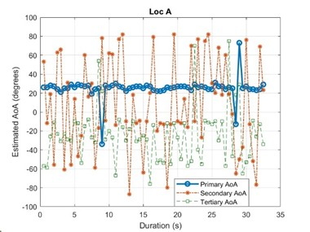 | 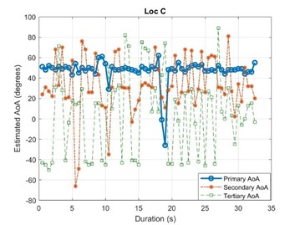
Figure 6.3.1.1-1: Three primary AoAs for SRS from UE in Locations A and C using MUSIC algorithm.
DoAs of the TR 38.753 based CDLC channel provide a limited number of mid-term stable directions (clusters), that slowly fade in and out over time (or rather with RE distance).
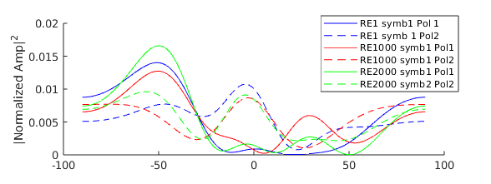 | 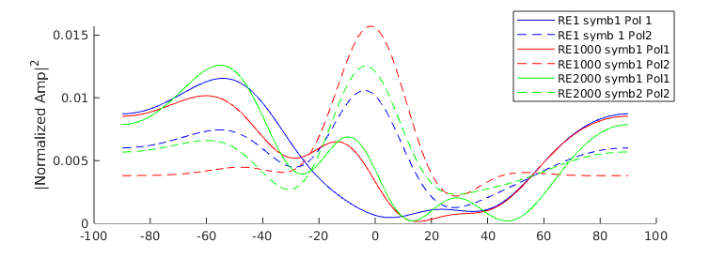
Slot 20 | Slot 1002
Figure 6.3.1.1-2: TR 38.753 based CDLC Uma Bartlett DoA analysis vs. relative “RE distance” (x-axis is DoA):
4x1 Xpol ULA assumption.
DoAs of the TR 38.753 based CDLC channel, we observe a limited number of mid-term stable directions (clusters), that slowly fade in and out over time (or rather with RE distance).
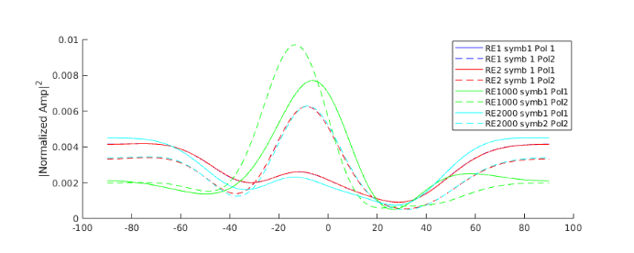 | 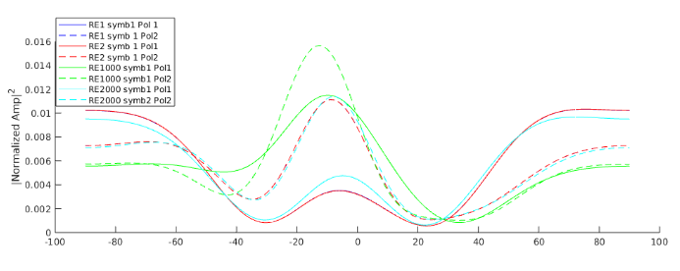
Slot 1 | Slot 100
Figure 6.3.1.1-3: TR 38.827 based CDLC Uma Bartlett DoA analysis vs. relative “RE distance” (x-axis is DoA):
4x1 Xpol ULA assumption.

6.3.1.2 SINR distributions
Per layer post-EQ SINR of each MIMO layer measured after the application of a baseband receiver/equalizer on the channel facing receive ports has been evaluated for CDL and TDL models in reference to measurements from field deployments. Post-EQ processed SINR distributions from field measurements, demonstrate that each spatial layer exhibits individual loss in a realistic deployment [R4-2402277, R4-2411557].
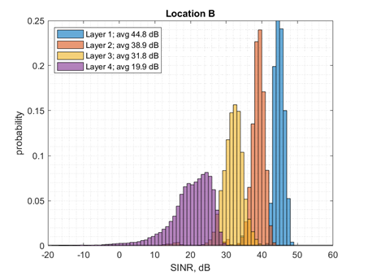 | 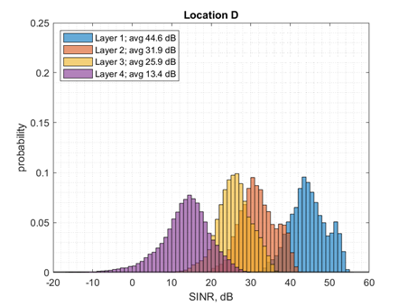
Figure 6.3.1.2-1: Histograms of the per layer SINR assuming SVD precoding and combining for measurement locations with a strong line of sight (B), and for non-line of sight position (D).
The post-EQ SINR distributions are derived with both random and fixed TypeI precoding and assuming MMSE-IRC receivers [R4-2509395]. The PDSCH post-EQ SINR profiles, when using TDL channel models do not match measurements. SDM processing does not impact performance, when using TDL channel models. CDL both shows typical post-EQ SINR profiles and typical deployment spatial components.
TDLC low | TDLC Med | 38.753 CDLC
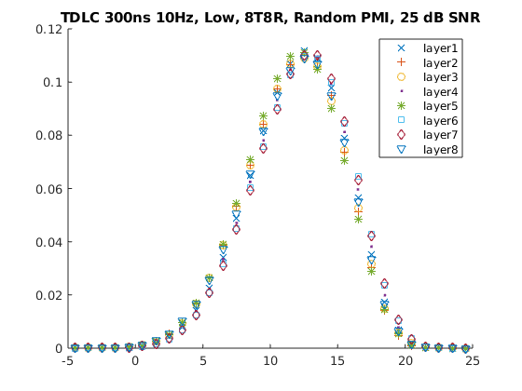 | 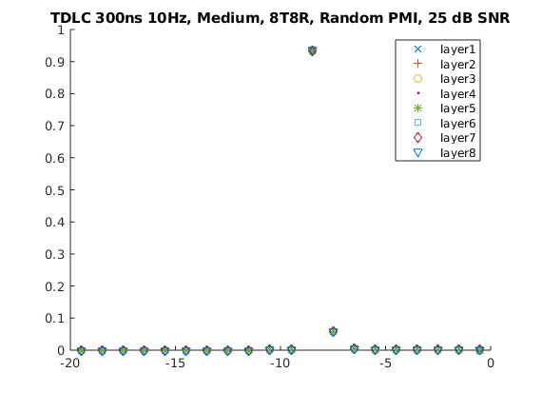 | 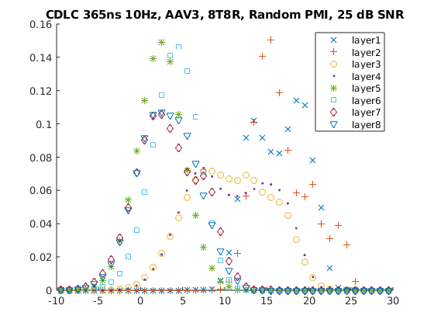
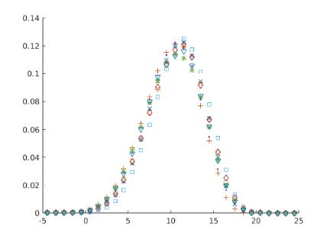 | 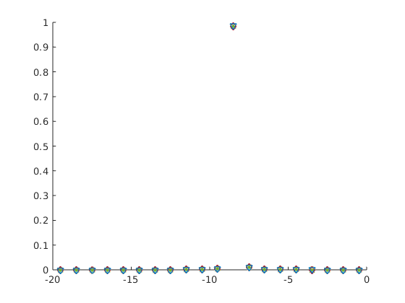 | 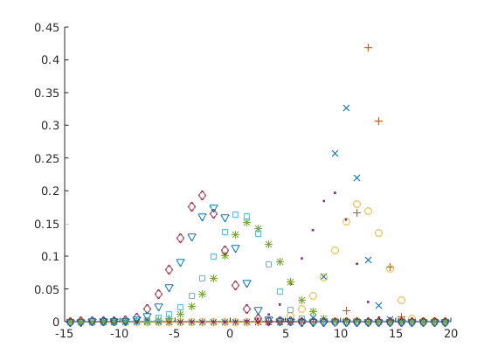
Figure 6.3.1.2-2: Post-EQ SINR distributions for channel candidates under random (top row) and fixed (bottom row) precoding.

6.3.2 TDL
Following observations can be drawn:
- Spatial properties of legacy channel models do not match the measured typical deployment MIMO characteristics
- The PDSCH post-EQ SINR profiles, when using TDL channel models do not match measurements. SDM processing does not impact performance, when using TDL channel models.
- TDL channel models are very simple and extensively used in RAN4 demodulation and CSI testing.
- Multi-cluster TDL models builds on top of the well-known and well-aligned legacy TDL models.
- Legacy TDL correlation models and related correlation derivation models introduce strong spatial selectivity so that higher transmission ranks are either infeasible or require unreasonably high SNR or low MCS.
- The multi-cluster TDL model reduces the spatial limitations of the underlying spatially correlated legacy TDL model so that higher ranks can be supported.
- The multi-cluster TDL model does not alter the Doppler spread or the frequency selectivity of the underlying legacy TDL model.
- The multi-cluster TDL model can be configured using a limited number of beam-steering parameters to match desired test behaviour. The steered beam directions and the relative beam power offsets are artificially configured.

6.3.2.1 Spatial properties
Looking at the DoAs of a 3GPP (low correlation) TDL channel, the large-scale spatial preference of the per RE channels is seen to fully decorrelate after about 2.5ms (5 slots in our simulation); it could be argued that this already occurs after only 1ms
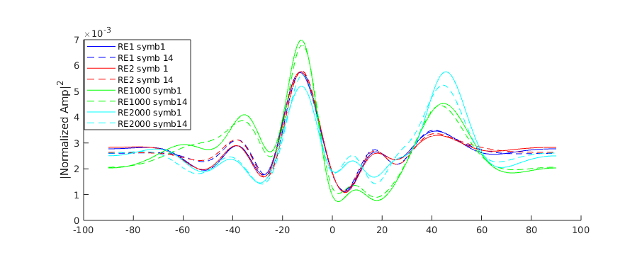 | 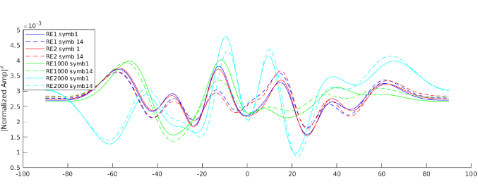
Slot 1 | Slot 5
Figure 6.3.2.1-1: TDLC300-100 (low) Bartlett DoA analysis vs. relative “RE distance”:
DoAs of a 3GPP TDLC300-100 MedA channel, we can directly see the limitation to broadside spatial preference, which remains unchanged indefinitely.
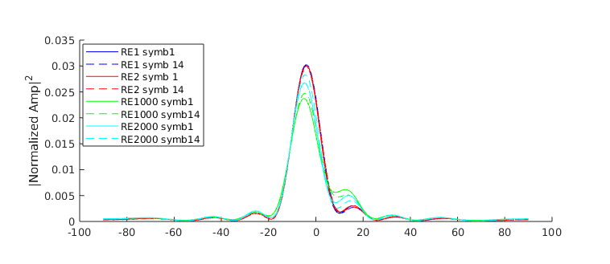 | 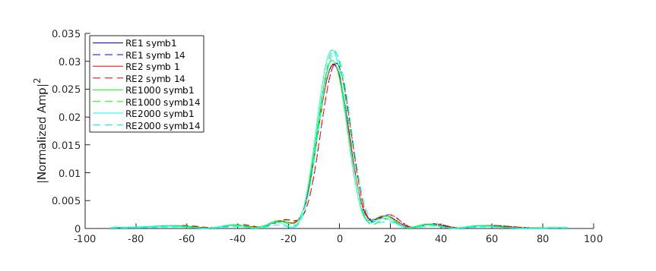
Slot 1 | Slot 5
Figure 6.3.2.1-2: TDLC300-100 (MedA) Bartlett DoA analysis vs. relative “RE distance”:

6.4 Channel Model Statistics Comparison
In this chapter, channel statistics for evaluation, comparison, alignment, and verification of channel models are defined and illustrated. Channel statistics can be gathered without the tput simulation burden and uncertainty resulting from different receiver algorithms implementations.
To specify the channel metrics, the following notations are defined. Arrange MIMO channel as a complex-valued 7-dimensional array:
$h\left(n,k,m_{1},m_{2},l,f, t\right)$ , where
  - $n=0,1,…, N_{rx1}-1$ is RX-antenna index within one polarization group,
  - $k=0,1$ is the RX-antenna polarization group index,
  - $m_{1}=0,1,…, N_{tx1}-1$ is 1st TX-antenna index within one polarization group,
  - $m_{2}=0,1,…, N_{tx2}-1$ is 2nd TX-antenna index within one polarization group,
  - $l=0,1$ is the TX-antenna polarization group index,
  - $f$ is frequency (subcarrier) index for channel frequency response (CFR), and
  - $t$ is time (symbol) index.
Here it is assumed that $N_{tx1}$ is the TX-array size in horizontal direction and $N_{tx2}$ in vertical direction. For 4TX and 8TX alignment cases, $N_{tx2}=1$. It is also worth noting that channel impulse response (CIR) representation can alternatively be used (except for frequency coherence) by replacing the frequency dimension with delay tap index dimension.

6.4.1 Metric definitions and direct measurement from channel realization
Spatial domain power density (SDPD) is defined at RX side as
$${SDPD}_{rx1}\left(θ\right)=E_{k,m_{1},m_{2},l, f,t}\left(\frac{1}{N_{rx1}}{\left|\sum_{n=0}^{N_{rx1}-1}{h\left(n,k,m_{1},m_{2},l, f, t\right)∙e^{-j∙θ∙n}}\right|}^{2}\right)$$
and at TX side as
$${SDPD}_{tx1}\left(θ\right)=E_{n,k,m_{2},l, f,t}\left(\frac{1}{N_{tx1}}{\left|\sum_{m_{1}=0}^{N_{tx1}-1}{h\left(n,k,m_{1},m_{2},l, f, t\right)∙e^{-j∙θ∙m_{1}}}\right|}^{2}\right)$$
Here, the range for phase shift $θ$ is $(-π,π)$ or equivalently $(0,2π)$. FFT can be utilized for fast calculation of SDPD. Notation $E_{(index list)}$ denotes statistical mean over the listed indexes/dimensions.
The complex-valued time coherence (TC) is defined as
$$TC\left(∆t\right)=E_{n,k,m_{1},m_{2},l, f,t}\left(h^{*}\left(n,k,m_{1},m_{2},l, f, t\right)∙h\left(n,k,m_{1},m_{2},l, f, t+∆t\right)\right)$$
where $∆t=0, 1, 2,…N_{t}$ symbols (or multiples of symbols).
The complex-valued frequency coherence (FC) is defined as
$$FC\left(∆f\right)=E_{n,k,m_{1},m_{2},l, f,t}\left(h^{*}\left(n,k,m_{1},m_{2},l, f, t\right)∙h\left(n,k,m_{1},m_{2},l, f+∆f, t\right)\right)$$
where $∆f=0, 1, 2,…N_{f}$ subcarriers (or multiples of subcarriers).
The average channel power is assumed to be normalized to unity so that $FC\left(0\right)=TC\left(0\right)=1$. As a result, the mean value of SDPD is also one.

6.4.2 Theoretical SDPD curves from CDL model parameters
For CDL models, the theoretical expected SDPD can directly be calculated from model parameters such as AOD, ZOD, AOA ray angles $φ_{n,m}^{tx1}$ , $φ_{n,m}^{tx2}$ , $φ_{n,m}^{rx1}$ and ray powers $p_{n,m}$, where n is the cluster index and m is the ray index. The ray indexing here is assumed to include the effect of applying the fixed coupling pattern of ray angles given in Table 5.1.4.2-1.
The per-ray channel processes are assumed uncorrelated so that their power responses can be summed. At TX side:
$${SDPD}_{tx1}\left(θ\right)=\frac{1}{N_{tx1}}\sum_{n,m}{p_{n,m}{\left|\sum_{k=0}^{N_{tx1}-1}{exp\left(j∙k∙\left(θ_{n,m}^{tx1}-θ\right)\right)}\right|}^{2}}$$
where $θ_{n,m}^{tx1}=π∙sin\left(φ_{n,m}^{tx1}-α_{tx}\right)$ and $α_{tx}=0$ is the horizontal TX antenna array rotation angle. At RX side:
$${SDPD}_{rx1}\left(θ\right)=\frac{1}{N_{rx1}}\sum_{n,m}{p_{n,m}{\left|\sum_{k=0}^{N_{rx1}-1}{exp\left(j∙k∙\left(θ_{n,m}^{rx1}-θ\right)\right)}\right|}^{2}}$$
where $θ_{n,m}^{rx1}=π∙sin\left(φ_{n,m}^{rx1}-α_{rx}\right)$ and $α_{rx}=180$ is the horizontal RX antenna array rotation angle. The ray powers include the tabulated cluster powers as well as the attenuation effect of the TX-side antenna radiation pattern $A\left(φ_{n,m}^{tx1}-α_{tx},φ_{n,m}^{tx2}-β_{tx}\right)$, where $β_{tx}=10$ is the TX-array downtilt angle and $φ_{n,m}^{tx2}$ is the ZOD angle of the ray. The powers are assumed normalized so that $\sum_{n,m}{p_{n,m}}=1$.

6.4.3 Theoretical SDPD curves from multi-cluster TDL model parameters
For multi-cluster TDL models, the expected SDPD can directly be calculated from the cluster-specific TX-RX steering parameters $θ_{tx1}^{(n)}$, $θ_{rx1}^{(n)}$ and from the spatial correlation matrices of the underlying TDL model. For notational convenience, define column vector d of length N as function of phase shift x: $d\left(x,N\right)={\left[\begin{matrix}\begin{matrix}1 & e^{jx}\end{matrix} & \begin{matrix}⋯ & e^{jx(N-1)}\end{matrix}\end{matrix}\right]}^{T}$. At TX side:
$${SDPD}_{tx1}\left(θ\right)=\frac{1}{N_{tx1}}\sum_{n}{p_{n}}∙d^{H}\left(θ_{tx1}^{(n)}-θ,N_{tx1}\right)∙C_{tx1}∙d\left(θ_{tx1}^{(n)}-θ,N_{tx1}\right)$$
where $C_{tx1}$ is the $N_{tx1}×N_{tx1}$ spatial correlation matrix in the first TX-array dimension with correlation parameter $α_{1}=0.9$ for XP-High. Here, power $p_{n}$ of cluster n is the aggregate power of all the channel taps of the cluster. The powers are assumed normalized so that $\sum_{n}{p_{n}}=1$.
Similarly, at RX side:
$${SDPD}_{rx1}\left(θ\right)=\frac{1}{N_{rx1}}\sum_{n}{p_{n}}∙d^{H}\left(θ_{rx1}^{(n)}-θ,N_{rx1}\right)∙C_{rx1}∙d\left(θ_{rx1}^{(n)}-θ,N_{rx1}\right)$$
where $C_{rx1}$ is the $N_{rx1}×N_{rx1}$ spatial correlation matrix in the first RX-array dimension with correlation parameter $β=0.9$ for XP-High.

6.4.4 Numerical results
In this section, metrics for CDL and TDL models are plotted.
Here, the final truncated 12-cluster model rCDL-C1 is referred to as A4, and its untruncated 24-cluster version is referred to as A2. Figure 6.4.4-1 depicts the SDPD of CDL-C A2 and A4. As can be seen, the TX side is much more spatially selective than the RX side. The difference between models A2 and A4 is very small. The theoretical and measured curves match very well at TX side, while at RX side some difference remains.
Figure 6.4.4-2 shows the absolute value of FC for CDL-C A2 and A4. As can be seen, the frequency coherence properties of the 24-cluster A2 and the 12-cluster A4 models are somewhat different. This is mainly due to the post-truncation delay scaling.
Figure 6.4.4-3 shows the TC of CDL-C A2 and A4. As can be seen, TC is complex-valued. This implies that the Doppler spectrum is not symmetric around zero frequency. The shapes of TC for A2 and A4 are similar.

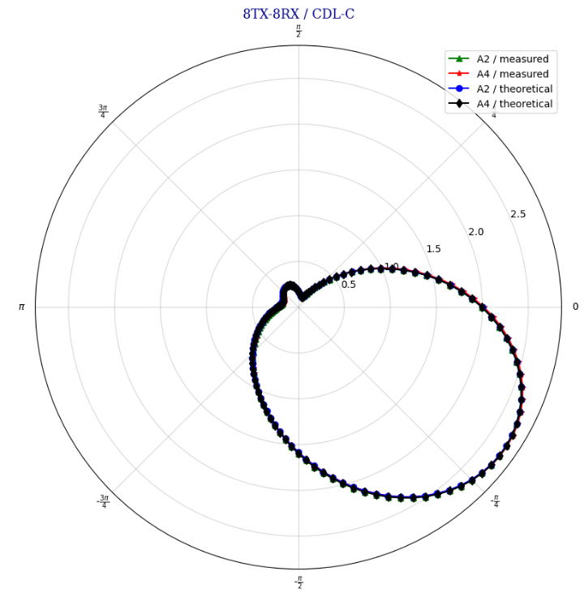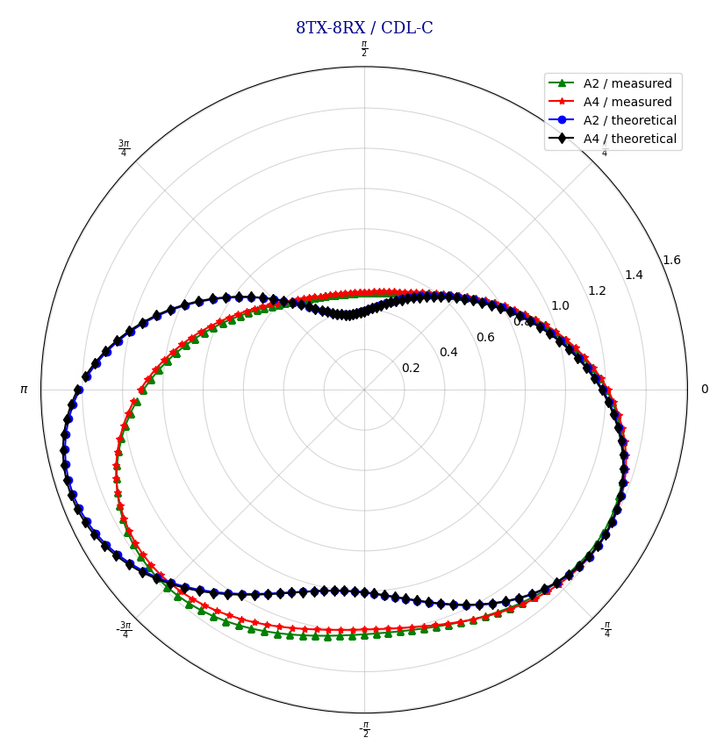
Figure 6.4.4-1: Measured and theoretical SDPD at TX (left) and at RX (right) for CDL-C.

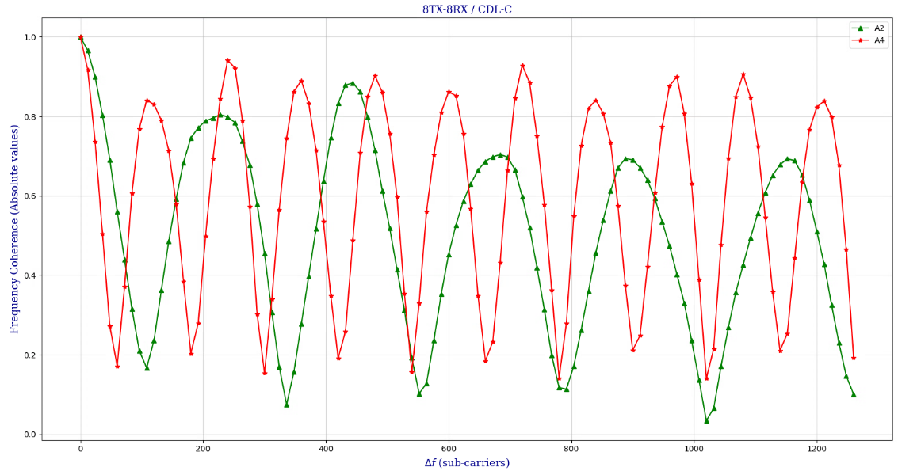
Figure 6.4.4-2: Measured frequency coherence (FC) for CDL-C.

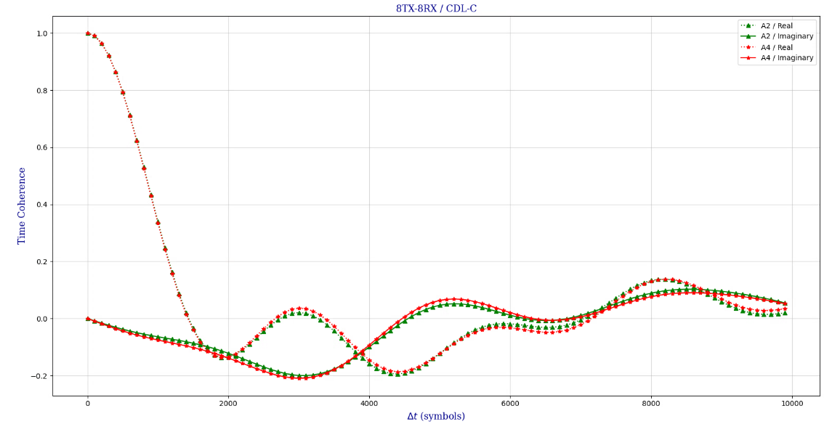
Figure 6.4.4-3: Measured time coherence (TC) for CDL-C with 3 km/h UE speed.

The left side of Figure 6.4.4-4 depicts the SDPD of two multi-cluster TDL model configurations, as detailed in Table 5.2.3-1 for xTDL-C1, and in Table C.1.1.2-1 for the alternative xTDL-C model. Note that the models are defined to be symmetrical so that the phase shifts and correlation coefficients at the TX and RX side are the same. Therefore, also the SDPD at the TX and the RX sides are identical with 8TX-8RX antenna arrays. In general, multi-cluster TDL models need not be symmetrical. The channels are spatially selective, and the theoretical curves match well with the measured curves. The spatial selectivity pattern can be tailored to suit any test purpose by properly selecting the cluster-specific phase shifts and powers.
For comparison, the right side of Figure 6.4.4-4 depicts the SDPD of legacy TDL channels with different correlation levels. As can be seen, spatial correlation results in spatial selectivity so that the signal is amplified at beam phase zero. The theoretical curves match with the measured curves very closely.
Figure 6.4.4-5 shows the absolute value of FC for the two multi-cluster TDL models. As can be seen, their frequency coherence properties are identical. This is because the channel tap delays and powers are directly inherited from the underlying TDL-C model.
Figure 6.4.4-6 shows the TC for the two multi-cluster TDL models. Time coherence is in practice real-valued (imaginary part is very close to zero) and it follows the shape of Bessel function. This is due to the symmetric Jakes Doppler spectrum inherited from the underlying TDL-C channel.

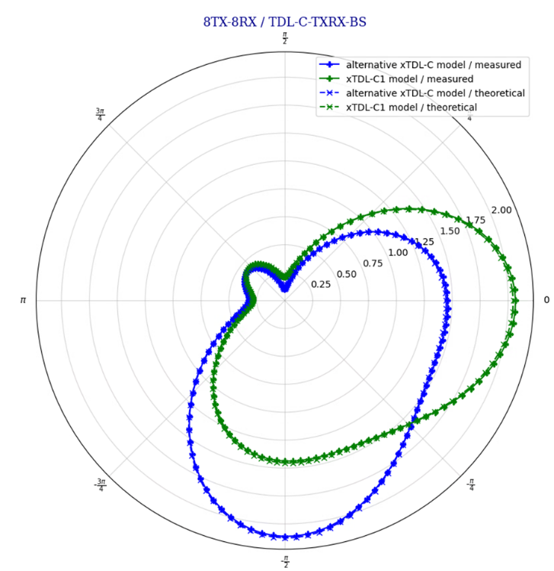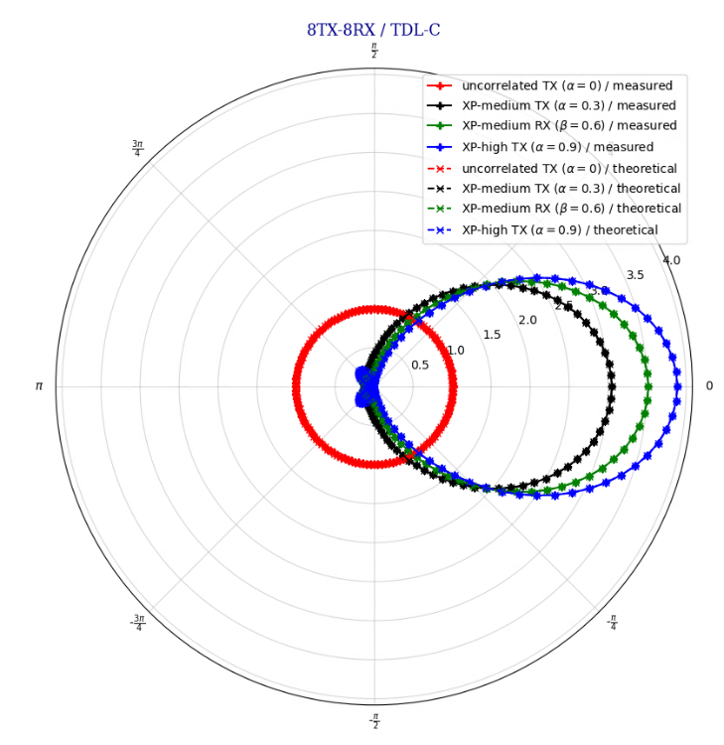
Figure 6.4.4-4: SDPD of multi-cluster TDL-C channels (left) and legacy TDL-C channels (right).
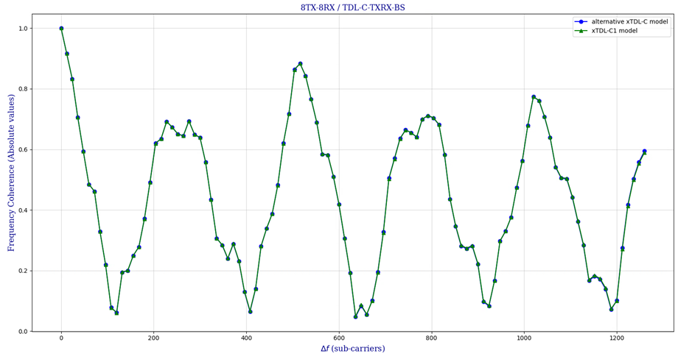
Figure 6.4.4-5: Measured FC (absolute value) of multi-cluster TDL-C channels.
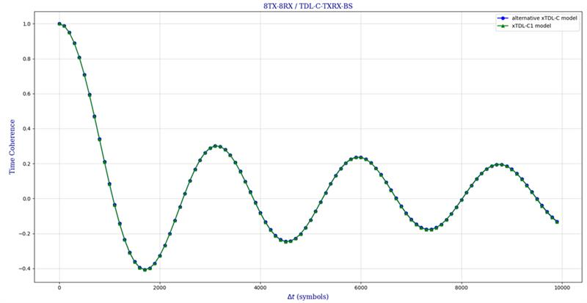

Figure 6.4.4-6: Measured TC (real part) of multi-cluster TDL-C channels with 10Hz Doppler.

6.4.5 Single-cluster time correlation properties
One company studied the temporal correlation properties of a single cluster in the CDL profile. For this analysis the dominant cluster (cluster with the strongest power) was selected, and its temporal autocorrelation (according to the textbook definition) is represented in Figure 6.4.5.-1.
In general, the time evolution of the CDL coefficients results to be deterministic, given the complex gain per each ray at time t=0. That is because, the radiation pattern gains, analog beamforming gains, polarization leakage, initial phases, etc, can all be combined into ray gains that depend on the realization (initial seed) but are static for every run. Each cluster is then composed by a set of 20 rays, which sum up to the cluster average power according to the CDL profile table.
The following observations can be drawn based on the results:
- The autocorrelation shows a periodic nature, which can be expected due to the inherent periodicity of the component rays.
- The autocorrelation does not show a decay with time and strong peaks persist for an unrealistic and unwanted duration (beyond the figure 4s window).
- There is a pronounced correlation between the in-phase and quadrature coefficient components.
- The autocorrelation does not depend on the initial seed, as the time evolution of the cluster rays is deterministic.
Based on the results and the observation above, it is necessary to further study the deterministic behaviour of rCDL and, if necessary, identify countermeasures before considering the applications of rCDL to settings that involve time-domain prediction.
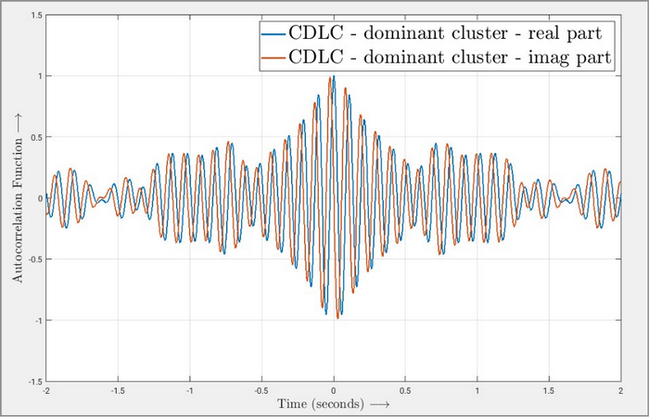
Figure 6.4.5-1: Time correlation of single-cluster CDL channel.

<End of Change 1>

