3GPP TSG-RAN WG4 Meeting #116 R4-2511454
Bangaluru, India, August 25 - 29, 2025

Agenda item: 7.24.1
Source: Moderator (Huawei)
Title: Topic summary for [116][308] NR_LPWUS
Document for: Information

Introduction
This contribution summarizes the documents that are submitted to agenda 7.24.4 for RAN4#116 and it concentrates on the following aspect.
- Topic #1: On BS RF requirements for LP-WUS/WUR

Topic #1: On the BS RF requirement for LP-WUS

Companies’ contributions summary
T-doc number | Company | Proposals / Observations
R4-2509192 | Nokia | Proposal 1: There is no need to specify the EVM requirement for LP-WUS/LP-SS.  Proposal 2: There is no need to test the EVM requirement for LP-WUS/LP-SS even if it is specified.  Proposal 3: There is no restriction of LP-WUS operation with higher order modulation.
R4-2509382 | CATT | Observation 1: Two different methods have been used for selecting EVM values, one from system level performance perspective for a low order modulation scheme, the other from link level performance perspective for a high order modulation scheme.  Observation 2: The two methods cannot be directly used for determining EVM requirement for LP-WUS due to non-applicability of throughput as the performance metric.  Proposal 1: RAN4 to decide whether or not to introduce EVM requirement for LP-WUS based on system level instead of link level simulations.  Proposal 2: RAN4 to consider a new method to determine EVM value for LP-WUS by modifying the system-level performance based method and checking CDF loss at the required SNR for different arbitrary EVM values.  Proposal 3: RAN4 to determine EVM value for LP-WUS at 1% CDF loss at the required SNR compared with the case of 0% EVM.  Proposal 4: RAN4 to set EVM requirement as 28.5% for LP-WUS.  Proposal 5: No restriction of LP-WUS operation, this is BS implementation issue.
R4-2509383 | CATT | draftCR to TS 38.141-1 on declaration of support for LP-WUS  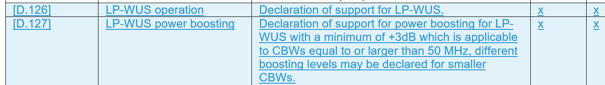
R4-2509384 | CATT | draftCR to TS 38.141-2 on declaration of support for LP-WUS  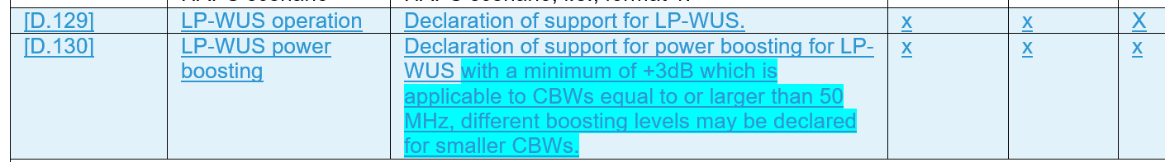
R4-2510135 | CMCC | Proposal 1: No restriction of LP-WUS operation.
R4-2510399 | ZTE | Observation 1: Frequency-domain EVM on LP-WUS has minor impact on the receiving MDR.  Proposal 1: It is proposed not to define EVM requirements for LP-WUS, but BS still needs to satisfy the NR EVM requirements on each NR carrier for different modulation schemes on PDSCH if the BS supports LP-WUS operation.  Proposal 2: Support Option 2: No restriction of LP-WUS operation.
R4-2510414 | Qualcomm | draftCR to TS 38.104 on introduction of LP-WUS FR2-1 BS RF considerations  Change #1  Change #2  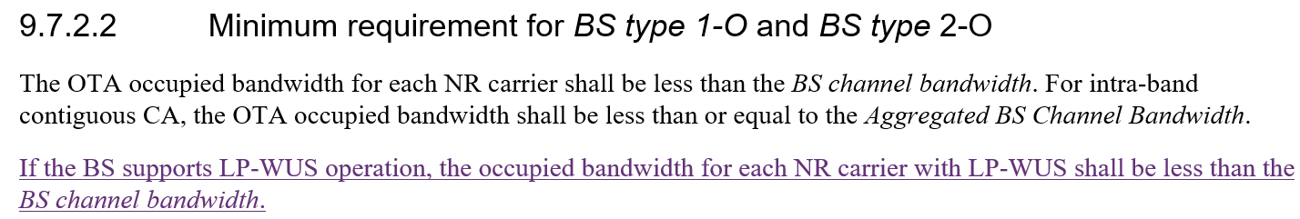  Change #3  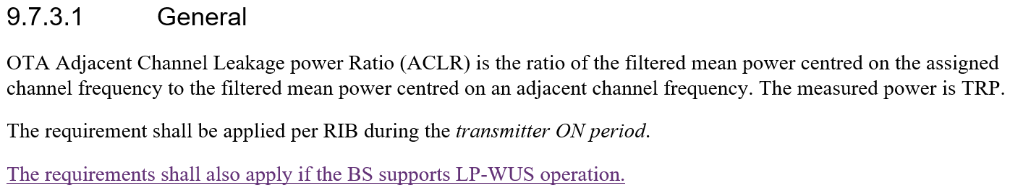  Change #4  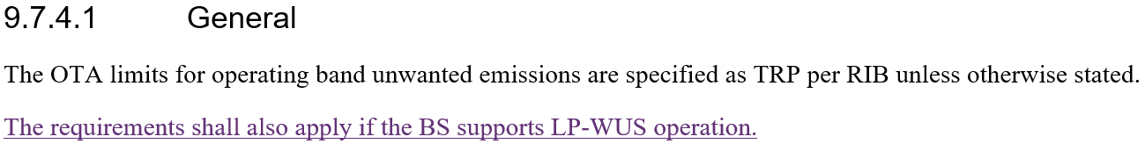  Change #5  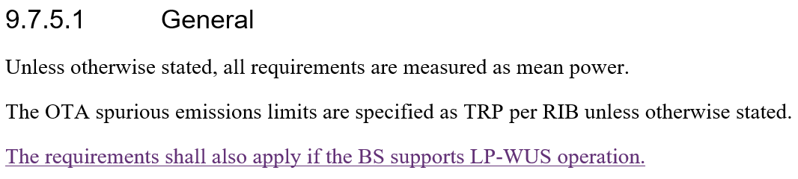  Change #6  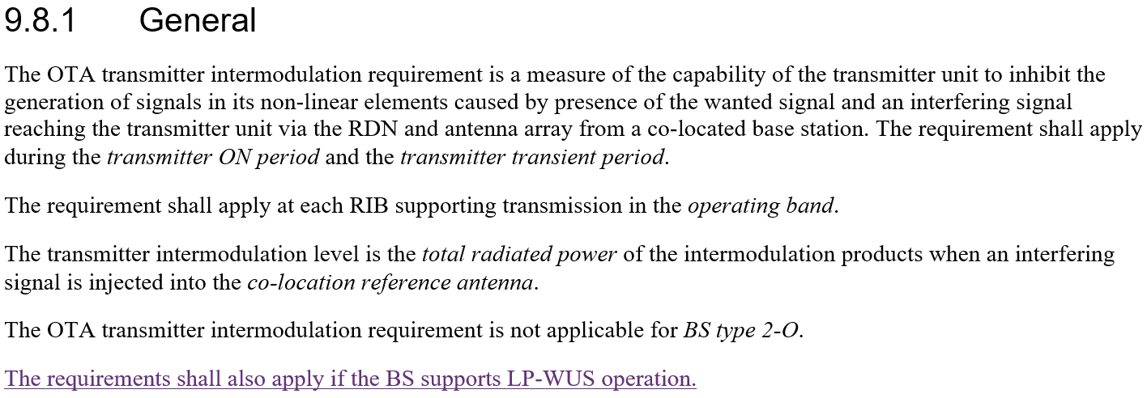
R4-2511000 | Huawei, HiSilicon | Proposal 1: No need to define EVM requirements for LP-WUS.  Observation: LP-WUS could introduce noticeable EVM degradation in certain cases for 256QAM.  Proposal 2: It is proposed to restrict in-band LP-WUS operation to cases where the NR signal employs a maximum modulation order of 64QAM. This limitation should be explicitly specified to ensure robust system performance.
R4-2511004 | Huawei, HiSilicon | draft CR to TS 38.104 on clarification of transmitted signal quality for LP-WUS operation  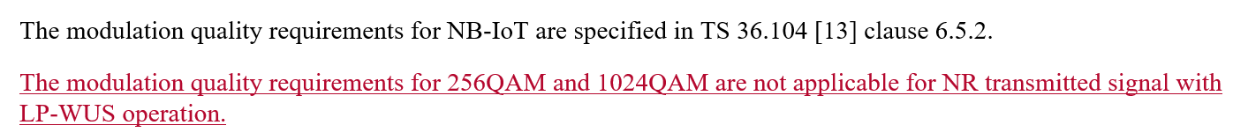
R4-2511005 | Huawei, HiSilicon | draft CR to TS 38.141-1 on clarification of transmitted signal quality for LP-WUS operation  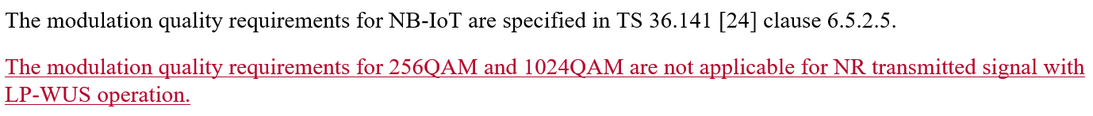
R4-2511006 | Huawei, HiSilicon | draft CR to TS 38.141-2 on clarification of transmitted signal quality for LP-WUS operation  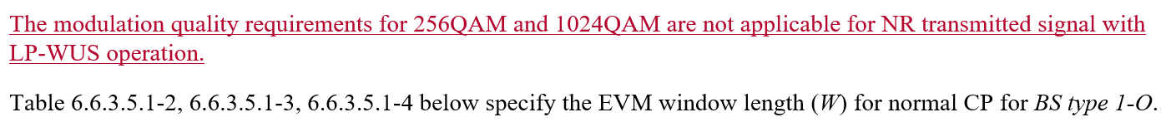
R4-2511425 | Ericsson | CR to 38.104 for transmit signal quality of LP-WUS  Change #1  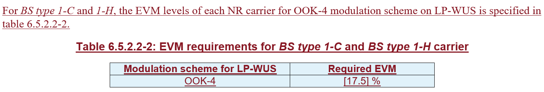  Change #2  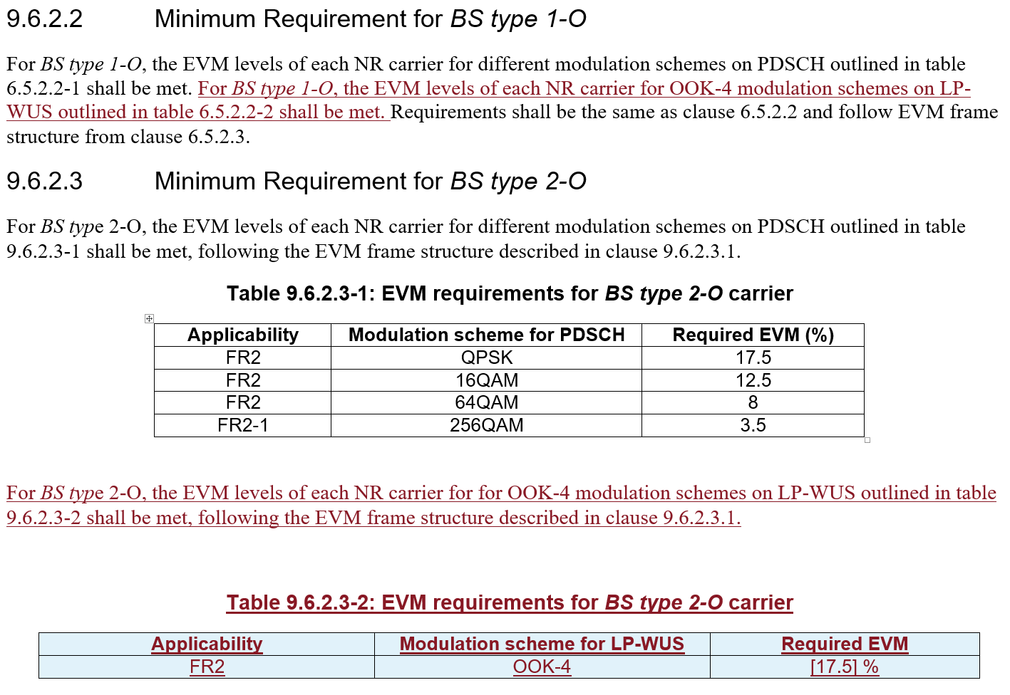
R4-2511426 | Ericsson | Observation 1 WID objective mandates the BS new requirement subject to the declaration and use the legacy NR requirement as baseline.  Proposal-1: 17.5% EVM requirement for LP-WUS.  Proposal-2: The OOK4 signal quality test can be dependent on the 64QAM EVM test.  Proposal-3: No restriction on the LP-WUS operation.

Open issues summary

Sub-topic 1-1 Remaining issues for LP-WUS
Issue 1-1: Whether/How to define EVM requirements for LP-WUS
- Options
  - Option 1: No EVM requirement specified for LP-WUS.
  - Option 2: Specify EVM requirement for LP-WUS.
    - Option 2-1: Set it as 28.5% for LP-WUS, which is based on SLS by evaluating SNR loss under different EVM values.
    - Option 2-2: Set it as 17.5% for LP-WUS, which is the EVM requirement for NR OFDM signal with QPSK modulation order.

- Recommended WF
  - TBA

Issue 1-2: Whether/how to test EVM requirements for LP-WUS
- Options
  - Option 1: No EVM test for LP-WUS/LP-SS.
    - Option 1a: The BS still needs to satisfy the NR EVM requirements on each NR carrier for different modulation schemes on PDSCH if the BS supports LP-WUS.
  - Option 2: The OOK4 signal quality test can be dependent on the 64QAM EVM test.

- Recommended WF
  - Pending on the outcome of Issue 1-1.

Issue 1-3: Whether to introduce restriction for LP-WUS operation with higher order modulation
- Proposals
  - Proposal 1: No restriction of LP-WUS operation with higher modulation order. (Nokia, CATT, CMCC, ZTE, Ericsson)
  - Proposal 2: Restrict in-band LP-WUS operation to cases where the NR signal employs a maximum modulation order of 64QAM. This limitation should be explicitly specified to ensure robust system performance. (Huawei)

- Recommended WF
  - Check if RAN4 can agree on no restriction of LP-WUS operation with higher modulation order in this meeting.

Issue 1-4: Submitted TP
- TPs
  - R4-2511426 TP to TR38.774: BS RF requirement overview for LP-WUS. (Ericsson)

- Recommended WF
  - Proponent is encouraged to check companies’ view regarding the TP.

Issue 1-5: Submitted draft CR
- Draft CRs
  - TS 38.104
    - R4-2510414 Draft CR to TS 38.104 on introduction of LP-WUS FR2-1 BS RF considerations. (Qualcomm)
    - R4-2511004 Draft CR to TS 38.104 on clarification of transmitted signal quality for LP-WUS operation. (Huawei)
    - R4-2507087 CR to 38.104 for transmit signal quality of LP-WUS. (Ericsson)
  - TS 38.141-1/2
    - R4-2509383 Draft CR to TS 38.141-1 on declaration of support for LP-WUS. (CATT)
    - R4-2509384 Draft CR to TS 38.141-2 on declaration of support for LP-WUS. (CATT)
    - R4-2511005 Draft CR to TS 38.141-1 on clarification of transmitted signal quality for LP-WUS operation. (Huawei)
    - R4-2511006 Draft CR to TS 38.141-2 on clarification of transmitted signal quality for LP-WUS operation. (Huawei)

- Recommended WF
  - Proponent is encouraged to check companies’ view regarding the draft CR.

