**3GPP TSG-RAN4 Meeting #116R4-2509107**

**Bengaluru, India, 25 – 29, August 2025**

**Agenda item:** 7.22.5

**Source:** Huawei, HiSilicon

**Title:** Text proposal for Annex A and B of 39.191

**Document for:** approval

**<<< START OF CHANGES >>>**

### Annex A (Normative)

### Device Coordinate System

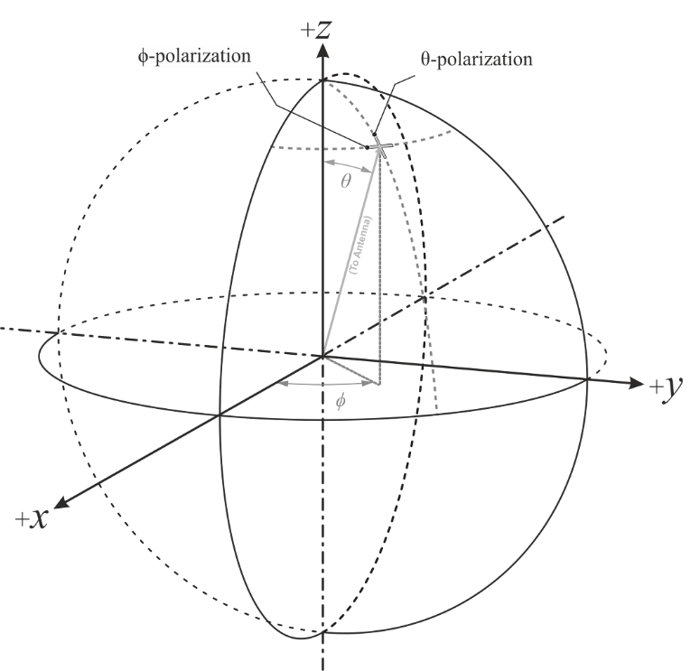

Figure A.1: Reference coordinate system

The reference coordinate system is shown in figure A.1. If device has a rectangular shape, its orientation in the coordinate system is shown in figure A.2 with front and back side declared by device manufacturers. Otherwise, device positioning is based on device declaration.

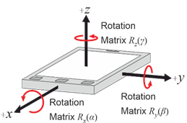

**Figure A.2: Reference coordinate system**

**<<< END OF CHANGES >>>**

**<<< START OF CHANGES >>>**

### Annex B (Normative)

### Estimation of Measurement uncertainty

Based on Measurement Uncertainty (MU) values in [x, 38.870], the MU values of ambient IoT measurements for backscatter power and sensitivity are given below.

**Table 1 MU for backscatter power**

|  |  |  |
| --- | --- | --- |
| UID | Description of uncertainty contribution for backscatter power | Uncertainty value |
| Stage 2: DUT measurement | | |
| 1 | Mismatch of receiver chain | 0.22 |
| 2 | Insertion loss of receiver chain | 0 |
| 3 | Influence of the measurement antenna cable | 0 |
| 4 | CW for backscatter measurement uncertainty of the absolute output level | -0.65 |
| 5 | Sensitivity measurement: output level step resolution | 0 |
| 6 | Measurement distance | 0 |
| 7 | Quality of quiet zone | 0.5 |
| 8 | Coarse sampling grid | 0.1 |
| 9 | Random uncertainty | 0.4 |
| 10 | Frequency Response | 0 |
| **Stage 1: Calibration measurement, network analyzer method** | | |
| 11 | Uncertainty of network analyzer | 0.2 |
| 12 | Mismatch of receiver chain | 0 |
| 13 | Insertion loss of receiver chain | 0 |
| 14 | Mismatch in the connection of calibration antenna | 0 |
| 15 | Influence of the calibration antenna feed cable | 0.3 |
| 16 | Influence of the measurement antenna cable | 0 |
| 17 | Uncertainty of the absolute gain/radiation efficiency of the calibration antenna | 0.58 |
| 18 | Measurement distance | 0 |
| 19 | Quality of quiet zone | 0.5 |
| **Systematic Errors** | | |
| 20 | Systematic Error related to grids | 0 |

**Table 2 MU for sensitivity**

|  |  |  |
| --- | --- | --- |
| UID | Description of uncertainty contribution for sensitivity | Uncertainty value |
| Stage 2: DUT measurement | | |
| 1 | Mismatch of receiver chain | 0.22 |
| 2 | Insertion loss of receiver chain | 0 |
| 3 | Influence of the measurement antenna cable | 0 |
| 4 | R2D for sensitivity measurement: uncertainty of the absolute output level | 0.27 |
| 5 | Sensitivity measurement: output level step resolution | 0 |
| 6 | Measurement distance | 0 |
| 7 | Quality of quiet zone | 0.5 |
| 8 | DUT sensitivity drift | 0.12 |
| 9 | Coarse sampling grid | 0.1 |
| 10 | Random uncertainty | 0.4 |
| 11 | Frequency Response | 0 |
| **Stage 1: Calibration measurement, network analyzer method (Figure 7.3-1)** | | |
| 12 | Uncertainty of network analyzer | 0.2 |
| 13 | Mismatch of receiver chain | 0 |
| 14 | Insertion loss of receiver chain | 0 |
| 15 | Mismatch in the connection of calibration antenna | 0 |
| 16 | Influence of the calibration antenna feed cable | 0.3 |
| 17 | Influence of the measurement antenna cable | 0 |
| 18 | Uncertainty of the absolute gain/radiation efficiency of the calibration antenna | 0.58 |
| 19 | Measurement distance | 0 |
| 20 | Quality of quiet zone | 0.5 |
| **Systematic Errors** | | |
| 21 | Systematic Error related to grids | 0 |

**<<< END OF CHANGES >>>**