3GPP TSG-RAN WG4 Meeting #116 R4-2510254

Bengaluru, India, August 25th – 29th, 2025
CR-Form-v12.3
CHANGE REQUEST
 | 38.870 | CR | <CR#> | rev | <Rev#> | Current version: | 19.1.0
For HELP on using this form: comprehensive instructions can be found at
http://www.3gpp.org/Change-Requests.

Proposed change affects: | UICC apps |  | ME | X | Radio Access Network |  | Core Network

Title: | Draft CR to TR 38.870 on AIoT test method
Source to WG: | vivo
Source to TSG: | R4
Work item code: | Ambient_IoT_Solutions-Core |  |  |  |  |  | Date: |  |  | 2025-08-15
Category: | B |  |  |  |  |  | Release: |  |  | Rel-19
 | Use one of the following categories:  F (correction)  A (mirror corresponding to a change in an earlier release)  B (addition of feature),  C (functional modification of feature)  D (editorial modification)  Detailed explanations of the above categories can  be found in 3GPP TR 21.900. |  |  |  |  |  |  |  | Use one of the following releases:  Rel-8 (Release 8)  Rel-9 (Release 9)  Rel-10 (Release 10)  Rel-11 (Release 11)  …  Rel-17 (Release 17)  Rel-18 (Release 18)  Rel-19 (Release 19)  Rel-20 (Release 20)
Reason for change: |  | In R19, the OTA test method for AIoT device is studied and this CR create new sections to capture related conclusions.
Summary of change: |  | Add the device type, operationg band and related test parameters, test setup, test procedure, and MU assessment for ambient IoT device
Consequences if not approved: |  | The test details for ambient IoT device is absent
Clauses affected: |  | 4.1, 4.3.2, 4.3.3, new 5.5, 6.1, new 7.2.2, new 7.4.7, new 7.4.8, new B.6
 |  | Y | N
Other specs |  | X |  | Other core specifications |  |  |  | TS 38.191
affected: |  |  |  | Test specifications |  |  |  | TS/TR ... CR ...
(show related CRs) |  |  |  | O&M Specifications |  |  |  | TS/TR ... CR ...
Other comments:
This CR's revision history:

<<Start of Change>>

References
The following documents contain provisions which, through reference in this text, constitute provisions of the present document.
- References are either specific (identified by date of publication, edition number, version number, etc.) or non-specific.
- For a specific reference, subsequent revisions do not apply.
- For a non-specific reference, the latest version applies. In the case of a reference to a 3GPP document (including a GSM document), a non-specific reference implicitly refers to the latest version of that document in the same Release as the present document.

[1] 3GPP TR 21.905: "Vocabulary for 3GPP Specifications".
[2] 3GPP TR 38.827: “Study on radiated metrics and test methodology for the verification of multi-antenna reception performance of NR User Equipment (UE)”.
[3] 3GPP TS 38.101-1: “NR; User Equipment (UE) radio transmission and reception; Part 1: Range 1 Standalone”.
[4] 3GPP TS 38.101-3: “NR; User Equipment (UE) radio transmission and reception; Part 3: Range 1 and Range 2 Interworking operation with other radios”.
[5] 3GPP TS 38.521-1: “NR; User Equipment (UE) conformance specification; Radio transmission and reception; Part 1: Range 1 Standalone”.
[6] 3GPP TS 38.521-3: “NR; User Equipment (UE) conformance specification; Radio transmission and reception; Part 3: Range 1 and Range 2 Interworking operation with other radios”.
[7] 3GPP TS 38.508-1: “5GS; User Equipment (UE) conformance specification; Part 1: Common test environment “.
[8] 3GPP TR 25.914: “Measurements of radio performances for UMTS terminals in speech mode”.
[9] IEEE Std 149: “IEEE Standard Test Procedures for Antennas”, IEEE.
[10] JCGM 100:2008: “Evaluation of measurement data — Guide to the expression of uncertainty in measurement”.
[11] ETSI TR 102 273-1-1: “Electromagnetic compatibility and Radio spectrum Matters (ERM); Improvement on Radiated Methods of Measurement (using test site) and evaluation of the corresponding measurement uncertainties; Part 1: Uncertainties in the measurement of mobile radio equipment characteristics; Sub-part 1: Introduction”.
[12] ETSI TR 100 028-2: “ElectroMagnetic Compatibility and Radio Spectrum Matters (ERM); Uncertainties in the measurement of mobile radio equipment characteristics; Part 2”.
[13] ETSI TR 102 273-1-2: “Electromagnetic compatibility and Radio spectrum Matters (ERM); Improvement on Radiated Methods of Measurement (using test site) and evaluation of the corresponding measurement uncertainties; Part 1: Uncertainties in the measurement of mobile radio equipment characteristics; Sub-part 2: Examples and annexes”.
[14] CTIA Certification™: “CTIA Certification Test Plan for Wireless Device Over-the-Air Performance, CTIA 01.71 Device Setup and Positioning Guidelines”, latest active version available at: https://ctiacertification.org/test-plans/
[15] Foegelle, M.D., “The Surface Standard Deviation Method for TRP Measurement Uncertainty”, 25th Proceedings of the Antenna Measurement Techniques Association (AMTA 2003), A03-027
[16] 3GPP TR 37.902: “Measurements of User Equipment (UE) radio performances for LTE/UMTS terminals; Total Radiated Power (TRP) and Total Radiated Sensitivity (TRS) test “.
[17] 3GPP TS 37.544: “Universal Terrestrial Radio Access (UTRA) and Evolved Universal Terrestrial Radio Access (E-UTRA); User Equipment (UE) Over The Air (OTA) performance; Conformance testing “.
[18] 3GPP TR 37.941: “Radio Frequency (RF) conformance testing background for radiated Base Station (BS) requirements”
[19] 3GPP TR 38.810: “NR; Study on test methods”
[20] 3GPP TR 38.903, “NR; Derivation of test tolerances and measurement uncertainty for User Equipment (UE) conformance test cases”
[21] “Reverberation Chamber Metrology for Wireless Internet of Things Devices”, Anouk Hubrechsen, Kate A. Remley and Sara Catteau, IEEE Microwave Magazine, February 2022, pp.75-85
[22] “Proximity and antenna orientation effects for large-form-factor devices in a reverberation chamber” Willem T. C. Burger, Kate A. Remley, Christopher L. Holloway, John M. Ladbury, 2013 IEEE International Symposium on Electromagnetic Compatibility, pp.671-676
[23] “A Significance Test for Reverberation-Chamber Measurement Uncertainty in Total Radiated Power of Wireless Devices”, Kate A. Remley, Chih-Ming Jack Wang, Dylan F. Williams, Johannes J. aan den Toorn and Christopher L. Holloway, IEEE TRANSACTIONS ON ELECTROMAGNETIC COMPATIBILITY, VOL. 58, NO. 1, FEBRUARY 2016, pp.207-219
[24] 3GPP TR 38.834: “Measurements of User Equipment (UE) Over-the-Air (OTA) performance for NR FR1; Total Radiated Power (TRP) and Total Radiated Sensitivity (TRS) test methodology (Release 17)”
[25] CTIA Certification™: “CTIA Certification Test Plan for Wireless Device Over-the-Air Performance, CTIA 01.72: Near-Field Phantoms”, latest active version available at: https://ctiacertification.org/test-plans/
[26] CTIA Certification™: “CTIA Certification Test Plan for Wireless Device Over-the-Air Performance, CTIA 01.70: Measurement Uncertainty”, latest active version available at: https://ctiacertification.org/test-plans/
[27] 3GPP R4-2412049, Final Analysis of 3GPP Rel-18 TRP TRS AC lab alignment and RC harmonization measurement results, vivo
[28] 3GPP TS 38.306: "NR; User Equipment (UE) radio access capabilities".
[29] 3GPP TS 38.101-5: "NR; User Equipment (UE) radio transmission and reception; Part 5: Satellite access Radio Frequency (RF) and performance requirements".
[30] 3GPP TS 36.102: "Evolved Universal Terrestrial Radio Access (E-UTRA); User Equipment (UE) radio transmission and reception for satellite access".
[31] 3GPP TS 38.521-5: "NR; User Equipment (UE) conformance specification; Radio transmission and reception; Part 5: Satellite access Radio Frequency (RF) and performance requirements".
[32] 3GPP TS 36.521-4: "Evolved Universal Terrestrial Radio Access (E-UTRA); User Equipment (UE) conformance specification; Radio transmission and reception; Part 4: Satellite access Radio Frequency (RF) and performance Conformance Testing".
[33] 3GPP TS 36.508: "Evolved Universal Terrestrial Radio Access (E-UTRA) and Evolved Packet Core (EPC); Common test environments for User Equipment (UE) conformance testing".
[34] 3GPP TS 38.191: "Ambient IoT device radio transmission and reception".

<<Unchanged part is omitted >>

4.1 Device types
The following device types are within the scope of TRP TRS test:
- Smartphone
- Considering UEs with antenna configurations of 1Tx, 2Tx, 2 Rx and 4 Rx
- Wearable (e)Redcap UE
- XR devices, including glasses and head mounted display
- Only test XR devices with 5G link to gNB in networks, not those with side link or wired connections
- 1Tx XR devices is prioritized
- NTN devices, including both NR-NTN and IoT-NTN,
- handheld UE type is first priority
- Tablet
- Laptop embedded equipment (LEE)
- Laptop mounted equipment (LME)
- Ambient IoT device

<<Unchanged part is omitted >>

4.3.2 Operating bands
Operating bands for NR FR1 are defined in Table 5.2-1 and Carrier Aggregation (CA) are defined in Clause 5.5A in TS 38.101-1 [3]. The operating bands for EN-DC are defined in Clause 5.5B in TS 38.101-3 [4].
The FR1-NTN bands are defined in Table 5.2.2-1 in TS 38.101-5 [29]. The IoT-NTN bands are defined in Table 5.2-1 in TS 36.102 [30].
For Ambient IoT bands are defined in Table 5.2-1 in TS 38.191 [34]

<<Unchanged part is omitted >>

5.5 Definition of the Effective Isotropic Radiated Power (EIRP) for AIoT device

5.5.1 Definition of the Effective Isotropic Radiated Power (EIRP) for AC
Transmitter power measurements shall be performed using the Effective Isotropic Radiated Power (EIRP) as the measurement metric. The EIRP is combined from θ and ϕ polarizations:
EIRPθ,ϕ=EIRPθθ,ϕ|cwθθ,ϕ+EIRPϕθ,ϕ|cwθθ,ϕ+EIRPθθ,ϕ|cwϕθ,ϕ+EIRPϕθ,ϕ|cwϕθ,ϕ
Where EIRPθ and EIRPϕ are the EIRP in the corresponding θ and ϕ polarizations, CWθ and CWϕ are the incident CW in the corresponding θ and ϕ polarizations,
For backscatter power measurement, the EIRP only includes the power of 1st sidebands and excludes power of CW.

5.6 Definition of the EIS and EIS partial sphere coverage for AIoT device

5.6.1 Definition of the EIS and EIS partial sphere coverage for AC
The effective isotropic sensitivity (EIS) is defined as the minimum power level at which the success rate no less than 90% under the specified FRC, at each given test point.
The EIS is combined from θ and ϕ polarizations:
EISθ,ϕ=1(1EISθθ,ϕ+1EISϕθ,ϕ)
Where EIS_{θ} and EIS_{ϕ} are the EIS in the corresponding θ and ϕ polarizations.
The EIS partial sphere coverage metric is defined as the maximum R2D EIS radiated in the Theta and Phi range from partial surface within ±45° angular width degrees.
Figure 8.2.1-1: Visualization of Partial sphere within ±45° angular range
For simplycity, only 4 edge points are selected for deriving the maximium EIS over the partial sphere: (θ=45º, ϕ=0º), (θ=45º, ϕ=90º), (θ=45º, ϕ=180º), (θ=45º, ϕ=270º)

<<Unchanged part is omitted >>

6.1 Free space
For Free space configuration, the centre of the reference coordinate system shall be aligned with the geometric centre of the DUT in order to minimize the offset between antenna arrays integrated at any position of the UE and the centre of the quiet zone.
Table 6.1-1: UE positioning for Free space
Test condition | DUT  orientation | Diagram
Free space  DUT | α = 0º;  β = 0º;  γ = 0º | 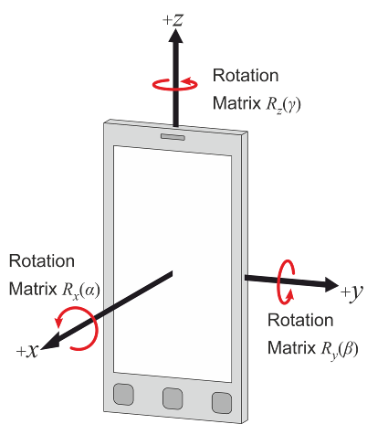

For Ambient IoT device, if the device has a rectangular shape, the DUT orientation in Table 6.1-2 is applied. The front and back side of device is based on device declaration. Otherwise, the device positioning is based on device declaration.
Table 6.1-2: AIoT device positioning for Free space
Test condition | DUT  orientation | Diagram
Free space  DUT | α = 0º;  β = -90º;  γ = 0º | 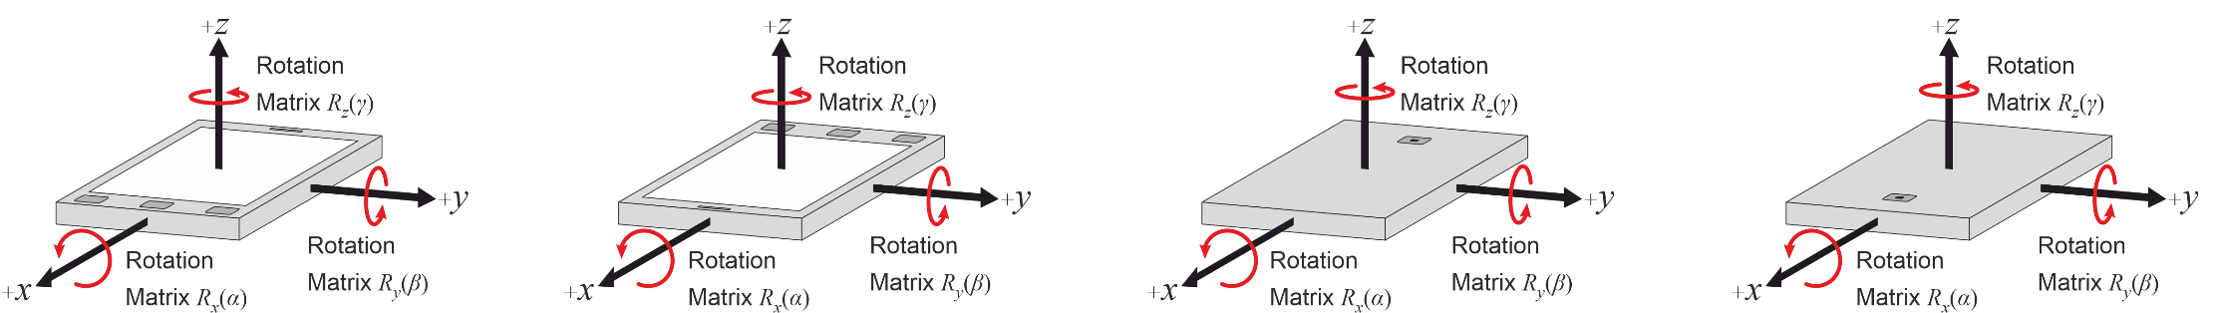

<<Unchanged part is omitted >>

7.2.1 General Test system
For FR1 TRP TRS testing, both Single-antenna and multiple-antennas anechoic chambers can be applied. In Figure 7.2.1-1, an example TRP TRS test system with combined axes system is presented.
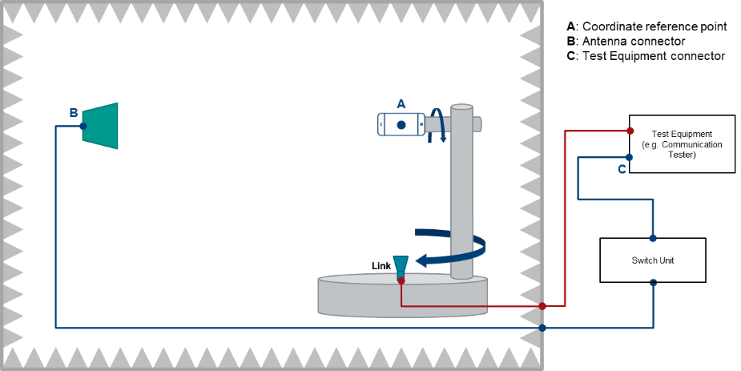
Figure 7.2.1-1: Example of a FR1 TRP TRS OTA test system with combined axis
In Figure 7.2.1-2, an example TRP TRS test system with distributed axes system is presented.
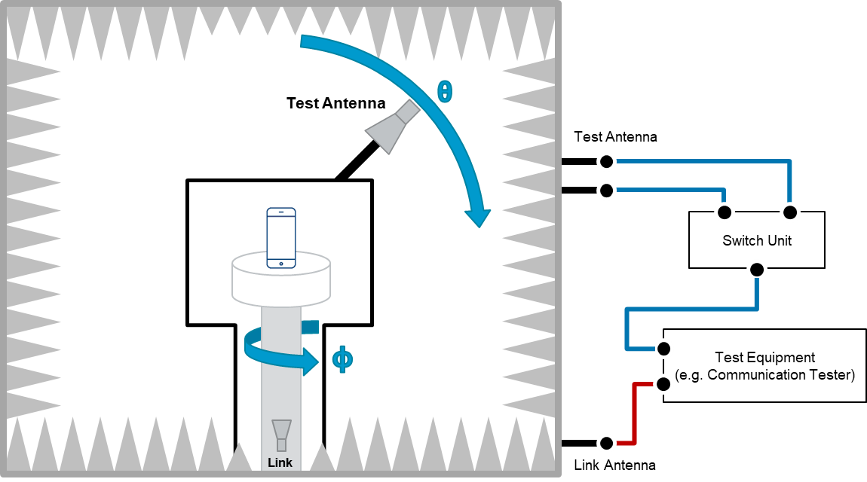
Figure 7.2.1-2: Example of a FR1 TRP TRS OTA test system with distributed axis

7.2.2 Test system for AIoT device
For AIoT device, the test system is same as in 7.2.1, while the test antenna with two linear orthogonal polarizations supports both CW and Reader, namely CW and Reader share the same antenna with CW occupying one polarization and Reader using both polarizations.

<<Unchanged part is omitted >>

7.4.7 Radiated transmitter test procedure for Ambient IoT device

7.4.7.1 Device configuration
Device should be fully charged beforeduring the measurement according to device declaration on the required energy conditions.

7.4.7.2 Test procedure
For ambient IoT device, the measurement procedure includes the following steps:
- Place DUT based on UE positioning guidelines in clause 6.1.
- Set the target test frequency and transmit power of CW signal in signal generator. The CW power EIRPCWθ,ϕ received by DUT is according to TS38.191[34].
- Transmit CW signal and measure the backscattering power at DUT peak direction. Iterate all polarization combinations as described in clause 5.5.1 and calculate EIRPD2Rθ,ϕ by adding the composite loss of the entire transmission path. The peak direction is based on DUT declaration.

7.4.8 Radiated receiver test procedure for Ambient IoT device

7.4.8.1 Device configuration
Device should be fully charged beforeduring the measurement according to device declaration on the required energy conditions.

7.4.8.2 Test procedure
For ambient IoT device, the measurement procedure includes the following steps:
- Place DUT based on UE positioning guidelines in clause 6.1.
- Set the target test frequency and transmit power of CW signal in signal generator. The CW power EIRPCWθ,ϕ received by DUT is according to TS38.191[34].
- Determine whether DUT can send the correct response in D2R channel within timing window
- Determine EIS at peak direaction by adjusting the downlink R2D signal level until the minimum power level at which the success rate no less than 90% according to the specified FRC in TS38.191[34]. The peak direction is based on DUT declaration.
- Move to next measurement point and repeat step 3-4 until complete all the testing points specified in clause 5.6.1

<<End of Change >>

