3GPP TSG-RAN WG4 Meeting # 116 R4-2511766
Bengaluru , IN, August 25 – 29, 2025
Agenda item: 7.3.3
Source: Apple, Samsung
Title: TP to TR38.768 on low NR band aggregation via switching
WI/SI: NR_LBCA_Sw-Core
Release: Rel-19
Document for: Approval

1 Introduction
In the previous RAN4 meeting (Meeting #115, Malta, 19th – 23rd May, 2025), several aspects of the low NR band aggregation via switching feature were debated. As highlighted in the meeting WF [1], agreements were made on the time masks, switching period locations, as well as the addition of 70μs to the list of switching period values, resulting in a set of 3 values (35μs, 70μs, and 140μs) as possible values for the UE switching period capability when the UE supports the low NR band aggregation via switching feature. The TR38.768 [2] was updated to include the requirements for the time masks and switching period locations. However, the new value of the switching period (70μs) was not added in the TR.
This contribution provides the following text proposals to TR38.768:
- Change 1: Include 70μs switching period value in all the clauses where the switching period values are captured.
- Change 2: Add the applicability of the inter-band carrier aggregation aspects for a UE which supports the low NR band carrier aggregation via switching
- Change 3: The configuration aspects related to low NR band carrier aggregation via switching
- Change 4: Impact on MSD requirements
- Change 5: Impact on ΔRIB,c and ΔTIB,c requirements
- Change 6: Aspects related to the RMCs

2 References
[1] R4-2508118, “WF on UE RF requirements for LB CA via switching,” by Apple, 3GPP RAN4 #115, Malta, 19th – 23rd May, 2025
[2] R4-2508119, “TR 38.768-004” by Apple, 3GPP RAN4 #115, Malta, 19th – 23rd May, 2025
[3] R4-2505439, “UE RF requirements for LB CA via switching,” Apple, 3GPP RAN4 #115, May 2025

3 Text Proposal

<< begin change 1 >>

5.1 Switching periods
To accommodate different UE implementations, RAN4 has reached the agreement in RAN4#114 on the applicable switching periods of 35μs, 70μs, and 140μs for switching between Case 1 and Case 2 as an optional UE capability.

5.2 Switching period location

5.2.1 General
For what follows we consider switching between an FDD and SDL band for the CA-n5A-29A configuration in Table 4-1 but without loss of generality: one UL is configured in a paired band with the DL Scell configured in either a DL band of another paired band or in an SDL band.
.
The timing reference for the switching pattern and switching gap at the UE is the DL timing of the Pcell (in the FDD band). The uplink radio frame transmission on the Pcell takes place T_{TA} = (N_{TA} + TA_{offset})T_{c} before the reception of the first detected path (as defined in TS 38.133) in time on the corresponding DL radio frame. This means that the timing advance must be considered at switching events.
The duration of the switching gap is RRC configured. The network ensures that the switching gap is large enough to cover the switching period (35 , 70μs, and 140 𝜇s according to the UE capability), transient periods and the TA, if needed, in both switch directions.

5.2.2 FDD to SDL switch
For the FDD to SDL switch the gNB configures a gap long enough to accommodate timing advance such that no collisions should occur. Figure 5.2.2-1 shows the case with T_{TA} > 0 µs. The figure illustrates the applicable transient periods, switching period (35, 70μs, and 140 𝜇s according to UE capability), and the applicability of ON and OFF power requirements.
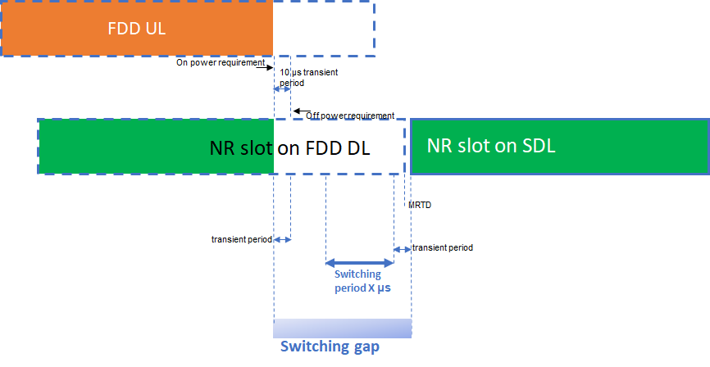
Figure 5.2.2-1: FDD to SDL switch with the switching gap on the switched-from carrier.
The UL slot will always end before the DL slot, neglecting any timing errors in case TA = 0 µs. The worst case in terms of switching is that in which T_{TA} = 0 µs, the DL and UL timing are the same (again neglecting the errors that are of the order of 1 µs) and the SDL starts RTD µs before the Pcell DL slot timing. Switching period is always after UL transient period. The switching gap with respect to the end of the last FDD DL symbol must therefore be at least
actual switching gap length > T_{switch} + MRTD + FDD UL trailing end transient period +
where the MRTD = [CP length/TAE] assuming that the FDD and SDL carriers are colocated.

5.2.3 SDL to FDD switch
For the SDL to FDD switch, the switching gap ends at end of slot on “switch from” carrier (SDL). The timing advance must also be accounted for; Figure 5.2.3-1 illustrates this for all applicable switching periods (35 , 70μs, and 140 𝜇s according to UE capability), by placing the switching period X before the start of the time advanced UL. The applicability of ON and OFF power requirements is also shown.
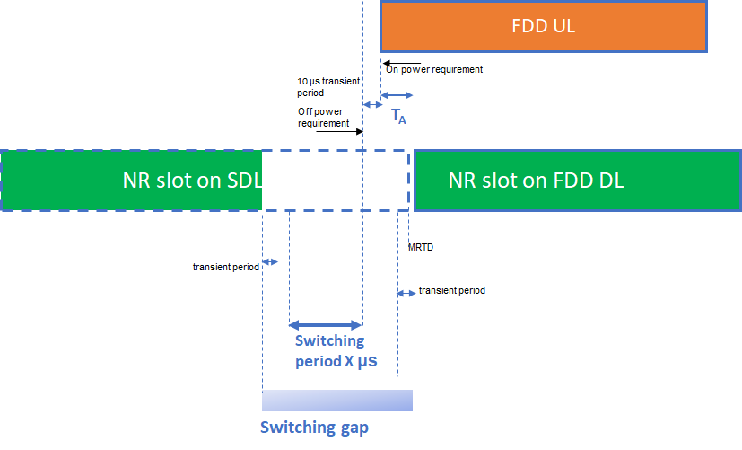
Figure 5.2.3-1: SDL to FDD switch with the switch occurring before the start of the UL slot.
The time mask shall be devised such that the switching period occurs always before the transient period of the UL slot of the switched-to FDD carrier, this to avoid dropping symbols on the UL that starts T_{TA} before the first symbol of the FDD DL slot. Notwithstanding, the switching gap on the SDL carrier must be at least
Actual switching gap length > Tswitch + TTA + MRTD + + FDD UL leading transient period
with account of the SDL received at maximum RTD of a [CPlength/TAE]. The worst case is when the SDL is traling the Pcell DL as shown in the figure.
In the live network operation, timing advance for a UE in a cell is variable. It is the network task to adjust the length of the switching gap by [LBCA-SwitchingGap-Duration-SCelltoPCell] so that the UL transient period is not overlapping with switching period X.
<< end change 1 >>
<< begin change 2 >>

5.3 Applicability of simultaneous Rx/Tx requirements
The following statement in section 5.2A.2 of TS38.101-1 captures the applicability of simultaneous Rx/Tx requirements when the UE supports the low NR band carrier aggregation via switching: “Concurrent operation between these bands is not applicable to UEs indicating support of low NR band aggregation via switching [supportedLowBandSwitching-r19] for this band combination.”
<< end of change 2 >>

<< begin of change 3 >>

5.4 CA configurations
Low NR band inter-band CA configurations in which the UE is allowed to indicate support of the configuration via switching [supportedLowBandSwitching-r19] are indicated with the corresponding note in the configuration tables in sub-clause 5.5A.3.1 of TS38.101-1.
The following notes to be added in Table 5.5A.3.1-1d of TS38.101-1 next to the band combinations that support low NR band aggregation via switching: “The UEs is allowed to indicate support of low NR band carrier aggregation via switching [supportedLowBandSwitching-r19] for this NR CA configuration”.
The following notes to be added in Table 5.5A.3.1-1f of TS38.101-1 next to the band combinations that support low NR band aggregation via switching: “Applicable only for UEs which indicate support of low NR band carrier aggregation via switching [supportedLowBandSwitching-r19] for this NR CA configuration”.
<< end of change 3 >>

<< begin of change 4 >>

5.5 MSD requirements
The following note to be added in Table 7.3A.6-1 and Table 7.3A.6-1a-1 of TS38.101-1 to indicate that the specified MSD is not applicable to UEs indicating support of low NR band carrier aggregation via switching :.”Not applicable to UEs indicating support of low NR band aggregation via switching [supportedLowBandSwitching-r19] for this band combination”
<< end of change 4 >>

<< begin of change 5>>

5.6 ΔR_{IB,c} requirements
The following note to be added in Table 7.3A.3.2.1-1 of TS38.101-1 to indicate that the specified ΔR_{IB,c} is not applicable to UEs indicating support of low NR band carrier aggregation via switching : “Not applicable to UEs indicating support of low NR band aggregation only via switching [supportedLowBandSwitching-r19] for this band combination”
<< end of change 5>>

