3GPP TSG-RAN WG3 #129 R3-25xxxx
Bengaluru, India, 25 – 29 August 2025
Agenda Item: 10.3.1
Source: CATT (moderator)
Title: Summary of SONMDT for NTN
Document for: Approval

Introduction
# 28_Strange_and_Contentious_Topic
- capture initial assumptions
- merge/revise as needed
- remove ed notes
- attempt agreement on issues 1 and 2
- check details
(CompanyXXXX - moderator)
Summary of offline disc R3-20xxxx

For the Chairman’s Notes
Propose the following:
R3-20xxxa, R3-20xxxc merged
R3-20xxxc rev [in xxxg] – agreed
R3-20xxxd rev [in xxxh] – agreed
R3-20xxxe rev [in xxxi] – agreed
R3-20xxxf rev [in xxxj] – endorsed
Propose to capture the following:
Agreement text…
Agreement text…
WA: carefully crafted text…
Issue 1: no consensus
Issue 2: issue is acknowledged; need to further check the impact on xxx. May be possible to address with a pure st2 change. To be continued…

Discussion

MDT
To introduce a geographical area scope for NTN MDT including either reference location/radius or a polygon-based area for NG and Xn.
FFS on whether the geographical area scope applies to both logged and immediate MDT or only logged MDT.
Majority companies propose to apply geographical area scope to both logged and immediate MDT.
[Easy] Proposal 1a: The geographical area scope applies to both logged and immediate MDT.

ZTE[2], HW[4] and SS[6] think RAN2 and SA5 need to be informed our outcomes.
[Easy] Proposal 1b: Send LS to SA5 and CC RAN2 for geographical area scope for NTN MDT.

FFS on whether to add the geographical area scope inside or outside the existing area scope IE.
- Inside: Nokia [1], ZTE [2], QC [3], HW [6], Jio [10], CATT [14]
The companies support “inside” considers to follow the legacy behaviors, with low UE complexity. If there is no UE location available, the UE can simply pause geographical area based logged MDT.
- Outside: SS [4], Lenovo [5], E/// [12]
The companies support “outside” considers the UE location issue and the complexity of choices from network. Also, the geographical area scope should together with PLMN because the MDT measurements and logging may limit to a subset of the MDT PLMN list.
Moderator thinks that we can discuss this issue in RAN3 parallel with RAN2 considering this is the last meeting. We can inform RAN2 our decision.
Q1a: Whether to add the geographical area scope inside or outside the existing area scope IE?
Q1b: Send LS to RAN2 to inform our decision? Agree TP for 38.413, 38.423 and 37.320?
Example for 37.320 in HW [4]
- (optionally) configuration of a logging area. A UE will log measurements as long as it is within the configured logging area. The scope of the logging area may consist of one of:
- for NR, a list of up to 8 geographical area. If this list is configured, the UE will only log measurements when comping in any cell belongs to the configured geographical areas.

Other issues
E/// [12] propose to include NTN wide indication in the MDT Area Scope to enable MDT collection.

SON

RACH-less handover
Divide the MRO for RACH-less handover case into two scenarios:
- RACH-less handover was attempted but failed;
- UE was configured RACH-less handover but did not attempt RACH-less handover because RSRP is below threshold
[2], [12] and [14] think that NW is lack of necessary information to accurately tune the RACH-less HO configuration, e.g. the information of the measured RSRP for the SSB beam(s) for the configured grant can be used for the NW to achieve more successful RACH-less handover. In details,
ZTE [2] proposes to report:
- RACH-less HO related configuration (e.g., RSRP threshold for CG configuration, TCI State ID or SSB index for DG configuration) in the RLF report.
E/// [12] and CATT [14] propose to report:
- Measured RSRP for the SSB beam(s)
However, Lenovo [5] think no matter for case 1 and case 2, network can know the RSRP threshold and whether SSB measurement is higher/lower than the RSRP threshold. Therefore, no need to include the RSRP threshold for RACH-less HO in RLF report
Moderator think the RACH-less HO related configuration is already known by network via UE context, but the measured RSRP for SSB beam is only known by UE and it can be used to tune RSRP threshold configuration to achieve more successful RACH-less handover.
Q2a: Whether to report measured RACH-less HO related configuration?
Q2b: Whether to report measured RSRP for SSB beam in SON report to optimize RACH-less configuration?
Q2c: Which SON report is used e.g., RACH report, RLF report and SHR or only RACH report?
Q2d: Send LS to RAN2?

Mobility Setting Change for NTN
Nokia [2] think in case of moving cells and local propagation changes, each cell has to start similar MRO analysis anew, which limits the effectiveness of the MRO mechanism. However, the existing Mobility Setting Change procedure is cell-scale or SSB-scale which is too wide for NTN
Nokia [2] propose to enhance Mobility Setting Change procedure to provide per-UE adaptation of the HO configuration to the next cell serving the area where similar MRO adaptation is needed.
HW [11] also gives a scenario about non-moving objects with a static impact on the coverage of cells. The cells are moving from right to left. A building currently in the coverage of cell A creates shadow fading for UEs located close to the building and MRO has realised it is preferable to move the cell border (dashed line) a bit so that handovers are performed a bit earlier for UEs in this area. But if the node handling cell B is not informed, he may choose to handover the UE back to cell A, causing ping pong.
HW [11] proposes to per-UE adaptation but give another solution i.e., including an offset in the Handover Preparation.
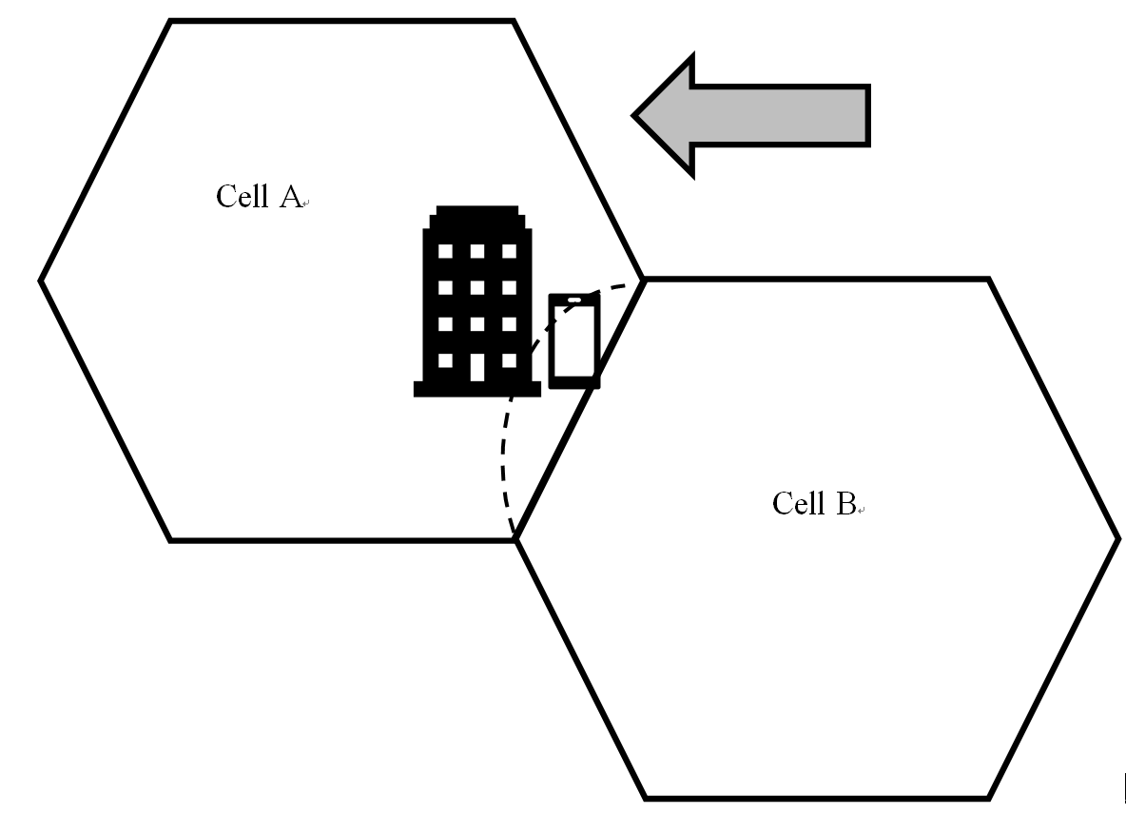
Q3a: Whether to consider per-UE mobility offset for NTN?
Q3b: if Q3a yes, which options is adopted?
- Option 1: add UE CHO Offset for NTN List in Mobility Setting Change procedure
- Option 2: add Source NG-RAN node Mobility Parameters in HANDOVER REQUEST.

UHI related enhancements for NTN
E/// [14] proposes to add new NTN cell types (e.g. LEO, GEO) to Cell Type IE for indicating the NTN cells in UHI.

9.3.1.98 Cell Type
This IE provides the cell coverage area.
IE/Group Name | Presence | Range | IE type and reference | Semantics description
Cell Size | M |  | ENUMERATED (verysmall, small, medium, large, …)
NTN Cell Type | O |  | ENUMERATED (LEO, GEO, …)

E/// [14] proposes to enhance Cause value to reflect cell mobility in a non-terrestrial network.
Radio Network Layer Cause: Intra-NTN Handover, Satellite switch with re-sync

Conclusion, Recommendations [if needed]
If needed

References
1 | R3-255194 | (SON TP to BL CR to TS 38.423 and MDT TP to BL CR TS 38.413) Solution to avoid restarting MRO in NTN deployments and a proposal for the MDT area definition (Nokia) | other
2 | R3-255261 | (TPs to BL CR for 38.300, 38.413 and 38.423) Further discussion on SONMDT enhancements for NTN (ZTE Corporation) | other
3 | R3-255316 | MDT enhancements for NTN (Qualcomm Incorporated) | discussion
4 | R3-255350 | (TP for MDT BLCRs for TS38.413, TS38.423) SON/MDT enhancements for NTN (Samsung) | other
5 | R3-255395 | Discussion on SON/MDT for NTN (Lenovo) | discussion
6 | R3-255428 | Discussion on SONMDT for Intra-NTN mobility (Huawei, CMCC, Jio Platforms, China Unicom) | discussion
7 | R3-255429 | (TP for MDT BLCR for TS38.413): MDT enhancement for NTN (Huawei, CMCC, Jio Platforms, China Unicom) | other
8 | R3-255430 | (TP for MDT BLCR for TS38.423): MDT enhancement for NTN (Huawei, CMCC, Jio Platforms, China Unicom) | other
9 | R3-255431 | (TP for MDT BLCR for TS37.320): MDT enhancement for NTN (Huawei, CMCC, Jio Platforms, China Unicom) | other
10 | R3-255433 | SON MDT for Intra-NTN Mobility (Jio Platforms) | discussion
11 | R3-255495 | MRO for NTN (Huawei) | other
12 | R3-255597 | SON-MDT enhancements for NTN (Ericsson) | discussion
13 | R3-255598 | (TP for BL CR to 38.413 for SON) Additional cause values and cell types for NTN (Ericsson) | other
14 | R3-255643 | (TP for 38.300) Intra-NTN mobility for SON (CATT) | other
15 | R3-255644 | (TP for 38.413 and 38.423) Intra-NTN mobility for MDT (CATT) | other

