**3GPP TSG-RAN WG3 #129 R3-255874**

**Bengaluru, India, 25th - 29th Aug, 2025**

Agenda Item: 15.2

Source: ZTE Corporation

Title: Summary of discussion on CB: # 27_IoTNTN

Document for: Discussion

# Introduction

This is to kick off the offline discussion of CB: # IoTNTN

|  |
| --- |
| **CB: # 27_IoTNTN**  **- align with NTN**  **- discuss store&forward and any other open topics**  (ZTE) |

# For the Chairman’s Notes

**Approved Contributions**

R3-255294 Agreed

R3-255507 Agreed

R3-255509 rev in R3-255897 Agreed

R3-255750 rev in R3-255892 Agreed

# Discussion

During the offline discussion, we went through the store and forward issue in R3-255513 and R3-255514. In addition, the mirror corrections from NR NTN were also discussed.

## Store and Forward Issue

In **R3-255513** (with response in R3-255747), it is proposed to agree that during the S&F mode transition (i.e., from the S&F mode to the normal mode or vice versa), the MME is not changed for its served UEs (for all connected/idle UEs).

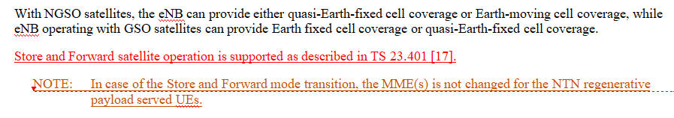

**Noted**

In **R3-255514** (with response in R3-255748), it is proposed to introduce an OAM-provision the S&F mode indication of the neighbour cell pending to RAN2 decision. Noted

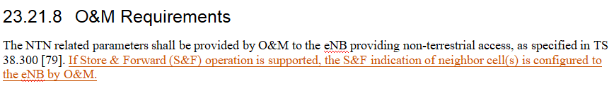

**Noted**

## Corrections to align with NR NTN

**R3-255294**: The missing Removal function in Section 19.2.1.8 is added, the “instance” from “interface instance” is deleted and the typo issue is corrected.

**Agreed**

**R3-255507**: The missing Removal function in Section 7 is added, the “instance” from “interface instance” is deleted and the typo issue is corrected.

**Agreed**

**R3-255509**: Mirror TP of R3-255508 in NR NTN.

-Remove the second change and align with NR NTN TP on first change

Rev in 255897 **Agreed**

**R3-255512**: Add “or TNL functionality” in Section 23.21.5.3

**Noted**

**R3-255516**: LS to SA2 to provide RAN3’s progress in IoT NTN so far.

**Noted**

**R3-255750**: Mirror TP of R3-255547.

-Only Keep the TP

Rev in R3-255892 **Agreed**

# Reference

RAN3#129 Contributions in AI15.2