3GPP TSG-RAN WG3 Meeting #129 R3-255774
Bengaluru, India, 25 – 29 August 2025

Title: Summary of offline discussion on Ambient IoT
Agenda Item: 16.2
Source: Huawei(moderator)
Document for: Agreement

Introduction
This paper provides the records of the Ambient IoT offline discussion.
CB: # 16_AmbientIOT
- TPs capturing the above agreements
- Address remaining open issues
- BL CR cleanup
(Huawei)

For the Chairman’s Notes
Detailed IE encoding and miscellaneous
- Include the Expected D2R Message Size IE (encoded as INTEGER (1..256,…) Unit: Byte), in the Inventory Assistance Information IE in the Inventory Request Transfer IE, and change the presence of Inventory Assistance Information IE to mandatory.
- For the A-IoT Device Identification Requested IE, encode the group devices inventory branch for A-IoT Device Identification Requested IE as OCTET STRING. For both the single device inventory branch and the group devices inventory branch, upon receiving the octet string, the gNB changes it to bit string. Add magic sentence in asn.1 “-- the detailed encoding needs to be refined--”
- Update the encoding of Approximate Number of Target A-IoT Devices IE from INTEGER (1..2048, …) to INTEGER (1..65535, …).
- Encode the A-IoT Correlation Identifier IE as OCTET STRING, with magic sentence in asn.1 “-- needs to be replaced by a constrained type definition--”.
- Encode the AIOTF Identifier IE as OCTET STRING refers to NfInstanceId IE defined in TS 29.571, with magic sentence in asn.1 “-- needs to be replaced by a constrained type definition--”.
- Upon receiving the Time Interval IE, the gNB may take it into account. Encode the Time Interval IE as INTEGER (1..256, ...) units: 0.1 second, with magic sentence in asn.1 ““--the detailed value needs to be revisited--”.
Interface Management
- In the NG SETUP REQUEST message, the “not applicable IEs” to be ignored by the A-IoT CN node include the Supported TA List IE and Default Paging DRX IE.
- gNB is aware of direct connectivity (directly connecting with AIOTF) via OAM.
- In case of direct connectivity, include AIOTF Identifier IE and AIOTF Name IE in the NG SETUP RESPOSE message.
- In case of direct connectivity, the gNB ignores the not applicable IEs received in NG SETUP RESPOSE message.
- In case of indirect connectivity, if the gNB only support A-IoT, the gNB ignores the not applicable IEs received in NG SETUP RESPOSE message.
Reader Selection
- Upon receiving only the reader list in Inventory Request, the gNB shall take the requested reader list into account to perform inventory (within the request reader list).
- The “receiving both the area and the reader list in Inventory Request” case is allowed.
Session Release and Inventory Complete Indication
- Keep the presence of the Reader Report List IE contained in the Inventory Report Transfer IE as mandatory, with magic sentence in asn.1 “-- the presence of the IE may be revisited --”
TPs to be agreed
- R3-255792 (TP to TS 38.300 BL CR) Session Release and Inventory Complete Indication
- R3-255793 (TP to TS 38.413 BL CR) Session Release and Inventory Complete Indication
- R3-255794 (TP to TS 38.413 BL CR) Interface Management
- R3-255795 (TP to TS 38.300 BL CR) Reader Selection
- R3-255796 (TP to TS 38.300 BL CR) Detailed IE encoding and miscellaneous
- R3-255797 (TP to TS 38.413 BL CR) Detailed IE encoding and miscellaneous
- R3-255798 (TP to TS 38.401 BL CR) Miscellaneous

Discussion of leftover issues

Detailed IE encoding and miscellaneous

Expected D2R Message Size IE in Inventory Request
Progress made during Tue online discussion:
Confirm that the Estimate of Expected D2R Message Size IE is mandatory provided in INVENTORY REQUEST.
Question 1: where to capture the Expected D2R Message Size IE?
- Option A: Include the Expected D2R Message Size IE in the Inventory Request Transfer IE
- Option B: Include the Expected D2R Message Size IE in the Inventory Assistance Information IE in the Inventory Request Transfer IE, and change the presence of Inventory Assistance Information IE to mandatory.

Question 2: How to encode the Expected D2R Message Size IE?
- INTEGER type
  - SIZE 1..128 byte: Huawei, Samsung, CMCC?
  - SIZE(1..256, …) byte: CATT
  - SIZE 1..256 bit: LGE
  - SIZE 104..1024: Xiaomi

A-IoT Device Identification Requested IE in Inventory Request
Progress in last meeting:
- Define the A-IoT Device Identification Requested IE as CHOICE type, with three branches:
  - single device inventory: OCTET STRING refer to Device Identifier
  - group devices inventory: FFS on the encoding
  - all devices inventory: NULL

R3-255346: It can be observed from above that neither single device id nor group device id is byte aligned, so it is better to define these Identities as BITSTRING. In addition, in order to be future proof, the size of the BITSTRING can be set as 1024.
About the A-IoT Device Identification Requested IE:
Proposal 1: For group devices inventory, encode as BIT STRING (SIZE (1..1024, ...))
Proposal 2: For single device inventory, encode as BIT STRING (SIZE (1..1024, ...))

Option 1: encode as BIT STRING (SIZE (1..1024, ...)), with comment below.
Option 2: encode as OCTET STRING, gNB changes the OCTET STRING to BIT STRING, with comment below.
With comment in asn.1 “– the detailed encoding needs to be refined.”

Approximate Number of Target A-IoT Devices IE
In NGAP BLCR, Approximate Number of Target A-IoT Devices IE is encoded as INTEGER (1..2048, …), considering that in case Q is set to 15, there could be 32768 access occasions, it is better for RAN3 to set the max value of the Approximate Number of Target A-IoT Devices as e.g., 65535.
- Note: In current Inventory Report:
Proposal: Update the encoding of Approximate Number of Target A-IoT Devices IE from INTEGER (1..2048, …) to INTEGER (1..65535, …).

A-IoT Correlation Identifier IE
Question: How to encode the A-IoT Correlation Identifier IE?
- Option A: OCTET STRING
  - CATT, Huawei, LGE, Samsung, Jio
- Option B: INTEGER (0..65535,…)
  - Nokia
With comment in asn.1 as: “-- needs to be replaced by a constrained type definition”

AIOTF Identifier IE
Question: How to encode the AIOTF Identifier IE?
- Option A: OCTET STRING, refer to the NfInstanceId IE defined in TS 29.571
  - CATT, Huawei, LGE, Samsung, CMCC, Jio
- Option B: GUAMI IE
  - Ericsson
With comment in asn.1 as: “-- needs to be replaced by a constrained type definition”

Time Interval IE
Progress made during Tue online discussion:
Introduce Time Interval as Inventory Assistance Information.

Question: How to encode the Time Interval IE?
- ENUMERATED (small, medium, large, …) (detailed values left to implementation/OAM configuration)
- INTEGER (0..255, ...) unit: seconds
- INTEGER (1, 600, …) unit: seconds
- INTEGER (1..2048, ...) units: milliseconds.

INTEGER (1..256, ...) units: 0.1 second.
With comment in asn.1 as: “—the detailed value needs to be revisited”
The gNB may take it into account.

Command Type (write, read, disable, …) in Command Request Transfer
Progresses made during Tue online discussion:
Introduce Command Type (write, read, disable, …) in Command Request Transfer?
Proposal: No consensus, contribution driven.

Interface Management
Progresses made during Tue online discussion:
Turn the previous WA: Define the A-IoT Support IE in NG Setup Request as ENUMERATED (A-IoT only, A-IoT and NR Uu,..) into agreement
If the “A-IoT support” IE is included in NG Setup Request and is set to “A-IoT only”, the AMF (in case of indirect connectivity) can ignore those IEs that are not applicable to A-IoT (e.g., Default Paging DRX) and consider only the A-IoT applicable IEs upon receiving the NG Setup Request.
If the “A-IoT support” flag is included in NG Setup Request and is set to “A-IoT and NR Uu”, the AMF (in case of indirect connectivity) will consider the A-IoT applicable IEs for A-IoT communication and the A-IoT non-applicable IEs for Uu communication.
In NG Setup Response, add clarification in the Semantics description of the not applicable IEs that: “This IE is ignored if the gNB directly connects to the AIOTF”.

For NG SETUP REQUEST message:
Proposal 1: The “not applicable IEs” to be ignored by the A-IoT CN node include: Supported TA List IE and Default Paging DRX IE.

For NG SETUP RESPONSE message:
Proposal 1: gNB is aware of direct connectivity (directly connecting with AIOTF) via OAM.

Proposal 2：In case of direct connectivity, the gNB ignores the not applicable IEs received in NG SETUP RESPOSE message.

Proposal 3: In case of indirect connectivity, if the gNB only support A-IoT, the gNB ignores the not applicable IEs received in NG SETUP RESPOSE message.

Proposal 4: The “not applicable IEs” in the NG SETUP RESPOSE message includes: AMF Name IE, Served GUAMI List IE, Relative AMF Capacity IE, PLMN Support List IE.

Q: In direct connectivity, whether the gNB needs to get “ID and name of the AIOTF”?
- Yes
- No
Q: how to provide the ID and name?
- Known via OAM configuration
- Include AIOTF Identifier IE and AIOTF Name IE in the NG SETUP RESPOSE message.
- Reuse the AMF Name IE and Served GUAMI List IE in the NG SETUP RESPOSE message.

Reader Selection
Previous RAN3 agreements/WA:
- Upon only receiving the area in Inventory Request, the gNB selects readers within the indicated area.
- Upon receiving neither the area nor the reader list in Inventory Request, the gNB selects all the served readers.
- WA: Upon only receiving the reader list in Inventory Request, the gNB selects the readers indicated by the reader list.
- FFS: Upon receiving both the area and the reader list in Inventory Request, the gNB selects the readers within the indicated area and the readers within the reader list.

Progresses made during Tue online discussion:
Upon receiving only the reader list in Inventory Request, the gNB shall use all the readers indicated by the reader list to perform inventory; or
Upon receiving the reader list in Inventory Request, no matter whether AIoT service area is included, the gNB shall take it into account when performing inventory

Proposal 1: Upon receiving only the reader list in Inventory Request, choose one option to go:
- Option A: the gNB use all the readers indicated by the reader list to perform inventory.
  - Shall use (strict limitation), i.e., in case 100 readers are indicated, fail the procedure if 1 reader within the list cannot be used
  - QCOM
  - Should use (strong recommendation), i.e., in case of 100 readers are indicated, success if any reader within the list success
    - QCOM, Huawei, CMCC, Xiaomi
- Option B: the gNB shall take the requested reader list into account to perform inventory, (within the request reader list).
  - Nokia, ZTE, Huawei, Ericsson, CMCC, Xiaomi, CATT, Samsung
- Option C: the gNB performs inventory within the requested reader list.

Proposal 2: The “receiving both the area and the reader list in Inventory Request” case is allowed.

Session Release and Inventory Complete Indication
Progresses made during Tue online discussion:
A-IoT Session release should not only rely on the class 2 A-IoT Session Release Request procedure, the Class 1 CN triggered A-IoT Session Release procedure should be performed in all scenarios.
In the case of Inventory with command scenario, introduce Inventory Complete indication to inform the AIoT CN about the complete of the triggered Inventory session.
Inventory Complete indication shall be sent via the container within the Inventory Report message, other than a new procedure.
The Reader Report List IE contained in the Inventory Report Transfer IE included in Inventory Report message shall be optional instead of mandatory.

Proposal: Change the presence of the Reader Report List IE contained in the Inventory Report Transfer IE from mandatory to optional.
Support: Huawei, ZTE, Samsung
Not support: Ericsson,
Keep it mandatory, with magic sentence comment in asn.1 that the presence of the IE may be revisited.

TPs
About Session Release and Inventory Complete Indication
- (TP to TS 38.300 BL CR) on Session Release and Inventory Complete Indication (Nokia)
- (TP to TS 38.413 BL CR) on Session Release and Inventory Complete Indication (Xiaomi)
About Interface Management
- (TP to TS 38.413 BL CR) on Interface Management (CATT)
About Reader Selection
- (TP to TS 38.300 BL CR) on Reader Selection (ZTE)
About Detailed IE encoding and miscellaneous
- (TP to TS 38.300 BL CR) on Detailed IE encoding and miscellaneous (Ericsson)
Besides capturing the agreements, also capture following clean up:
- 16.xx.x3 Inventory procedure
- 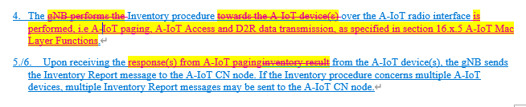
- 16.xx.x4 Command procedure
- 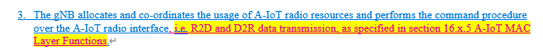
Moderator comment: “A-IoT Access” need to be updated to “A-IoT access procedure”
- (TP to TS 38.413 BL CR) on Detailed IE encoding and miscellaneous (Huawei)
Besides capturing the agreements, also capture following clean up:
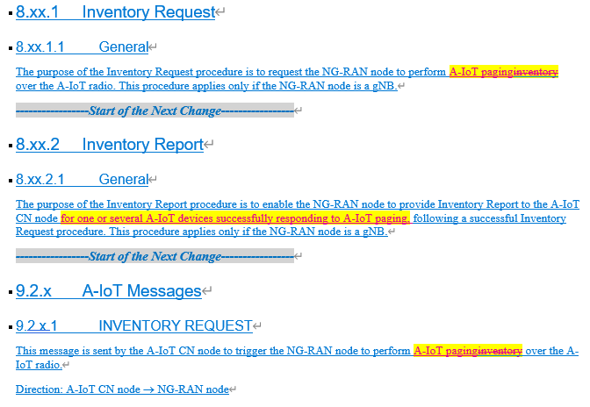
About TS 38.401 BL CR
- (TP to TS 38.401 BL CR) on miscellaneous (Samsung)
Capture the following changes:
  - 