3GPP TSG-RAN WG3 Meeting #129 R3-25xxxx
Bengaluru, India, 25 – 29 August 2025

Agenda item: 20.2
Source: Ericsson (moderator)
Title: CB: # 17_AIPHY
Document for: Discussion and Decision

1 Introduction
This contribution provides summary of offline discussion on AI/ML for PHY (Positioning) based on the following CB minutes:
CB: # 17_AIPHY
- Further check 5572 and 5337
- TPs to reflect the above agreements
- BL CR cleanup and completion
- Reply LS to SA2 based on 5583
(Ericsson)

2 For the Chair’s Notes

3 Further check 5572 and 5337 (Case 3b TPs)
Based on offline discussion, it has been agreed to rename the “UL-SRS-TDCP” in R3-255572/5337 TPs into “UL-SRS-TDCP item”, to reflect this is an element of the Nt list constituting the power information.
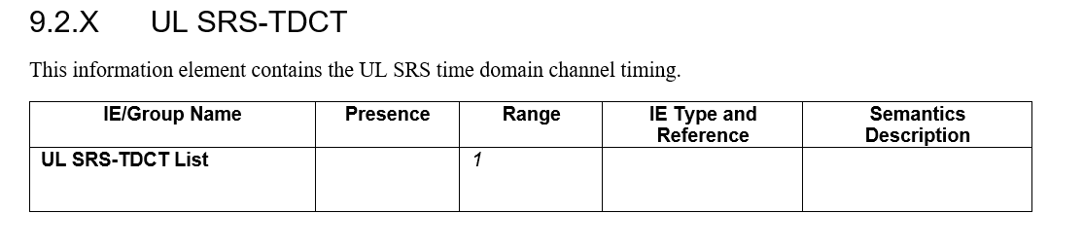
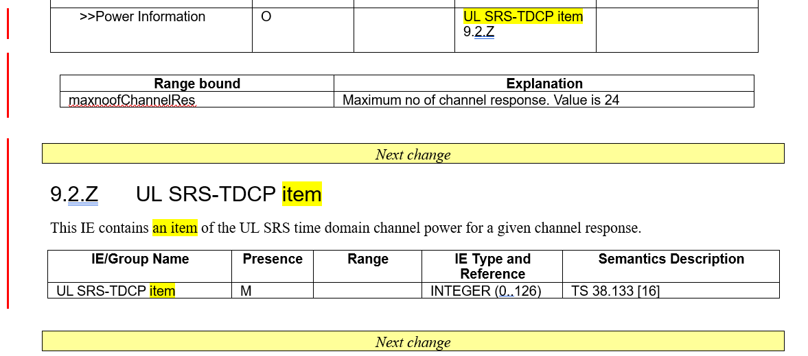

Proposal 1: Agree revisions R3-25xxxx and R3-25xxxx of 5572 and 5337
Company | Comment

4 Case 3a NRPPa TP
It has been agreed during the online session that:
The "LoS/NLoS indicator" can also be a gNB inferred measurement.
- Change #1: It is proposed to remove the FFS from the TRP Measurement Result IE:
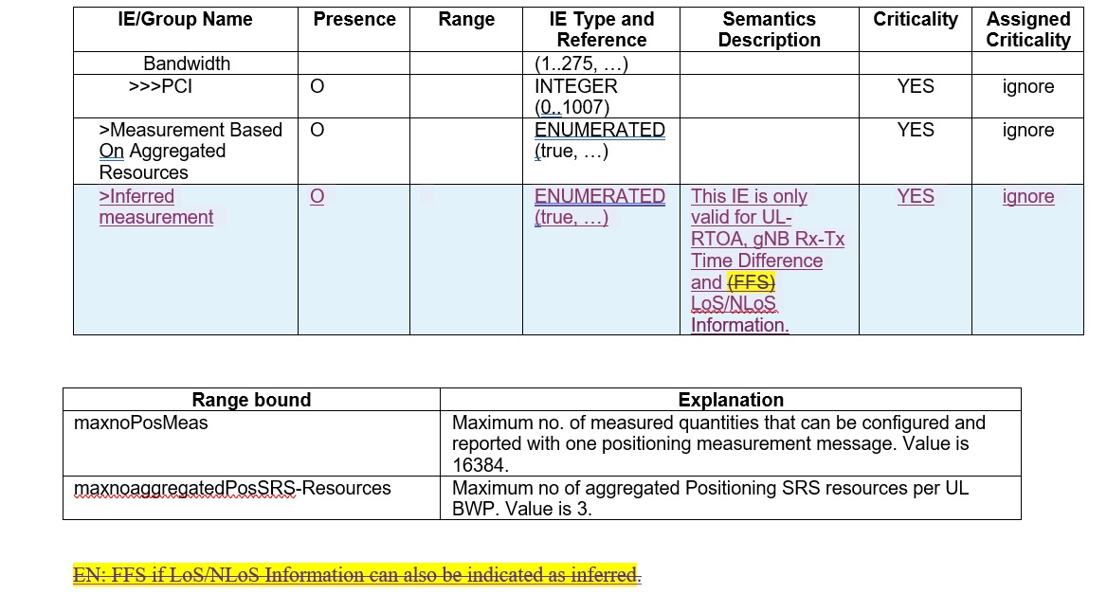

It was also agreed online that In a POSITIONING DATA COLLECTION REPORT message, a LMF can provide the LoS/NLoS label information independently of any timing information label. The current semantics description in IE Positioning Data Information (9.2.Z2 [1]) is removed.
- Change #2: delete the semantics of the LoS/NLoS Information IE in 9.2.Z2:
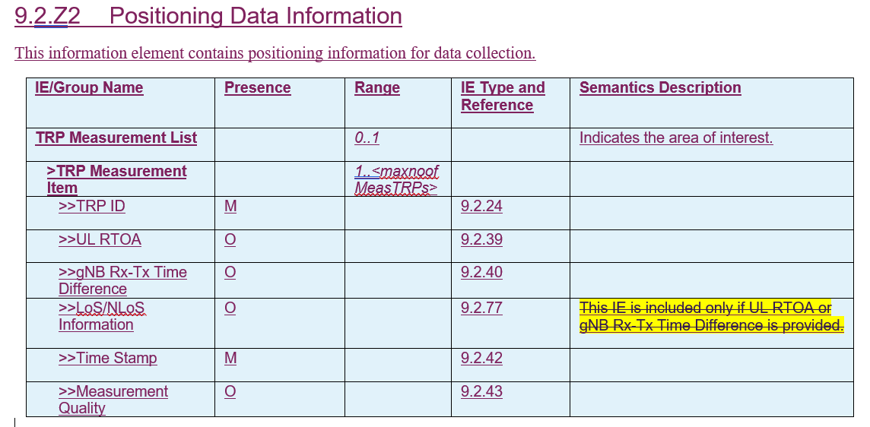

Another online agreement was that: It should be possible for an LMF to specifically request for AI/ML inferred measurements from TRPs.
- Change #3: add a new bit “inferred timing measurement” in the MCRI
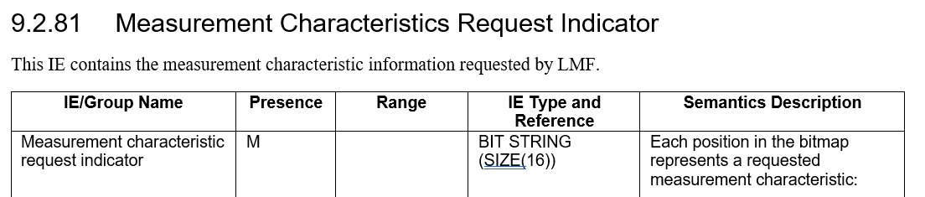
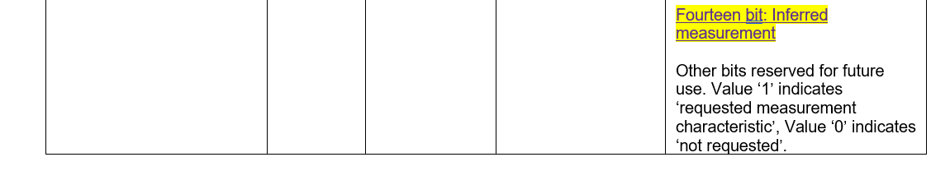

Finally, on the indication of "Positioning Data Unavailable", it was agreed:
Add the following error causes to the Positioning Data Unavailable IE:
- Positioning Data Information Not Supported
- Positioning Data Information Supported But Currently Not Available
- Change #4 revise the codepoints of the Positioning Data unavailable IE (ASN.1 change needed)
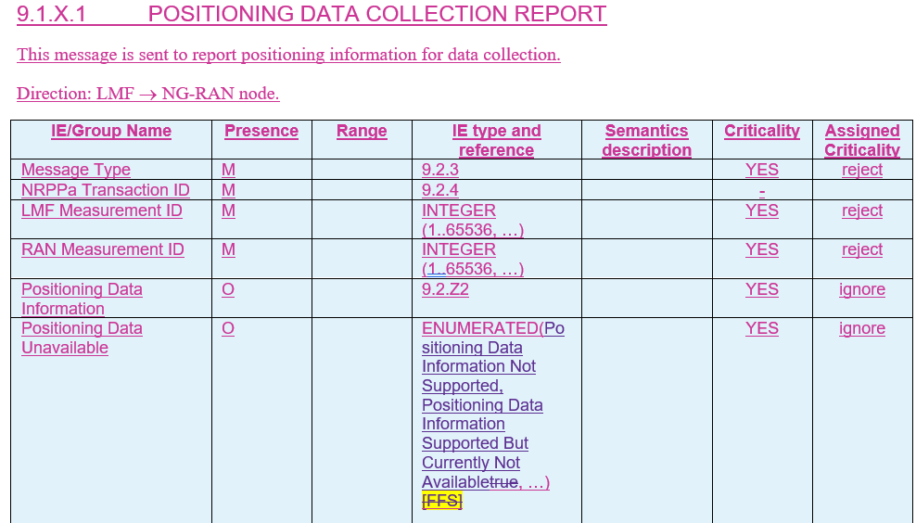

Proposal 2: Agree revisions R3-25xxxx NRPPa TP capturing changes #1, #2, #3, #4:
- Change #1: remove the FFS from the TRP Measurement Result IE:
- Change #2: delete the semantics in 9.2.Z2:
- Change #3: add a new bit “inferred timing measurement” in the MCRI
- Change #4 revise the codepoints of the Positioning Dat Unavailable IE (ASN.1 change needed)

Company | Comment
Ericsson | Change 1: As said online, can be done in stage 2 with no stage 3 impacts  Change #2, #3: OK  Change #4: the codepoints names are too long, suggest to be shortened to “not supported”, “not available”
CEWiT | Change 1: It is better to introduce one more conditional codepoint as suggested in TDoc R3-255288 as below. This is to reflect that both the measurement and LOS/NLOS information can be inferred and reported but LOS/NLOS can be reported only when measurement reported.  >Inferred measurement O ENUMERATED(true, …) This IE is only valid for UL-RTOA, gNB Rx-Tx Time Difference. YES ignore  >Inferred LoS/NLoS Information C-ifInferred measurementtrue ENUMERATED(true, …) LoS/NLoS Information is included only if UL RTOA or gNB Rx-Tx Time Difference is provided YES ignore  Change 2: Okay  Change 3: Agree with E// cause names are too long. Further are these the only cause possible. Should we add cause “Unknown”?

5 Stage 2 clean-up
A TP will be provided by CATT capturing the stage 2 edits from other companies in R3-25xxxx. It is proposed to review it offline and provide comments directly in the document.
Proposal 3: Agree revisions R3-255775 merging other TS 38.305 TPs

6 LS reply to SA2 based on 5583
As part of online discussion it is proposed to reply to SA2 in (R3-255023 - S2-2505943) indicating that RAN3 will pursue solution 1 in Rel-19.
Based on R3-255583, below a revised text:
1. Overall Description:
RAN3 thanks SA2 for their LS response with feedback to RAN3 solutions on case 3a (NW-sided model, AI/ML-assisted positioning).

RAN3 will proceed with solution 1 in Rel-19. RAN3 kindly asks SA2 to add support of related LMF procedures in TS 23.273 as needed.

2. Actions:
To RAN2 : RAN3 kindly asks SA2 to take the above into account and introduce support for solution 1 in TS 23.273 as needed.

Proposal 4: Agree revisions R3-25xxxx LS to SA2
Company | Comment
CEWiT | Okay with the CR. But as commented online, the CR is not necessary as SA2 has gone ahead and discussing the possible changes in TS 23.273.

7 Other proposals
The following issues have not been discussed online, or slightly touched upon, they are to be discussed on a best effort basis during the offline session:
- Reply LS to RAN2 on logged Measurement Data during HO, capture and send in a LS to RAN2 that RAN3 will not do any work on this in Rel-19.
- Whether the Positioning Data Collection Needed IE should remain a top level IE or included per TRP in a TRP list in the Measurement Response/Report messages
- Addition of time stamp in the Positioning Data Collection Needed IE to indicate the desired time for report of data collection
- Introduce a NOTE in the TP for BLCR to TS 38.305 to indicate that a gNB may use different Nt', Nt and/or k values, other than the signalled parameters for measurement
- New cause values in case gNB cannot provide UL-SRS-TDCT
Company | Comment
Ericsson | Issue #1: OK  Issue #2: we think it should be per TRP, but fine to keep it as it is. A stage 2 clarification will anyway be needed. Either to be clarified this meeting or during maintenance.  Issue #3: OK, gNB hosting the model knows when in time it needs training data and include a reference time. We note this has not been precluded from RAN1 agreements. We are fine to consider this now or during maintenance.  Issue #4: OK, either now or during maintenance.  Issue #5: NOK, existing cause values are sufficient

References
R3-255009 | LS on Rel-19 AI/ML positioning higher layer parameters list Post RAN1#121 (RAN1(Ericsson)) | LS in
R3-255016 | Logged Data Handling During Handover (RAN2(Nokia)) | LS in
R3-255023 | Reply LS on AI/ML Positioning Case 3a (SA2(Nokia)) | LS in
R3-255029 | Reply LS on OAM-centric solution for NW-side data collection (SA5(Huawei)) | LS in
R3-255160 | Views on the Open Issues for AI/ML Positioning Accuracy Enhancements (Qualcomm Incorporated) | Discussion
R3-255161 | TP to BL CR for TS 38.305 (Qualcomm Incorporated) | Other
R3-255184 | (TP to BL CR for TS38.305) Support of AI Positioning (CATT) | Other
R3-255185 | (TP to BL CR for TS38.455) Support of AI Positioning for Case 3a (CATT) | Other
R3-255200 | [TP for BL CR to TS 38.305 & TP for BL CR to TS 38.455] Discussion on AI/ML for positioning Case 3a (NEC) | Other
R3-255201 | [TP for BL CR to TS 38.455] Discussion on AI/ML for positioning Case 3b (NEC) | Other
R3-255288 | Remaining Issues for AI/ML based positioning case 3a and TP to NRPPa (CEWiT, IITM, Tejas Networks) | Discussion
R3-255336 | (TPs for TS 38.305 and TS 38.455) Support of gNB-side model (case 3a) (Xiaomi) | Other
R3-255337 | (TP to BL CR TS 38.473) addition of UL SRS time domain channel measurement (Xiaomi, Ericsson, CATT, Nokia, Samsung) | other
R3-255338 | (Draft LS out) Logged data handling during handover (Xiaomi) | LS out To: RAN2 CC:
R3-255372 | (TPs for AI/ML BLCR to TS 38.300/305/401/455/473) Remaining open issues for AI/ML-based positioning Case 3a and Case 3b (Huawei) | Other
R3-255373 | (Draft Reply LS to RAN2) Discussion on R3-255016 (R2-2504950) LS Logged Data Handling During Handover (Huawei) | other
R3-255377 | Discussion on support of AI/ML assisted positioning (Case 3a) (China Telecom) | Discussion
R3-255378 | (TP to TS38.305) On support of AIML assisted positioning (China Telecom) | other
R3-255406 | Discussion on NW side data collection (Lenovo) | discussion
R3-255407 | (TP to BLCR 38.455) Provision of associated ID in Case 1 (Lenovo) | Other
R3-255456 | (TP to TS 38.300) AI/ML Training in OAM for case 3a (Nokia, Ericsson, Xiaomi, Samsung, CATT, ZTE) | other
R3-255457 | (TP to TS 38.305) Addressing remaining aspects in case 3a and case 3b (Nokia) | other
R3-255458 | Logged Data Handling after a Handover Event (Nokia) | discussion
R3-255459 | [Draft] Reply LS on Logged Data Handling During Handover (Nokia) | LS out To: RAN2 CC: SA5
R3-255503 | (TP to BL CR to 38.401) AI/ML assisted Positioning (ZTE Corporation, Ericsson, Xiaomi, Nokia, Samsung, CATT) | other
R3-255504 | (TP to BL CR to 38.455) Support of AI/ML assisted Positioning (case 3a) (ZTE Corporation) | Other
R3-255505 | [Draft LS] Reply LS on logged Data Handling During Handover (ZTE Corporation) | other
R3-255570 | (TP to NRPPa/TS 38.305 BL CR): Addressing remaining issues of NW-assisted AI/ML positioning with gNB-sided model (Ericsson, Nokia) | other
R3-255571 | Way forward for Proactive (NGAP-based solution) for AI/ML NG-RAN assisted positioning (Ericsson) | discussion
R3-255572 | (TP to NRPPa BL CR): addition of UL SRS time domain channel measurement (Ericsson, Xiaomi, CATT, CEWIT, Nokia, Samsung) | other
R3-255583 | [Draft] Reply LS on AI/ML Positioning Case 3a (Nokia) | LS out To: SA2 CC:
R3-255669 | Discussion on AI for positioning case 3a and case 3b (Samsung) | Discussion
R3-255670 | Discussion on Logged Data Handling During Handover (Samsung) | other

