3GPP TSG RAN WG2 #131bis R2-250xxxx
Prague, Czech Republic, Oct 13th-17th, 2025

Agenda item: 8.17
Source: Samsung
Title: Way forward on X501
WID/SID: IoT_NTN_TDD
Document for: Discussion and Decision
- Introduction
This discussion is for:
- [AT131bis][309][IoT NTN TDD] radioFrameoffset per cell (Samsung)
Scope: Discuss how to implement radioFrameoffset per cell
Intended outcome: summary of the offline discussion (in R2-2507778)
Deadline for offline discussion summary: Friday 2025-10-17 09:00

- Discussion

In IoT NTN, for idle mode cell reselection, the satellite ID is defined per frequency as seen in SIB3-NB and SIB5-NB:

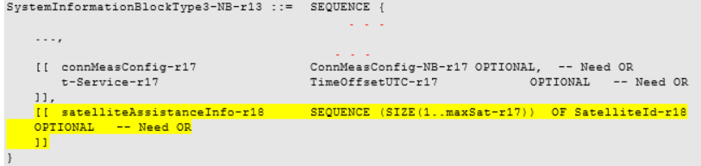

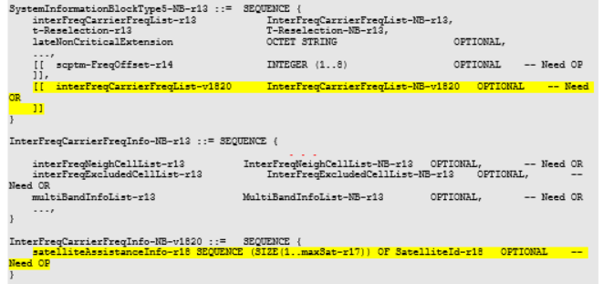

This is used for the UE to search for cells using pre-compensation based on matching list elements in NeighSatelliteInfoList with matching satellite IDs. In other words, as opposed to NR NTN, the signalling design does not configure satellite IDs with PCIs in NB-IoT NTN. This is natural as indicating specific cells for cell reselection is optional and not the baseline for perform cell reselection. It has occasionally been discussed to introduce per-cell satellite ID signalling in in IoT NTN, but it has not been agreed.

The following was agreed:
R2-2507674 Discussion on the RIL X501 (radioFrameOffset-r19) for IoT NTN TDD Beijing Xiaomi Electronics discussion Rel-19 IoT_NTN_TDD-Core
Proposal 1: The radioFrameoffset-r19 should be configured per cell rather than per satellite.
- The radioFrameoffset-r19 should be configured per cell rather than per satellite.
- Continue in offline 309 to discuss how to implement this
Proposal 2: The radioFrameoffset should be included in SIB4-NB and SIB5-NB respectively.
- The radioFrameoffset should be included in SIB4-NB and SIB5-NB respectively.
Proposal 3: The provided TP can be considered.

The issue with the suggested design in R2-2507674 is that the UE would only be given the radio frame offset for a specific PCI. This would likely not be useful unless the UE is also provided with the ephemeris, which is used to identify time and frequency offset for a specific cell. The UE could potentially use the satellite IDs provided in SIB3-NB and SIB5-NB, but this means that the UE would have to search all of the ephemeris for a specific PCI at a specific frequency. Also, the idle mode neighbour cell measurements RAN4 requirements only apply if ephemeris is provided. Therefore, the satellite IDs are required.

If the intention is to still agree the RIL X501 and for RAN4 requirements to apply, then satellite IDs would be required to be provided if configured per PCI along with the radioFrameOffset. Since this somewhat breaks with the past IoT NTN RRM configuration, and since satellite ID per PCI has been proposed and rejected in the past, we think that there may be restrictions introduced to only configure the satellite ID for IoT NTN TDD. This restriction can be captured by ensuring that both fields need to be configured together. For this purpose, there are two options in Annex.

Proposal 1: Introduce satellite ID per PCI if radioFrameOffset is configured with a restriction that it can only be used for IoT NTN TDD and is configured together with radioFrameOffset. Use TP in Annex as a baseline.

Comment on P1:

Company | Agree? (Y/N) | Comment

Discussion:

- Conclusions
In the e-mail discussion we have the following proposal:

Proposal 1: Introduce satellite ID per PCI if radioFrameOffset is configured with a restriction that it can only be used for IoT NTN TDD and is configured together with radioFrameOffset.

- References
[1] R2-2506558，Introduction of IoT NTN TDD mode

- Annex – Option A

– SystemInformationBlockType4-NB
The IE SystemInformationBlockType4-NB contains neighbouring cell related information relevant only for intra-frequency cell re-selection. The IE includes cells with specific re-selection parameters.
SystemInformationBlockType4-NB information element
-- ASN1START

SystemInformationBlockType4-NB-r13 ::= SEQUENCE {
intraFreqNeighCellList-r13 IntraFreqNeighCellList OPTIONAL, -- Need OR
intraFreqExcludedCellList-r13 IntraFreqExcludedCellList OPTIONAL, -- Need OR
lateNonCriticalExtension OCTET STRING OPTIONAL,
...,
[[ nsss-RRM-Config-r15 NSSS-RRM-Config-NB-r15 OPTIONAL, -- Need OR
intraFreqNeighCellList-v1530 IntraFreqNeighCellList-NB-v1530 OPTIONAL -- Need OR
]],
[[
intraFreqNeighCellList-v19xy IntraFregNeighCellList-NB-v19xy OPTIONAL -- Need OR
]]
}

IntraFreqNeighCellList-NB-v1530 ::= SEQUENCE (SIZE (1..maxCellIntra)) OF IntraFreqNeighCellInfo-NB-v1530

IntraFreqNeighCellList-NB-v19xy ::= SEQUENCE (SIZE (1..maxCellIntra)) OF IntraFreqNeighCellInfo-NB-v19xy

IntraFreqNeighCellInfo-NB-v1530 ::= SEQUENCE {
nsss-RRM-Config-r15 NSSS-RRM-Config-NB-r15 OPTIONAL -- Cond NSSS-RRM
}

IntraFreqNeighCellInfo-NB-v19xy ::= SEQUENCE {
radioFrameOffset-r19 INTEGER (-4..4) OPTIONAL -- Need OR
satelliteId-r19 SatelliteId-r18 OPTIONAL -- Need OR
}

-- ASN1STOP

SystemInformationBlockType4-NB field descriptions
intraFreqExcludedCellList
List of exclude-listed intra-frequency neighbouring cells.
intraFreqNeighCellList
List of intra-frequency neighbouring cells with specific cell re-selection parameters. If E-UTRAN includes intraFreqNeighCellList-v19xy, it includes the same number of entries, and listed in the same order, as in intraFreqNeighCellList-r13.
nsss-RRM-Config
For FDD: Configuration for NSSS-based RRM measurements.
If intraFreqNeighCellList-NB-v1530 is present then for a cell which is included in intraFreqNeighCellList, the UE applies the nsss-RRM-Config configured in the corresponding entry of IntraFreqNeighCellList-NB-v1530. Otherwise, the UE applies the nsss-RRM-Config configured in SystemInformationBlockType4-NB-r13.
radioFrameOffset
Offset, in number of frames, from the start of IoT NTN TDD pattern of serving cell to the start of the nearest IoT NTN TDD pattern of the neighbor cell, at the uplink time synchronization reference point defined in clause 16.1.2 of TS 36.213 [23].
satelliteId
Satellite ID used to associate with satellite assistance information, configured together with radioFrameOffset. This is only configured for IoT NTN TDD.

– SystemInformationBlockType5-NB
The IE SystemInformationBlockType5-NB contains information relevant only for inter-frequency cell re-selection i.e. information about other NB-IoT frequencies and inter-frequency neighbouring cells relevant for cell re-selection. The IE includes cell re-selection parameters common for a frequency as well as cell specific re-selection parameters.
SystemInformationBlockType5-NB information element
-- ASN1START

SystemInformationBlockType5-NB-r13 ::= SEQUENCE {
interFreqCarrierFreqList-r13 InterFreqCarrierFreqList-NB-r13,
t-Reselection-r13 T-Reselection-NB-r13,
lateNonCriticalExtension OCTET STRING OPTIONAL,
...,
[[ scptm-FreqOffset-r14 INTEGER (1..8) OPTIONAL -- Need OP
]],
[[ interFreqCarrierFreqList-v1820 InterFreqCarrierFreqList-NB-v1820 OPTIONAL -- Need OR
]]
}

InterFreqCarrierFreqList-NB-r13 ::= SEQUENCE (SIZE (1..maxFreq)) OF InterFreqCarrierFreqInfo-NB-r13

InterFreqCarrierFreqList-NB-v1820 ::= SEQUENCE (SIZE (1..maxFreq)) OF InterFreqCarrierFreqInfo-NB-v1820

InterFreqCarrierFreqInfo-NB-r13 ::= SEQUENCE {
dl-CarrierFreq-r13 CarrierFreq-NB-r13,
q-RxLevMin-r13 Q-RxLevMin,
q-QualMin-r13 Q-QualMin-r9 OPTIONAL, -- Need OP
p-Max-r13 P-Max OPTIONAL, -- Need OP
q-OffsetFreq-r13 Q-OffsetRange DEFAULT dB0,
interFreqNeighCellList-r13 InterFreqNeighCellList-NB-r13 OPTIONAL, -- Need OR
interFreqExcludedCellList-r13 InterFreqExcludedCellList-NB-r13 OPTIONAL, -- Need OR
multiBandInfoList-r13 MultiBandInfoList-NB-r13 OPTIONAL, -- Need OR
...,
[[ delta-RxLevMin-v1350 INTEGER (-8..-1) OPTIONAL -- Cond Qrxlevmin
]],
[[ powerClass14dBm-Offset-r14 ENUMERATED {dB-6, dB-3, dB3, dB6, dB9, dB12}
OPTIONAL, -- Need OP
ce-AuthorisationOffset-r14 ENUMERATED {dB5, dB10, dB15, dB20, dB25, dB30, dB35} OPTIONAL -- Need OP
]],
[[ nsss-RRM-Config-r15 NSSS-RRM-Config-NB-r15 OPTIONAL, -- Need OR
interFreqNeighCellList-v1530 InterFreqNeighCellList-NB-v1530 OPTIONAL -- Need OR
]],
[[ dl-CarrierFreq-v1550 CarrierFreq-NB-v1550 OPTIONAL -- Cond TDD
]],
[[
interFreqNeighCellList-v19xy InterFregNeighCellList-NB-v19xy OPTIONAL -- Need OR
]]

}

InterFreqCarrierFreqInfo-NB-v1820 ::= SEQUENCE {
satelliteAssistanceInfo-r18 SEQUENCE (SIZE(1..maxSat-r17)) OF SatelliteId-r18 OPTIONAL -- Need OP
}

InterFreqNeighCellList-NB-r13 ::= SEQUENCE (SIZE (1..maxCellInter)) OF PhysCellId

InterFreqNeighCellList-NB-v1530 ::= SEQUENCE (SIZE (1..maxCellInter)) OF InterFreqNeighCellInfo-NB-v1530

InterFreqNeighCellInfo-NB-v1530 ::= SEQUENCE {
nsss-RRM-Config-r15 NSSS-RRM-Config-NB-r15 OPTIONAL -- Cond NSSS-RRM
}

InterFreqNeighCellList-NB-v19xy ::= SEQUENCE (SIZE (1..maxCellInter)) OF InterFreqNeighCellInfo-NB-v19xy

InterFreqNeighCellInfo-NB-v19xy ::= SEQUENCE {
radioFrameOffset-r19 INTEGER (-4..4) OPTIONAL -- Need OR
satelliteId-r19 SatelliteId-r18 OPTIONAL -- Need OR
}

InterFreqExcludedCellList-NB-r13 ::= SEQUENCE (SIZE (1..maxExcludedCell)) OF PhysCellId

-- ASN1STOP

