3GPP TSG-RAN WG2 #131 R2-250xxxx
Bengaluru, India, 25-29 August 2025

Agenda Item: 7.0.2.19
Source: LG Electronics Inc.
Title: [Draft] Report of [AT131][404][Relay] SI reception for multi-path relay (LG)
Document for: Discussion and decision

Introduction
This is the trigger of the following email discussion, regarding correction to SI reception by remote UE for multi-path in R2-2505543 (i.e. CR5422 to 38.331 for NR_SL_relay_enh-Core):
- [AT131][404][Relay] SI reception for multi-path relay (LG)
Scope: Discuss the CR in R2-2505543 and determine if a change is needed.
Intended outcome: Agreeable CR if applicable in R2-2506310
Deadline: Wednesday 2025-08-27 1900 IST

Discussion

Question 1: Do you agree that the following agreements and the following texts in 38.300 clause 16.21.3.3 are still valid for multi-path?
RAN2#120 agreement
- If CSS for SI is configured within the active BWP on PCell, the remote UE can perform direct system information acquisition on PCell as currently specified in 38.331; besides, dedicated signaling can be used to deliver SIB via SRB1 configured on direct and/or indirect path as currently specified in 38.331.

RAN2#121 agreement
- The remote UE in MP operation receives system information at least PBCH/MIB on the direct path and directly acquires SFN from MIB on the direct path, if necessary.
- If CSS for Paging is configured within the active BWP on the direct path on PCell, the remote UE in multi-path operation in RRC_CONNECTED monitors paging on PCell for updated system information or ETWS/CMAS indication, as currently specified in 38.331. The gNB can also provide updated system information or warning message(s) to the remote UE on SRB1, as currently specified.

38.300 clause 16.21.3.3
The L2 MP Remote UE can acquire any necessary SIB(s) over Uu interface or indirect path. If common search space for system information is configured with the active BWP on PCell, the L2 MP Remote UE can perform direct system information acquisition on PCell. The L2 MP Remote UE can also receive system information at lease PBCH/MIB on the direct path and directly acquires SFN from MIB on the direct path. Besides, the L2 MP Remote UE can receive the system information via dedicated RRC signalling via SRB1.

Company | Yes/No | Any comment?
LG Electronics | Yes | It is not desirable to revert the previous agreements.
Apple | Yes

Question 2: Do you agree that the following in 38.331 clause 5.2.2.2.2 is also applied to L2 U2N Remote UE configured with MP in RRC_CONNECTED?
UEs in RRC_CONNECTED shall monitor for SI change indication in any paging occasion at least once per modification period if the UE is provided with common search space, including pagingSearchSpace, searchSpaceSIB1 and searchSpaceOtherSystemInformation, on the active BWP to monitor paging, as specified in TS 38.213 [13], clause 13.

Company | Yes/No | Any comment?
LG Electronics | Yes | We should not change the legacy UE behaviour. If no, we think that we need to change this legacy UE behaviour.
Apple | Yes

Meanwhile, the following has been specified in 38.331 clause 5.2.2.2.1 and 5.2.2.2.2 without possibility of the L2 MP Remote UE directly acquiring any necessary SIB(s) over Uu interface (instead of indirect path), if common search space for system information is configured with the active BWP on PCell.

38.331 clause 5.2.2.2.1
A L2 U2N Remote UE in RRC_CONNECTED receives SIB1 and other SIB(s) in RRCReconfiguration message and performs on-demand SI request if required, as defined in clause 5.2.2.3.5 and 5.2.2.3.6. The L2 U2N Remote UE in RRC_IDLE or RRC_INACTIVE or RRC_CONNECTED (when MP is not configured) is not required to obtain SI over Uu interface, but it may decide to perform the SI acquisition procedure over Uu interface as defined in clause 5.2.2.3 by UE implementation.
NOTE: The storage and management of the stored SIBs in addition to the SIBs valid for the current serving cell is left to UE implementation.
38.331 clause 5.2.2.2.2
A L2 U2N Remote UE is not required to monitor paging occasion for SI modifications and/or PWS notifications. It obtains the updated system information and SIB6/7/8 from the connected L2 U2N Relay UE as defined in clause 5.8.9.9.3.

Question 3: Do you think that the above texts in 38.331 clause 5.2.2.2.1 and 5.2.2.2.2 are always applied to L2 U2N Remote UE configured with MP in RRC_CONNECTED, regardless of whether the UE configured with MP is provided with common search space (including pagingSearchSpace, searchSpaceSIB1 and searchSpaceOtherSystemInformation) on the active BWP to monitor paging?

Company | Yes/No | Any comment?
LG Electronics | No | When the UE configured with MP is provided with common search space (including pagingSearchSpace, searchSpaceSIB1 and searchSpaceOtherSystemInformation) on the active BWP, the UE configured with MP can directly receive SIB1 and other SIB(s) and monitor paging occasion for SI modifications and/or PWS notifications.
Apple | See comment | The text in 5.2.2.2.1 has already said “(when MP is not configured)”, so it has exclude the MP case explicitly. For text in 5.2.2.2.2, we think “is not required” is a very weak statement and does not mandate any MP Remote UE behavior, so it seems fine. But we can accept to add “(when MP is not configured)” in this section.

Question 4: How should RAN2 ensure that the above previous RAN2 agreements and the above texts in 38.300 clause 16.21.3.3 are still valid in 38.331?
- Opt 1: No change to 38.331 (i.e. the previous RAN2 agreements need to be reverted, which changes the above text in 38.300 clause 16.21.3.3)
- Opt 2: Agree the CR to 38.331 in R2-2505543 (with or without any modification to the proposed changes)
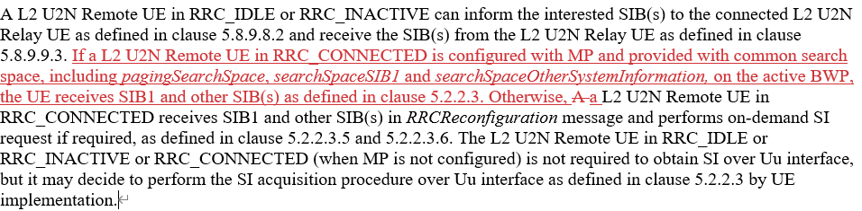
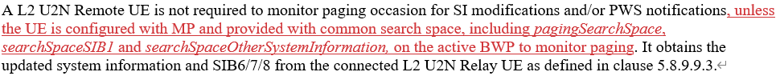

- Opt 3: Introduce another CR to 38.331 with an alternative change, for example:
38.331 clause 5.2.2.2.1
A L2 U2N Remote UE in RRC_CONNECTED can receives SIB1 and other SIB(s) in RRCReconfiguration message and performs on-demand SI request if required, as defined in clause 5.2.2.3.5 and 5.2.2.3.6. Unless required in clause 5.2.2.2.2 to obtain SI over Uu interface when MP is configured, Tthe L2 U2N Remote UE in RRC_IDLE or RRC_INACTIVE or RRC_CONNECTED (when MP is not configured) is not required to obtain SI over Uu interface, but it may decide to perform the SI acquisition procedure over Uu interface as defined in clause 5.2.2.3 by UE implementation.

38.331 clause 5.2.2.2.2
Unless mentioned otherwise, Aa L2 U2N Remote UE is not required to monitor paging occasion for SI modifications and/or PWS notifications. It obtains the updated system information and SIB6/7/8 from the connected L2 U2N Relay UE as defined in clause 5.8.9.9.3.

Note that any other way to change is also welcome for option 3.

Company | Preference: Option 1, 2 or 3 | Any comment
LG Electronics | Option 2  but option 3 is also fine | No change to 38.331 means the previous RAN2 agreements need to be reverted, which changes the above text in 38.300 clause 16.21.3.3
Apple | Option 3 with comments | Add “when MP is not configured” in 5.2.2.2.2

Summary and suggestion
In conclusion….

