3GPP TSG-RAN2 Meeting # 131 R2-250

Bengaluru, India, 25 – 29 August, 2025

Agenda Item: 7.0.2.21
Source: Huawei, HiSilicon (Rapporteur)
Title: Summary for [AT131][401][POS] CRs on PosSIB segments in dedicated signalling (Huawei)
Document for: Discussion and Decision

1 Introduction
During the discussion in RAN2#131, we have discussed on the issues proposed by R2-2505324 on how to deliver multiple segments of the same posSIB via dedicated signalling. It was concluded that we examine the CR by the following email discussion
- [AT131][401][POS] CRs on posSIB segments in dedicated signalling (Huawei)
Scope: Check and update the CRs in R2-2505324 / R2-2505325 / R2-2505640, including confirming if there is a restriction in the spec today. Intention is to allow multiple segments of a posSIB when sent by dedicated signalling, without changing the broadcast behaviour or the non-positioning SIBs.
Intended outcome: Agreeable CRs in R2-2506301 / R2-2506302 / R2-2506303
Deadline: Wednesday 2025-08-27 1900 IST
This paper summarizes the email discussion.

2. Discussion

Question: Any comment on the CRs?
Company | Comments
vivo | I agree with the intention to allow multiple segments of a posSIB when sent by dedicated signalling.  However, I think the current spec has no restriction on the intention.  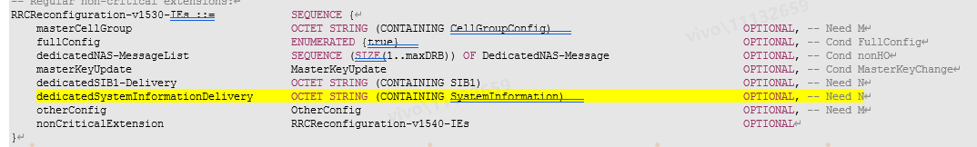  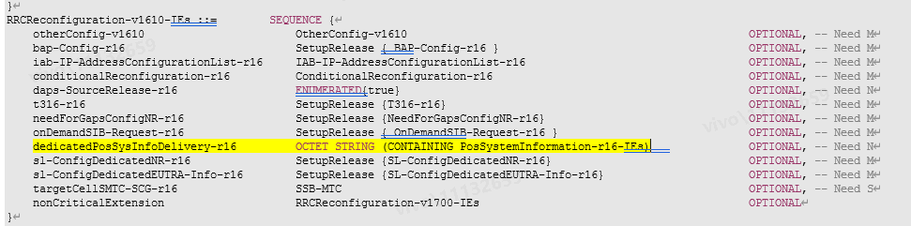
The current spec is copied as above, it can be observed that the normal SIB and posSIB are carried in different container. For the normal SIB, it is carried in SI message, while for posSIB, it is carried in PosSystemInformation-r16-IEs.
And the current spec only have restriction on the SI message container, i.e., Each SIB and posSIB is contained at most once in an SI message.
Therefore, we think no restriction on the list in PosSystemInformation-r16-IEs, that is, multiple posSIB with the same type can be contained in the PosSystemInformation-r16-IEs when it is sent via dedicated signaling.
ZTE | We share the same view with vivo.  If gNB transmit SI message which contains PosSystemInformation-r16-IEs (via broadcast signaling), the restriction in 5.2.1 (each posSIB segment is contained at once in a SI message) should be followed; if gNB only transmit PosSystemInformation-r16-IEs (via dedicated signaling), the restriction in 5.2.1 does not apply.  So, if the PosSystemInformation-r16-IEs is sent in dedicated signalling, according to current spec, gNB is already possible to set the multiple segments of one posSIB type in one PosSystemInformation-r16-IEs:  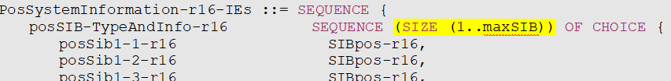  Of course, if the PosSystemInformation-r16-IEs is contained in SI message sent by broadcast signalling, the above gNB behaviour is not allowed according to 5.2.1.  So it is just a clarification to the current spec. Nothing is wrong in current spec. if companies still have concern on the understanding, instead of this NBC change, we suggest to make the following agreement in chair notes to clarify:  When gNB sends PosSystemInformation-r16-IEs to UE in dedicated RRC signalling, the PosSystemInformation-r16-IEs may contain multiple segments of a posSIB.
MediaTek | Comment #1  Agree with the intention of the CRs.  Comment #2  Agree with Vivo that the term "SI message" seems to refer to SystemInformation message, thus restriction seems not applicable to posSIBs sent in RRCReconfiguration. This terminology can be seen in the third bullet in clause 5.2.1:  "- SIBs other than SIB1 and posSIBs are carried in SystemInformation (SI) messages, which are transmitted on the DL-SCH. <omit the rest>"  Based on this, it seems the CRs are not required. We could clarify that dedicatedPosSysInfoDelivery can carry multiple instances of the same posSIB type in a chairman note instead.  Comment #3  The NOTE in the field description of dedicatedPosSysInfoDelivery looks unclear/incorrect.  "NOTE: When the number of segments of posSIB exceed the maximum number of posSIBs that a SI message could carry (i.e., 32), the posSIB segments could be delivered by multiple SI messages ..."  The RRCReconfiguration contains single instance of field dedicatedPosSysInfoDelivery-r16, so single PosSystemInformation-r16-IEs IE. This IE contains max 32 of CHOICE of different posSIBs. This means that it is not possible to include more than 32 segments of a posSIB in a single RRCReconfiguration. For this reason, the NOTE seems unclear/incorrect.
Nokia | As I mentioned during online discussions, the current CR as such is very confusing in terms of both the problem description in the CR cover and the text changes to the RRC spec. The CR cover can be worked on later but if we must have this CR, my concerns and suggestions are as follows:  - The text changes to 5.2.1 creates ambiguity as to what would be the behavior when SI is delivered via dedicated signalling message. The text changes in 5.2.1 also seems to have some redundant or repeated texts.  - The NOTE in the field description for dedicatedPosSysInfoDelivery is a bit unclear. I assume the motivation here is to send multiple SI messages in the OCTET STRING container, all carrying different segments of ONE posSIB of the same posSIB type?  Then, here are my suggestions for text changes to 5.2.1 and the field description for dedicatedPosSysInfoDelivery:  The only change to 5.2.1 that I would like to see is the addition of the following new bullet, right after the bullet that describes the dedicated deliver of SI message for a UE in RRC_CONNECTED:  - For a UE in RRC_CONNECTED, the network may provide multiple segments of a posSIB of the same posSIB type in an SI message through dedicated signalling using the RRCReconfiguration message.  For the field description, I suggest the following TP:  dedicatedPosSysInfoDelivery  This field is used to transfer SIBPos to the UE in RRC_CONNECTED. This field may contain multiple posSIB segments of the same posSIB type in one SI message. When the number of segments of posSIB of the same posSIB type exceeds the maximum number of posSIBs that a SI message could carry (i.e., 32), the posSIB segments of the same posSIB type could be delivered in multiple SI messages.
Qualcomm | Agree with Nokia TP.
Ericsson | Yes, we are also fine with Nokia TP
CATT | The posSIB which is broadcast via SI or via dedicate signalling when there is no common search space comes to gNB via NRPPa which is segmented by LMF.  9.2.19 Assistance Information  This IE contains the assistance information.  IE/Group Name Presence Range IE type and reference Semantics description  Assistance Information M  >System Information 1..<maxNrOfPosSImessage> Corresponds to the number of SI messages with posSIBs to be scheduled  >>Broadcast Periodicity M ENUMERATED (ms80, ms160, ms320, ms640, ms1280, ms2560, ms5120, ...) Corresponds to information provided in posSI-Periodicity contained in the PosSI-SchedulingInfo IE as defined in TS 38.331 [13]  >>Pos SIBs 1..<maxNrOfPosSIBs> Number of posSIBs in the System Information.  >>>PosSIB-Type M 9.2.22  >>>PosSIB Segments M 9.2.20  >>>Assistance Information Meta Data O 9.2.21  >>>Broadcast Priority O INTEGER (1..16, ...) The priority of the assistance Information where 1 represents the highest priority and 16 the lowest priority  According to the existing TS 38.331, “Each SIB and posSIB is contained at most once in an SI message.  For SIBs and posSIBs with segments, the segments contained in SI messages are transmitted according to the SI message periodicity, with one segment of a particular sibType/posSibType in each SI message;”  The segments by LMF follow the restriction for SI in my opinion.  However there is no such restriction to send only one segment in RRCReconfig message. So it’s gNB’s implementation to combine multiple segments in RRCReconfig message since there is a container.  dedicatedPosSysInfoDelivery-r16 OCTET STRING (CONTAINING PosSystemInformation-r16-IEs) OPTIONAL, -- Need N  PosSystemInformation-r16-IEs ::= SEQUENCE {  posSIB-TypeAndInfo-r16 SEQUENCE (SIZE (1..maxSIB)) OF CHOICE {  posSib1-1-r16 SIBpos-r16,  posSib1-2-r16 SIBpos-r16,  …  Of course, gNB may send two segments in one RRCReconfig message if the size of RRCReconfig is good enough.  So there is no observed issue in existing RRC spec.

3. Conclusion
TBD

