**3GPP TSG-RAN WG2 Meeting #131 R2-250xxxx**

Bangalore, India, 25th – 29th August 2025

**Agenda item: 8.4.2**

**Source: Huawei/HiSilicon**

**Title: Summary of [AT131][203][LPWUS] Proposals for NAS signalling to support enabling/disabling LP-WUS per UE (Huawei)**

**WID: NR_LPWUS-Core**

**Document for: Discussion and Decision**

# Introduction

RAN2 made the following agreement on enabling/disabling LP-WUS per UE:

* RAN2 assumes NAS signalling is introduced to support enabling/disabling LP-WUS per UE. Inform SA2, CT1 and RAN3 about this conclusion.

This document aims to collect views from companies for the following offline discussion:

* [AT131][203][LPWUS] Proposals for NAS signalling to support enabling/disabling LP-WUS per UE (Huawei)

Intended outcome: Summary with proposals in R2-2506245, draft LS in R2-2506246

Deadline: before Thursday CB.

# Discussion

CN can assign CN subgroup ID if UE requests CN subgroup ID in the Registration procedure. As “requesting CN subgroup ID” is optional, NAS signalling needs to be extended if LP-WUS functionality needs to be disabled/enabled for the UE.

NAS signalling solution described in the post email discussion after RAN2-130 is shown below for discussion.

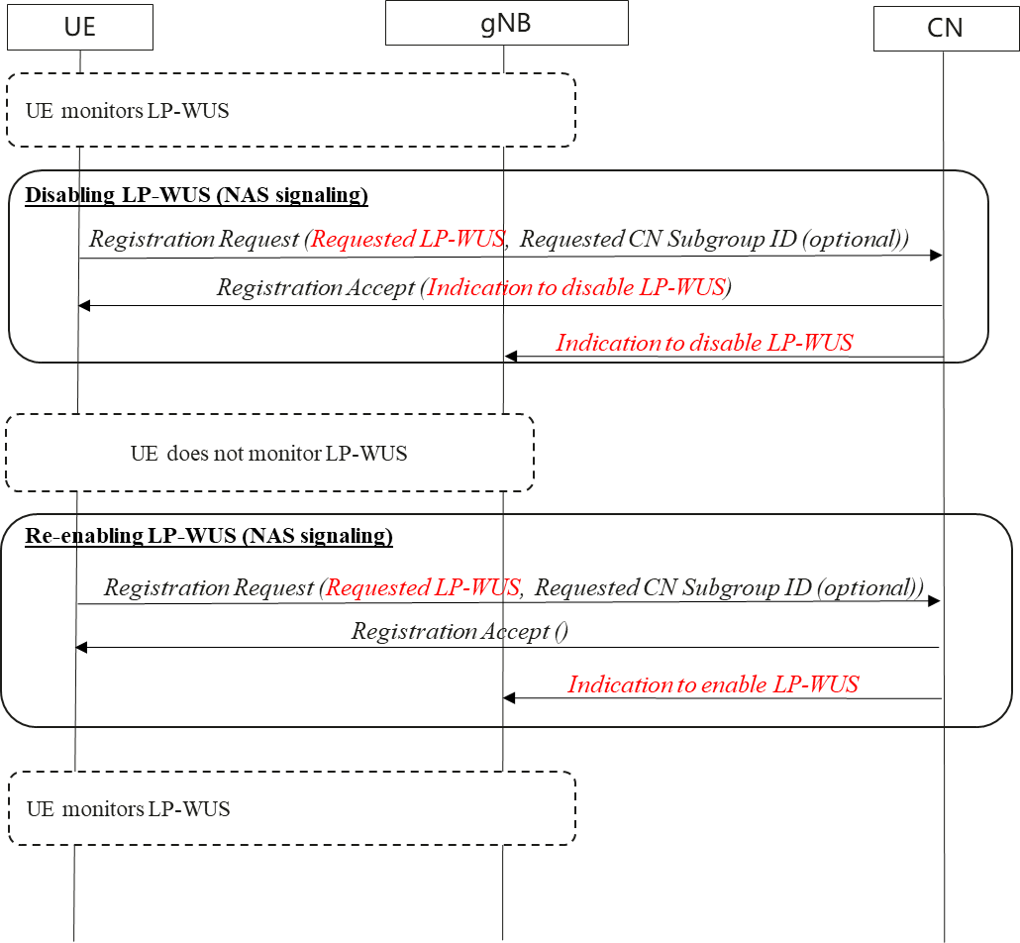

Figure : Disabling/Enabling of LP-WUS with NAS signaling

Assume that the UE is monitoring LP-WUS. CN decides to disable LP-WUS for the UE due to some conditions in the PLMN.

A brief description of the procedure and its impact to other WGs:

* **Disabling LP-WUS:** CN indicates explicitly to the UE to disable LP-WUS in the registration procedure. Even though the solution details are up to CT1, a new parameter “*Requested LP-WUS*” in Registration Request is needed. Otherwise CN is not aware whether UE supports LP-WUS or not if UE does not include the optional parameter “*Requested CN Subgroup ID*”
* **Enabling LP-WUS:** If the conditions in the NW are favourable to re-enable LP-WUS, CN will enable it in the subsequent registration procedure.
* **Impacts to other WGs:**
  + SA2/CT1: Extend NAS Registration procedure
  + RAN3: Indicate to gNB that LP-WUS is disabled/enabled.

Even though the decision on the solution details is up to SA2/CT1/RAN3, it may be better to share the identified impacts to NAS signalling. For example, some of the following details can be provided in the LS.

|  |
| --- |
| **RAN2 assumes NAS signalling is introduced to support enabling/disabling LP-WUS per UE. RAN2 identifies the following potential impacts:**   1. **Introduction of new parameters in Registration procedure to support UE requesting LP-WUS functionality and CN disabling LP-WUS functionality** 2. **To minimize changes to CN, explicit indication is proposed to disable LP-WUS functionality. No explicit indication means the LP-WUS functionality is enabled by default.** 3. **Introduction of new parameter to support CN indicating gNB that LP-WUS functionality is disabled/enabled (i.e., in Paging message for IDLE, Initial Context Setup Req (Core Network Assistance Information for RRC INACTIVE UE for RAN paging)** |

**Discussion:**

**Rapporteur’s input:**

**Proposals:**

# Conclusions

Based on the inputs from companies, the following proposals are made:

# References

1. R2-2505381 Summary of [Post130][222][LPWUS] Enabling Disabling LP-WUS per UE

# Draft LS

|  |
| --- |
| **3GPP TSG RAN WG2 #131 R2-250xxxx**  **Bangalore, India, 25th-29th August, 2025**  **Title:** [Draft] LS on enabling/disabling LP-WUS per UE with NAS signalling  **Response to:** -  **Release:** Rel-19  **Work Item:** NR_LPWUS-Core  **Source:** Huawei, HiSilicon [To be RAN2]  **To: SA2, CT1, RAN3**  **Cc:**  **Contact Person:**  **Name:** Rama Kumar Mopidevi  **E-mail Address:** rama.kumar@huawei.com  **Send any reply LS to: 3GPP Liaisons Coordinator,** [**mailto:3GPPLiaison@etsi.org**](mailto:3GPPLiaison@etsi.org)  **Attachments:** None  **1. Overall Description:**  RAN2 discussed to support enabling/disabling LP-WUS per UE and made the following agreement:   * RAN2 assumes NAS signalling is introduced to support enabling/disabling LP-WUS per UE.   RAN2 also identified the following potential impacts to SA2, CT1, RAN3: TODO  **2. Actions:**  **To SA2, CT1, RAN3:**  **ACTION:** RAN2 respectfully asks TODO.  **3. Date of Next RAN2 Meetings:**  RAN2#131bis 13th October – 17th October 2025 Prague, Czech  RAN2#132 17th November – 21st November 2025 Dallas, USA |