3GPP TSG-RAN WG1 Meeting #122 R1-250nnnn
Bengaluru, India, Aug 25th – 29th, 2025
Agenda Item: 11.1
Title: FL summary#1 on overview of 6GR air interface
Source: Moderator (NTT DOCOMO)
Document for: Discussion, Decision

1 Introduction
This document summarizes contributions [3] – [57] submitted to agenda item 11.1 (Overview of 6GR air interface).
Since this is the first RAN1 meeting to discuss this SI [1], RAN1 focuses on the following aspects to make reasonable progress, while keeping open minded.
- Make common understanding among companies on the terminologies
- Establish a finer agenda for future meetings, including the main focus in each meeting

The following sections are categorized according to the following guidance provided by RAN1 chair:
High level design proposals/principles/target and overall design of 6G air interface to illustrate/address the pain points observed from different angles, e.g., aspects of how to design a single RAT to serve diverse devices, channel bandwidth (at least minimum and maximum), aspects of overall coverage, aspects of initial access and common channel, aspects of MRSS, aspects of service/channel multiplexing/collision, including concurrence of UL transmissions,…..., aspects of concept and operation of bandwidth, aspects of supporting existing and new services, aspects of spectrum utilization and operations, aspects of spectrum efficiency, aspects of all duplex types, as well as concepts and aspects of harmonization of TN and NTN, etc.

Note: A number of companies provide views on technical details of the following aspects. As per guidance from RAN1 chair, those aspects will be discussed in separate agenda items and/or future RAN1 meetings:
- This RAN1 meeting
  - Evaluation assumptions for 6GR air interface
    - Discussions on models, scenarios, parameters, and methodology, metrics/criteria that can be used for evaluating technology proposals, energy efficiency, sensing performance (including potential extension of channel model).
  - Waveform
    - Including proposals for improving spectrum efficiency, power efficiency, coexistence and coverage, etc.
  - Frame structure
    - Including numerology and frame structure (for all duplex types), as well as compatibility with 5G NR to allow for efficient 5G-6G Multi-RAT Spectrum Sharing (MRSS).
  - Channel coding
    - Including metrics/criteria that can be used for evaluating technology proposals and for down selecting proposals
  - Modulation, joint channel coding and modulation
    - Including metrics/criteria that can be used for evaluating technology proposals and for down selecting proposals
  - Energy efficiency
    - Including discussion of proposal for NW power saving, UE power saving, and joint mechanisms taking both NW and UE into account for power saving, targeting to categorize proposals by RAN1#123. From RAN1#124, proposals will be distributed to respective related agenda.
  - AI/ML in 6GR interface
    - Collecting AI/ML use cases in all potential components in physical layer design, targeting to select some use cases by RAN1#123. From RAN1#124, selected use cases will be distributed to respective related agenda.
- Future RAN1 meetings
  - Initial access
    - Placeholder only and to be broken down. No contributions before RAN1#124. Including synchronization signal and raster, broadcast signals/channel and physical random access channel, etc.
  - MIMO operation
    - Placeholder only and to be broken down. No contributions before RAN1#124.
  - Physical layer control, data scheduling and HARQ operation
    - Placeholder only and to be broken down. No contributions before RAN1#124.
  - Duplexing
    - Placeholder only and to be broken down or adapted based on the discussion in AI 11.1. No contributions before RAN1#124.
  - 6GR spectrum utilization and aggregation
    - Placeholder only and to be broken down. No contributions before RAN1#124.
  - NTN
    - Placeholder only and to be broken down or adapted based on the discussion in AI 11.1. No contributions before RAN1#124.
  - Other physical layer signals, channels and procedures
    - Placeholder only and to be broken down. No contributions before RAN1#124.
  - Sensing
    - Including PHY functions and procedures for sensing technology (e.g., waveform. reference signals, measurement feedback, etc…), aspects of integration with communication services.
    - Placeholder only and to be broken down. No contributions before RAN1#124b.

Similarly, a number of companies provide views on 6G RAN requirements, which is subject to the progress in RANp study for 6G RAN requirements.

2 Proposals for Online Sessions

2.1 Proposals for xxxday Online
To be updated

3 How to design a single RAT to serve diverse devices, channel bandwidth (at least minimum and maximum)
Related to these aspects, the SID states following objectives and Interim Milestone:
- Single technology framework based on a stand-alone architecture (Note1) to support the agreed existing and new services, and to satisfy the usage scenarios, requirements, deployment scenarios and design principles with acceptable performance/complexity trade-off, as determined by the RAN requirements in [RP-250810] and [TR38.914], including: [RAN1], [RAN2], [RAN3], [RAN4]
  - Ensuring appropriate set of functionalities, minimize the adoption of multiple options for the same functionality, avoid excessive configurations, excessive UE capabilities and UE capabilities reporting.
  - Energy efficiency and energy saving: both for network and device.
  - Enhanced spectral efficiency.
  - Enhanced overall coverage, focus on cell-edge performance and UL coverage.
  - Wider channel bandwidth (at least 200MHz) support for 6G deployments at least above 2 GHz, around 7 GHz.
  - Re-use of existing 5G mid-band (~3.5GHz) site grid for 6G deployments in at least around 7 GHz and targeting comparable coverage to 5G mid-band.
  - Target scalable and forward compatible design for diverse device types.
  - Improved spectrum utilization and operations taking into account diverse spectrum allocations.
  - Aim at using common 6G Radio design, which meets mobile broadband service requirements as high priority, to also meet vertical needs.
  - Aim at a harmonized 6G Radio design for TN and NTN, including their integration.
  - System simplification, including reducing configuration complexity, enabling more efficient Cell/UE management, etc.
Note1: the term stand-alone architecture does not imply any particular Core network architecture, which is up to SA2 discussion.

- Physical Layer structure for 6GR,
  - Waveforms (OFDM-based) and modulations. 5G NR Waveforms and modulation should be considered for 6GR and is also the benchmark for other potential proposals. [RAN1, RAN4]
  - Frame structure, including compatibility with 5G NR to allow for efficient 5G-6G Multi-RAT Spectrum Sharing (MRSS). [RAN1]
  - Channel coding, using LDPC and Polar Code as baseline, considering applicable extensions to satisfy 6G requirements and characteristics with acceptable performance/complexity trade-off [RAN1]
  - Channel Bandwidth (at least minimum and maximum), Numerology, avoiding multiple numerologies for the same band / sub-range (e.g., enabling synergies among frequency bands in the ~7GHz range) [RAN1, RAN4]
  - Physical layer control, data scheduling and HARQ operation [RAN1, RAN2]
  - MIMO operation [RAN1, RAN4]
  - Duplexing [RAN1, RAN4]
  - Initial access [RAN1, RAN2, RAN4]
    - Studies on synchronization signal and raster, broadcast signals/channel and physical random access channel [RAN1, RAN4]
    - Studies on initial access procedure, random access procedures, system information and paging [RAN2, RAN1, RAN4]
  - 6GR spectrum utilization and aggregation. [RAN1, RAN2, RAN4]
  - Other physical layer signals, channels and procedures [RAN1, RAN2, RAN4]
  - Evaluate performance of at least energy efficiency, spectrum efficiency, and coverage compared to 5G NR, and deliver the initial result at the end of study [RAN1].
    - RAN4 can be involved, if necessary, based on the LS from RAN1
…
TSG#112 (June/2026):
RAN1 to provide interim assessment on the following areas:
- Waveform, modulation, channel coding: scope of enhancements beyond NR baseline ((2) a, c)
- Channel bandwidth (min and max), frame structure, numerology ((2) b, d)
- Basic sync signal structure and associated periodicity(ies) ((2) h)
For objectives where RAN4 may be impacted, RAN1 shall coordinate with RAN4 early to enable the above assessment by June 2026.

Regarding how to design a single RAT to serve diverse devices, quite a few companies mention that common/scalable 6GR should be studied. More specifically, modular/nucleus/scalable design is mentiend by a number of companies and some examples are shown below. Although the details need to be further discussed, the commonality among these concepts is to have a basic feature set / framework commonly applicable to all 6G use cases / device types, as well as add-on features (modules) dedicated to specific use cases / device types.

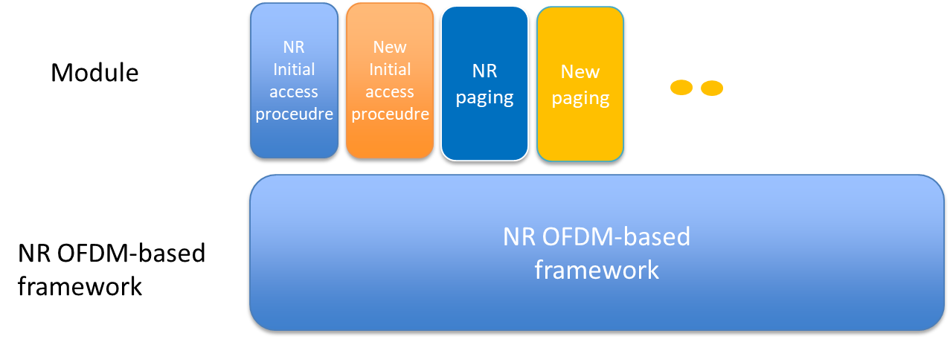
Modular design in [13]

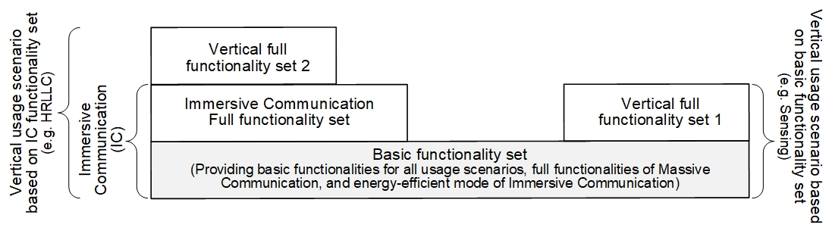
Modular design in [23]

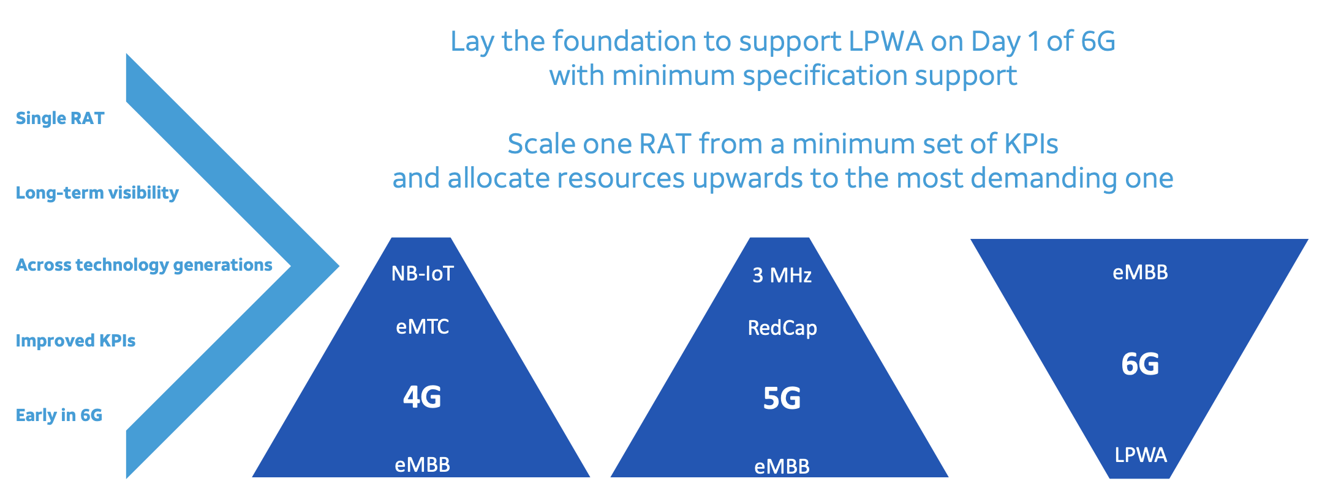
Scalable design in [46]

These concepts are well aligned with the objectives in the SID, and following proposal can be considered as starting point.

Proposal 3.1:
- Study a scalable 6GR design having at least the following aspects:
  - basic feature set / framework commonly applicable to all 6G use cases / device types
  - add-on features dedicated to specific use cases / device types
Company | Y/N | Comments
Tejas | Y | Scalable 6GR design need to address high data rate. It need not address all 6G use cases in the basic feature set.

Then, the next question is how to define diverse device types to be supported by 6GR. A number of companies provide views and some examples are shown below. Although the details need to be further discussed, the commonality among companies are limiting the number of device types to avoid excessive UE capabilities, and having some mandatory capability set in each device type.

Device types in [10]
 | Device type A | Device type B | Device type C
Typical Device/service | Smartphones, immersive eMBB, CPE, | Reduced capability eMBB, e.g., wearable/XR, etc | IoT
Downlink peak data rate | ~10Gbps | 200Mbps ~ 1Gbps | ~10Mbps
Uplink peak data rate | ~2Gbps | 50Mbps ~ 200Mbps | ~5Mbps
Supported maximum downlink channel bandwidth | At least 200 MHz | 100 MHz | ~5MHz for FDD  ~20MHz for TDD
Supported maximum uplink channel bandwidth | [100/200] MHz | 100 MHz | ~5MHz for FDD  ~20MHz for TDD
Supported maximum Downlink MIMO layer | At least 4 layers | 1~2 layers | 1~2 layers
Supported maximum Uplink MIMO layer | At least 2 layers | 1 layer | 1 layer

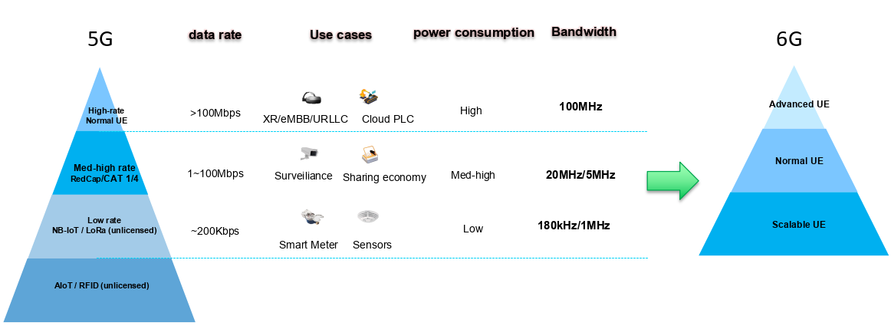
Device types in [12]

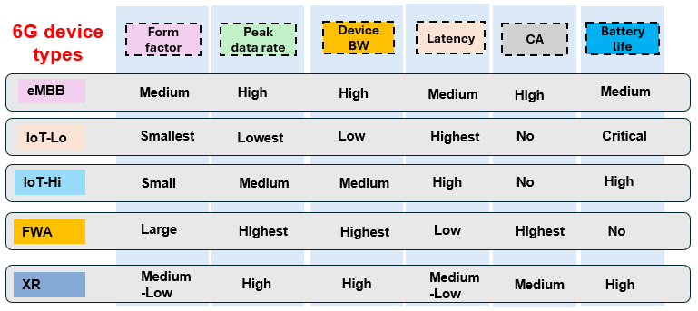
Device types in [26]

These views are well aligned with the objectives in the SID, and following proposal can be considered as starting point.

Proposal 3.2:
- Study how to define device types suppored by 6GR, including at least
  - How to avoid excessive UE capabilities
  - Mandatory capability set in each device type
Company | Y/N | Comments
Tejas | Y | Support the proposal

Regarding the channel bandwidth (at least minimum and maximum), there is in general good alignment among companies for avoiding multiple numerologies for the same band / sub-range, while companies may have different preference on which SCS/numerology to take in each band / sub-range, resulting in different assumptions of the maximum CBW and required FFS size for the SCS as shown in below table. Note that the maximum supported BW for low-tier 6G UE is discussed in Section 9.
FR | Range | SCS (kHz) | Required FFT size | Max CBW (MHz) | Min CBW (MHz)
FR1 | 400 MHz – 6.425 GHz | 15, 30 | 4096, 8192 | 20, 100 | 3, 5 (FDD)  10, 20 (TDD)
FR1 | 6.425 – 7.125 GHz | 15, 30, 60 | 4096, 8192 | 100, 200, 400 | 20
New FR(s) | 7.125 – X GHz | 30, 60 | 4096, 8192,16384 | 200, 400 | 20
New FR(s) | X – 24.25 GHz | 60, 120 | 4096, 8192 | 400, 800 | 20
FR2-1 | 24.25 – 52.6 GHz | 120 | 4096, 8192 | 400, 800 | 50, 100
TBD: the value X

Also, the view on max/min CBW can be different due to different situation for the spectrum allocation in each region. As stated in the SID and pointed out by some companies, this issue would need RAN4 involvement in early stage.
As this issue was also discussed in AI11.3.2 (Frame structure), moderators in each agenda coordinated how to avoid overlap. {SCS, required FFT size, Max CBW} are more suitable to be discussed under AI11.3.2 since those would highly affect overall design of frame structure. On the other hand, Min CBW can be discussed in this agenda item since this would not have much impact on overall design design of frame structure, rather related to the maximum supported BW for low-tier 6G UE and the spectrum allocation in each region.
Therefore, following proposal can be considered as starting point for further discussion together with RAN4.

Proposal 3.3:
- Study the minimum CBW in each band / sub-range using the following table as starting point
  - Note: RAN4 involvement is necessary
  - TBD the value X, including the possibility that this value is not defined, i.e., common values in the new FR(s).
FR | Range | Min CBW (MHz)
FR1 | 400 MHz – 6.425 GHz | 3, 5 (FDD)  10, 20 (TDD)
FR1 | 6.425 – 7.125 GHz | 20
New FR(s) | 7.125 – X GHz | 20
New FR(s) | X – 24.25 GHz | 20
FR2-1 | 24.25 – 52.6 GHz | 50, 100

Company | Y/N | Comments
Tejas | Y | Support the proposal. 3 MHz channel BW support is required in 6G.

4 Overall coverage
Related to this aspect, the SID states following objectives:
- Single technology framework based on a stand-alone architecture (Note1) to support the agreed existing and new services, and to satisfy the usage scenarios, requirements, deployment scenarios and design principles with acceptable performance/complexity trade-off, as determined by the RAN requirements in [RP-250810] and [TR38.914], including: [RAN1], [RAN2], [RAN3], [RAN4]
- Ensuring appropriate set of functionalities, minimize the adoption of multiple options for the same functionality, avoid excessive configurations, excessive UE capabilities and UE capabilities reporting.
- Energy efficiency and energy saving: both for network and device.
- Enhanced spectral efficiency.
- Enhanced overall coverage, focus on cell-edge performance and UL coverage.
- Wider channel bandwidth (at least 200MHz) support for 6G deployments at least above 2 GHz, around 7 GHz.
- Re-use of existing 5G mid-band (~3.5GHz) site grid for 6G deployments in at least around 7 GHz and targeting comparable coverage to 5G mid-band.
- Target scalable and forward compatible design for diverse device types.
- Improved spectrum utilization and operations taking into account diverse spectrum allocations.
- Aim at using common 6G Radio design, which meets mobile broadband service requirements as high priority, to also meet vertical needs.
- Aim at a harmonized 6G Radio design for TN and NTN, including their integration.
- System simplification, including reducing configuration complexity, enabling more efficient Cell/UE management, etc.
Note1: the term stand-alone architecture does not imply any particular Core network architecture, which is up to SA2 discussion.

Quite a few companies provide the views on coverage target for 6GR, including not only + 5 to 10 dB enhancement from normal coverage (144dB MCL) for cell-edge performance but also overall UL performance improvements in anywhere within the cell coverage. However, the target values need to be discussed and clarified in RANp study for 6G requirements and hence, RAN1 needs to wait for their progress.
While RAN1 does not have exact target value for coverage enhancement, as stated in SID, the 6GR is assumed to support enhanced overall coverage. Therefore, RAN1 can start studying some technical direction for coverage enhancements, including which signals/channels need to be improved, and which UEs/device types need to support features for coverage enhancements. According to the contributions, there is in general good alignment to consider coverage enhancement not only dedicated channels (e.g. scheduled PDSCH/PUSCH) but also common signals/channels during initial/random access (e.g., PRACH, Msg3 PUSCH) from the 1st release, while further discussion would be necessary on the applicable UEs (e.g., MBB and/or IoT, TN and/or NTN). Therefore, following proposal can be considered as starting point for further discussion.

Proposal 4.1:
- Study how to enhance overall coverage, including at least
  - which signals/channels need to be improved, including both cell-common and UE-dedicated signals/channels
  - which UEs/device types need to support features for coverage enhancements
Company | Y/N | Comments
China Telecom |  | Considering the importance of coverage for us operators, we think 6G DAY-1 needs to pay more attention to this topic. Meantime, we need to learn lessons from 5G to ensure a good coverage at the beginning. Since the coverage target is not determined currently, we think instead of identifying which signals/channels need to be improved (maybe all the channels need to be improved), it’s better to study which technique can improve the coverage and can be supported in 6G, e.g., coverage enhancement solutions studied/specified in 5G. Then, after the target coverage related values are determined, we think evaluation is needed to check if the target can be met for each channel. Thus, we suggest the following proposal instead:  - Study potential techniques/solutions for coverage improvement for both downlink and uplink channels.
Tejas | Y | Support the proposal

Regarding ~7GHz band coverage, a number of companies mention larger number of antennas is necessary to achieve the comparable coverage to 5G mid-band (~3.5GHz). This aspect can be discussed in RANp SI for 6G requirement (especially for deployment scenarios) as well as RAN1 6G study AI11.2 for evaluation assumptions.

5 Initial access and common channel
Related to these aspects, the SID states following objectives and Interim Milestone:
- Physical Layer structure for 6GR,
- Waveforms (OFDM-based) and modulations. 5G NR Waveforms and modulation should be considered for 6GR and is also the benchmark for other potential proposals. [RAN1, RAN4]
- Frame structure, including compatibility with 5G NR to allow for efficient 5G-6G Multi-RAT Spectrum Sharing (MRSS). [RAN1]
- Channel coding, using LDPC and Polar Code as baseline, considering applicable extensions to satisfy 6G requirements and characteristics with acceptable performance/complexity trade-off [RAN1]
- Channel Bandwidth (at least minimum and maximum), Numerology, avoiding multiple numerologies for the same band / sub-range (e.g., enabling synergies among frequency bands in the ~7GHz range) [RAN1, RAN4]
- Physical layer control, data scheduling and HARQ operation [RAN1, RAN2]
- MIMO operation [RAN1, RAN4]
- Duplexing [RAN1, RAN4]
- Initial access [RAN1, RAN2, RAN4]
    - Studies on synchronization signal and raster, broadcast signals/channel and physical random access channel [RAN1, RAN4]
    - Studies on initial access procedure, random access procedures, system information and paging [RAN2, RAN1, RAN4]
- 6GR spectrum utilization and aggregation. [RAN1, RAN2, RAN4]
- Other physical layer signals, channels and procedures [RAN1, RAN2, RAN4]
- Evaluate performance of at least energy efficiency, spectrum efficiency, and coverage compared to 5G NR, and deliver the initial result at the end of study [RAN1].
- RAN4 can be involved, if necessary, based on the LS from RAN1
…
TSG#112 (June/2026):
RAN1 to provide interim assessment on the following areas:
- Waveform, modulation, channel coding: scope of enhancements beyond NR baseline ((2) a, c)
- Channel bandwidth (min and max), frame structure, numerology ((2) b, d)
- Basic sync signal structure and associated periodicity(ies) ((2) h)
For objectives where RAN4 may be impacted, RAN1 shall coordinate with RAN4 early to enable the above assessment by June 2026.

Initial access aspects are planned to be discussed from RAN1#124 (Feb. 2026). Therefore, in general, it is better to wait for RAN1#124 to open the discussion on initial access aspects. However, the Interim Milestone states that RAN1 needs to provide interim assessment on the basic sync signal structure and associated periodicity(ies) by June 2026. Therefore, at least on these aspects, RAN1 should start discussion earlier to provide enough assessment.
Regarding the basic sync signal periodicity, quite a few companies provide views to introduce longer SSB periodicity than that assumed for NR initial access (i.e., 20ms) from NES perspective. The candidate values vary from 40ms to 320ms and it was pointed out by some companies that RAN1 needs to consider the trade-off between NES gaing and UE complexity. As this aspects highly related to AI11.5 for Energy efficiency, moderator suggest discussing SSB periodicity in AI11.5.
Also, it is interesting to note that multiple operators have similar concept to minimize always-on signals (including SSB/SI) for the case of multi-carrier operation, and some examples are shown below. The commonality among these concepts is that the initial cell search is done only on a specific carrier and hence, the always-on signals can be minimized on other carriers. This aspect can be discussed in Section 10 as well.

Elastic cell concept in [39]

Perch/anchor/data concept in [48]

Regarding the basic sync signal structure, the design needs to consider at least following aspects:
- NES: Reduced number of sync raster, which can be obtained by narrower SSB BW
- Low-tier 6G device: maximum supported BW for complexity reduction, which is discussed in Section 9
- Detection performance: If narrower SSB BW is considered, more OFDM symbols would be required to maintain the NR performance
At the same time, not a few companies mention NR SSB structure should be the baseline. Unlike the periodicity, the structure design include multiple aspects (not only NES), and hence, moderator suggest discussing SSB sturcure in this AI. Following proposal can be considered as starting point for further discussion. Note that this aspect also needs early RAN4 imvolvement.

Proposal 5.1:
- Study the basic sync signal structure considering at least following aspects:
  - NR SSB as baseline
  - Whether to reduce SSB BW considering at least NES and low-tier 6G device
  - Whether to increase the number of OFDM symbols considering at least detection performance
  - Note: RAN4 involvement is necessary
Company | Y/N | Comments
China Telecom | Y | For SS structure, we support to take NR SSB as a baseline, for the 2nd and 3rd bullet, we think they can be treated as kinds of optimization. If we follow the principle that only high level design is considered for this agenda, we suggest to make it simple as follows:  Proposal 5.1:  - Study the basic sync signal structure considering at least following aspects:  - NR SSB as baseline  - Wheter optimization is needed  - Whether to reduce SSB BW considering at least NES and low-tier 6G device  - Whether to increase the number of OFDM symbols considering at least detection performance  - Note: RAN4 involvement is necessary
Tejas | Y | In addition to this, we would like to include the what should be KPI should be used for 6G SSB.  More number of symbols to improve the detection performance & study whether new services can signalled in the initial access.

6 MRSS
Related to this aspect, the SID states following objectives:
- Physical Layer structure for 6GR,
  - Waveforms (OFDM-based) and modulations. 5G NR Waveforms and modulation should be considered for 6GR and is also the benchmark for other potential proposals. [RAN1, RAN4]
  - Frame structure, including compatibility with 5G NR to allow for efficient 5G-6G Multi-RAT Spectrum Sharing (MRSS). [RAN1]
  - Channel coding, using LDPC and Polar Code as baseline, considering applicable extensions to satisfy 6G requirements and characteristics with acceptable performance/complexity trade-off [RAN1]
  - Channel Bandwidth (at least minimum and maximum), Numerology, avoiding multiple numerologies for the same band / sub-range (e.g., enabling synergies among frequency bands in the ~7GHz range) [RAN1, RAN4]
  - Physical layer control, data scheduling and HARQ operation [RAN1, RAN2]
  - MIMO operation [RAN1, RAN4]
  - Duplexing [RAN1, RAN4]
  - Initial access [RAN1, RAN2, RAN4]
    - Studies on synchronization signal and raster, broadcast signals/channel and physical random access channel [RAN1, RAN4]
    - Studies on initial access procedure, random access procedures, system information and paging [RAN2, RAN1, RAN4]
  - 6GR spectrum utilization and aggregation. [RAN1, RAN2, RAN4]
  - Other physical layer signals, channels and procedures [RAN1, RAN2, RAN4]
  - Evaluate performance of at least energy efficiency, spectrum efficiency, and coverage compared to 5G NR, and deliver the initial result at the end of study [RAN1].
    - RAN4 can be involved, if necessary, based on the LS from RAN1
…
- Migration from 5G NR to 6GR as well as interworking and mobility between 5G NR and 6GR:
- 5G-6G Multi-RAT Spectrum Sharing for migration [RAN1, RAN2, RAN4, RAN3]
- Study if any additional migration mechanism is necessary. [RAN] [RAN2, RAN1, RAN3, RAN4]
NOTE: the start of this study objective (b) should be triggered by RAN plenary in time to guarantee proper completion of the WG study.
- Mobility between 5G NR and 6GR [RAN2, RAN3, RAN4]

Not only the frame structure as stated in the SID, a number of companies mention that 5G compatible design should be ensured for MRSS, including waveform, modulation, numerology, channel coding and so on. All these aspects are discussed in other AIs in RAN1, and hence, moderator suggest considering MRSS aspects when discussion the above topics in other AIs 11.3.1, 11.3.2, 11.4.1, 11.4.2.
When considering the coexistence with NR signals/channels on MRSS carrier, in general there are following two directions and companies view are split, and hence, further discussion is necessary to clarify the pros/cons for each direction.
- NR/6GR resources are split via TDM/FDM, including rate-matching
- 6GR shares NR signals/channels
Another aspect is whether “5G-6G MRSS” includes LTE as well as NR, since LTE Rel-15 or later are also considered as 5G. Some companies mention that coexistence with eMTC/NB-IoT should be ensured, which needs further discussion.
Based on the above, following proposal can be considered as starting point for further discussion.

Proposal 6.1:
- For NR-6GR MRSS support, study the following options for the coexistence with NR signals/channels on MRSS carrier
  - Opt1: NR/6GR resources are split via TDM/FDM, including rate-matching
  - Opt2: 6GR shares NR signals/channels
  - FFS: whether/how to support LTE-6GR MRSS
Company | Y/N | Comments
China Telecom |  | Opt 2 is not clear to us, does it mean 6GR has the same signals/channels as NR on MRSS carrier? From our perspective, we think the collision between NR/6GR resources should be avoided. For LTE-6GR MRSS, we don’t think it is needed, but we can live with the FFS.
Tejas | Y | We also want to include whether 6GR can use new waveform and can coexist with 5G NR

7 Service/channel multiplexing/collision, including concurrence of UL transmissions
The SID does not have text explicitly mentioning this aspect. However, according to companies’ contributions so far, companies have high interest in improvement/simplification of the Service/channel multiplexing/collision, including PUSCH/PUCCH transmissions, UCI multiplexing/prioritization, common RS for communication/sensing/positioning, and so on. Since these aspects are highly related to other agenda items to be discussed in RAN1 (e.g., “Physical layer control, data scheduling and HARQ operation”, “Other physical layer signals, channels and procedures”, and “Sensing”), moderator suggests discussing the above aspects in other RAN1 agenda items. Following is open question to hear companies’ view.

Question 7.1:
- Companies are invited to provide views on whether to discuss any features which contribute to improvement/simplification of service/channel multiplexing/collision, other than the features (to be) discussed in other agendas in RAN1. If yes, please elaborate which features need to be studied in this agenda.
Company | Y/N | Comments
Tejas | Y | We would like to study on simplifying UCI multiplexing

Concept and operation of bandwidth
The SID does not have text explicitly mentioning this aspect. However, according to companies’ contributions so far, companies have high interest in improvement/simplification of NR BWP framework, which is fundamental unit of BW for UE transmissions/receptions, including but not limited to
- SCS switching
- Association with CORESET/Search space
- BWP switching delay
- RRC configuration overhead
- BWP types
- Frequency location between DL and UL
- Discuntiguous frequency resources within BWP
- Combined with TCI framework
- Support diverse device types

Since the potential scope for the improvement/simplification of NR BWP framework is quite broad, following proposal can be considered as starting point for further discussion. Note that the aspects on BW from multiple carrier perspectives can be discussed in Section 10.

Proposal 8.1:
- Study how to improve/simplify BWP framework for 6GR
Company | Y/N | Comments
China Telecom | Y | Support.
Tejas | Y | We support the study.

9 Supporting existing and new services
Related to these aspects, the SID states following objectives and Interim Milestone:
- Single technology framework based on a stand-alone architecture (Note1) to support the agreed existing and new services, and to satisfy the usage scenarios, requirements, deployment scenarios and design principles with acceptable performance/complexity trade-off, as determined by the RAN requirements in [RP-250810] and [TR38.914], including: [RAN1], [RAN2], [RAN3], [RAN4]
- Ensuring appropriate set of functionalities, minimize the adoption of multiple options for the same functionality, avoid excessive configurations, excessive UE capabilities and UE capabilities reporting.
- Energy efficiency and energy saving: both for network and device.
- Enhanced spectral efficiency.
- Enhanced overall coverage, focus on cell-edge performance and UL coverage.
- Wider channel bandwidth (at least 200MHz) support for 6G deployments at least above 2 GHz, around 7 GHz.
- Re-use of existing 5G mid-band (~3.5GHz) site grid for 6G deployments in at least around 7 GHz and targeting comparable coverage to 5G mid-band.
- Target scalable and forward compatible design for diverse device types.
- Improved spectrum utilization and operations taking into account diverse spectrum allocations.
- Aim at using common 6G Radio design, which meets mobile broadband service requirements as high priority, to also meet vertical needs.
- Aim at a harmonized 6G Radio design for TN and NTN, including their integration.
- System simplification, including reducing configuration complexity, enabling more efficient Cell/UE management, etc.
Note1: the term stand-alone architecture does not imply any particular Core network architecture, which is up to SA2 discussion.

As stated in the SID, the scope of this SI is limited to the “agreed” existing and new services, while no requirements of existing and new services have been agreed/captured in the RANp SI TR38.914 v0.1.0 yet. Companies provide views on whether/how to support existing and new services, including low-tier device (e.g. IoT, LPWA, RedCap), XR, voice, FWA, positioning, broadcast/multicast, sidelink, unlicensed spectrum, HRLLC, NW for AI, sensing, and so on. Especially on sensing, quite a few companies provide some details on how to support sensing for 6GR. However, this is to be discussed in other agenda items in RAN1 from RAN1#124bis (Apr. 2026) after the use cases and the associated requirement are clarified in RANp study for 6G requirements. Similar to this, moderator does not see any urgency to start discussion on how to support the “agreed” existing and new services in this meeting, except for Low-tier device.
Regarding the low-tier device (e.g. IoT, LPWA, RedCap), as discussed in Section 3, in general companies have aligned view that common/scalable 6GR framework should be studied for diverse device types, including the low-tier device. Toward this, it would be better to clarify the maximum supported BW for the low-tier device in early stage, so that some fundamental aspects discussed in this agenda (minimum CBW in Section 3, SSB BW in section 5) can make progress. Companies have split views on the maximum supported BW; 5MHz BW has the highest interest, while some other candidates, such as 3MHz, 10MHz, and 20MHz are also mentioned. Since too narrow UE BW may cause negative impact to the overall 6GR design, the pros/cons for those options need further study.
Other aspects for low-tier device, including the target use cases, complexity reduction (peak data reduction, reduced# of antennas, HD-FDD, and so on), UE power savings, coverage enhancements, and so on, can be discussed in RANp study for 6G requirements at first, and can be refined in RAN WGs.

Proposal 9.1:
- For low-tier device support by common/scalable 6GR framework, study following options for maximum supported UE BW
  - Opt1: 3MHz
  - Opt2: 5MHz
  - Opt3: 10MHz
  - Opt4: 20MHz
Company | Y/N | Comments
Tejas | Y | Option1 of 3MHz also needs to be studied (This should be minimum supported UE Bandwidth)

10 Spectrum utilization and operations
Related to these aspects, the SID states following objectives:
- Single technology framework based on a stand-alone architecture (Note1) to support the agreed existing and new services, and to satisfy the usage scenarios, requirements, deployment scenarios and design principles with acceptable performance/complexity trade-off, as determined by the RAN requirements in [RP-250810] and [TR38.914], including: [RAN1], [RAN2], [RAN3], [RAN4]
- Ensuring appropriate set of functionalities, minimize the adoption of multiple options for the same functionality, avoid excessive configurations, excessive UE capabilities and UE capabilities reporting.
- Energy efficiency and energy saving: both for network and device.
- Enhanced spectral efficiency.
- Enhanced overall coverage, focus on cell-edge performance and UL coverage.
- Wider channel bandwidth (at least 200MHz) support for 6G deployments at least above 2 GHz, around 7 GHz.
- Re-use of existing 5G mid-band (~3.5GHz) site grid for 6G deployments in at least around 7 GHz and targeting comparable coverage to 5G mid-band.
- Target scalable and forward compatible design for diverse device types.
- Improved spectrum utilization and operations taking into account diverse spectrum allocations.
- Aim at using common 6G Radio design, which meets mobile broadband service requirements as high priority, to also meet vertical needs.
- Aim at a harmonized 6G Radio design for TN and NTN, including their integration.
- System simplification, including reducing configuration complexity, enabling more efficient Cell/UE management, etc.
Note1: the term stand-alone architecture does not imply any particular Core network architecture, which is up to SA2 discussion.

- Physical Layer structure for 6GR,
- Waveforms (OFDM-based) and modulations. 5G NR Waveforms and modulation should be considered for 6GR and is also the benchmark for other potential proposals. [RAN1, RAN4]
- Frame structure, including compatibility with 5G NR to allow for efficient 5G-6G Multi-RAT Spectrum Sharing (MRSS). [RAN1]
- Channel coding, using LDPC and Polar Code as baseline, considering applicable extensions to satisfy 6G requirements and characteristics with acceptable performance/complexity trade-off [RAN1]
- Channel Bandwidth (at least minimum and maximum), Numerology, avoiding multiple numerologies for the same band / sub-range (e.g., enabling synergies among frequency bands in the ~7GHz range) [RAN1, RAN4]
- Physical layer control, data scheduling and HARQ operation [RAN1, RAN2]
- MIMO operation [RAN1, RAN4]
- Duplexing [RAN1, RAN4]
- Initial access [RAN1, RAN2, RAN4]
    - Studies on synchronization signal and raster, broadcast signals/channel and physical random access channel [RAN1, RAN4]
    - Studies on initial access procedure, random access procedures, system information and paging [RAN2, RAN1, RAN4]
- 6GR spectrum utilization and aggregation. [RAN1, RAN2, RAN4]
- Other physical layer signals, channels and procedures [RAN1, RAN2, RAN4]
- Evaluate performance of at least energy efficiency, spectrum efficiency, and coverage compared to 5G NR, and deliver the initial result at the end of study [RAN1].
- RAN4 can be involved, if necessary, based on the LS from RAN1

As discussed in Section 5, multiple operators have similar concept to minimize always-on signals (including SSB/SI) for the case of multi-carrier operation. The commonality among these concepts is that the initial cell search is done only on a specific carrier and hence, the always-on signals can be minimized on other carriers.
In addition, companies provide views on how to improve the spectrum utilization and operations, including Flexible DL/UL pairing, DL/UL decoupling, flexible carrier switching, fast SCell activation/deactivation, single cell multi-carrier operation, and so on. Some examples are shown below:

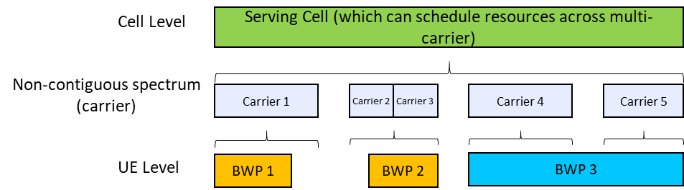
Single cell multi-carrier operation in [10]

DL/UL decoupling in [20]

Although the technical details on the above aspects can be further discussed in other agenda items to be discussed in RAN1 (e.g., “Initial access”, “Physical layer control, data scheduling and HARQ operation”, and “6GR spectrum utilization and aggregation”), it wold be better to discuss some high-level direction on how to improve the spectrum utilization and operations in this agenda items, because this issue has impact on multiple agenda items. Following proposal can be considered as starting point for further discussion.

Proposal 10.1:
- Study how to improve the spectrum utilization and operations for multi-carrier operations
  - Note: the study under this agenda item should be kept on high-level directions, and the technical details can be studied under other agendas in future RAN1 meetings
Company | Y/N | Comments
China Telecom | Y | Support the mainbullet. But we’re not sure what “high-level directions” will be like for this part. From our perspective, we support to study: Single cell multiple carriers, Flexible UL DL carrier association and Flexible carrier switching. We wonder whether the above three aspects can be high-level directions?
Tejas | Y

11 Spectrum efficiency
Related to these aspects, the SID states following objectives:
- Single technology framework based on a stand-alone architecture (Note1) to support the agreed existing and new services, and to satisfy the usage scenarios, requirements, deployment scenarios and design principles with acceptable performance/complexity trade-off, as determined by the RAN requirements in [RP-250810] and [TR38.914], including: [RAN1], [RAN2], [RAN3], [RAN4]
- Ensuring appropriate set of functionalities, minimize the adoption of multiple options for the same functionality, avoid excessive configurations, excessive UE capabilities and UE capabilities reporting.
- Energy efficiency and energy saving: both for network and device.
- Enhanced spectral efficiency.
- Enhanced overall coverage, focus on cell-edge performance and UL coverage.
- Wider channel bandwidth (at least 200MHz) support for 6G deployments at least above 2 GHz, around 7 GHz.
- Re-use of existing 5G mid-band (~3.5GHz) site grid for 6G deployments in at least around 7 GHz and targeting comparable coverage to 5G mid-band.
- Target scalable and forward compatible design for diverse device types.
- Improved spectrum utilization and operations taking into account diverse spectrum allocations.
- Aim at using common 6G Radio design, which meets mobile broadband service requirements as high priority, to also meet vertical needs.
- Aim at a harmonized 6G Radio design for TN and NTN, including their integration.
- System simplification, including reducing configuration complexity, enabling more efficient Cell/UE management, etc.
Note1: the term stand-alone architecture does not imply any particular Core network architecture, which is up to SA2 discussion.

- Physical Layer structure for 6GR,
- Waveforms (OFDM-based) and modulations. 5G NR Waveforms and modulation should be considered for 6GR and is also the benchmark for other potential proposals. [RAN1, RAN4]
- Frame structure, including compatibility with 5G NR to allow for efficient 5G-6G Multi-RAT Spectrum Sharing (MRSS). [RAN1]
- Channel coding, using LDPC and Polar Code as baseline, considering applicable extensions to satisfy 6G requirements and characteristics with acceptable performance/complexity trade-off [RAN1]
- Channel Bandwidth (at least minimum and maximum), Numerology, avoiding multiple numerologies for the same band / sub-range (e.g., enabling synergies among frequency bands in the ~7GHz range) [RAN1, RAN4]
- Physical layer control, data scheduling and HARQ operation [RAN1, RAN2]
- MIMO operation [RAN1, RAN4]
- Duplexing [RAN1, RAN4]
- Initial access [RAN1, RAN2, RAN4]
    - Studies on synchronization signal and raster, broadcast signals/channel and physical random access channel [RAN1, RAN4]
    - Studies on initial access procedure, random access procedures, system information and paging [RAN2, RAN1, RAN4]
- 6GR spectrum utilization and aggregation. [RAN1, RAN2, RAN4]
- Other physical layer signals, channels and procedures [RAN1, RAN2, RAN4]
- Evaluate performance of at least energy efficiency, spectrum efficiency, and coverage compared to 5G NR, and deliver the initial result at the end of study [RAN1].
- RAN4 can be involved, if necessary, based on the LS from RAN1

Quite a few companies provide the view related to the improvement of spectrum efficiency, and most of them can be fall into MIMO and AI/ML related features, which are (to be) discussed in other agenda items in RAN1. Therefore, moderator does not see any aspects to be discussed in this agenda item related to the improvement of spectrum efficiency. Following is open question to hear companies’ view. Note that in RANp study for 6G requirements, only a few target values for spectrum efficiency has been agreed yet, and RAN1 needs to wait for further RANp progress to see how much spectrum efficiency improvement 6GR aims to achieve.

Question 11.1:
- Companies are invited to provide views on whether to discuss any features which contribute to spectrum efficiency improvements, other than the features (to be) discussed in other agendas in RAN1. If yes, please elaborate which features need to be studied in this agenda.
Company | Y/N | Comments
Tejas | Y | Relook at Guardband & Guard-time and reduced rolloff in conjuction with RAN-4

12 All duplex types
Related to this aspect, the SID states following objectives:
- Physical Layer structure for 6GR,
- Waveforms (OFDM-based) and modulations. 5G NR Waveforms and modulation should be considered for 6GR and is also the benchmark for other potential proposals. [RAN1, RAN4]
- Frame structure, including compatibility with 5G NR to allow for efficient 5G-6G Multi-RAT Spectrum Sharing (MRSS). [RAN1]
- Channel coding, using LDPC and Polar Code as baseline, considering applicable extensions to satisfy 6G requirements and characteristics with acceptable performance/complexity trade-off [RAN1]
- Channel Bandwidth (at least minimum and maximum), Numerology, avoiding multiple numerologies for the same band / sub-range (e.g., enabling synergies among frequency bands in the ~7GHz range) [RAN1, RAN4]
- Physical layer control, data scheduling and HARQ operation [RAN1, RAN2]
- MIMO operation [RAN1, RAN4]
- Duplexing [RAN1, RAN4]
- Initial access [RAN1, RAN2, RAN4]
    - Studies on synchronization signal and raster, broadcast signals/channel and physical random access channel [RAN1, RAN4]
    - Studies on initial access procedure, random access procedures, system information and paging [RAN2, RAN1, RAN4]
- 6GR spectrum utilization and aggregation. [RAN1, RAN2, RAN4]
- Other physical layer signals, channels and procedures [RAN1, RAN2, RAN4]
- Evaluate performance of at least energy efficiency, spectrum efficiency, and coverage compared to 5G NR, and deliver the initial result at the end of study [RAN1].
- RAN4 can be involved, if necessary, based on the LS from RAN1

Since the dedicated agenda item on duplexing is planned to be started from RAN1#124, technical details can be discussed there. However, as also stated by RAN1 chair, the 6GR frame structure is discussed for “all duplex types”, it would be better to clarify what “all duplex types” means. It is moderator’s understanding that the frame structure will be studied for the agreed duplex types for study. In this sense, this agenda discusses which duplex types are to be studied in 6GR at first.
There is sufficient support from companies to consider at least following duplexing types,
- FD-FDD
- Semi-static TDD
- gNB semi-static SBFD

while companies may have split views on whether to consider following duplexing types
- HD-FDD, subject to the support for low-tier 6G device
- Dynamic TDD, especially on whether to support SFI
- gNB dynamic SBFD
- UE SBFD
- gNB FD

Based on the above, following proposal can be considered as starting point for further discussion.

Proposal 12.1:
- On 6GR duplexing study, RAN1 considers at least following duplex types
  - FD-FDD
  - Semi-static TDD
  - gNB semi-static SBFD
- FFS whether to consider following duplexing types
  - HD-FDD
  - Dynamic TDD
  - gNB dynamic SBFD
  - UE SBFD
  - gNB FD
Company | Y/N | Comments
China Telecom | Y | We think gNB FD can also be studied for 6G as the evolution of SBFD.
Tejas | Y | HD-FDD is required for NTN at higher frequencies, hence we suggest to include HD-FDD.  gNB dynamic SBFD and gNB full duplex will increase spectral efficiency and should be considered for 6G duplex study.

13 Harmonization of TN and NTN
Related to this aspect, the SID states following objectives:
- Single technology framework based on a stand-alone architecture (Note1) to support the agreed existing and new services, and to satisfy the usage scenarios, requirements, deployment scenarios and design principles with acceptable performance/complexity trade-off, as determined by the RAN requirements in [RP-250810] and [TR38.914], including: [RAN1], [RAN2], [RAN3], [RAN4]
- Ensuring appropriate set of functionalities, minimize the adoption of multiple options for the same functionality, avoid excessive configurations, excessive UE capabilities and UE capabilities reporting.
- Energy efficiency and energy saving: both for network and device.
- Enhanced spectral efficiency.
- Enhanced overall coverage, focus on cell-edge performance and UL coverage.
- Wider channel bandwidth (at least 200MHz) support for 6G deployments at least above 2 GHz, around 7 GHz.
- Re-use of existing 5G mid-band (~3.5GHz) site grid for 6G deployments in at least around 7 GHz and targeting comparable coverage to 5G mid-band.
- Target scalable and forward compatible design for diverse device types.
- Improved spectrum utilization and operations taking into account diverse spectrum allocations.
- Aim at using common 6G Radio design, which meets mobile broadband service requirements as high priority, to also meet vertical needs.
- Aim at a harmonized 6G Radio design for TN and NTN, including their integration.
- System simplification, including reducing configuration complexity, enabling more efficient Cell/UE management, etc.
Note1: the term stand-alone architecture does not imply any particular Core network architecture, which is up to SA2 discussion.

Since the dedicated agenda item on NTN is planned to be started from RAN1#124, technical details can be discussed there. Howerver, for the harmonized 6GR design for TN and NTN, it would be better to identify which technical areas the NTN aspects need to be considered in early stage. In this sense, this agenda discusses to identify the affected technical areas for the harmonized 6GR design for TN and NTN.
According to the contributions, the potentially affected areas by NTN are quite broad. There is a joint contribution from satellite companies [52] and another contribution from another satellite company [53]. It would be good to start from their proposal as starting point to reflect the industry’s view. Other aspects can be included through discussion.
Note that the orbit type and payload type will be discussed in RANp study for 6G requirements.

Proposal 13.1:
- For harmonized 6GR design for TN and NTN, RAN1 studies to identify the technical aspects affected by NTN characteristics, including at least
  - a) GNSS-resilient operation
    - Further discuss how to avoid duplication with Rel-20 5G-A NR-NTN study
  - b) PAPR reduction for NTN DL
  - c) Frame structure
  - d) Coverange enahncements
  - e) Duplex types
  - f) Propagation impairments
  - g) Long propagation delay
  - h) Grant free access
  - i) Beam hopping and longer SSB periodicity
  - j) Positioning/Location
  - k) NTN/TN mobility
  - l) DC/CA
  - m) Coexistence with IoT-NTN/NR-NTN
  - n) Beam-specific signal/channel design
  - o) Interference management for TN-NTN, inter-orbit, and inter-satellite cases
Company | Y/N | Comments
China Telecom |  | We are a bit confused here. For example, for Frame structure part, since there is an agnenda being discussed in parallel, then how to deal with the relationship between them?
Tejas | Y | Dual connectivity of TN and NTN should be considered as well.

14 Other aspects
Other than the aspects discussed in the above sections or other agenda items (including those planned in future RAN1 meetings), some companies mention the aspects related to PHY security, NW resilience, and so on. It is moderator’s understanding that neither of other aspects can be discussed in RAN1 without any progress in RANp study on 6G requirements. RAN1 cannot discuss any features without justification on the target/motivation, which need to be clarified in RANp study at first. Following is open question to hear companies’ view.

Question 14.1:
- Companies are invited to provide views on whether to discuss any features, other than those (to be) discussed in other sections in this summary or in other agendas in RAN1. If yes, please elaborate which features need to be studied in this section.
Company | Y/N | Comments

15 Conclusions
Following agreements were made in this meeting:
To be updated

References
[1] | RP-251881 | New SID: Study on 6G Radio | NTT DOCOMO (Moderator)
[2] | R1-2506303 | RAN1 workplan for Rel-20 Study of 6GR | NTT DOCOMO, China Mobile, AT&T, Vodafone
[3] | R1-2505125 | Nokia Views on 6G Radio Air Interface | Nokia
[4] | R1-2505143 | High level views on 6GR air interface | FUTUREWEI
[5] | R1-2505170 | Spreadtrum overview on 6GR air interface | Spreadtrum, UNISOC
[6] | R1-2505181 | Overview of 6GR air interface | Huawei, HiSilicon
[7] | R1-2505263 | Overview of 6GR Air Interface | Google
[8] | R1-2505285 | Discussion on the overview of 6GR air interface | TCL
[9] | R1-2505295 | Outline and highlight of 6GR air interface | CATT, CICTCI
[10] | R1-2505414 | Overall design considerations on 6GR air interface | vivo
[11] | R1-2505461 | 6GR air interface design overview | Xiaomi
[12] | R1-2505509 | High-level views on 6GR | ZTE Corporation, Sanechips
[13] | R1-2505511 | Overview proposal of 6GR air interface | Panasonic
[14] | R1-2505516 | Overview of 6GR air interface | China Telecom
[15] | R1-2505519 | Overview of 6GR air interface | NVIDIA
[16] | R1-2505582 | Design of 6GR air interface | Samsung
[17] | R1-2505612 | Tiami Networks views on 6G Radio Interface | Tiami Networks
[18] | R1-2505627 | Clarifying MRSS Requirement for 6G Waveforms | Cohere Technologies
[19] | R1-2505648 | Overview of 6GR air interface | Pengcheng Laboratory, BUPT
[20] | R1-2505650 | Overview of the 6G air interface | Ericsson Telecom S.A. de C.V.
[21] | R1-2505655 | Views on 6GR air interface | Fainity Innovation
[22] | R1-2505673 | Initial Views on 6GR Air Interface | Ofinno
[23] | R1-2505755 | Overview of 6GR: A unified air interface with modular design | OPPO
[24] | R1-2505763 | Overview of 6GR air interface | InterDigital, Inc.
[25] | R1-2505771 | Intel’s view on 6GR air interface | Intel
[26] | R1-2505790 | Overview of 6GR air-interface | Lenovo
[27] | R1-2505798 | Overview of 6GR air interface | KT Corp.
[28] | R1-2505813 | Overview of 6GR air interface | Fraunhofer IIS, Fraunhofer HHI
[29] | R1-2505854 | Views on overall design and techniques for 6GR air interface | LG Electronics
[30] | R1-2505865 | 6G Radio Access Needs Overview | T-Mobile USA Inc.
[31] | R1-2505911 Revised in R1-2506396 | Overview of 6GR air interface | Apple
[32] | R1-2505933 | Overview of 6GR air interface | NEC
[33] | R1-2505957 | Overview on 6G Air interface | Tejas Network Limited
[34] | R1-2505967 | Fujitsu’s view of 6GR air interface | Fujitsu
[35] | R1-2505982 | Overview of 6GR air interface | Sharp
[36] | R1-2506002 | Discussion on overview of 6GR air interface | HONOR
[37] | R1-2506018 | Overview of 6GR air interface | MediaTek Inc.
[38] | R1-2506063 | Overview of the 6GR air interface | ETRI
[39] | R1-2506095 | Overview of 6GR air interface | CMCC
[40] | R1-2506116 | Overview of 6GR air interface | Sony
[41] | R1-2506139 | Discussion on the Overview of 6GR Air Interface | Rakuten Mobile, Inc
[42] | R1-2506150 | Views on overview of 6GR air interface | SK Telecom
[43] | R1-2506156 | Physical-layer security considerations for 6G Radio (6GR) | ST Engineering iDirect, Philips
[44] | R1-2506164 | Discussion on 6G Radio | TOYOTA Info Technology Center
[45] | R1-2506216 | Overview of 6GR air interface | Qualcomm Incorporated
[46] | R1-2506238 | Views on 6GR Air Interface Design | AT&T, Ericsson
[47] | R1-2506262 | Views on 6G AI-native System Design | CAICT.
[48] | R1-2506304 | Discussion on overview of 6GR air interface | NTT DOCOMO, INC.
[49] | R1-2506323 | Overview of 6G Radio air interface | WILUS Inc.
[50] | R1-2506325 | General aspects of 6G IoT and NTN | Nordic Semiconductor ASA
[51] | R1-2506326 | Discussion on Overview of 6GR air interface | China Unicom
[52] | R1-2506327 | Overview of 6GR air interface | THALES
[53] | R1-2506335 | Views on 6GR air interface | CSCN
[54] | R1-2506358 | Overview of 6G Air Interface | CEWiT
[55] | R1-2506365 | Overview of 6GR air interface | KDDI Corporation
[56] | R1-2506368 | Views on 6GR air interface design criteria | NICT
[57] | R1-2506394 | Views on 6G PHY choices | BT, Orange, Vodafone, Deutsche Telekom, Turkcell, KPN

RAN1 agreements

RAN1#122
To be updated

