3GPP TSG RAN WG1 #124 R1-2601506
Gothenburg, SE, Feb. 9th ~ 13th, 2026

Agenda Item: 9.2
Source: Ad-Hoc Chair (Ericsson)
Title: Session Notes of AI 9.2
Document for: Endorsement

NR MIMO Phase 6

Please refer to RP-252936 for detailed scope of the WI.
[124-R20-MIMO] Email discussion on Rel-20 MIMO – Darcy (MTK)
- To be used for sharing updates on online/offline schedule, details on what is to be discussed in online/offline sessions, tdoc number of the moderator summary for online session, etc

R1-2601506 Session Notes of AI 9.2 Ad-Hoc Chair (Ericsson)

Improvement of SRS capacity and coverage
Including a) Multiple frequency-domain starting positions for SRS repetition, and b) Cross-slot SRS between one U slot and one adjacent S slot.

R1-2600085 Improvement of SRS capacity and coverage Huawei, HiSilicon
R1-2600098 Discussion on improvement of SRS capacity and coverage Spreadtrum, UNISOC
R1-2600131 NR MIMO Phase 6: SRS Enhancement InterDigital, Inc.
R1-2600176 Discussion on enhancement of SRS capacity and coverage for MIMO phase 6 OPPO
R1-2600225 Discussion on enhancement of SRS capacity and coverage for MIMO phase 6 TCL
R1-2600272 Discussion on improvement of SRS capacity and coverage ZTE Corporation, Sanechips
R1-2600320 Discussion on enhancements for SRS capacity and coverage CATT
R1-2600337 Improvement of SRS capacity and coverage Tejas Network Limited
R1-2600350 Improvement of SRS capacity and coverage MediaTek Inc.
R1-2600414 Discussion on the SRS capacity and coverage enhancement Xiaomi
R1-2600483 Discussion on improvement of SRS capacity and coverage vivo
R1-2600618 Improvement of SRS Capacity and Coverage Nokia
R1-2600675 Discussion on improvement of SRS capacity and coverage NEC
R1-2600682 Discussion on SRS capacity and coverage improvement China Telecom
R1-2600710 On Rel-20 improvement of SRS capacity and coverage Ericsson
R1-2600740 Views on Improvement of SRS capacity and coverage Samsung
R1-2600779 Improvement of SRS capacity and coverage Lenovo
R1-2600813 On Rel-20 MIMO SRS capacity and coverage improvement Apple
R1-2600866 Discussion on improvement of SRS capacity and coverage Fujitsu
R1-2600881 Discussion on improvement of SRS capacity and coverage Panasonic
R1-2600888 Discussion on Enhancing DL CSI acquisition LG Electronics
R1-2600941 Discussion on improvement of SRS capacity and coverage HONOR
R1-2600990 Discussion on improvement of SRS capacity and coverage for NR MIMO Phase 6 ETRI
R1-2601121 Further discussion on improvements of SRS capacity and coverage Sony
R1-2601164 Discussion on Improvement of SRS capacity and coverage NTT DOCOMO, INC.
R1-2601257 SRS enhancements in 5G MIMO Phase 6 Qualcomm Incorporated
R1-2601317 Improvement of SRS capacity and coverage Sharp
R1-2601328 Discussion on Improvement of SRS Capacity and Coverage Rakuten Mobile, Inc
R1-2601357 Views on improvement of SRS capacity and coverage KDDI Corporation

R1-2600321 Moderator summary on improvement of SRS capacity and coverage: Round1 Moderator (CATT)
R1-2600322 Moderator summary on improvement of SRS capacity and coverage: Round2 Moderator (CATT)
R1-2600323 Moderator summary on improvement of SRS capacity and coverage: Round3 Moderator (CATT)
R1-2600324 Moderator summary on improvement of SRS capacity and coverage: Round4 Moderator (CATT)

Agreement:
For $K<R$, the following exact patterns of starting position hopping within a hop across repetition symbols can be supported for a given $K$ according to the configured $P_{F}$, as derived from the corresponding basic pattern and $k_{F}=\{0,1,…,P_{F}-1\}$:
- {0,…,0, 1,…,1} and {1,…,1, 0,…,0} when $P_{F}=K=2$.
- {0,…,0, 2,…,2}, {1,…,1, 3,…,3}, {2,…,2, 0,…,0} and {3,…,3, 1,…,1} when $P_{F}=4$ and $K=2$.
- {0,…,0, 2,…,2, 1,…,1, 3,…,3}, {1,…,1, 3,…,3, 2,…,2, 0,…,0}, {2,…,2, 0,…,0, 3,…,3, 1,…,1} and {3,…,3, 1,…,1, 0,…,0, 2,…,2} when $P_{F}=K=4$.

Conclusion:
For intra-repetition hopping for SRS repetition symbols within each SRS frequency hop, the case when R is not an integer multiple of K is not supported.

Agreement:
Support PUSCH transmission with a priority index 0 and corresponding DMRS after all the SRS resource(s) of the same resource set with time-domain resource allocation entirely in the U slot for scenario 1 and scenario 2 (if scenario 2 is agreed).

Proposal:
For the time-domain location determination of aperiodic SRS resources within the cross-slot resource set, down select one of the following alternatives:
- Alt 1: Introduce per-resource slot offset
  - Alt 1-1: 1-bit flag is configured per SRS resource to indicate whether the transmission of the SRS resource is completed in the first slot or the second slot.
    - FFS: whether offset is included in the resource configuration or resource set configuraiton
  - Alt 1-2: 1-bit flag is configured for the SRS resource confined within the first (i.e. S slot) or second slot (i.e. U slot)
- Alt 2: Time-domain location determination based on SRS resource index, i.e., SRS resources are transmitted following the order in which their IDs appear in the srs-ResourceIdList field of the SRS resource set. No additional per-SRS resource slot offset is introduced.
------------------------------------------------------------------------------------------------------------------------------
Examples of Alt 1-2
Alt 1-2-1: a resource is configured with a flag, only if it is transmitted in S slot.
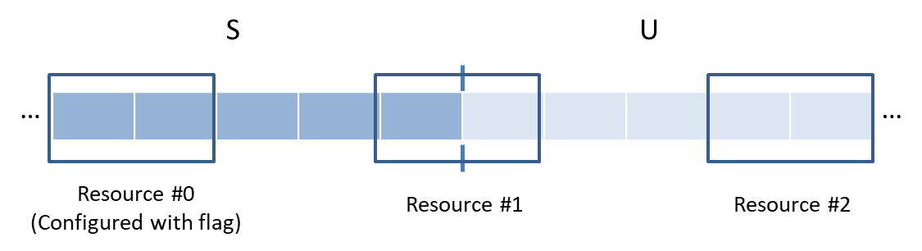

Alt 1-2-2: a resource is configured with a flag, only if it is transmitted in U slot.
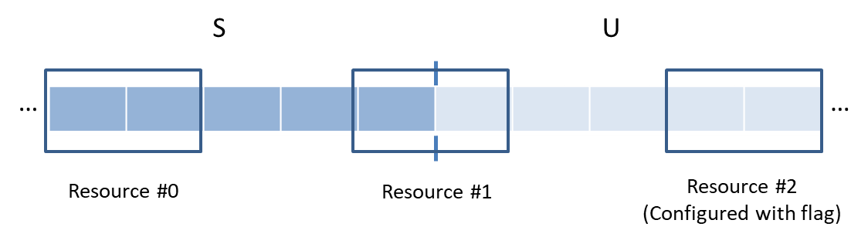
------------------------------------------------------------------------------------------------------------------------------

Enhancing DL CSI acquisition
Including a) Early SRS/CSI/CSI-RS triggering, and b) CSI-RS density reduction for 48, 64, and 128 CSI-RS ports.

R1-2600064 Enhancing DL CSI acquisition FUTUREWEI
R1-2600086 DL CSI acquisition enhancement Huawei, HiSilicon
R1-2600099 Discussion on enhancing DL CSI acquisition Spreadtrum, UNISOC
R1-2600132 NR MIMO Phase 6: DL CSI Enhancement InterDigital, Inc.
R1-2600177 Discussions on Enhancing DL CSI Acquisition OPPO
R1-2600226 Discussions on Enhancing DL CSI Acquisition TCL
R1-2600273 Discussion on enhancing DL CSI acquisition ZTE Corporation, Sanechips
R1-2600325 Discussion on enhancing DL CSI acquisition CATT
R1-2600338 Enhancing DL CSI acquisition Tejas Network Limited
R1-2600351 Enhancing DL CSI acquisition MediaTek Inc.
R1-2600371 On DL CSI Acquisition Enhancements for FR1 Nokia
R1-2600415 Discussion on enhancing DL CSI acquisition Xiaomi
R1-2600484 Discussion on enhancing DL CSI acquisition vivo
R1-2600599 Discussion on enhancing DL CSI acquisition Ofinno
R1-2600655 Discussion on Enhancing DL CSI acquisition NEC
R1-2600741 Views on Enhancing DL CSI acquisition Samsung
R1-2600777 Enhancing DL CSI acquisition Lenovo
R1-2600814 On Rel-20 MIMO CSI enhancement Apple
R1-2600867 Discussion on enhancing DL CSI acquisition Fujitsu
R1-2600981 Discussion on early DL CSI acquisition design Fainity Innovation
R1-2600991 Discussion on enhancing DL CSI acquisition for NR MIMO Phase 6 ETRI
R1-2601067 Discussion on Early DL CSI Acquisition Enhancements Panasonic
R1-2601122 Further discussion on DL CSI acquisition enhancements Sony
R1-2601165 Discussion on Enhancing DL CSI acquisition NTT DOCOMO, INC.
R1-2601204 Discussion on enhancing DL CSI acquisition Google
R1-2601236 Discussion on DL CSI acquisition ITRI, Acer Incorporated
R1-2601258 DL CSI acquisition enhancements in 5G MIMO Phase 6 Qualcomm Incorporated
R1-2601289 Enhancing DL CSI acquisition Sharp
R1-2601327 Enhanced DL CSI acquisition for MIMO Phase 6 Ericsson
R1-2601332 Discussion on Enhancement of DL CSI Acquisition Rakuten Mobile, Inc
R1-2601405 Discussion on Enhancing DL CSI acquisition LG Electronics
R1-2601406 Discussion on enhancing DL CSI acquisition NICT

R1-2600647 Moderator summary on enhancing DL CSI acquisition (Round 0) MediaTek Inc.
R1-2600648 Moderator summary on enhancing DL CSI acquisition (Round 1) MediaTek Inc.
R1-2600649 Moderator summary on enhancing DL CSI acquisition (Round 2) MediaTek Inc.
R1-2600650 Moderator summary on enhancing DL CSI acquisition (Round 3) MediaTek Inc.

Conclusion:
There is no RAN1 consensus to support periodic TRS triggered by a MAC-CE in MSG4 when UE transition from IDLE/INACTIVE to CONNECTED mode.

Agreement:
Support a MAC-CE in MSG4 PDSCH for triggering aperiodic SRS-AS/CSI-RS indicates at least
- The slot offset used to determine the transmission slot of aperiodic SRS-AS if triggered,
- The slot offset used to determine the transmission slot of aperiodic CSI-RS associated with AP CSI reporting if triggered, and
- The slot offset used to determine the transmission slot of aperiodic CSI-RS of the first TRS burst, if triggered.
- The slot offset used to determine the transmission slot of the PUSCH for aperiodic CSI reporting, if triggered, via the UL grant provided in the MAC-CE
  - FFS: How to indicate the slot offset by the UL grant provided in the MAC-CE
Note: Whether to indicate the other settings (i.e., comb offset, repetition factor, cyclic shift and the number of TRS bursts, the parameters (e.g., slot offset, time gap) to determine the Tx slot(s) of the TRS burst(s), if triggered, other than the first TRS burst) via MAC-CE in MSG4 are separately discussed.

Agreement:
For aperiodic CSI reporting for a SCell(s), triggered based on a legacy SCell activation command activating the SCell(s), the SCell activation command indicates a UL grant for a PUSCH to carry the aperiodic CSI report(s) for the CSI report configuration(s) triggered for the SCell(s)
- Strive to reuse legacy UL grant design in RAR
- The aperiodic CSI report(s) is reported in the same PUSCH.
- FFS: The serving cell where the PUSCH is scheduled in

Agreement:
To determine the transmission/reception slot of the DL/UL signalling triggered/scheduled based on a legacy SCell activation command (i.e., aperiodic SRS-AS, aperiodic CSI-RS and the PUSCH scheduled for aperiodic CSI reporting), for applying a slot offset between a reference slot and a transmission/reception slot of the DL/UL signalling triggered/scheduled based on the legacy SCell activation command, the reference slot is the first slot that is 3ms after UE transmits HARQ-ACK for the PDSCH carrying the SCell activation command

Agreement
To determine the transmission/reception slot of a MSG4-triggered DL/UL signalling (i.e., aperiodic SRS-AS, aperiodic TRS, aperiodic CSI-RS and the PUSCH scheduled for aperiodic CSI reporting), for applying a slot offset between a reference slot and a transmission/reception slot of the MSG4-triggered DL/UL signalling, the reference slot is the first slot that is 3ms after UE transmits HARQ-ACK for the MSG4 PDSCH carrying the MAC-CE.

Conclusion:
There is no RAN1 consensus to support the followings in UE transition from IDLE/INACTIVE to CONNECTED mode:
- Aperiodic SRS-AS must be always triggered along with aperiodic CSI reporting and associated CSI-RS, via a MSG4
- Aperiodic TRS must be always triggered along with aperiodic CSI reporting and associated CSI-RS, via a MSG4

