3GPP TSG-SA5 Meeting #160 S5-251981

Stor-Göteborg, Sweden, 7th Apr 2025 - 11th Apr 2025
CR-Form-v12.3
CHANGE REQUEST
 | 28.541 | CR | 1513 | rev | 1 | Current version: | 19.3.0
For HELP on using this form: comprehensive instructions can be found at
http://www.3gpp.org/Change-Requests.

Proposed change affects: | UICC apps |  | ME |  | Radio Access Network | X | Core Network

Title: | Rel-19 CR 28.541 Update sector equipment and antenna function definitions
Source to WG: | Ericsson Canada Inc.
Source to TSG: | S5
Work item code: | AdNRM_Ph3 |  |  |  |  |  | Date: |  |  | 2025-03-28
Category: | C |  |  |  |  |  | Release: |  |  | Rel-19
 | Use one of the following categories:  F (correction)  A (mirror corresponding to a change in an earlier release)  B (addition of feature),  C (functional modification of feature)  D (editorial modification)  Detailed explanations of the above categories can  be found in 3GPP TR 21.900. |  |  |  |  |  |  |  | Use one of the following releases:  Rel-8 (Release 8)  Rel-9 (Release 9)  Rel-10 (Release 10)  Rel-11 (Release 11)  …  Rel-17 (Release 17)  Rel-18 (Release 18)  Rel-19 (Release 19)  Rel-20 (Release 20)
Reason for change: |  | SectorEquipmentFunction is imported and it is unclear which diagram defines its relationships.
Summary of change: |  | Update the existing figure title to indicate it defines the SectorEquipmentFunction relationship.
Consequences if not approved: |  | The relationships for SectorEquipmentFunction are not clear.
Clauses affected: |  | 4.2.1.1-3
 |  | Y | N
Other specs |  |  | X | Other core specifications |  |  |  | TS/TR ... CR ...
affected: |  |  | X | Test specifications |  |  |  | TS/TR ... CR ...
(show related CRs) |  |  | X | O&M Specifications |  |  |  | TS/TR … CR ...
Other comments:
This CR's revision history:

1st Change

4.2 Class diagram

4.2.1 Class diagram for gNB and en-gNB
4.2.1.1 Relationships
This clause depicts the set of classes (e.g. IOCs) that encapsulates the information relevant for this gNB and en-gNB. For the UML semantics, see 3GPP TS 32.156 [43]. Subsequent clauses provide more detailed specification of various aspects of these classes.
The model fragments are for management representation of gNB and en-gNB for all NG-RAN deployment scenario as listed below.
- Non-split NG-RAN deployment scenario, represents the gNB defined in TS 38.401[4]. In this scenario, a gNB is represented by a combination of a GNBCUCPFunction, one or more GNBCUUPFunctions and one or more GNBDUFunctions.
- 2-split NG-RAN deployment scenario, represents the gNB consist of gNB-CU and gNB-DU defined in TS 38.401[4] clause 6.1.1. In this scenario, a gNB-CU is represented by a combination of a GNBCUCPFunction and one or more GNBCUUPFunctions, whereas a gNB-DU is represented by a GNBDUFunction.
- 3-split NG-RAN deployment scenario, represents the gNB consist of gNB-CU-CP, gNB-CU-UP and gNB-DU defined in TS 38.401[4] clause 6.1.2. In this scenario, a gNB-CU-CP is represented by a GNBCUCPFunction, a gNB-CU-UP is represented by a GNBCUUPFunction, and a gNB-DU is represented by a GNBDUFunction.
Figure 4.2.1.1-1: NRM for all deployment scenarios

Figure 4.2.1.1-2: NRM for EPs for all deployment scenarios
Figure 4.2.1.1-3: NRM for <<IOC>>NRSectorCarrier,<<IOC>>BWP, <<IOC>>SectorEquipmentFunction and <<IOC>> BWPSet for all deployment scenarios
Figure 4.2.1.1-4: Cell Relation view for all deployment scenarios
NOTE 1: The above NRM fragment uses SubNetwork to hold both NR and LTE external entities and frequencies.
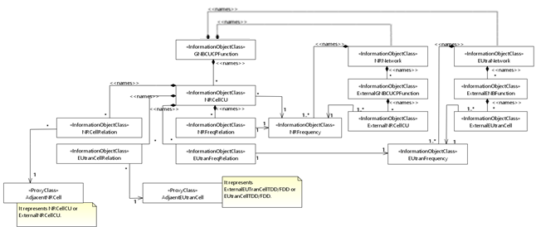Figure 4.2.1.1-5: Cell Relation view for all deployment scenarios
NOTE 2: The above NRM fragment uses ExternalNRNetwork to hold NR external entities and frequency and using ExternalEUtraNetwork to hold LTE external entities and frequency.
Figure 4.2.1.1-6: NRM fragment for abstract RRM Policies

Figure 4.2.1.1-6a: NRM fragment for RRMPolicyRatio
Figure 4.2.1.1-7: NRM fragment to support RIM

Figure 4.2.1.1-8: NRM fragment for pre-configured 5QIs in NG-RAN
NOTE 3: Void
Figure 4.2.1.1-9: NRM fragment for DANR Management
Figure 4.2.1.1-10: NRM fragment for DES Management
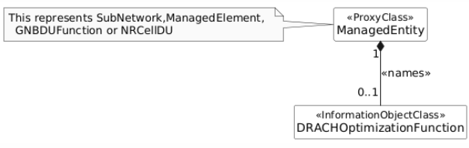
Figure 4.2.1.1-11: NRM fragment for DRACH Management
Figure 4.2.1.1-12: NRM fragment for DMRO Management
Figure 4.2.1.1-13: NRM fragment for DPCI Management
Figure 4.2.1.1-14: NRM fragment for CES Management
Figure 4.2.1.1-15: NRM fragment for CPCI Management

Figure 4.2.1.1-16: NRM fragment for dynamically assigned 5QIs in NG-RAN

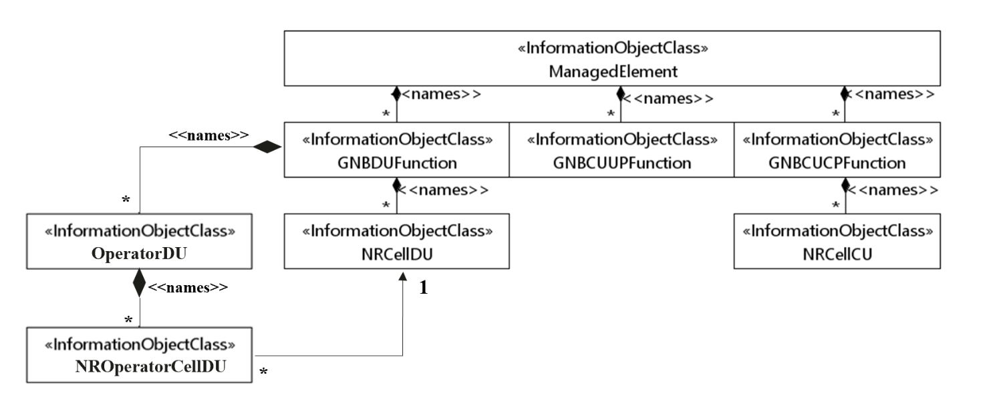
Figure 4.2.1.1-17: NRM fragment for NG-RAN MOCN network sharing with multiple cell identity broadcast feature
Figure 4.2.1.1-18: NRM fragment for F1 related EPs to support individual F1 interface for NG-RAN MOCN network sharing with multiple cell identity broadcast feature

Figure 4.2.1.1-19: NRM fragment for DLBO Management
Figure 4.2.1.1-20: NRM fragment for CCO Management
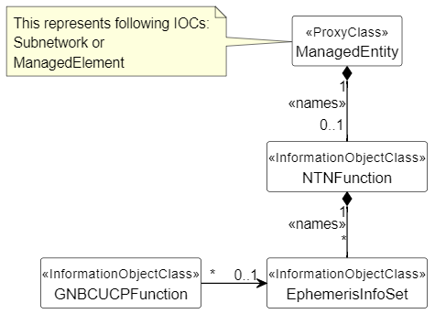
Figure 4.2.1.1-21: NRM fragment to support NTN management

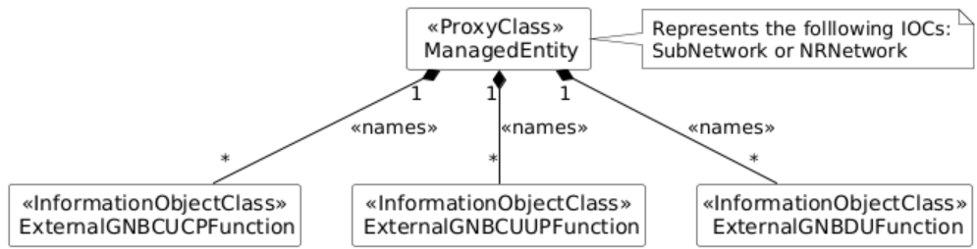
Figure 4.2.1.1-22: NRM fragment for ExternalGNBCUCPFunction, ExternalGNBCUUPFunction and ExternalGNBDUFunction

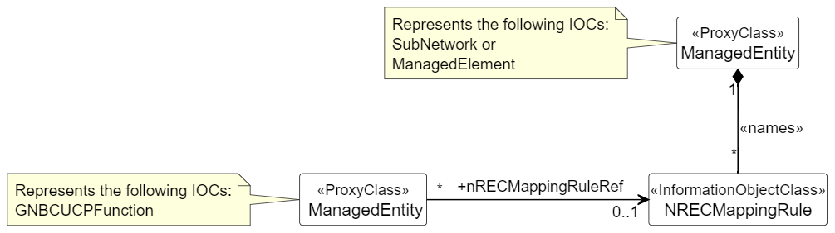
Figure 4.2.1.1-23: NRM fragment for energy cost mappi

