**3GPP TSG-SA5 Meeting #156 *S5-244303***

Maastricht, The Netherlands, 19 - 23 Aug 2024

**Source: Ericsson Inc.**

**Title:** **Discussion paper on enhancing sector equipment and antenna function modelling for NR**

**Document for: Endorsement**

**Agenda Item: 6.4.11**

# 1 Decision/action requested

***This discussion paper is to present issues with the current NR model support for sector and antenna equipment, and to seek SA5 endorsement on a potential solution to address them.***

# 2 References

[1] 3GPP TS 28.662: "Generic Radio Access Network (RAN) Network Resource Model (NRM) Integration Reference Point (IRP); Information Service (IS)".

[2] 3GPP TS 28.541: "Management and orchestration; 5G Network Resource Model (NRM); Stage 2 and stage 3”.

[3] 3GPP TS 28.663: "Generic Network Resource Model (NRM) Integration Reference Point (IRP); Solution Set (SS)”.

# 3 Rationale

This discussion paper explores options to improve the modelling support for sector equipment and antenna modelling for NR deployments, as well as for nodes containing both LTE and NR.

## 3.1 Background

At present the NR NRM [2] defines sector equipment through reuse of the *SectorEquipmentFunction* IOC defined in Generic NRM [1]:

IOC import, clause 4.1.1:

|  |  |
| --- | --- |
| Label reference | Local label |
| TS 28.622 [30], IOC, ManagedFunction | ManagedFunction |
| TS 28.622 [30], IOC, EP_RP | EP_RP |
| TS 28.662 [11], IOC, **SectorEquipmentFunction** | **SectorEquipmentFunction** |
| TS 28.658 [19], IOC, ExternalENBFunction | ExternalENBFunction |
| TS 28.708 [21], IOC, ServingGWFunction | ServingGWFunction |
| TS 28.658 [19], IOC, EUtranCellFDD | EUtranCellFDD |

Relationships, clause 4.2.1:



Figure 4.2.1.1-3: NRM for <<IOC>>NRSectorCarrier,<<IOC>>BWP, and <<IOC>> BWPSet for all deployment scenarios

## 3.2 Issues

**Issue #1**: The *SectorEquipmentFunction* definition imported from [1] could be enhanced to better support all NR and mixed mode deployments. There is no need to define technology specific attributes in the common definitions. The references to/from shared resources should also be more flexible.

**Issue #2:** NR NRM [2] does not include any definition for antenna equipment.There is a definition for *AntennaFunction* in Generic NRM [1] but not currently used in NR NRM [2].

**Issue #3:** It is unclear how to model mixed mode deployments with nodes containing both 4G and 5G.

**Issue #4:** Generic RAN IS [3] and Generic RAN SS [4] seemingly do not apply to NR:

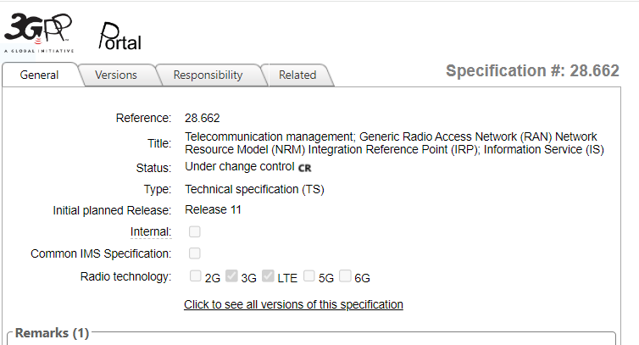

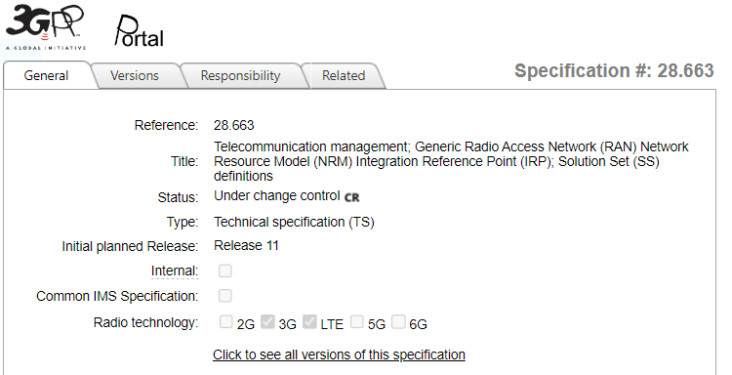

**Issue #5:** Although Generic NRM [2] does not define a specific IRP interface it does imply that an “IRP based” solution is applicable. Excerpt from clause 1, Scope:

***The present document specifies the Generic Radio Access Network (RAN) network resource model (NRM) that can be communicated between an IRPAgent and an IRPManager*** *for telecommunication network management purposes, including management of converged networks.*

*This document specifies the semantics and behaviour of information object class attributes and relations visible across the reference point in a protocol and technology neutral way. It does not define their syntax and encoding.*

*In order to access the information defined by this NRM, an Interface IRP such as the "Basic CM IRP" is needed (3GPP TS 32.602 [5]). However, which Interface IRP is applicable is outside the scope of the present document.*

It is not clear whether any of the contents in [1] are applicable to SBMA based implementations.

# 4 Potential Solutions

Potential solution needs to consider the following:

- consistency of solutions for 4G, 5G, and mixed 4G&5G

- impact to existing solutions

## 4.1 Potential Solution 1: Update Generic RAN NRM

This solution would update the following to address each issue:

* Issue #1: update sector equipment function definition in Generic NRM [1].
* Issue #2: update antenna equipment function definition Generic NRM [1]. Update NR NRM [2] to include antenna function.
* Issue #3: update the relationships to cover 5G, and mixed 4G&5G in Generic NRM [1].
* Issue #4: update the applicable radio technologies to include 5G
* Issue #5: update the scope to be applicable to IRP or SBMA

Pro: consistency between 4G and 5G as defined in Generic NRM.

Con: non-backwards compatible changes to Generic NRM, updates required for impacted solution sets.

More details on this potential solution are included in Annex A in the form of proposed updates to [1] and [2].

## 4.2 Potential Solution 2: Update NR NRM

This solution would update the following to address each issue:

* Issue #1: Remove import of *SectorEquipmentFunction* and add sector equipment function definition to NR NRM [2].
* Issue #2: Add antenna equipment function definition to NR NRM [2].
* Issue #3: update the relationships to cover 5G, and mixed 4G & 5G in NR NRM [2].
* Issue #4: N/A
* Issue #5: N/A

Pro: support for mixed 4G & 5G in NR NRM [2] and SBMA, without impacting other solutions.

Con: Inconsistency between 4G solution in Generic NRM [1] vs. mixed 4G & 5G in NR NRM [2].

Most changes required would be similar as for solution 1, however they would be implemented as new content to NR NRM [2] as opposed to updates to Generic NRM [1].

# 5 Detailed proposal

SA5 is asked to endorse Potential Solution #1 in clause 4.1.

# Annex A, potential changes for solution 1

The following provides overview of the changes required to implement solution 1.

Potential updates to impacted solution sets are not included.

# A.1 potential changes to Generic NRM, 28.662

|  |
| --- |
| **1st Change** |

# 1 Scope

The present document specifies the Generic Radio Access Network (RAN) network resource model (NRM) that can be used for telecommunication network management purposes, including management of converged networks.

This document specifies the semantics and behaviour of information object class attributes and relations visible in the NRM in a protocol and technology neutral way. It does not define their syntax and encoding.

In order to access the information defined by this NRM, an Interface IRP such as the "Basic CM IRP" (3GPP TS 32.602 [5]) or the Generic Provisioning MnS (28.532 [x]) is needed. However, which interface is applicable is outside the scope of the present document.

|  |
| --- |
| **2nd Change** |

# 2 References

The following documents contain provisions which, through reference in this text, constitute provisions of the present document.

- References are either specific (identified by date of publication, edition number, version number, etc.) or non‑specific.

- For a specific reference, subsequent revisions do not apply.

- For a non-specific reference, the latest version applies. In the case of a reference to a 3GPP document (including a GSM document), a non-specific reference implicitly refers to the latest version of that documentin the same Release as the present document.

[1] 3GPP TR 21.905: "Vocabulary for 3GPP Specifications".

[2] 3GPP TS 32.101: "Telecommunication management; Principles and high level requirements".

[3] 3GPP TS 32.102: "Telecommunication management; Architecture".

[4] 3GPP TS 32.150: "Telecommunication management; Integration Reference Point (IRP) Concept and definitions".

[5] 3GPP TS 32.602: "Telecommunication management; Configuration Management (CM); Basic CM Integration Reference Point (IRP); Information Service (IS)".

[6] Void.

[7] 3GPP TS 36.104: "Evolved Universal Terrestrial Radio Access (E_UTRA); Base Station (BS) radio transmission and reception".

[8] Void.

[9] Void.

[10] 3GPP TS 28.661: "Telecommunication management; Generic Radio Access Network (RAN) Network Resource Model (NRM) Integration Reference Point (IRP); Requirements".

[11] 3GPP TS 32.111-2: "Telecommunication management; Fault Management; Part 2: Alarm Integration Reference Point (IRP): Information Service (IS)".

[12] 3GPP TS 28.652: "Telecommunication management; Universal Terrestrial Radio Access Network (UTRAN) Network Resource Model (NRM) Integration Reference Point (IRP); Information Service (IS)".

[13] 3GPP TS 28.658: "Telecommunication management; Evolved Universal Terrestrial Radio Access Network (E-UTRAN) Network Resource Model (NRM) Integration Reference Point (IRP); Information Service (IS)".

[14] 3GPP TS 28.655:"Telecommunication management; GSM/EDGE Radio Access Network (GERAN) Network Resource Model (NRM) Integration Reference Point (IRP); Information Service (IS)".

[15] 3GPP TS 28.622: "Telecommunication management; Generic Network Resource Model (NRM) Integration Reference Point (IRP); Information Service (IS)".

[16] 3GPP TS 32.302: "Telecommunication management; Configuration Management (CM); Notification Integration Reference Point (IRP): Information Service (IS)".

[17] 3GPP TS 32.662: "Telecommunication management; Configuration Management (CM); Kernel CM Information Service (IS)".

[18] 3GPP TS 25.106: "Technical Specification Group Radio Access Network; UTRA repeater radio transmission and reception".

[19] 3GPP TS 45.005: "Radio transmission and reception".

[20] 3GPP TS 45.010: "Radio subsystem synchronization".

[21] 3GPP TS 25.104: "Base Station (BS) radio transmission and reception (FDD)".

[22] 3GPP TS 25.105: "Base Station (BS) radio transmission and reception (TDD)".

[23] 3GPP TS 38.104: "NR; Base Station (BS) radio transmission and reception".

[24] 3GPP TS 28.541: "NR and NG-RAN Network Resource Model (NRM) stage 2 and stage 3".

[25] 3GPP TS 28.652: "UTRAN Network Resource Model (NRM) Integration Reference Point (IRP): Information Service (IS)".

[26] 3GPP TS 37.466: "Iuant Interface: Application Part".

[x] 3GPP TS 28.532: “Management and Orchestration: Generic Management Services”.

|  |
| --- |
| **3st Change** |

### 4.3.1 SectorEquipmentFunction

#### 4.3.1.1 Definition

This IOC represents a set of cells within a geographical area that has common functions relating to AntennaFunction, TMAFunction and supporting equipment, such as power amplifier.

This IOC is required as part of the capability to satisfy the Requirements statement identified below.

|  |  |  |
| --- | --- | --- |
| Referenced TS | Requirement label | Comment |
| 3GPP TS 28.661 [10] | REQ-GRAN_NRM-CON-001 |  |
| 3GPP TS 28.661 [10] | REQ-GRAN_NRM-CON-002 |  |

#### 4.3.1.2 Attributes

|  |  |  |  |  |  |
| --- | --- | --- | --- | --- | --- |
| **Attribute name** | **Support Qualifier** | **isReadable** | **isWritable** | **isInvariant** | **isNotifyable** |
| frequencyBands | M | T | F | F | T |
| outputPower | O | T | T | F | F |
| **Attribute related to role** |  |  |  |  |  |
| theTMAList | CM | T | F | F | T |
| theAntennaList | CM | T | F | F | T |
| referencedBy | M | T | F | F | T |

#### 4.3.1.3 Attribute constraints

|  |  |
| --- | --- |
| Name | Definition |
| theTMAList CM Support Qualifier | Condition: Association between SectorEquipmentFunction and AntennaFunction is absent AND is supporting the UTRAN/E-UTRAN sharing/non-sharing case OR is supporting the GERAN sharing case. In such case, at least one TMAFunction is present. |
| theAntennaList CM Support Qualifier | Condition: Association between SectorEquipmentFunction and TMAFunction is absent AND is supporting the UTRAN/E-UTRAN sharing/non-sharing OR is supporting GERAN sharing case. In such case, at least one AntennaFunction is present. |

#### 4.3.1.4 Notifications

The common notifications defined in subclause 4.5 are valid for this IOC, without exceptions or additions.

|  |
| --- |
| **4th Change** |

### 4.3.2 AntennaFunction

#### 4.3.2.1 Definition

This IOC represents an array of radiating elements that may be tilted to adjust the RF coverage of a cell(s).

This IOC is required as part of the capability to satisfy the Requirements statement identified below.

|  |  |  |
| --- | --- | --- |
| Referenced TS | Requirement label | Comment |
| 3GPP TS 28.661 [10] | REQ-GRAN_NRM-CON-001 |  |
| 3GPP TS 28.661 [10] | REQ-GRAN_NRM-CON-002 |  |

#### 4.3.2.2 Attributes

|  |  |  |  |  |  |
| --- | --- | --- | --- | --- | --- |
| Attribute name | Support Qualifier | isReadable | isWritable | isInvariant | IsNotifyable |
| totalTiltValue | M | T | T | F | T |
| bearing | O | T | T | F | T |
| height | O | T | T | F | T |
| maxAzimuthValue | O | T | T | F | T |
| minAzimuthValue | O | T | T | F | T |
| horizBeamwidth | O | T | T | F | T |
| vertBeamwidth | O | T | T | F | T |
| altitude | M | T | F | F | T |
| latitude | M | T | F | F | T |
| longitude | M | T | F | F | T |
| **Attribute related to role** |  |  |  |  |  |
| referencedBy | M | T | F | F | T |

#### 4.3.2.3 Attribute constraints

|  |  |
| --- | --- |
| Name | Definition |

#### 4.3.2.4 Notifications

The common notifications defined in subclause 4.5 are valid for this IOC, without exceptions or additions.

|  |
| --- |
| **5th Change** |

## Attribute definitions

### 4.4.1 Attribute properties

| **Attribute Name** | **Documentation and Allowed Values** | **Properties** |
| --- | --- | --- |
| altitude | Altitude of transmitter antenna position measured in meters. Positive value means height, negative value means depth. Altitude is in relation to WGS84 reference ellipsoid. WGS84 reference ellipsoid is based on theoretical mean sea level.  If empty, value is not defined.  allowedValues:  { -32768..32767 } | type: Integer  multiplicity: 1  isOrdered: N/A  isUnique: N/A  defaultValue: None  isNullable: True |
| aRFCN | This attribute (Absolute Radio Frequency Channel Number) defines a pair of Radio Frequency (RF) channel frequencies for uplink and downlink use.  See 3GPP TS 45.005 [19] clause 2 for the ARFCN for GSM. ARFCN are based on a 200 kHz channel raster.  allowedValues: See 3GPP TS 45.005 [19] clause 2 | type: String  multiplicity: 1  isOrdered: N/A  isUnique: N/A  defaultValue: None  isNullable: True |
| aTA | This attribute (allowed Timing Advance) defines the signal sent by the BTS to the MS which the MS uses to advance its timings of transmissions to the BTS so as to compensate for propagation delay.  allowedValues: See 3GPP TS 45.010 [20] | type: Integer  multiplicity: 1  isOrdered: N/A  isUnique: N/A  defaultValue: None  isNullable: True |
| outputPower | It defines the allowed total power to use for all cells together in this sector. It may be set by the operator and/or limited by HW limitation or licensed power, e.g.: 20, 40, 60, 80,120 watts  allowedValues: N/A | type: Integer  multiplicity: 1  isOrdered: N/A  isUnique: N/A  defaultValue: None  isNullable: True |
| ctrlConnMode | Remote communication mode used by a repeater to send and receive control message, such as GSM SMS, WCDMA SMS, Circle Switch Data-CSD, Package Switch Dat-IP, Serial port.  allowedValues: N/A | type: String  multiplicity: 1  isOrdered: N/A  isUnique: N/A  defaultValue: None  isNullable: True |
| dlAttenuation | Downlink signal attenuation of the device to change downlink gain.  allowedValues: N/A | type: Integer  multiplicity: 1  isOrdered: N/A  isUnique: N/A  defaultValue: None  isNullable: True |
| environmentInfo | The repeater device is located either in the building or out of the building.  allowedValues: N/A | type: String  multiplicity: 1  isOrdered: N/A  isUnique: N/A  defaultValue: None  isNullable: True |
| firmwareVer | Version of the device firmware.  allowedValues: N/A | type: String  multiplicity: 1  isOrdered: N/A  isUnique: N/A  defaultValue: None  isNullable: True |
| frequencyBands | The list of frequency bands supported by the hardware associated with the SectorEquipmentFunction.  The earfcnDl and earfcnUl of cells associated with the SectorEquipmentFunction must be assigned with a value within one of the specified frequencyBand values.  allowedValues: N/A | type: Integer  multiplicity: 1..*  isOrdered: False  isUnique: True  defaultValue: None  isNullable: True |
| latitude | The latitude of the antenna location based on World Geodetic System (1984 version) global reference frame (WGS 84). Positive values correspond to the northern hemisphere.  allowedValues: -90.0000 to +90.0000 | type: Integer  multiplicity: 1  isOrdered: N/A  isUnique: N/A  defaultValue: None  isNullable: True |
| longitude | The longitude of the antenna location based on World Geodetic System (1984 version) global reference frame (WGS 84). Positive values correspond to degrees east of 0 degrees longitude.  allowedValues: -180.0000 to +180.0000 | type: Integer  multiplicity: 1  isOrdered: N/A  isUnique: N/A  defaultValue: None  isNullable: True |
| priority | The priority of a repeater decided by an operator.  allowedValues: N/A | type: Integer  multiplicity: 1  isOrdered: N/A  isUnique: N/A  defaultValue: None  isNullable: True |
| powerSwitch | Power switch of device which has two status: ON/OFF.  allowedValues: ON, OFF | type: Boolean  multiplicity: 1  isOrdered: N/A  isUnique: N/A  defaultValue: None  isNullable: True |
| relatedAntennaList | This attribute contains the DNs of one or more AntennaFunction**.**  allowedValues: N/A | type: DN  multiplicity: 1..*  isOrdered: N/A  isUnique: T  defaultValue: None  isNullable: True |
| relatedSectorEquipment | This attribute contains the DN of one SectorEquipmentFunction.  allowedValues: N/A | type: DN  multiplicity: 1  isOrdered: N/A  isUnique: N/A  defaultValue: None  isNullable: True |
| relatedTMAList | This attribute contains the DNs of one or more TmaFunction.  allowedValues: N/A | type: DN  multiplicity: 1..*  isOrdered: N/A  isUnique: T  defaultValue: None  isNullable: True |
| repeaterType | The repeater type defined by operator, such as wide band, frequency selective, indoor and fiber optic.  allowedValues: N/A | type: String  multiplicity: 1  isOrdered: N/A  isUnique: N/A  defaultValue: None  isNullable: True |
| totalTiltValue | The required beam tilt for the AntennaFunction. Achieved by the combination of mechanical tilt and electrical tilt. | type: Integer  multiplicity: 1  isOrdered: N/A  isUnique: N/A  defaultValue: None  isNullable: True |
| sharedTechnologies | This attribute defines the radio access technologies sharing the common functionalities of a Base Station (BS).  allowedValues: GSM, UMTS, LTE, or any combination thereof | type: Integer  multiplicity: 1  isOrdered: N/A  isUnique: N/A  defaultValue: None  isNullable: True |
| tmaAntennaBearing | A data field defined in Table B.3 of 3GPP TS 37.466 [26].  See definition in 3GPP TS 37.466 [26].  allowedValues: N/A | type: Integer  multiplicity: 1  isOrdered: N/A  isUnique: N/A  defaultValue: None  isNullable: True |
| tmaBaseStationId | A data field defined in Table B.3 of 3GPP TS 37.466 [26]  allowedValues: N/A | type: String  multiplicity: 1  isOrdered: N/A  isUnique: N/A  defaultValue: None  isNullable: True |
| tmaFunctionFlag | Defined in 3GPP TS 37.466 [26]  allowedValues: N/A | type: Integer  multiplicity:  isOrdered: N/A  isUnique: N/A  defaultValue: None  isNullable: True |
| tmaGainFigure | Defined in 3GPP TS 37.466 [26]  allowedValues: N/A | type: Integer  multiplicity: 1  isOrdered: N/A  isUnique: N/A  defaultValue: None  isNullable: True |
| tmaGainResolution | A data field defined in Table B.3 of 3GPP TS 37.466 [26]  allowedValues: N/A | type: Integer  multiplicity: 1  isOrdered: N/A  isUnique: N/A  defaultValue: None  isNullable: True |
| tmaInstalledMechanicalTilt | A data field defined in Table B.3 of 3GPP TS 37.466 [26]  allowedValues: N/A | type: Integer  multiplicity: 1  isOrdered: N/A  isUnique: N/A  defaultValue: None  isNullable: True |
| tmaMaxGain | Defined in 3GPP TS 37.466 [26]  allowedValues: N/A | type: Integer  multiplicity: 1  isOrdered: N/A  isUnique: N/A  defaultValue: None  isNullable: True |
| tmaMinGain | Defined in 3GPP TS 37.466 [26]  allowedValues: N/A | type: Integer  multiplicity: 1  isOrdered: N/A  isUnique: N/A  defaultValue: None  isNullable: True |
| tmaNumberOfSubunits | Defined in 3GPP TS 37.466 [26]  allowedValues: -- | Defined in 3GPP TS 37.466 [26]  type: --  multiplicity: --  isOrdered: --  isUnique: --  defaultValue: --  isNullable: -- |
| tmaResolution | Defined in 3GPP TS 37.466 [26]  allowedValues: N/A | type: Integer  multiplicity: 1  isOrdered: N/A  isUnique: N/A  defaultValue: None  isNullable: True |
| tmaSectorId | A data field defined in Table B.3 of 3GPP TS 37.466 [26]  allowedValues: N/A | type: String  multiplicity: 1  isOrdered: N/A  isUnique: N/A  defaultValue: None  isNullable: True |
| tmaStateFlag | Defined in 3GPP TS 37.466 [26]  allowedValues: N/A | type: Integer  multiplicity: 1  isOrdered: N/A  isUnique: N/A  defaultValue: None  isNullable: True |
| tmaSubunitNumber | Defined in 3GPP TS 37.466 [26]  allowedValues: N/A | type: Integer  multiplicity: 1  isOrdered: N/A  isUnique: N/A  defaultValue: None  isNullable: True |
| tmaSubunitRxFrequencyBand | A data field defined in Table B.3 of 3GPP TS 37.466 [26]  allowedValues: See 3GPP TS 37.466 [26]. | type: Integer  multiplicity: 2  isOrdered: True  isUnique: True  defaultValue: None  isNullable: False |
| tmaSubunitType | A data field defined in Table B.3 of 3GPP TS 37.466 [26]  allowedValues: N/A | type: Integer  multiplicity: 1  isOrdered: N/A  isUnique: N/A  defaultValue: None  isNullable: True |
| tmaSubunitTxFrequencyBand | A data field defined in Table B.3 of 3GPP TS 37.466 [26]  allowedValues: See 3GPP TS 37.466 [26]. | type: Integer  multiplicity: 2  isOrdered: True  isUnique: True  defaultValue: None  isNullable: False |
| tsc | This attribute has the same definition as the one used in GsmCell IOC. The presence of GSMCellPart means the tsc attribute in GsmCell IOC instance is irrelevant (not applicable).  allowedValues: N/A | type: Integer  multiplicity: 1  isOrdered: N/A  isUnique: N/A  defaultValue: None  isNullable: True |
| ulAttenuation | Uplink signal attenuation of the device to change uplink gain.  allowedValues: N/A | type: Integer  multiplicity: 1  isOrdered: N/A  isUnique: N/A  defaultValue: None  isNullable: True |
| **Attribute related to role** |  |  |
| externalUTRANCell | This role (when present) represents RepeaterFunction capability to identify one ExternalUtranCell.  When present, it shall contain one ExternalUtranCell DN.  allowedValues: N/A | type: DN  multiplicity: 1  isOrdered: N/A  isUnique: N/A  defaultValue: None  isNullable: True |
| referencedBy | This attribute contains the DNs of one or more objects (e.g. Cells, NRSectorCarriers) if associations between them exist. | type: DN  multiplicity: *  isOrdered: False  isUnique: True  defaultValue: None  isNullable: True |
| theAntennaList | This attribute contains the DNs of one or more AntennaFunction.  allowedValues: N/A | type: DN  multiplicity: 1..*  isOrdered: False  isUnique: True  defaultValue: None  isNullable: True |
| theProxyBsList | A CommonBsFunction instance serves a number of ProxyBsFunction instances. This CommonBsFunction role-attribute contains a list of DNs of ENBFunction (3GPP TS 28.658 [13]), NodeBFunction (3GPP TS 28.652 [12]) and BssFunction (3GPP TS 28.655 [14]) that it serves.  allowedValues: N/A | type: DN  multiplicity: 1..*  isOrdered: False  isUnique: True  defaultValue: None  isNullable: True |
| theTMAList | This attribute contains the DNs of one or more TMAFunction.  allowedValues: N/A | type: DN  multiplicity: 1..*  isOrdered: False  isUnique: True  defaultValue: None  isNullable: True |

# A.2 potential changes to NR NRM, 28.541

|  |
| --- |
| **1st Change** |

## 4.1 Imported and associated information

### 4.1.1 Imported information entities and local labels

|  |  |
| --- | --- |
| Label reference | Local label |
| TS 28.622 [30], IOC, ManagedFunction | ManagedFunction |
| TS 28.622 [30], IOC, EP_RP | EP_RP |
| TS 28.662 [11], IOC, SectorEquipmentFunction | SectorEquipmentFunction |
| TS 28.658 [19], IOC, ExternalENBFunction | ExternalENBFunction |
| TS 28.708 [21], IOC, ServingGWFunction | ServingGWFunction |
| TS 28.658 [19], IOC, EUtranCellFDD | EUtranCellFDD |
| TS 28.658 [19], IOC, EUtranCellTDD | EUtranCellTDD |
| TS 28.658 [19], dataType, PLMNId | PLMNId |
| TS 28.658 [19], IOC, ENBFunction | ENBFunction |
| TS 28.708 [21], IOC, ExternalServingGWFunction | ExternalServingGWFunction |
| TS 28.658 [19], IOC, ExternalEUtranCellFDD | ExternalEUtranCellFDD |
| TS 28.658 [19], IOC, ExternalEUtranCellTDD | ExternalEUtranCellTDD |
| TS 28.658 [19], IOC, AdjacentCell | AdjacentEUtranCell |
| TS 28.658 [19], IOC, EUtranFrequency | EUtranFrequency |
| TS 28.658 [19], IOC, EUtranFreqRelation | EUtranFreqRelation |
| TS 28.658 [19], IOC, EUtranRelation | EUtranCellRelation |
| TS 28.622 [30], dataType, Tai | Tai |
| TS 28.622 [30], choice, NpnId | NpnId |
| TS 28.662 [11], IOC, AntennaFunction | AntennaFunction |

### 4.1.2 Associated information entities and local labels

|  |  |
| --- | --- |
| Label reference | Local label |
| TS 28.622 [30], IOC, ManagedElement | ManagedElement |
| TS 28.622 [30], IOC, SubNetwork | SubNetwork |
| TS 28.105 [105], IOC, MLModel | MLModel |
| TS 28.105 [105], IOC, AIMLInferenceFunction | AIMLInferenceFunction |

|  |
| --- |
| **2nd Change** |

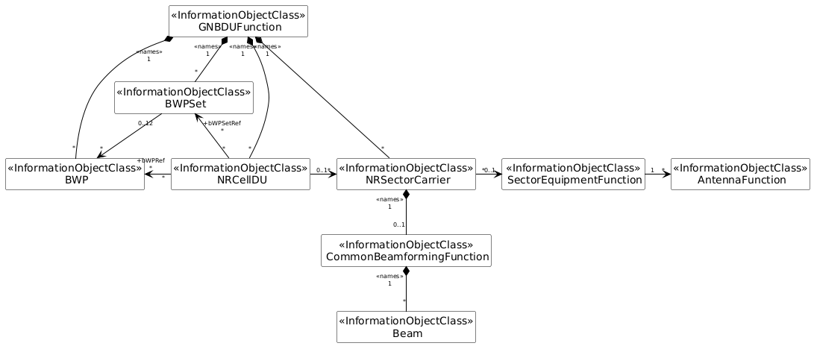

Figure 4.2.1.1-3: NRM for <<IOC>>NRSectorCarrier,<<IOC>>BWP, <<IOC>>SectorEquipment, <<IOC>>AntennaFunction, and <<IOC>> BWPSet for all deployment scenarios

|  |
| --- |
| **3rd Change** |

## 7.4 YANG Definitions for NR and NG-RAN

YANG definitions are specified in 3GPP Forge [99].

Directory: yang-models

Files:

_3gpp-nr-nrm-antennafunction.yang

_3gpp-nr-nrm-beam.yang

_3gpp-nr-nrm-bwp.yang

_3gpp-nr-nrm-bwpset.yang

_3gpp-nr-nrm-cesmanagementfunction.yang

_3gpp-nr-nrm-commonbeamformingfunction.yang

_3gpp-nr-nrm-cpciconfigurationfunction.yang

_3gpp-nr-nrm-danrmanagementfunction.yang

_3gpp-nr-nrm-desmanagementfunction.yang

_3gpp-nr-nrm-dlbofunction.yang

_3gpp-nr-nrm-dmrofunction.yang

_3gpp-nr-nrm-dpciconfigurationfunction.yang

_3gpp-nr-nrm-drachoptimizationfunction.yang

_3gpp-nr-nrm-ep.yang

_3gpp-nr-nrm-eutrancellrelation.yang

_3gpp-nr-nrm-eutranetwork.yang

_3gpp-nr-nrm-eutranfreqrelation.yang

_3gpp-nr-nrm-eutranfrequency.yang

_3gpp-nr-nrm-externalamffunction.yang

_3gpp-nr-nrm-externalenbfunction.yang

_3gpp-nr-nrm-externaleutrancell.yang

_3gpp-nr-nrm-externalgnbcucpfunction.yang

_3gpp-nr-nrm-externalgnbcuupfunction.yang

_3gpp-nr-nrm-externalgnbdufunction.yang

_3gpp-nr-nrm-externalnrcellcu.yang

_3gpp-nr-nrm-externalservinggwfunction.yang

_3gpp-nr-nrm-externalupffunction.yang

_3gpp-nr-nrm-gnbcucpfunction.yang

_3gpp-nr-nrm-gnbcuupfunction.yang

_3gpp-nr-nrm-gnbdufunction.yang

_3gpp-nr-nrm-nrcellcu.yang

_3gpp-nr-nrm-nrcelldu.yang

_3gpp-nr-nrm-nrcellrelation.yang

_3gpp-nr-nrm-nrfreqrelation.yang

_3gpp-nr-nrm-nrfrequency.yang

_3gpp-nr-nrm-nrnetwork.yang

_3gpp-nr-nrm-nroperatorcelldu.yang

_3gpp-nr-nrm-nrsectorcarrier.yang_3gpp-nr-nrm-operatordu.yang

_3gpp-nr-nrm-rimrsset.yang

_3gpp-nr-nrm-rrmpolicy.yang

_3gpp-nr-nrm-sectorequipmentfunction.yang