3GPP TSG-SA5 Meeting #148e S5-233319
E-meeting, 17 - 25 April 2023

Source: SA5 VC (Huawei), SA5 Chair, SA5 VC (Matrixx)

Title: SA5 Collection of Rel-19 potential topics for SA workshop preparation

Document for: Endorsement
Agenda Item: 5.2

1 Decision/action requested
It’s proposed the agree to agree on this proposal.

2 References
[1] SA#98e: Rel-19 Planning (SP-221353 endorsed)
[2] S5-232763 Rel-18&Rel-19 time plan proposal for OAM
[3] S5-232752 SA5 Collection of Rel-19 potential topics for SA workshop preparation

3 Rationale
SA is planning for SA level Rel-19 workshop in June,2023. The related background information has been shared by SA5 leaders in SA5#146Bis-e in S5-232763.
This document is to capture the preliminary information of potential work areas in Rel-19, and the content will be used as SA5 input to Rel-19 SA workshop.
Please note company could also provide their inputs directly through company contributions to Rel-19 SA workshop.
================Extract information from S5-232763=====================
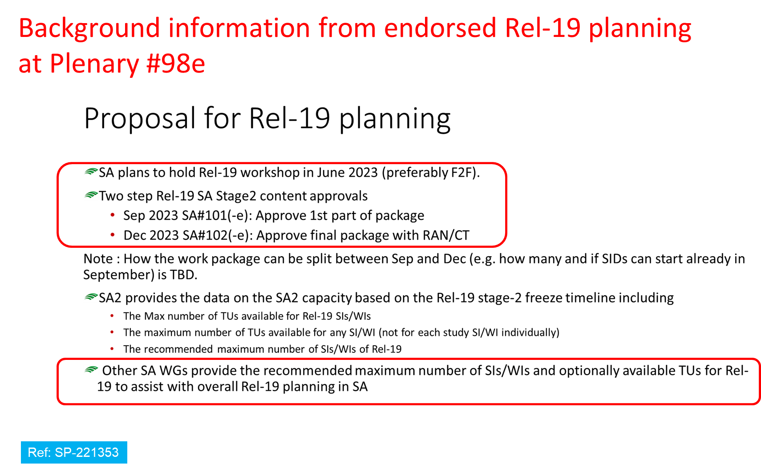

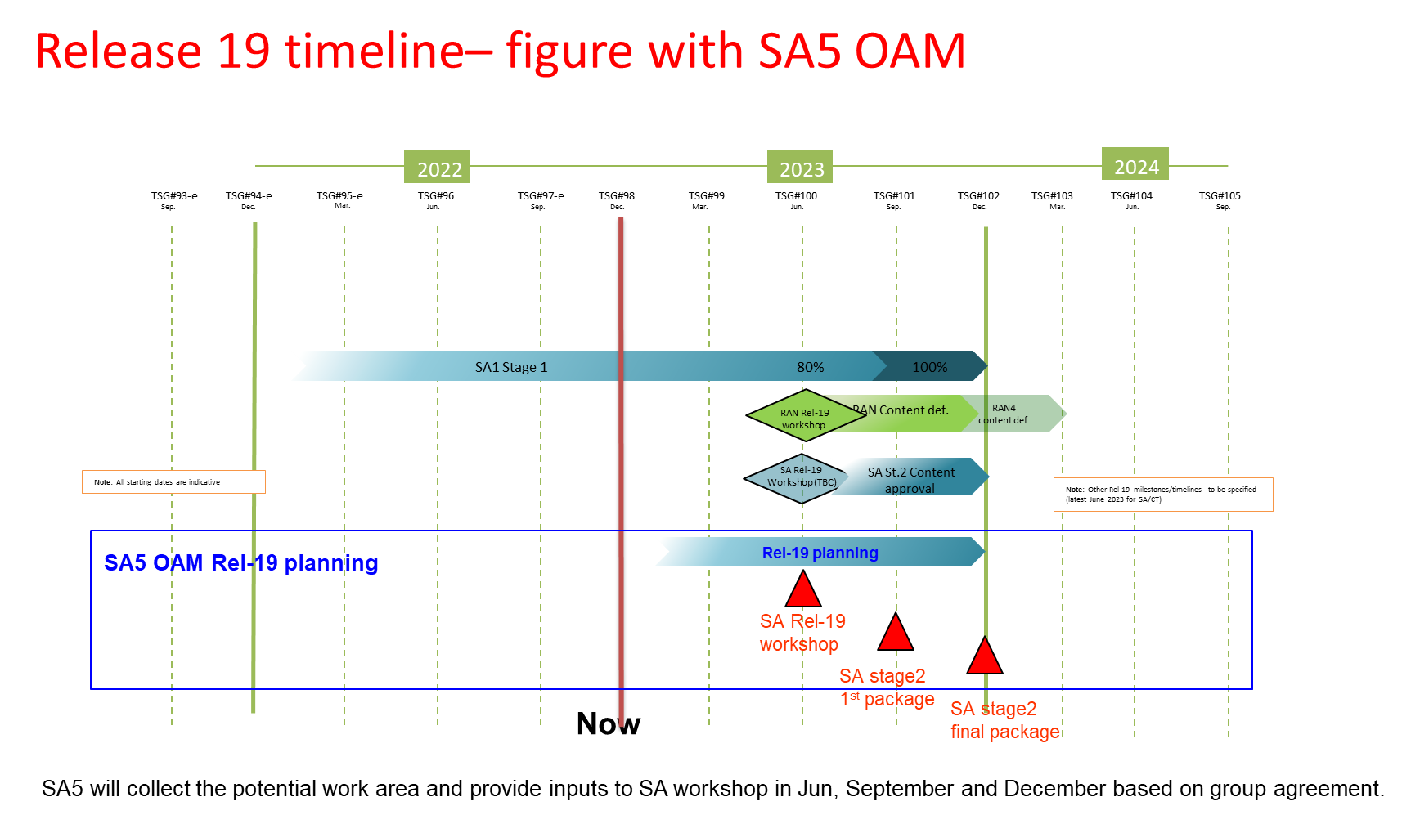
Note: Charging aspects to be covered in SA5 will be addressed during the Rel-19 packaging in the SA1/SA2 content approvals.
================Extract information from S5-232763=====================
====Information shared by SA5 Chair from SA#99 Rel-19 planning discussions (extract from the draft SA#99 report):================
SP-230344 (DISCUSSION) Time schedule for Release 19 (Source: Ericsson Limited)
Document for: Decision
Abstract:
The time schedule for Rel-19 is proposed for decision.
Plenary Discussion:
Release 19 timeline:
…
Release 19 planning:
The TSG SA Chair commented that the two step approach appeared to be a useful method of helping control the work load and progress of the Rel-19 work. Samsung commented that the future new SA WG2 Leadership will need to provide the estimates on TU budget and a maximum number of WIs to be handled. The SA WG2 Chair confirmed that this would need to be done in SA WG2. He agreed that the proposal in this document to take all WGs into account in the work planning and input on their capacity and WI load would be expected. The SA WG6 Chair suggested that some uniform input for this information would be needed and some guidance on how to collate this information would be welcome. The TSG SA Chair did not think rules should be introduced for this, but WGs are expected to raise any issues they foresee. Each WG may choose their own metrics to determine their budgets and work load and can choose the SA WG2 method if considered suitable. The SA WG2 Chair commented that the WGs should not be micro-managed, but the units can be made common, e.g. maximum number of WIs, Time Units per meeting, etc.
SA WG3 and SA WG4 Chairs indicated they could use the TU concept to some extent. The SA WG5 Chair indicated that it would be difficult to agree on the TUs per WI without having a similar prioritization exercise as is done for SA WG2. The SA WG2 Chair commented that the TU concept is not specific to SA WG2 and has been used by RAN WGs for some time. The calculation of TU budget is dependent on number of parallel sessions, number of meetings, additional ad-hoc meetings, etc. A template may be drafted to facilitate providing this information into the Rel-19 Workshop.
This was then noted.

================List of inputs which has been incorporated in this tdoc=====================
S5-233391rev4 DP for Rel-19 topic.docx (Samsung)
S5-233319 SA5 Collection of Rel-19 potential topics for SA workshop preparation_Intel_NEC.doc (Intel&NEC)

4 Detailed proposal
This document is used as a living document to trigger thinking about Rel-19 work area in SA5 and collect potential work area information. The listed potential work areas will be used as SA5 inputs for prepration of SA Rel-19 workshop planned in June, September and December 2023.

Potential work areas in SA5 to adress management and charging aspects in Rel-19:
- Intelligence and Automation
- AI/ML management phase 2
Potential scope includes:
(1) AI/ML management and operational capabilities to support additional 3GPP AI/ML functionalities, such as AI/ML over the air interface, and 5G system support for AI/ML-based Services;
(2) Energy efficiency aspects of AI/ML;
(3) Enhancements of AI/ML operational capabilities to support different types of learning, such as Federated Learning, Reinforcement Learning, and Generative Learning.
Potential collaboration groups and related topics:
Estimation of workload ??
2. Management Data Analytics (MDA) phase 3
Potential scope includes:
(1) Edge computing performance and energy efficiency analytics;
(2) Data correlation analytics;
(3) (e)MIMO performance analytics,
(4) ATSSS performance analytics,
(5) non-3GPP access performance analytics,
(6) Management and network operation conflict and coordination analytics.
Potential collaboration groups and related topics:
Estimation of workload ??
3. Enhanced Closed Control Loop Phase 2
Potential scope includes:
(1) enabling dynamic CCL composition: The CCL can be composed by the management system implicitly (without explicit request i.e createMOI for AssuranceClosedControlLoop) based on some network events (e.g performance degradation, threshold crossing, creating for slice Intent)
(2) managing multi-vendor CCL: The CCL can be disintegrated into four parts each coming from different vendor implying the standardized interaction between them. It is to be studied where the opportunities are for multi-vendor scenarios and why. This may also include determining which SA5 defined management service can support individual steps (Monitor, Analyze, Decide and Execute) of a CCL
(3) conflict resolution among CCL: Several CCL can target the same Managed Function as part of its Execute step. This conflict should be avoided and if happens should be dealt with appropriately and automatically.
(4) state management of a CCL
(5) CCL scope extensions: The Rel-16 COSLA and Rel-17 eCOSLA defined the CCL only used for communication service assurance scenarios (including network slice and network slice subnet). It is to be studied if the CCL scope can be extended to cover other scenarios.
Potential collaboration groups and related topics: ETSI ZSM
Estimation of workload ??

<To be added>
A. Topic name
Potential scope includes:
(1)…
(2)…
Potential collaboration groups and related topics:
Estimation of workload ??

- Management Architecture and Mechanisms
<To be added>
B. Topic name
Potential scope includes:
(1)…
(2)…
Potential collaboration groups and related topics:
Estimation of workload ??

- Support of New Services
<To be added>
C. Topic name
Potential scope includes:
(1)…
(2)…
Potential collaboration groups and related topics:
Estimation of workload ??

1. Study on management aspects of Digital Twin Network
Potential scope includes:
- Identify the potential scenarios, use cases and corresponding requirements for management and orchestration purposes based on digital twin of the 5G network. This also includes identifying the network domain, function or feature which needs to be managed using digital twin.
- Investigate the potential enhancements (e.g., new interfaces) and extensions (e.g., data collection type, frequency and methods) of the MnSs to support the management and orchestration based on digital twin of the identified 5G network.
Potential collaboration groups and related topics:
Estimation of workload ??

1. Study on new aspects of EE for 5G networks Phase 3
Potential scope includes:
- address new use cases and requirements from SA1 TR 22.882” Study on Energy Efficiency as service criteria”;
- Investigate the potential enhancements for energy saving:
- Support different energy states of network elements and network functions.
- Energy Utilization Monitoring
- Energy efficiency/usage information exposure
- Investigate the potential enhancements for energy consumption
- Support service level energy consumption measurement of network functions
- Investigate the potential impact on 3GPP management system for supporting carbon-aware communication service
Potential collaboration groups and related topics: SA1
Estimation of workload ??

- Charging aspects to be supported in following work areas
<list of SA1/SA2 work areas to be added>
D. Topic name
Potential scope includes:
(1)…
(2)…
Potential collaboration groups and related topics:
Estimation of workload ??

