**3GPP TSG SA WG5 Meeting #146-e S5-226520**

**November 14 – November 18, 2022, e-Meeting**

**Source: Samsung**

**Title: Discussion Paper on including EW bound interface into eECM.**

**Document for: Endorsement**

**Agenda Item: 6.2**

# 1 Decision/action requested

***The group is asked to discuss and approve the proposals.***

# 2 References

# 3 Discussion

1. As part of SP-211580 3GPP provided the following response to GSMA regarding E/WBI requirements. The SA replies (mainly on NBI, EWBI and SBI-CHF) were based on the inputs from SA5. The EWBI has a lot of similarities with NBI. However, it may require some additional work to support functionalities like Federation management and Availability Zone.

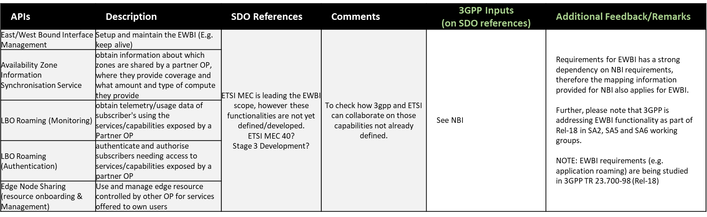

1. GSMA then further sent an LS (S5-225019) to SA5 with the EWBI API specification and asked SA5 to consider OPAG input as a baseline proposal for edge federation that should evolve towards a common industry reference. In Toulouse, we decided not to send reply to GSMA directly. Instead, we have sent our inputs to SA (as requested by SA6), in S5-226729, stating “SA5 is looking into solutions to support requirements on east/west bound interface including edge federation”.
2. The GSMA E/WBI APIs included the following functionalities relevant to SA5 and eECM
   1. Federation establishment and management between OPs (ECSP Management System): The federation is defined as relationship among member OPs who agrees to offer OP PRD defined services and capabilities to the application providers and end users of member OPs.
      1. **eECM Relevance: The edge services are provided by Edge Data Network by one ECSP. Federation may exists between two ECSP enabling access to edge services for one ECSP provided by the other ECSP. The federation relationship between ECSP need to be managed.**
   2. Availability zone information synchronization: As per GSMA PRD the edge services are provided per Availability Zone. In context of E/WBI the available Availability Zones need to be made available to other ECSP. The edge services are provided to other ECSP in the bundle of a particular Availability Zone.
      1. **eECM Relenavce: The concept of Availability Zone need to be addressed as part of eECM work item**
   3. Application Service APIs: There are basically the NBI APIs which are exposed on E/WBI towards other ECSP. This includes:
      1. Application Artefacts Management: Application artifact management APIs enables an OP to share application component descriptors information with partner OP. The application providers via NBI interface submits artifacts information and link artifacts with their edge applications. Leading OP based on application provider intent can share the artifacts with partner OP over E/WBI interface
         1. **eECM Relevance: TBD**
      2. Application Provider Resource Management: The REST APIs mentioned in this section provides the capabilities to reserve and manage compute resources of an application provider on a partner OP
         1. **eECM Relevance: The reservation functionality need to exposed to ECSP so that ASPs can reserve resource on other ECSP.**
      3. Application Onboarding Management: Application onboarding management APIs are used to share the application information on request from application providers to partner OP
         1. **eECM Relevance: TBD**
      4. Application Instance Lifecycle Management: The API mentioned in this section provides the capabilities for managing the edge applications instantiation and terminating the running instance, inquire the status of the application instance etc for applications with partner OPs
         1. **eECM Relevance: The EAS lifecycle management functionality need to ECSP so that ASPs can manage EAS on other ECSP.**
      5. Edge Node Sharing: Edge node sharing is the concept for two operators to share edge nodes(should be read as compute resources in partner OP availability zones) between their coverage area for example from a geographical point of view (south and north).
         1. **eECM Relevance: TBD**
3. Relevance with FS_NSCE: As part of FS_NSCE we are studying how to expose our management services (provisioning, PA, FS etc.) to external consumer including granular access authorization. **The management services (including both NBI and E/WBI related MnSes) related with edge computing, once defined as part of eECM, can also be exposed to other operators using the same mechanisms.** The E/WBI management functionality is missing that need to be defined anyway.
4. The objectives of eECM does not include EWBI

Based on the above it is evident that SA5 should look into the EWBI requirements/APIs.

# 4 Proposals

It is proposed to update the eECM WID to include E/WBI management.

|  |
| --- |
| **End of modified section** |