3GPP TSG-SA5 Meeting #146 S5-22xxxx
Nov 14 - 18, 2022

Source: Ericsson

Title: pCR Add Intent Reporting support to NRM

Document for: Approval

Agenda Item: 6.x.x.x

1 Decision/action requested
The group is asked to discuss and approve.

2 References
[1] 3GPP TS 28.312: “Intent driven management services for mobile networks (Release 17)”
v17.0.1
[2] 3GPP TS 28.912: “Study on enhanced intent driven management services for mobile networks (Release 18)” v0.3.0
[3] TM Forum IG1253A: "Intent Management API Profile v1.1.1"

3 Rationale
As indicated in 28.912 [2], “Issue #4.5 Intent Report” the current ability to report intent fulfilment status is not sufficient, and further support to support Intent Reporting is required.
For discussion, re: SA5 definition of “Intent Report”:
- TMF defines “Intent Reporting” requirements in [3], sec 3.1.2, as follows:
Intent reports are created and sent to the intent owner according to reporting criteria specified in reporting expectation by the intent owner. This means the intent owner can configure within the intent when and under which conditions is wants to be informed by the handler with an intent report. Typically reports are sent at major events in the intent life-cycle, such as acceptance of the intent or a modification, violation of the intent, success of fulfilling an intent, etc. Furthermore, the intent owner can configure reporting to send regular reports. This means reporting is a ‘push’ mechanism from the intent handler to the intent owner according to criteria set by the owner. As the intent reporting conditions are specified within the intent as additional expectation, the intent owner can change the reporting for the intent by updating it.
- Further TMF specification of the “intent reports” includes:
  - Intent Report Event definition, [3] sec 3.9 – notifications related to Intent object LCM (e.g. IntentReceived, IntentHandlingEnded, StateDegrades)
  - Requirements to Functions, [3] sec 4.1 – requirement to support “IntentReport” event
  - Intent Report definition, [3] sec 5.2 – indicates reporting begins once an intent is
sent to handler, and that there will be a sequence of reports per intent
  - Domain event definitions, [3] sec 6 – definitions for events in sec 3.9
- Some observations on the TMF definition of “Intent Reporting” vs. SA5 requirements
  - TMF focus is on Intent Owner receiving notifications for changes to Intent objects; in particular, Intent LCM related events are well defined.
    - A notifications approach seems sufficient to meet the TMF requirements. E.g. sending an “Intent Report Event” when intent fulfilment status changes, or Intent object LCM update occurs
  - SA5 proposes more detailed reporting of the fulfilment status, including associated resources and metrics for expectation targets at specified reporting intervals.
    - A notifications approach is sufficient to meet requirements similar to those in TMF. E.g. monitoring attribute changes in Intent MOIs for LCM, fulfilment status changes, etc.
    - Unclear if notifications are sufficient to support more detailed requirements proposed for SA5 intent reporting, e.g. metrics for current/predicted values for specific expectation targets
  - On assumption that SA5 requires detailed Intent reporting, this document attempts to define the requirements to support this, and proposes several solutions for how this could be achieved

Requirements defined in 28.912 [2] for monitoring of Intent fulfilment include:
REQ-Intent_Driven_MnS: The intent driven MnS should have capability enabling MnS consumer to request intent report information.
REQ-Intent_Driven_MnS: The intent driven MnS should have capability enabling MnS consumer to obtain intent report information with current performance value for corresponding expectation targets.
Also, 28.912 [2] sec 4.5.1 indicates that reporting needs may differ across MnS Consumers.
“Different MnS consumer may have different requirements for intent report (e.g. Some MnS consumer may want to have corresponding performance value information while others don't want, Different MnS consumer may want to calculate or monitor the performance value in different period).”

For discussion re: SA5 requirements :
- Does above mean requirements should be updated/added in Rel-18? E.g. to support differing report content, and differing reporting intervals? (if yes, see proposed REQs in 4.5.1 below)
- Should there be any limitations on how many “reports” can be defined per Intent?
- How configurable does the reporting internal need to be – per intent? per expectation target?
- Agreed that MnS Consumer needs to monitor the achieved values. Is some context information also needed in the report to interpret the values? E.g. is an achieved value always reported as an absolute value?
- Is there a requirement to report predicted values, including configurability on whether to include them in the reports? (if yes, see proposed REQ in 4.5.1 below)
- Assume access control is sufficient to control which MnS Consumers can monitor which Intents.

The NRM needed to support the Intent Reporting reqs specified in [2], sec 4.5.1 is not yet defined. A solution is briefly described in [2], sec 4.5.2.1 however it needs to be enhanced to fully define a solution.

4 Detailed proposal
This contribution proposes additions to the support Intent Reporting requirements defined in 28.912 [2], sec 4.5.1.
To address the requirements proposed in Rationale, the following updates are required, and proposed in this document:
- Enhancements to NRM to support Intent Report handling (report configuration, notification, reporting)
- Ability to allow MnS Consumer to monitor the status of a specific ExpectionObject, e.g. via configuring a specific ExpectationObject (by its id) to be included in an Intent Report
- Option to allow an intent report to contain the predicted value for performance indicated by corresponding expectation targets

1st Change

4.5 Issue#4.5: Intent Report

4.5.1 Description
In TS 28.312 [2], the Fulfilment information (including the intentFulfilmentinfo, expectationfulfilmentInfo and targetfulfilmentInfo) are defined for the MnS consumer obtain the intent fulfilment information. However, the intent report haven't been defined. The intent report can contain the current and optional predicted value for performance indicated by corresponding expectation targets (e.g. WeakRSRPRatio for the weakRSRPRatioTarget, Average UL RAN UE Throughput for aveULRANUEThptTarget), which can be used by MnS consumer to validate whether the intent is really fulfilled and to evaluate whether the intent (especially for expectation targets) needs to be updated if needed (improve the target value when corresponding target is fulfilled or reduce the target value when corresponding target is not fulfilled or not fulfilled with the reason of target confliction).
Different MnS consumer may have different requirements for intent report (e.g. Some MnS consumer may want to have corresponding performance value information while others don't want, Different MnS consumer may want to calculate or monitor the performance value in different period).
REQ-Intent_Driven_MnS: The intent driven MnS should have capability enabling MnS consumer to request specific intent report information.
REQ-Intent_Driven_MnS: The intent driven MnS should have capability enabling MnS consumer to obtain intent report information with current performance value for corresponding expectation targets.
REQ-Intent_Driven_MnS: The intent driven MnS should have capability enabling MnS consumer to specify the content of the report.
REQ-Intent_Driven_MnS: The intent driven MnS should have capability enabling MnS consumer to configure the frequency of the intent reporting.
REQ-Intent_Driven_MnS: The intent driven MnS should allow multiple reports to be configured for the same intent.
REQ-Intent_Driven_MnS: The intent driven MnS should allow reports to contain current values, and optionally predicted values, for specified expectation targets.

4.5.2 Potential solutions

4.5.2.1 Potential solution #1: Intent Report (NRM), configuration included in Intent
This solution extends the existing model in 28.312 [2] by adding new attributes to the Intent IOC to indicate what is to be observed, and a new IntentReport IOC to report the current values.
The following specific changes would be made:
- Extend the IntentExpectation <<dataType>> with the following attribute:
- "reportIndicator", represents MnS consumer's requirements for intent Report, which is a Boolean value. If the value is TRUE, MnS producer needs to create an instance of IntentReport IOC to capture the current performance values for corresponding Expectation Targets.
- "observationTime", represents MnS consumer's requirements for the observation period of performance value for corresponding Expectation Targets. The performance value for corresponding Expectation Targets will be observed from the start of each observation period, then at the end of each observation period, the value will be derived and configured
- Introduce the IntentReport <<IOC>>, represents the performance values for the Expectation Targets in the associated Intent. Then The MnS consumer can use the "getMOIAttributeValue" operation to query the IntentReport <<IOC>> to obtain the intent report information. The IntentReport <<IOC>> include the following attributes:
- "DN of the Intent <<IOC>>", indicates the associated instance of Intent <<IOC>>
- "TargetMetricInfoList", which is the list of [targetMetricName, currentValue]. The targetMetricName is same as ExpectationTarget Name in the associated Intent <<IOC>.
This could result in NRM for Intent Reporting as follows:
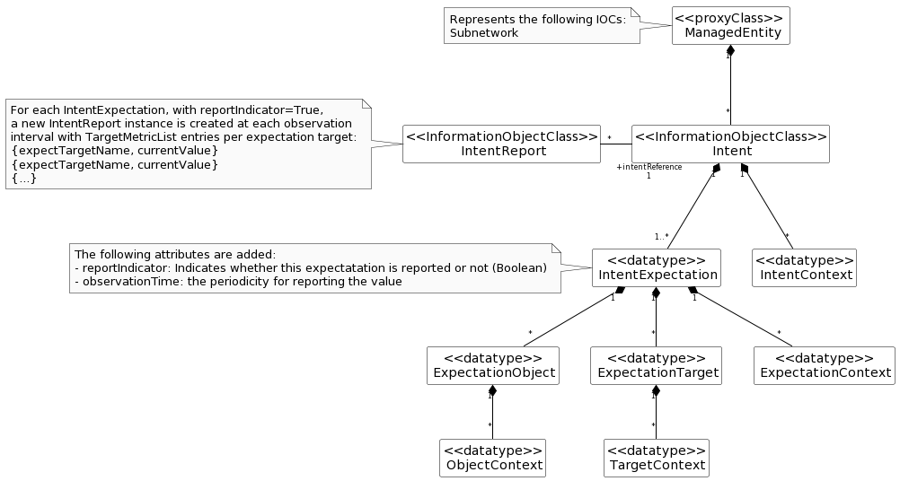

The above solution would require, per Intent, that:
  - MnS Consumer configures each IntentExpectation to be reported with ‘reportIndicator=True’ and ‘observationTime=N’
  - For each period N, MnS Producer reports the current value
  - For every period N, MnS Producer creates a new instance of IntentReport IOC, in which it reports the current value of the intent expectation as follows:
    - Each intent expectation appears in the report as: [targetMetricName, currentValue]
  - MnS Consumer receives notifications each time a new IntentReport IOC is created

Observations on this approach:
  - The configuration of the report output is contained in the Intent itself, and is a Boolean. This effectively limits the content of the report to a single report per Intent.
  - Each IntentExpectation is reported separately. The MnS Consumer may need to consolidate the output since the reporting may be configured at different observation intervals
    - Noting above, perhaps the ‘observationTime’ should be configured for the entire Intent and not individual expectation targets?

4.5.2.2 Potential solution #2: Attribute monitoring, configured in Intent
This solution extends the existing model in 28.312 [2] by adding new attributes to the Intent IOC to indicate what is to be observed. There is no separate IntentReport IOC required to report the achieved values.
The following specific changes could be made:
- Extend the IntentExpectation <<dataType>> with the following attribute:
- "observationTime", represents MnS consumer's requirements for the observation period of performance value for corresponding Expectation Targets. The performance value for corresponding Expectation Targets will be observed from the start of each observation period, then at the end of each observation period, the value will be derived and configured
- Introduce the "achieveValue" attribute in the ExpectationTarget to represent the performance value for the ExpectationTarget. Then The MnS consumer can use the "getMOIAttributeValue" operation to query the Intent <<IOC>> to obtain the achieveValue for a given ExpectationTarget.
This could result in NRM for Intent Reporting as follows:

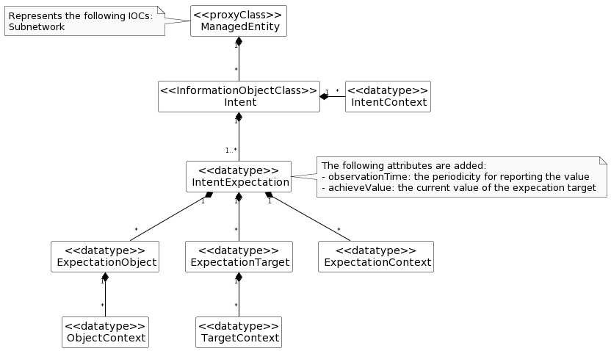

The above solution would require, per Intent, that:
  - MnS Consumer configures each IntentExpectation to be reported with ‘observationTime=N’
  - For each period N, MnS Producer reports the achieved value*
  - For every period N, MnS Producer updates the achievedValue of each expectation target
  - MnS Consumer queries achievedValue of interested targets
* Editor’s Note: would ‘achievedValue’ be current value (per Solution #1, as available in NRM at time of reporting), or some other computed value for the interval?
Observations on this approach:
  - Updates are provided via attributes defined in Intent IOC, and existing subscription mechanism can be used to monitor updates. E.g. Consumer subscribes to ‘achievedValue’.
  - All content to be reported needs to be configured as an attribute in Intent IOC. Alternatively new notifications could be defined to include such content.
  - Allows mix-and-match of observability times
  - Since the observationTime of each IntentExpectation is configured separately, MnS Consumer would need to be aware of how relatively up-to-date each value isg.
  - No need for separate IntentReport IOC.
    - The configuration of the report output is contained in the Intent itself.
    - Should avoid use of the term “report” which can be misleading, as there is no ‘report’ object (e.g. NRM, file, stream).

4.5.2.x Potential solution #x: IntentReport (NRM), configuration in Ctrl IOC
This solution would not modify the existing model in 28.312 [2].
A new IntentReport IOC would contain the monitoring data, in NRM.
A separate IntentReportCtrl IOC is proposed. The IntentReport IOC is used to contain the output of the expectation targets in NRM, as well as other status information currently contained in Intent.

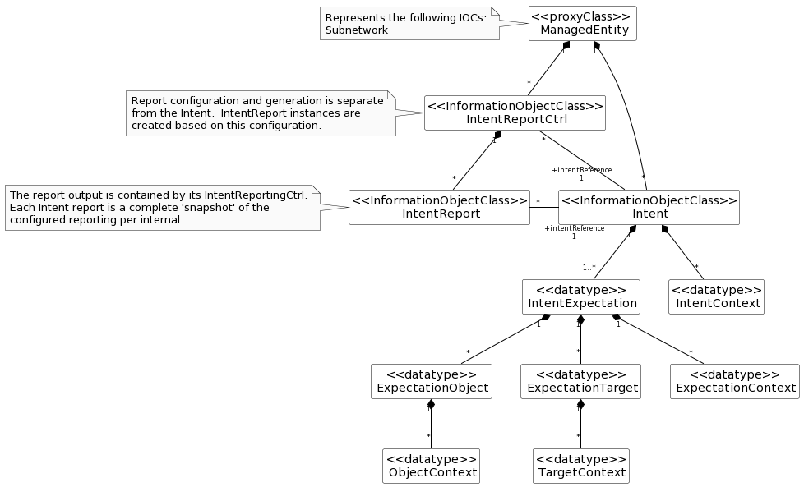

The above solution would require, per Intent, that:
  - MnS Consumer configures each IntentReportCtrl with ‘reportingPeriod=N’, and reference ‘intentReference’ to the Intent instance for which the report is to be produced
  - MnS Consumer configures each IntentReportCtrl with the content to be reported (e.g. selects the specific expectations, contexts, and/or fulfilment info to monitor)
  - MnS Consumer configures each IntentReportCtrl with frequency at which to create associated reports
  - For each period N, MnS Producer generates an IntentReport instance
  - For every period N, MnS Producer ‘snapshots’ the intent values, i.e. current values for the included report content
  - MnS Consumer receives notification of the new IntentReport instance

Observations on this approach:
  - The configuration of the report output is external to the Intent itself, and supports ability to configure different reports per Intent.
  - The content (i.e. attributes) and reporting intervals can differ for each report generated.
  - Each report is a ‘snapshot’ of the Intent at time of generation, available in NRM.
  - MnS Consumer does not need to handle different ‘observationIntervals’ per attribute within same Intent.

4.5.2.x.1 IntentReportCtrl <<IOC>>
4.5.2.x.1.1 Definition
This IOC represents a request to produce Intent Reports which provide intent driven management updates from MnS producer.
The IntentReportCtrl contains configuration used by MnS Producer to determine the content and frequency at which reports should be provided for an Intent.
MnS Consumer creates an instance of IntentReportCtrl instance with a reference to the Intent instance for which the Intent reports will be produced. Multiple IntentReportCtrl instances can reference the same Intent instance, meaning different reports can be produced for the same Intent.
The MnS Consumer configures the report output via intentExpectation, intentContext, and intentFulfilment attributes. These parameters are writable and can be configured to restrict (i.e. filter) the report results.
The content of each Intent report produced is based on its containing IntentReportCtrl configuration at the time it is produced. Only content configured in the reporting control will be included in its intent reports.
The userLabel contains the same value as userLabel in the associated Intent.
The IntentReportCtrl configures the report output, and determines when new IntentReport instances are created based.
The reportPeriod value indicates the frequency at which report are created by MnS Producer. A value of “0” indicates the MnS Producer will determine the periodicity.
The IntentReportCtrl IOC includes the attribute objectClass and objectInstance from the TOP IOC. The value of attribute objectClass is "IntentReport" and the value of attribute objectInstance is the DN of the instance of the IntentReport IOC.

4.5.2.x.1.2 Attributes
The Intent IOC includes attributes inherited from TOP IOC (defined in 3GPP TS 28.622 [6]) and the following attributes.
Table 6.2.1.2.1.2-1
Attribute Name | Support Qualifier | isReadable | isWritable | isInvariant | isNotifyable
intentReference | M | T | T | F | F
userLabel | M | T | T | F | F
reportingPeriod | M | T | T | F | F
intentExpectation | O | T | T | F | F
intentContext | O | T | T | F | F
intentFulfilmentInfo | O | T | T | F | F

4.5.2.x.1.3 Attribute constraints
None.

4.5.2.x.2 IntentReport <<IOC>>
4.5.2.x.2.1 Definition
This IOC represents an Intent Report to provide Intent status details from MnS producer.
The userLabel contains the same value as userLabel in the associated Intent.
The reportTimestamp contains the time at which the report was last updated. No further updates to the contents of a report are made once set.
The xxxInfo parameters are not writable in the report output. The content of the report is based on the configuration of its containing IntentReportCtrl. Each xxxInfo parameter contains information about the status of the associated xxx parameter in the Intent.
4.5.2.x.2.2 Attributes
The Intent IOC includes attributes inherited from TOP IOC (defined in 3GPP TS 28.622 [6]) and the following attributes.
Table 6.2.1.2.1.2-1
Attribute Name | Support Qualifier | isReadable | isWritable | isInvariant | isNotifyable
intentReference | M | T | F | F | F
userLabel | M | T | F | F | F
reportTimestamp | M | T | F | F | F
intentExpectationInfo | O | T | F | F | F

4.5.2.x.2.3 Attribute constraints
None.

4.5.2.y Potential solution #y: Intent Report (file/stream), configuration via jobs
4.5.2.y.1 Description
This solution does not modify the existing model or Intent IOC defined in 28.312 [2].
Output would be file and/or stream, with format based on existing perf. assurance formats.
A new IntentReportJob IOC is proposed to configure the output.

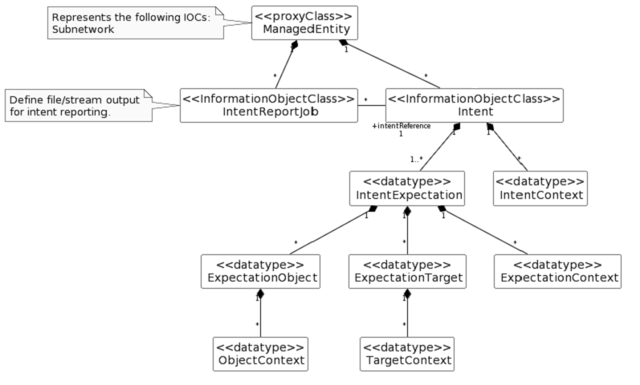

The above solution would require, per Intent, that:
  - MnS Consumer configures each IntentReportJob control for file or streaming output, and a reference ‘intentReference’ to the Intent instance for which the report is to be producer
  - For every period N, MnS Producer outputs the report content as configured in the job:
    - for file based, MnS Consumer receives notification of the new Intent report file
    - for stream, MnS Consumer receives streaming content

Observations on this approach:
  - This approach is consistent with other performance related reporting
  - Each report should be complete and self-describing, and suitable for offline processing and/or archival
  - A schema will need to be agreed, perhaps based on the existing PM/KPI formats for file and streaming

4.5.2.y.1 IntentReportJob <<IOC>>
4.5.2.y.2.1 Definition
This IOC represents a request to create a Job to perform intent reporting.
MnS Consumer creates an instance of IntentReportJob with a reference to the Intent instance for which the Intent reports will be produced. Multiple IntentReportJob instances can reference the same Intent instance, meaning different reports can be produced for the same Intent.
The content of each Intent report produced is based on values in the Intent at the time of reporting.
The userLabel contains the same value as userLabel in the associated Intent.
The attribute reportingCtrl specifies the method and associated control parameters for reporting the produced measurements to MnS consumers. Three methods are available: file-based reporting with selection of the file location by the MnS producer, file-based reporting with selection of the file location by the MnS consumer, and stream-based reporting.
Editor’s Note: the schema for the reporting format (file and stream) will need to be defined. What content to include in the output could be supported by options similar to those in other solutions, i.e. explicitly configured in the Intent itself (e.g. Solution 2, ‘reportIndicator’) or configured separately in the IntentReportJob (e.g. Solution X, IntentReportCtrl attributes).
4.5.2.y.2.2 Attributes
The IntentReportJob IOC includes attributes inherited from Top IOC (defined in clause 4.3.29) and the following attributes:
Attribute name | S | isReadable | isWritable | isInvariant | isNotifyable
administrativeState | M | T | T | F | T
operationalState | M | T | F | F | T
jobId | M | T | T | T | T
granularityPeriod | M | T | T | F | T
intentReference | M | T | T | F | F
userLabel | M | T | T | F | F
reportingPeriod | M | T | T | F | F
reportingCtrl | M | T | T | F | T
_linkToFiles | CO | T | F | T | F

Table zzz

4.5.2.y.2.3 Attribute constraints

4.5.2.y Potential solution #z: Notifications, configuration in Intent
4.5.2.z.1 Description
This solution would modify the existing model in 28.312 [2] to add configuration of notifications of achieved values.
The values to be included in such notifications are configured directly in the Intent.
There is no separate “report” object, and no need for IntentReport IOC.
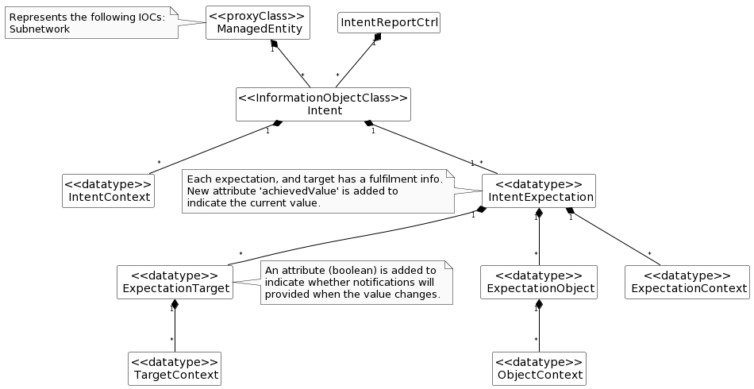

  - MnS Consumer configures each Intent with ‘reportIndicator=True’ for values to be monitored.
  - MnS Consumer subscribes to the ‘achievedValues’ in IntentExpection.
  - MnS Consumer receives notifications each time a new value is available.

Observations on this approach:
  - The configuration of the notifications is contained in the Intent itself, and is a Boolean. This effectively limits the content of the report to a single report per Intent.
  - This approach is different than subscribing to attribute notifications.
For discussion: is this specific method to define notification content required? Isn’t attribute monitoring and/or subscribing to generic attribute updates sufficient?
  - The notifications required, and how they represent values in NRM and/or derived values not in the NRM, needs to be defined.
  - There would be no “report’ objects with this approach. No new IntentReport IOC needed.

The IntentExpectation would require additional attributes to configure which updates to include in the notifications.
Table 6.2.1.3.1.2-1
Attribute Name | Support Qualifier | isReadable | isWritable | isInvariant | isNotifyable
notifyAchievement | O | T | F | F | T

The ExpectationTarget would require additional attributes for reporting the values, and for configuring notifications.
Table zzz
Attribute Name |  | Support Qualifier |  | isReadable |  | isWritable |  | isInvariant |  | isNotifyable
achievedValue |  | O |  | T |  | F |  | F |  | T
notifyAchievement | O |  | T |  | T |  | F |  | T

End of changes

