3GPP TSG-SA5 Meeting #140e S5-216xxx

e-meeting, 15 – 24 Nov 2021

Source: Ericsson, Nokia, Nokia Shanghai Bell

Title: TD enhance management service to support authentication

Document for: Discussion and Endorsement
Agenda Item: 6.x.x

1 Decision/action requested
Please discuss and endorse

2 References
[1] 3GPP TR 28.817: "Management and orchestration; Study on access control for management service".
[2] 3GPP TS 28.622: "Telecommunication management; Generic Network Resource Model (NRM) Integration Reference Point (IRP); Information Service (IS)".
[3] 3GPP TS 28.623: "Telecommunication management; Generic Network Resource Model (NRM) Integration Reference Point (IRP); Solution Set (SS) definitions".
[4] 3GPP TS 28.532: "Management and orchestration; Generic management services".

3 Rationale
According to conclusion in TR 28.817, the service based management architecture, Network Resource Model and Generic Management Service should be updated to support authentication, authorization and audit capabilities.
Solution to enhance Service Based Management Architecture (SBMA) to support authentication capability was proposed in TR 28.817 as following:
- Authentication service producer provides identity management capabilities. Identity management of MnS consumers and producers includes creating, reading, updating and deleting identities.
- Authentication service producer provides credential management capabilities. Credential management of MnS consumers includes creating, reading, updating and deleting credentials.
- Authentication service producer provides authentication policy management capabilities. Authentication policy management of MnS consumers and producers includes creating, reading, updating and deleting authentication policies.
- Authentication service producer provides capabilities for authentication of MnS consumer. Authentication service producer issues an assertion to the MnS consumer after successfully authenticated the MnS consumer.
- MnS producer validates the assertion issued by trusted authentication service producer to authenticate a MnS consumer.
What is the exact change in stage 2 and stage 3 will be decided in normative phase.
This discussion paper proposes solutions to enhance generic NRM and management service to support two authentication architectures to be supported for MnS Consumer authentication:
Alt 1: Explicit Authentication: Mns Consumer interacts directly with authentication service producer, to acquire authentication assertion or access token to interact with MnS Producer.
Alt 2: Implicit Authentication: MnS Consumer interacts indirectly with authentication via MnS Producer, to establish a secure session.

4 Detailed proposal

4.1 Add following authentication procedure of 3GPP management system in an Annex of 28.533, 28.532 or 28.622:

Alt1: Explicit Authentication

@startuml
skinparam shadowing false
skinparam monochrome true
hide footbox

participant "authentication (administrative)\nservice consumer" as ASC
participant "management service\nconsumer" as MnSC
participant "authentication service\nproducer" as ASP
participant "management service\nproducer" as MnSP

== precondition ==
ASC -> ASP: provision authenticaiton policy (policy)
ASC -> ASP: provision group of MnS producer/consumer (group,policies)
ASC -> ASP: assoicate group to authenticaiton policy (group,policies)
ASP -> ASP: update data store for group and policy
ASC -> ASP: provision identity of producer (identity, groups)
ASC -> ASP: assoicate identity to group of producer (identity, groups)
ASP -> ASP: update data store for group and policy
ASC -> ASP: provision identity of consumer (identity, groups)
ASC -> ASP: assoicate identity to group of consumer (identity, groups)
ASP -> ASP: update data store for identity and groups
group centralized authentication through MnS producer
ASC -> MnSP: preconfigure management service producers to communicate with authentication service producer
end

== during runtime ==
autonumber "100"
alt authenticate to authentication service producer
MnSC -> ASP: authentication request (identity,credential)
ASP -> ASP: validate credential and information related to the identity
ASP -> ASP: record authenticaiton state
alt successful
alt support assertion
ASP -> MnSC: authentication successful (assertion)
else not support assertion
ASP -> MnSC: authentication successful
end
else failure
ASP -> MnSC: authentication failure
end
autonumber "200"
else authenticate to management service producer
MnSC -> MnSP: client request (identity,credential)
alt centralized authentication based on preconfigured policy
alt authentication server is available
MnSP <-> ASP: validate with authentication service producer
else authentication server is not available
MNSP -> MnSP: fall back to local autthentication
end
else local authentication based on preconfigured policy
MnSP -> MnSP: validate locally
end
MnSP -> MnSP: record authenticaiton state
alt successful
MnSP -> MnSC: authentication successful
else failure
MnSP -> MnSC: authentication failure
end
end

@enduml

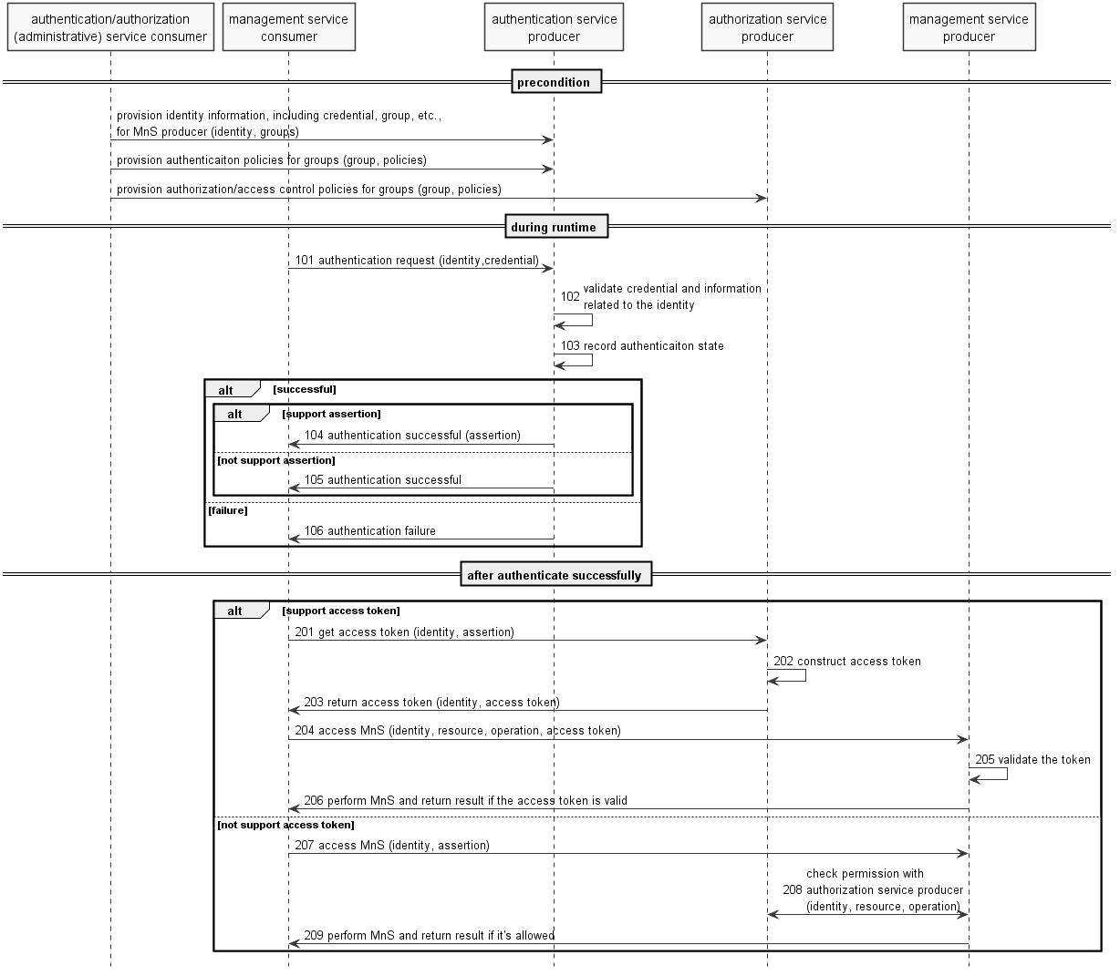

Note: the authentication (administrative) service consumer could be a portal or other operator tool acting on behalf of an administrator of operator.
Assumption: mutual authentication between authentication (administrative) service consumer and authentication/management service producer, as well as between management service producer and authentication service producer, has been done, according to operator's implementation.
Precondition:

- Authentication service producer contains authentication information required to perform authentication such as identities (including credential of the identity), and/or groups, and/or authentication policies. The specific information required will depend on the implementation.

Note: potential identity, group and policy update in management service producer to support local authentication is implementation dependent. Identity, group and policy management in authentication service producer should support authentication requests from either MnS consumer or MnS producer.

Procedure:
Assumption: The MnS consumer successfully authenticated (or validated the authenticity of) authentication/management service producer.

101. When authentication request is received,authentication service producer gets the identifier and credential of the MnS consumer, along with other context information (e.g. address of the client) from the request.
Note 1: challenges may be exchanged between management service consumer and authentication service producer for some authentication protocols.

102. Based on identifier in the request, authentication service producer gets identity information, e.g. status of the identity, associated group(s) of the identity, credential of the identity, etc., from data store. Then the producer authenticates the MnS consumer by validating the identity information and other context (e.g. time, location of the consumer) according to authentication policies (e.g. authentication factor, protocol, supported time, location, status of the consumer, etc. ) associated to the group(s) the MnS consumer belongs to.
103. The authentication service producer updates the authentication state of the MnS consumer in the data store after authenticated the MnS consumer.
Note 2: If authenticate successfully and authentication assertion is supported by the protocol, the authentication service producer constructs authentication assertion and may update the assertion of the MnS consumer in the data store.

104. If authenticate successfully and authentication assertion is supported by the protocol, the authentication service producer sends successful response with an authentication assertion to the consumer.
105. If authenticate successfully and authentication assertion is not supported by the protocol, the authentication service producer sends successful response without authentication assertion to the consumer.
106. If fail for authentication, the authentication service producer sends failure response to the consumer.
After the MnS consumer is authenticated:
If access token is supported by the MnS producer and consumer:
201. The MnS consumer gets access token from authorization service producer
202. The authorization service producer validates the assertion and construct access token
203. The authorization service producer returns access token to the consumer
204. The MnS consumer accesses MnS with the access token
205. The MnS producer validates the token
206. The MnS producer performs the operation and returns result to the consumer if the token is valid
If access token is supported by the MnS producer and consumer:
207. The MnS consumer accesses MnS from MnS producer
208. The MnS producer validate the authenticaiton assertion and check permission of the MnS consumer with authorization service producer
Note: The MnS producer may authorize the MnS request of MnS consumer according to local policies.
209. The MnS producer performs the operation and returns result to the consumer if the MnS request is allowed according to permissions
endalt support access token
MnSC -> ARSP: get access token (identity, assertion)
ARSP -> ARSP: construct access token
ARSP -> MnSC: return access token (identity, access token)
MnSC -> MnSP: access MnS (identity, resource, operation, access token)
MnSP -> MnSP: validate the token
MnSP -> MnSC: perform MnS and return result if the access token is valid
else not support access token
MnSC -> MnSP: access MnS (identity, assertion)
MnSP <-> ARSP: check permission with\nauthorization service producer\n(identity, resource, operation)
MnSP -> MnSC: perform MnS and return result if it's allowed
end

Alt2: Implicit Authentication

@startuml
skinparam shadowing false
skinparam monochrome true
hide footbox

participant "Administrator" as ADMIN
participant "Management Service\nConsumer" as MnSC
participant "Management Service\nProducer" as MnSP
participant "Authentication Service\nProducer" as ASP

== Pre-condition ==
ADMIN -> ASP: Provision authentication credentials
ADMIN -> ASP: Provision per MnS Consumer credentials \n(i.e. group associations)
ADMIN -> MnSP: Configure Authentication Service Provider
ADMIN -> MnSP: Configure local access credentials
ADMIN -> MnSP: Configure access control policies

autonumber "100"
== session establishment ==
MnSC <-> MnSP: Initiate management session (exchange credentials)
MnSP -> ASP: Verify the identity, and \nreceive access control information \n(group of the identity)
MnSP -> MnSP: If ASP unavailable, \nfallback to local authentication
alt Session
MnSP -> MnSC: Success response. Session is established between MnS Consumer and MnS Producer
MnSP -> MnSC: Failure. Session is not established.

== session duration ==
MnSC <-> MnSP: For each request
MnSP -> MnSP: Enforce access control using local policies \napplicable for the MnS Consumer

== session termination ==
MnSC <-> MnSP: Session close
@enduml

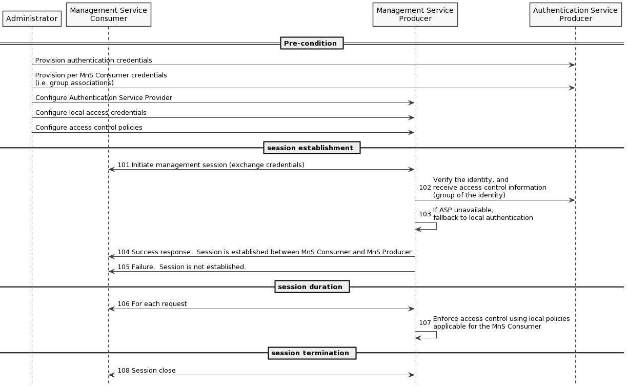

Assumption: A centralized authentication service producer, e.g. LDAP server, is deployed in operator’s network and will be used by MnS Producer to perform authentication. MnS Consumer does not interact directly with authenication service producer.
Precondition:
- Authentication service producer contains authentication information required for MnS Producer to perform authentication such as MnS Consumer identities (including credentials) and/or groups. The specific information required will depend on the implementation.
- MnS Producer has been configured to use the centralized authentication service producer.
- MnS Producer optionally has support for local authentication, i.e. in event centralized authentication service is unavailable.
- MnS Producer has been configured with access rules, used for local enforcement based on MnS Consumer access privileges.

Procedure:
Session Initiation:
101. MnS Consumer initiates a management session towards MnS Producer. As part of session establishment credentials are exchanged.
102. Based on credentials in the request, MnS Producer accesses Authentiation Service Producer to verify the identity, and information required to perform access control including the associated group(s) of the identity.
103. If Authentication Service Producer is unavailable, MnS Producer may opt to perform local authentication.
104. If authentication is successful, MnS Producer sends success response and an authentication context is established between MnS Consumer and MnS Producer.
105. If authentication fails, MnS Producer sends failure response to MnS Consumer.
106/7. For each MnS Consumer request, MnS Producer enforces access control using local policies applicable for the current authentication context.
108. Upon session termination the authentication context is also terminated.

Add authentication related NRM fragments in generic NRM.
Fragments need to be defined to support the alternatives proposed in this paper, with goal to align across solutions where possible.
Fragments identified to date:
- Authentication/authorization Service Provider (e.g. address of authentication service for centralized deployments)
  - Same information, only difference is where it is used:
    - Alt1: Consumer who uses this info to talk to ASP
    - Alt2: Producer who uses this info to talk to ASP
- Identity information of MnS consumer, e.g. identifier, credentials, group, etc.
- Access Control policies (i.e. policies to define access to be enforced for MnS Consumer access)
  - Alt1/Alt2: MnS Producer needs these policies. To support consistent AC across interfaces, the contents/requirements on the contents and MnS Producer handling should be aligned accordingly:
  - Considering:
    - NETCONF case: NACM embeds access control data directly in the datastore
    - OpenAPI case: Needs a mapping between the NRM (ops/model) to the interface in the token
  - Propose that although the policies will be implementation specific, there is common stage2 rules/reqs on how to use them within MnS Producer to perform access control:
      - REQ_1: Access Control is provided at IOC level (e.g. CRUD per MOI; comp B)
e.g. read, update or delete a MOI
      - REQ_2: Access Control is provided at attribute level (e.g. CRUD per attribute comp B)
e.g. read or update attribute of MOI
      - REQ_3: Notifications (comp C): Do you need R access to receive notifs? Of the NtfSubscriptionCtrl only, or the notification object?
          - PM, Alarm, CM: this could be very complicated
          - Enforcement is in the NtFSubscriptionControl IOC, not in the underlying/referenced object
          - Granularity is per notif type. E.g Consumer can create subscription for notif type A, but not type B.
      - REQ_4: Containment rules agreed, to enforce consistency across
e.g. read MIB tree (naming containment tree) of a MOI, create/delete child MOI (contained MOI)
        - Inherited permissions with ability to override should suffice. No special reqs for inheriting permissions are identified.
      - REQ_5: Access Control is provided at operation level (comp A)
        - Needs discussion: Are the CRUD privileges sufficient, or do we also need per operation. E.g. slice IOC access implies which operations are allowed based on the instance CRUD access (C=allocate; U=reallocate)
- Authentication context (i.e. the session or token based context for the MnS Consumer and MnS Producer)
  - Alt1/Alt2: Regardless of Alt1 or Alt2 a common "authentication context" will be defined

4.3 Add authentication related operation in 28.532.

Please endorse proposal 4.1, 4.2 and 4.3

