**3GPP TSG-SA5 Meeting #139-e *S5-21XXX***

**XXXXX**

**Source: Huawei**

**Title:** Discussion on the skeleton of TS 28.104

**Document for: Approval**

**Agenda Item: 6.4.18**

# 1 Decision/action requested

***In this box give a very clear / short /concise statement of what is wanted.***

# 2 References

1. S5-214143r1 pCR Add structure for TS 28.104
2. S5-214284 pCR Add structure for TS 28.104

# 3 Rationale

3GPP SA5# 138e meeting discusses the skeleton of TS 28.104 which still have divergence between the contribution S5-214143r1 and S5-214284. This contribution proposes comparing the two contributions clause by clause.

The structure of section 7 of S5-214284 and section 7 of S5-214143r1 is given below. This section aims to describe the use cases and requirements.

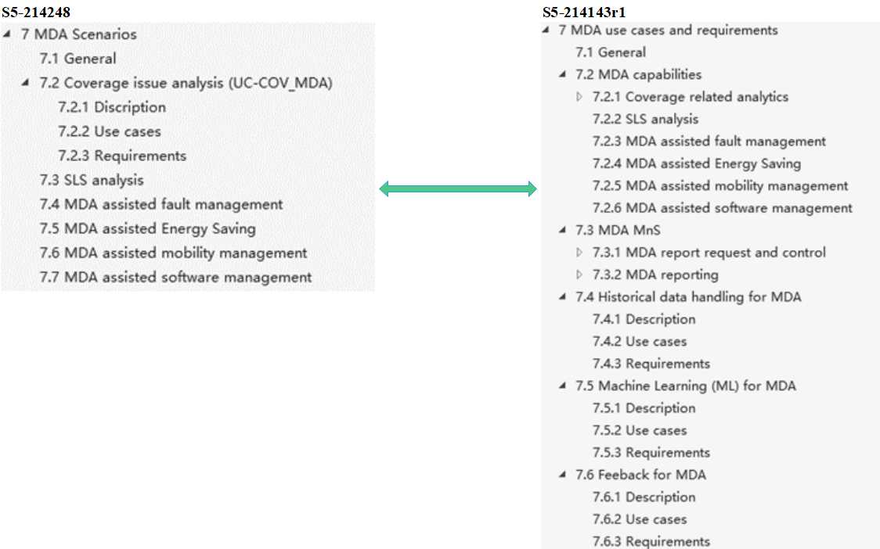

It seems a little confused for distinguish of the MDA capabilities and MDA MnS in S5-214143r1. In our understanding, all use cases defined in SA5 are used to derive the requirements for MnS (including component type A (i.e. operations/notification), B (NRM), C (performance/alarm information)), then the concrete MnS components can be defined for MDA MnS based on corresponding requirements. Therefore, we think that clause 7.3 is more appropriate to call “generic MDA”, and clause 7.4, 7.5, and 7.6 can be merged into clause 7.3.

Therefore, we propose that section 7 define three clause include “7.1 General”, “7.2 MDA capabilities” and “7.3 Generic MDA”, where the each use case is defined in clause 7.2, MDA report request control/MDA reporting/Historical data handling for MDA/Machine Learning(ML) for MDA/Feedback for MDA is defined in clause 7.3.

1. **It is propose that section 7 define three clause include “7.1 General”, “7.2 MDA capabilities” and “7.3 Generic MDA”, where the each use case is defined in clause 7.2, MDA report request control/MDA reporting/Historical data handling for MDA/Machine Learning(ML) for MDA/Feedback for MDA is defined in clause 7.3.**

The structure of section 8 of S5-214284 and section 8/9/10 of S5-214143r1 is given below. This section aims to define the NRM model and data definitions of each use cases.

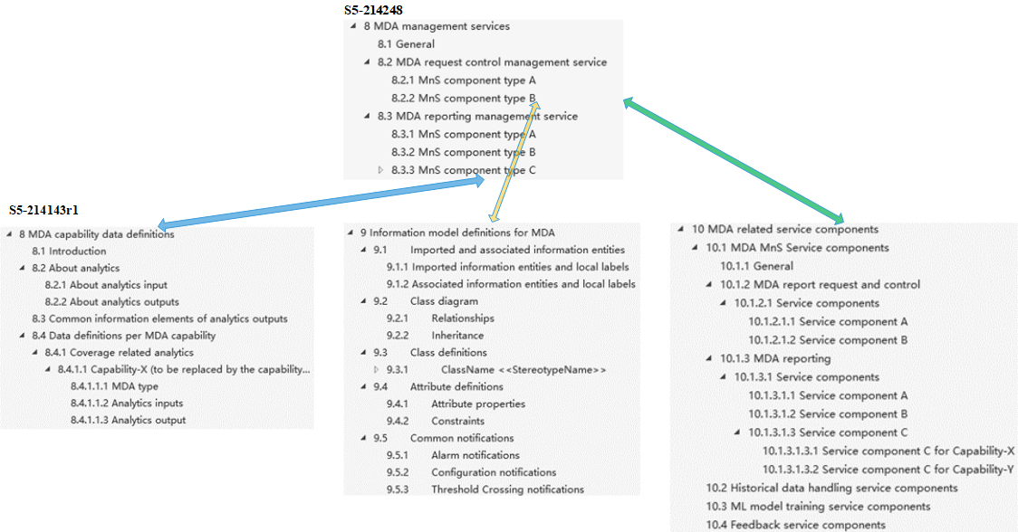

Compare the structure of the two contributions, In S5-214284, the NRM model and data definitions are directly defined in component B of MDA request control management service and component C of MDA reporting management service. However, in S5-214143r1, the NRM model and the data definitions are defined separately in two clause. The data definitions are defined in clause 8, the NRM model is defined in clause 9, and clause 10 merely references section 8 and section 9. In this way, it will be very difficult for an external reader to understand how MDA will be used to deliver any useful capabilities. In addition, since NRM model of MDA defined in TS 28.104 could not be reused by other TSs for other MnS currently, it makes no sense to define it independently.

Therefore, we propose to use structure of S5-214284.

1. **It is propose that the NRM model and data definitions should directly defined in component B of MDA request control management service and component C of MDA reporting management service for better readability.**

The other difference of the two structures in this section is the definition of input data. Section 8 in S5-214143r1 defines input data for each use case. We believe that standardizing input data will restricts the analysis function of the MDA. Therefore, it is unnecessary to standardize input data. Input data can be added as an example to the annex. MDA should mainly focuses on the standardized definition of output data for each use case.

1. **It is propose to define the input data to the annex as an example input data.**

The structure of section 9 of S5-214284 and section 11 of S5-214143r1 is given below. This section aims to define the workflows of each use cases. This section of the two contributions seems to be consistent. It is recommended that the structure of this section should be consistent with that of section 7.

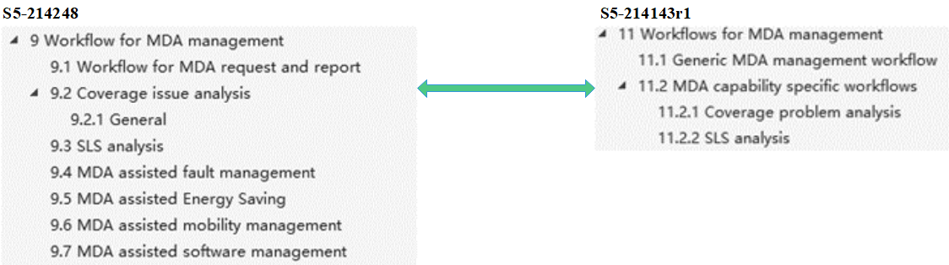

1. **It is propose that the structure of section 9 should be aligned with the structure of section 7.**

# 4 Detailed proposal

Based on the discussion in this paper, we have the following observations and proposal.

1. **It is propose that section 7 define three clause include “7.1 General”, “7.2 MDA capabilities” and “7.3 Generic MDA”, where the each use case is defined in clause 7.2, MDA report request control/MDA reporting/Historical data handling for MDA/Machine Learning(ML) for MDA/Feedback for MDA is defined in clause 7.3.**
2. **It is propose that the NRM model and data definitions should directly defined in component B of MDA request control management service and component C of MDA reporting management service for better readability.**
3. **It is propose to define the input data to the annex as an example input data.**
4. **It is propose that the structure of section 9 should be aligned with the structure of section 7.**