3GPP TSG-SA5 Meeting #138-e S5-21xxxx

e-meeting, 23 - 31 August 2021

Source: Huawei

Title: Discussion on the wayforwad for NRM solution for 5G MOCN network sharing scenarios

Document for: Approval
Agenda Item: 6.4.17

1 Decision/action requested
It proposes to discuss and endorse

2 References
[1] S5-211444 Discussion paper for NR NRM support 5G MOCN network sharing scenario.
[2] S5-205304 Discuss on NR NRM update to support MOCN network sharing scenario.
[3] S5-212270 RAN Sharing NRM support for MOCN.
[4] S5-212197 Rel-17 CR TS 28.541 Enhance the NRM definitions to support NG-RAN network sharing.
[5] S5-213214 Rel-17 CR 28.541 Update NR NRM to support MOCN network sharing scenario.
[5] TS 32.130 Telecommunication management; Network sharing; Concepts and requirements v17.1.0.
[6] S5-213171 Discussion paper for requirements and NRM solution support 5G MOCN network sharing scenario

3 Rationale

3.1 Background information:

3.1.1 Principles
Observation: It is endorsed in the DP S5-205304 that the NR NRM for MOCN Network sharing should follow following principles:
Principle#1: R17 focus on MOCN network sharing scenario (see TS 23.501[2).
Principle#2: R17 NR NRM supporting MOCN network sharing feature should backwards compatible with R16/R15 NR NRM. Also needs to consider flexibility for compatible with other R17 features and to avoid the data (e.g. CM data, PM data) migration issue and redundancy issue.
Principle#3: One NR NRM supporting RAN with and without MOCN network sharing feature, which means the NR NRM fragment specific for MOCN network sharing feature should be modelled as R17 optional NR NRM fragment.

3.1.2 Scenarios, requirements and potential solutions
Observation: It is endorsed in the DP S5-211444 that the NR NRM for MOCN Network sharing should support following two scenarios:
- NG-RAN MOCN Network Sharing with same Cell Identity broadcast.
- NG-RAN MOCN Network Sharing with multiple Cell Identity broadcast.

3.1.2.1 NG-RAN MOCN Network Sharing with same Cell Identity broadcast

3.1.2.1.1 Scenario description
For NG-RAN MOCN Network Sharing with same Cell Identity broadcast scenario, different operators use the same cell Identity and different PLMN Id, which is captured by following figure in TS 32.130.
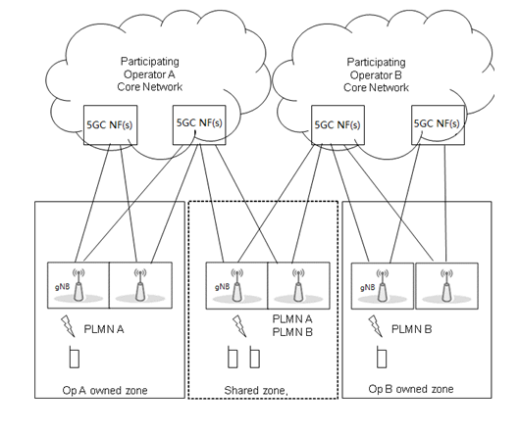

3.1.2.1.2 Management requirements
Observation: following requirements are captured in TS 32.130.
/***************Extracted from TS 32.130 Beginning*********************/
5.1.4 Requirements for management support for 5G MOCN network sharing scenario with same Cell Identity broadcast
Req-MOCN_SameCellId_Cfg-CON-1. The 3GPP management system shall have the capability to configure NgC and NgU individually for each supported network operator.
Req- MOCN_SameCellId_Cfg-CON-2. The 3GPP management system shall have the capability to configure PLMNId individually for each supported network operator.
Req- MOCN_SameCellId_Per-CON-3. The 3GPP management system shall have the capability to collect and report some measurements (e.g. active UEs measurements, packet delay measurements) in PLMN granularity for different network operator.
/***************Extracted from TS 32.130 Ending*********************/

3.1.2.1.3 Management solution
1. Solution of adding attribute “PLMNInfoList” in EP_NgC and EP_NgU is needed to support Req-MOCN_SameCellId_Cfg-CON-1.
2. Attribute “PLMNInfoList” in existing NR NRM can be used to support Req- MOCN_SameCellId_Cfg-CON-2.
3. Existing PLMN granularity subcounter can be used to Req- MOCN_SameCellId_Per-CON-3.

3.1.2.2 NG-RAN MOCN Network Sharing with Multi Cell Identity broadcast

3.1.2.2.1 Scenario description
For NG-RAN MOCN Network Sharing with multiple Cell Identity broadcast scenario, different operators use different PLMN Id, Cell Id and TAC, which is captured by following figure.
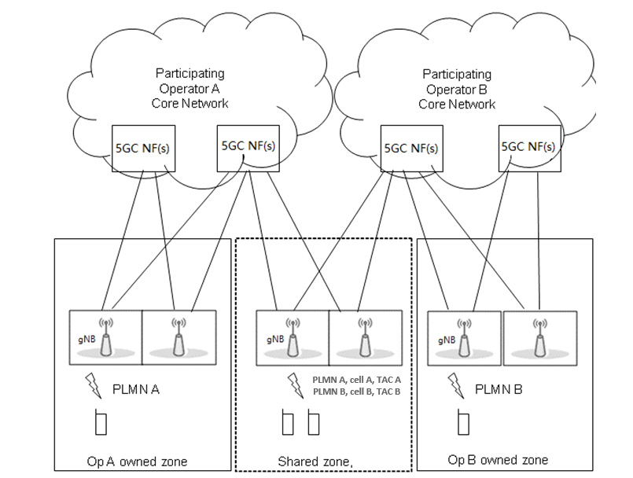

3.1.2.2.2 Management requirements
Observation: Following requirements are discussed and agreed in TS 32.130:
/******************************Extracted from TS 32.130 beginning*****************************/
5.1.5 Requirements for management support for 5G MOCN network sharing scenario with multiple Cell Identity broadcast
Req-MOCN-MultiCellId-Cfg-CON-1 The 3GPP management system shall have the capability to configure NgC and NgU individually for each supported network operator.
Req-MOCN-MultiCellId-Cfg-CON-2 The 3GPP management system shall have the capability to configure PLMN-IdentityInfo (including PLMNId, CellId, TAC) individually for each supported network operator.
Req-MOCN-MultiCellId-Perf-CON-3 The 3GPP management system shall have the capability to collect and report some measurements (e.g. active UEs measurements, packet delay measurements) in PLMN granularity for different network operator.
/******************************Extracted from TS 32.130 Ending*****************************/

3.1.2.2.3 Management solutions
1. For the Req-MOCN-MultiCellId-Cfg-CON-2, following NRM solution is proposed:
Main change proposal#1: Introduce new OperatorDU <<IOC>> name-contained by GNBDUFunction<<IOC >> to represents operator specific gNB level information (including operator specific gNB Id, gNBIdlength), and new NROperatorCellDU<<IOC>> name-contained by OperatorDU<<IOC>> to represent operator specific cell level information (including operator specific nRTAC, CelllocalId, PLMNInfoList).
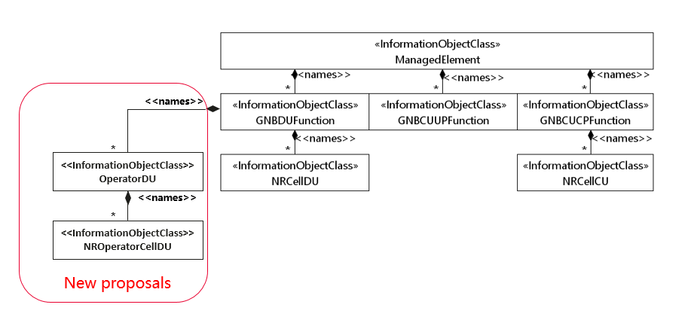
- OperatorDU<<IOC>>
Attribute name | Support Qualifier | isReadable | isWritable | isInvariant | isNotifyable
gNBId | M | T | T | F | T
gNBIdLength | M | T | T | F | T

Attribute name | Support Qualifier | isReadable | isWritable | isInvariant | isNotifyable
cellLocalId | M | T | T | F | T
pLMNInfoList | M | T | T | F | T
nRTAC | CM | T | T | F | T
Attribute related to role
nRCellDURef | M | T | T | F | T

Detailed NR NRM update proposal see the Revision of S5-21321, which is the revision of S5-213214 proposed in SA5#137emeeting.

2. For the Req-MOCN-MultiCellId-Cfg-CON-3, Operartor specific measurements and alarm can be associated to OperatorDU<<IOC>> and NROperatorCellDU<<IOC>>, Operator agnostic measurements can be associated to GNBDUFunction<<IOC>> and NRCellDU<<IOC>>.

4 Detailed proposal
It proposes to capture above information in the TR 28.825.

