3GPP TSG-SA5 Meeting #133e S5-205249

e-meeting, 12– 21 October 2020

Source: Nokia, Nokia Shanghai Bell

Title: TD tenant information to support multi-tenancy for network slice management

Document for: Discussion and Endorsement
Agenda Item: 6.4.7

1 Decision/action requested
Please discuss and endorse

2 References
[1] 3GPP TS 28.201: "Charging management; Network slice performance and analytics charging in the 5G System (5GS); Stage 2 ".
[2] 3GPP TS 28.202: "Charging management; Network slice management charging in the 5G System (5GS); Stage 2 ".
[3] 3GPP TS 28.541: "Management and orchestration; 5G Network Resource Model (NRM); Stage 2 and Stage 3".

3 Rationale
As studied in TR 28.804, management resource isolation and management service exposure to different tenants is critical to multi-tenancy network slice environement.
As shown in below picture, 3GPP management service consumer representing a tenant may call MnS of 3GPP managmenet system to provision or mornitor a network slice allocated to the tenant.

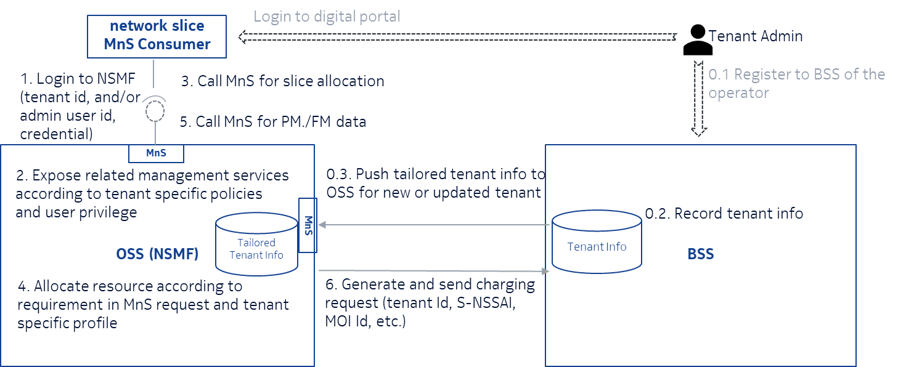
Therefore tenant info may be used in OSS in following cases:
1. A MnS consumer would be authenticated and authorized by MnS producer (a.k.a operator) according to tenant information
2. MnS producer exposes MnS service, either provisioing (e.g. create/delete/update service) or monitoring (e.g. report performance measurements, alarm of service) according to SLA signed with the tenant
3. MnS producer allocates resource to MnS consumer based on servie requirements and other SLAs signed with the teant
4. MnS producer generate charging data record for each management services used by the MnS consumer with Id of the tenant for which the MnS consumer represents.
Therefore, first, the tenant information should be in BSS system of operator after a tenant signed contract with operator. Part of the tenant information need to be transferred to OSS system to allow the OSS system to proceed service request from the service consumer on behalf of the tenant.
Tenant information is need to OSS to authenticate the MnS consumer on behalf of the tenant and allow OSS to grant permissions of management services to the MnS consumer based on agreement between operator and tenant, in addition to allocate resource for the service request accorindg to agreed polices.
On the other hand, as tenant information is sensitive to both operator and consumer, it should be separately and securely managed by producer and authorized consumer. Association between a tenant and services/resources allocated to the tenant should be securely created to support management resource isolation and management service exposure without leak tenant’s information to unauthorized users or systems.

4 Detailed proposal

Introduced a Tenant IOC in NRM fragment as below
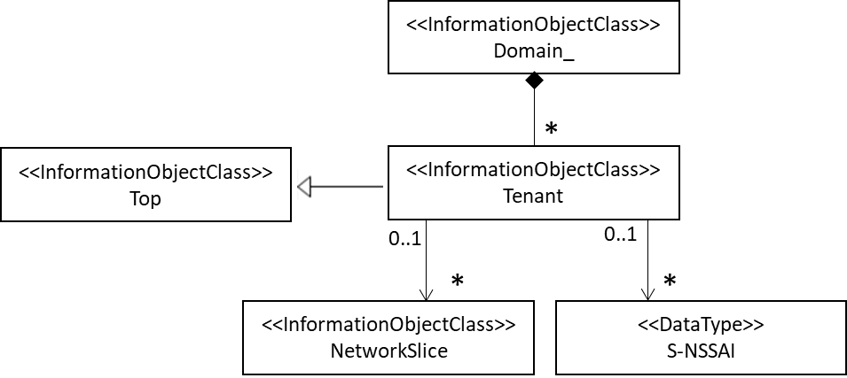
NRM Fragment of to support multi-tenancy

The Tenant IOC includes attributes inherited from Top IOC and the following attributes:
Attribute name | Support Qualifier | isReadable | isWritable | isInvariant | isNotifyable
tenantId | M | T | F | T | F
administrativeState | M | T | T | F | T
sNSSAIList | O | T | F | F | T
tenantProfile | O | T | T | F | T
Attribute related to role
networkSliceRef | O | T | F | F | T

Attribute properties:
Attribute Name | Documentation and Allowed Values | Properties
administrativeState | It indicates the administrative state of the tenant object in the network slice provider environment. An authorized operator could lock/unlock the tenant, and the tenant could lock the tenant object.  allowedValue: LOCKED, UNLOCKED | type: ENUM  multiplicity: 1  isOrdered: N/A  isUnique: N/A  defaultValue: None  allowedValues: N/A  isNullable: False
sNSSAIList | This parameter specifies the S-NSSAI list allocated to the tenant by network slice provider. | type: SNSSAI  multiplicity: *  isOrdered: N/A  isUnique: N/A  defaultValue: None  allowedValues: N/A  isNullable: False
tenantId | It is identifier that the network slice provider assigns to a tenant. It should be unique in the network slice provider environment. | type: string  multiplicity: 1  isOrdered: N/A  isUnique: N/A  defaultValue: None  allowedValues: N/A  isNullable: False
tenantProfile | The parameter defines necessary properties and policies of a tenant to support resource allocation and management for the tenant. It can be read and updated by the tenant and autormized operator on behalf of the tenant. | type: string  multiplicity: 1  isOrdered: N/A  isUnique: N/A  defaultValue: None  allowedValues: N/A  isNullable: False
networkSliceRef | This parameter specifies the network slice(s) offered to the tenant by network slice provider. | type: DN  multiplicity: *  isOrdered: N/A  isUnique: N/A  defaultValue: None  allowedValues: N/A  isNullable: False

