3GPP TSG-SA5 Meeting #136e S5-21xxxx

01 March to 09 March 2021, E-meeting

Source: Huawei

Title: Input discussion paper on charging for network slice in release 17

Document for: Discussion

Agenda Item: 7.5.1

1 Decision/action requested
The group is asked to discuss and agree on the proposal.

2 References
[1] 3GPP TR 28.847

3 Rationale
This discussion paper is to provide background information and analysis the goals of network slice quota control from slice provisioning and SLA requirements perspective.

4 Detailed proposal
a. Background of this discussion
The study is based on a new SID for slice quota control SID in SA2 for release 17. This SID in SA5 charging is also targeting release 17, but adding the scope of slice charging in general.
The SA2 study does more focus for 5GC NFs on the some SLA requirements (derived from parameters in network slice service profile) provided by OAM slice provisioning process (per 5G network and slice management and orchestration).
References as background information for this study:
- The network slice provisioning process can be seen in TS 28.532 and TS 28.533.
- The Study of eNS2.0 can be seen in TR 23.700-40.

References and also in the scope of study:
- TS 28.201.
- TS 28.202.
- TR 28.847.
- The work item (SA2): Enhancement of Network Slicing Phase 2 (eNS_Ph2)

The scope of this discussion on following solutions, are based on the key issues identified in TR 32.847, as following:
- Key Issue #1: Converged Charging for max. number of UEs per network slice
- Key Issue #2: Converged Charging for max. number of PDU sessions per network slice
- Key Issue #3: Volume based Converged Charging per network slice
- Key Issue #4: Converged Charging for max duration per network slice
- Key Issue #5: Converged charging for number of simultaneous UEs per network slice
- Key Issue #6: Converged Charging for number of unique UEs per network slice
- Key Issue #7: Converged charging for number of concurrent PDU sessions per network slice

b. Existing solution for release 16
As shown in following diagram:
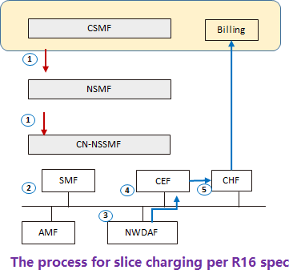
Figure 2.1.1 the diagram of network slice provisioning and charging information generation for network slice
The steps:
（1）slice provisioning (CSMF->NSMF->NSSMF)
（2）SLA assurance process
（3）slice SLA statistics（NWDAF at PDU session level per slice instance）
（4）Generate slice SLA charging information
（5）Charging CDR generation

Goals | Slice provisioning | Slice SLA enforcement | charging information generation | charging information collection | slice quota control in CP | slice quota in charging
Fulfillments | Yes | Yes (depends on implementations) | Yes (per 28.201) | Yes (per 28.201) | Yes (depends on implementations) | No (this is rather controlled during slice provisioning process)
Gap analysis | No gaps are found. | The SLA parameters are per slice instance. The distributions of SLA parameters are implementation and out of scope of standard. | No gaps (per 28.201) | No gaps (per 28.201) | This is an implementation in release 16. | Charging does not control slice quota, rather slice provisioning and 5GC control SLA parameters.
NOTE 1: There is an issue that how CHF update amount of quota when charging function controls the slice quota.
Table 2.1-1 the analysis on fulfillment of network slice use from SLA requirements and slice quota control perspective.

c. The conclusions:
- The standard in release 16 spec is not completed and depends on vendor specific implementations.
  - SLA assurance and control on key issue#1&2 regarding SA2 works
  - The quota control for admission control of new service quest related to key issue#1&2.
- Release 17 should focus on those missing in release 16.

