3GPP TSG-SA3 Meeting #120 S3-251169
Athens, Greece, 17 - 21 February 2025

CR-Form-v12.1
CHANGE REQUEST
 | 33.501 | CR | 2116 | rev | - | Current version: | 19.1.0
For HELP on using this form: comprehensive instructions can be found at
http://www.3gpp.org/Change-Requests.

Proposed change affects: | UICC apps |  | ME |  | Radio Access Network |  | Core Network | X

Title: | CR for security for PLMN hosting a NPN
Source to WG: | China Telecom, ZTE
Source to TSG: | S3
Work item code: | PLMNNPN |  |  |  |  |  | Date: |  |  | 2025-02-17
Category: | B |  |  |  |  |  | Release: |  |  | Rel-19
 | Use one of the following categories:  F (correction)  A (mirror corresponding to a change in an earlier release)  B (addition of feature),  C (functional modification of feature)  D (editorial modification)  Detailed explanations of the above categories can  be found in 3GPP TR 21.900. |  |  |  |  |  |  |  | Use one of the following releases:  Rel-8 (Release 8)  Rel-9 (Release 9)  Rel-10 (Release 10)  Rel-11 (Release 11)  …  Rel-15 (Release 15)  Rel-16 (Release 16)  Rel-17 (Release 17)  Rel-18 (Release 18)
Reason for change: |  | The feature of security for PLMN hosting a NPN needs to be added.
Summary of change: |  | CR for how the work on the security for PLMN hosting a NPN study can be implemented in TS 33.501. This CR is intended to compile a list of recommendations, based on the conclusions in TR 33.757, on how to secure the border between PLMN and hosted NPN when dedicated NFs interacting with PLMN through SBA interface.
Consequences if not approved: |  | The work item is incomplete.
Clauses affected: |  | Annex xx(new)
 |  | Y | N
Other specs |  |  |  | Other core specifications |  |  |  | TS/TR ... CR ...
affected: |  |  |  | Test specifications |  |  |  | TS/TR ... CR ...
(show related CRs) |  |  |  | O&M Specifications |  |  |  | TS/TR ... CR ...
Other comments:
This CR's revision history:

* * * First Change * * * *

Annex XX (Informative): Security for PLMN hosting a NPN through SBA interface

XX.1 General
This annex specifies the security aspects of PLMN hosting an NPN with dedicated NFs deployed in the PNI_NPN operational domain. The annex describes how to secure the boundary between PLMN operational domain and PNI_NPN operational domain when dedicated NFs interacting with PLMN operational domain through SBA interface and vice versa.
This annex is based on the following assumptions:
- Mutual trust between PLMN operational domain and the dedicated Network functions at the PNI_NPN operational domain is not in place.
- Attacks may happen from PNI_NPN operational domain to PLMN operational domain and PLMN operational domain to PNI_NPN operational domain.

XX.2 Architecture
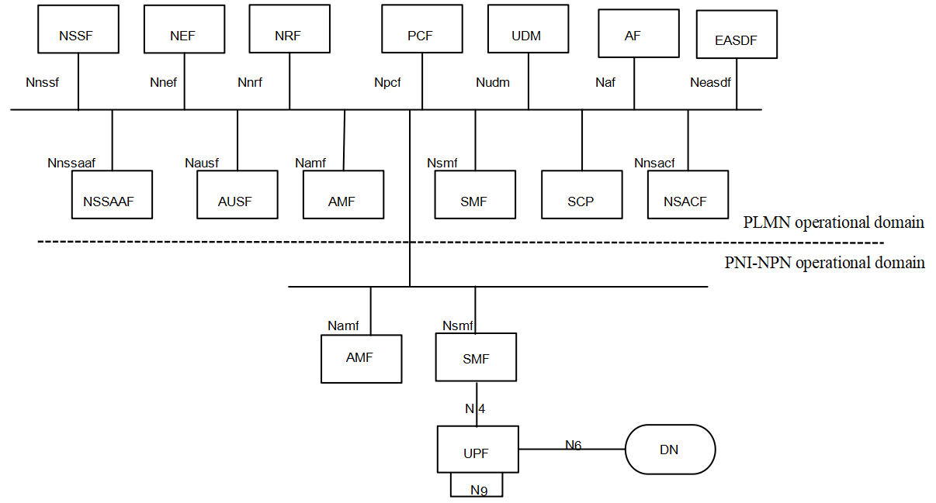
Figure XX.2-1 Example of dedicated NFs deployed in the PNI-NPN operational domain
As depicted in Figure XX.2-1, dedicated UPF and part of CP functions are deployed in the PNI-NPN operational domain. The interface between the dedicated NFs in the PNI-NPN operational domain and the NFs in the PLMN operational domain is SBA interface.
NOTE: The choice of which of these CP functions (i.e., AMF or SMF, or both or none) are deployed in the PNI-NPN operational domain is a matter for deployment. Whether additional CP functions are deployed in the PNI-NPN operational domain is not considered yet in the present document.
When the AMF is deployed in the PNI-NPN operational domain, there exists a privacy risk regarding SUPI exposure outside the PLMN operational domain. Appropriate measures to mitigate this risk may be considered when choosing this architecture for deployment.

XX.3 Proxy entity at the border
It is recommended to deploy one or more proxy entities at the border between PLMN and PNI-NPN operational domains. The security capabilities of these proxy entities are listed below.
- Transport layer protection solution (as defined in clause 13.3) is supported for mutual authentication between the proxy entities and between each proxy entity and the NFs they serve.
- SBA authorization framework (as defined in clause 13.4) is reused for authorization between NFs in the PLMN and PNI-NPN operational domains.
- Topology hiding to IP level (e.g., IP address or FQDN) and application level (e.g., target NFs in the discovery response, Callback URI in the payload of the messages) is supported.
- Message inspection and filtering, malformed message handling are supported.
NOTE: Specific method for above security capabilities c) and d) is left to implementation.
Besides the security capabilities listed above, the part of the routing functionalities listed below also needs to be supported:
- Indirect Communication (see TS 23.501[2] clause 7.1.1 for details).
- Delegated Discovery (see TS 23.501[2] clauses 7.1.1 and 6.3.1 for details).
- Message forwarding and routing to destination NF/NF service.
- Message forwarding and routing to a next hop. (Required for bi-directional protection)

XX.4 Security for DNS messages crossing the border
DNS messages crossing the trust boundary can be protected. Security configuration and profiling of DNS servers is left to implementation. The dedicated NFs in the PNI-NPN operational domain are provisioned with the DNS security configuration, for example using one of the following methods:
- Pre-configuring the DNS security configuration in the dedicated NF.
- Updating the DNS security configuration in the dedicated NF during NF instantiation via the OAM.
* * * End of Changes * * * *

