3GPP TSG-SA3 Meeting #117 S3-24xxxx
Maastricht, Netherlands, 19 - 23 August 2024

Source: Johns Hopkins University APL, Cisco Systems, MITRE-FFRDC, US National Security Agency

Title: Solution on certificate revocation

Document for: Approval
Agenda Item: 5.4

1 Decision/action requested
Approve the pCR to TR 33.776.

2 References
[2] IETF RFC 8555: "Automatic Certificate Management Environment (ACME)".
[3] 3GPP TS 33.310: "Network Domain Security (NDS); Authentication Framework (AF) ".
******** Start of Change 1 ********
[x] IETF RFC 5280: “Internet X.509 Public Key Infrastructure Certificate and Certificate Revocation List (CRL) Profile”.
******* End of Change 1 *******

3 Rationale
This contribution proposes a solution to address key issue #6 in TR 33.776.
Certificate revocation is an essential component of certificate management lifecycle to address potential vulnerabilities that may arise. There may be instances due to a misconfiguration or a leak or other events in which the private key of a valid certificate may have been exposed and the certificate needs to be revoked in a timely manner to mitigate potential threats.
Potential uses case for automated client-based certificate revocation
- Potential exposure of the certificate private key and need for a timely revocation of the certificate so that an attacker can no longer impersonate the NF.
- Due to changes in NF identifiers or names, relatively large number of certificates need to be updated. To mitigate potential threats of existing certificates (e.g., reuse to support malicious attacks), those certificates should be revoked in a comprehensive and reliable manner.
If the ACME client-based certificate enrolment procedure is supported but a client-side revocation procedure is not, then there will be a gap in the automated lifecycle management of certificates in the 5G SBA.

4 Detailed proposal
******** Start of Change 2 ********

6.Y Solution #Y: ACME automated revocation of certificates
6.Y.1 Introduction
This solution addresses key issue #6 on certificate revocation.
The ACME protocol [2] defines automated revocation procedures of ACME enrolled and renewed certificates using established authenticated and authorized credentials (i.e., key pair) verified during ACME client account activation and certificate issuance. The end entity (e.g., ACME client in the NF) can use its account key pair or the key pair of the issued certificate to request revocation of its certificate from the CA (i.e., ACME server).
NOTE: This client-side certificate revocation procedure does not impact existing CA initiated revocation mechanisms which are based on operator’s implementation and outside the scope of this solution. The CA operator will continue to have the ability to revoke certificates that have been issued. In addition, production and distribution of the revocation status messages (i.e., via CRL or OCSP) of the revoked certificates are solely dependent on CA operator’s implementation.
6.Y.2 Solution Details
This solution proposes certificate revocation procedure specified in RFC 8555 [2] to revoke valid certificates before expiration.
The solution assumes:
- Initial trust between end entities (i.e., ACME client and ACME server) has been established based on clause 10.2 of TS 33.310 [3].
- CRL and OCSP certificate revocation status checking profiles defined in TS 33.310 clause 6.1a and 6.1b, respectively, are reused [3].
- The certificate being requested for revocation has not expired.
- ACME client maintains the valid account key pair for the NF identifier for which the certificate was issued and/or access to the key pair of the issued certificate being requested for revocation to properly sign the revocation request.
- When the ACME client is co-located with the NF in 5G SBA, the ACME client does not have the privilege to request certificate revocation for other NFs.
- This solution does not impact the end entity certificate revocation requirement defined in TS 33.310 [3] in clause 5.2.12.

Figure 6.y.1.1 provides an overview of the ACME certificate revocation procedure, as summarized below:
- To initiate the certificate revocation request, the ACME client generates a JWS object, in which the JSON payload contains the certificate to be revoked. The revocation request is signed using the account private key or the certificate private key.
- The ACME client sends the revocation request to the ACME server. The reason for revocation is optional to include with valid reasonCode defined in RFC 5280 [x].
NOTE: To deny or accept revocation requests based on which reasonCode is left to operator’s implementation.
- The ACME server validates the revocation request by verifying that the private key used to sign the request is authorized to revoke the certificate. If the account private key was used, the request must come from the account to which the certificate was issued or the account that holds the authorization for all the identifiers in the certificate.
- If the revocation request is deemed valid during Step 3, the ACME server sends status is OK message. If revocation fails, the ACME server returns an error. If the certificate was already revoked, the ACME server returns status that it has been already revoked.
NOTE: When and how revoked certificates are added into the CRL and/or OCSP service is left to operator's implementation and out of scope of this solution.

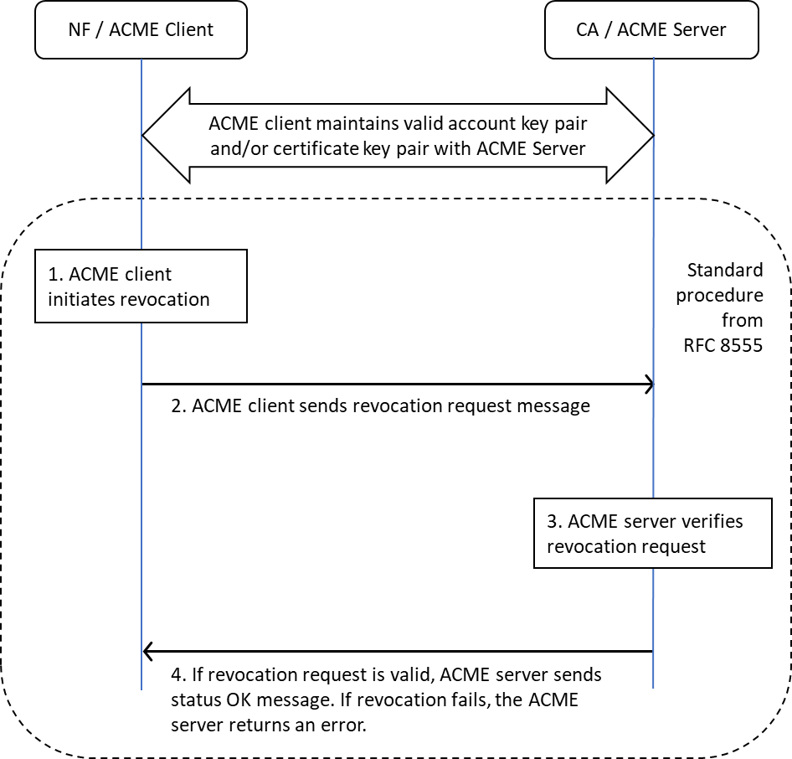

Figure 6.y.1. 1: Overview of ACME-based automated certificate revocation

6.Y.3 Evaluation
This solution addresses key issue #6 and utilizes an automated certificate revocation procedure based on the ACME protocol. An ACME-based revocation procedure provides timely and automated revocation of certificates whose private keys may have been exposed or leaked. In addition, this solution provides a method to revoke certificates that are no longer required but may pose a threat after changes to NF identifiers have been implemented.
Ability to revoke certificates is limited to the original enrolling NF ACME client or if the ACME client has knowledge of the certificate private key.
In scenarios where the NF has been compromised and ACME client is co-located, access to the ACME client may not be possible. In such instances, certificate revocation would use existing server-side operator’s implementation. If the compromised NF decides to revoke its own certificate, the revocation of the compromised NF certificate should not be viewed as a threat but rather as a positive outcome since revoking the NF certificate ensures that the NF is not trusted in the 5G SBA.
Use of end entity certificate revocation allows efficient automated management of NF certificate lifecycle.

******* End of Change 2 *******

