3GPP TSG-SA3 Meeting #116 S3-241709
Jeju, South Korea, 20th - 24th May 2024

Source: Ericsson

Title: Solution to prevent bidding down by restricting UE access to GERAN/UTRAN in its location

Document for: Approval
Agenda Item: 5.6

1 Decision/action requested
It is proposed to approve this solution to address KI#1 in TR 33.701

2 References
N/A

3 Rationale
During decommissioning phase when a PLMN gradually removes GERAN/UTRAN radio access types from the infrastructure, the phased approach results into coexistence of 5G NR/LTE and GERAN/UTRAN until GERAN/UTRAN is fully removed from the network. The proposed solution mitigates the risk of bidding down to GERAN/UTRAN by the network passing the allowed RATs to the UE for the UE to subsequently not access GERAN/UTRAN RAT in its registered location.

4 Detailed proposal
*** Start Change 1 ***

5.Y Solution #Y: Solution to prevent bidding down by restricting UE access to GERAN/UTRAN in its location

5.Y.1 Introduction
The proposed solution addresses the security requirement of key issue#1: "Bidding down attacks from LTE/NR to decommissioned GERAN/UTRAN".

5.Y.2 Solution details
The AMF/MME in the Core Network (CN) maintains the RAT availability information for GERAN/UTRAN presence/absence per location, for example in a table 5.Y.2-1 that maps location represented by Tracking Area Identity (TAI) with present/absent flag for GERAN/UTRAN. Accordingly, the CN informs the UE, therefore subsequent action by the UE not accessing GERAN/UTRAN in its location if PLMN's GERAN/UTRAN does not exist in UE's location. The CN nodes AMF/MME learns about UE's location based on UE's location update.
The proposed solution addresses UEs both in CM-CONNECTED and CM-IDLE mode in UE's last known location.
If the UE is in CM-IDLE mode in the CN, means UE is in RRC IDLE mode in the RAN. In this mode, UE does not have RRC connection with the radio network and does not have active NAS signalling with CN. Therefore, the network uses paging to reach out to UEs in a location where GERAN/UTRAN is removed.
As shown in the figure 5.Y.2-1 and 5.Y.2-2;
1. The CN pages the UEs in CM-IDLE/RRC IDLE in a location where GERAN/UTRAN is removed. As a result, UEs are expected to transition to CM-CONNECTED state to receive information from the CN. Alternatively, the UE could already be in CM-CONNECTED/RRC CONNECTED state.
If the GERAN/UTRAN is absent in UE's TAI, the AMF/MME informs the UE to only access allowed RATs in UE's registered last known location. The information is passed in the form of 'allowed RAT list' that comprises only NR/LTE in this case. The list could comprise any allowed RAT by the PLMN.
2a. As shown in the figure 5.Y.2-1, the CN sends an access and mobility instruction by a new IE in UE Configuration Update (UCU) Command in NAS signaling to pass this information to UE.
2b. The UE responds with a UCU Command Accept.

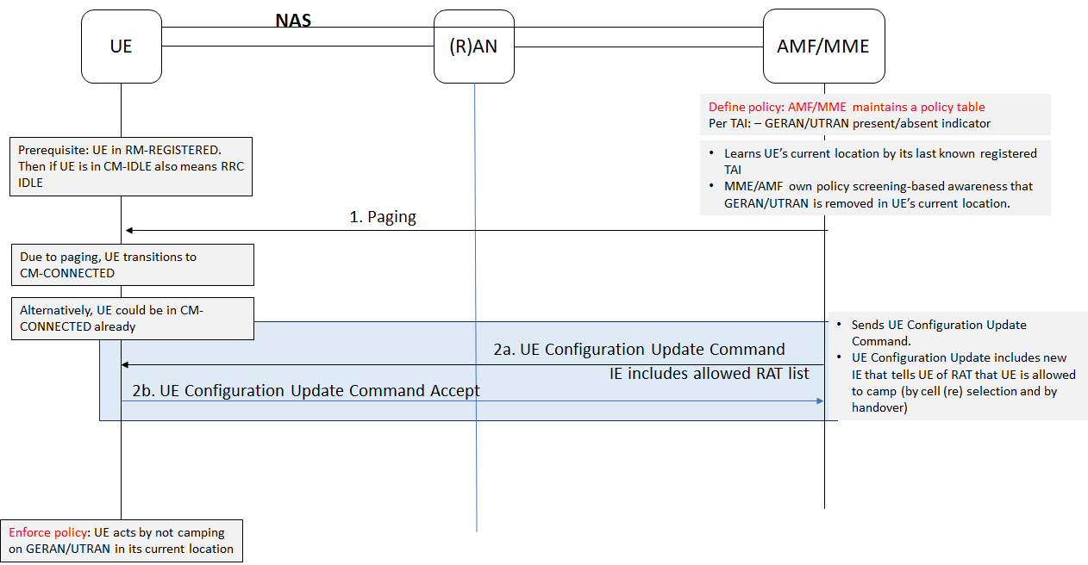
Figure 5.Y.2-1: CN informs UE of GERAN/UTRAN removal
Alternatively, as shown in the figure 5.Y.2-2, the CN can pass this information to RAN (in step 2) for RAN to inform the UE (in step-3) by RRC protocol signaling.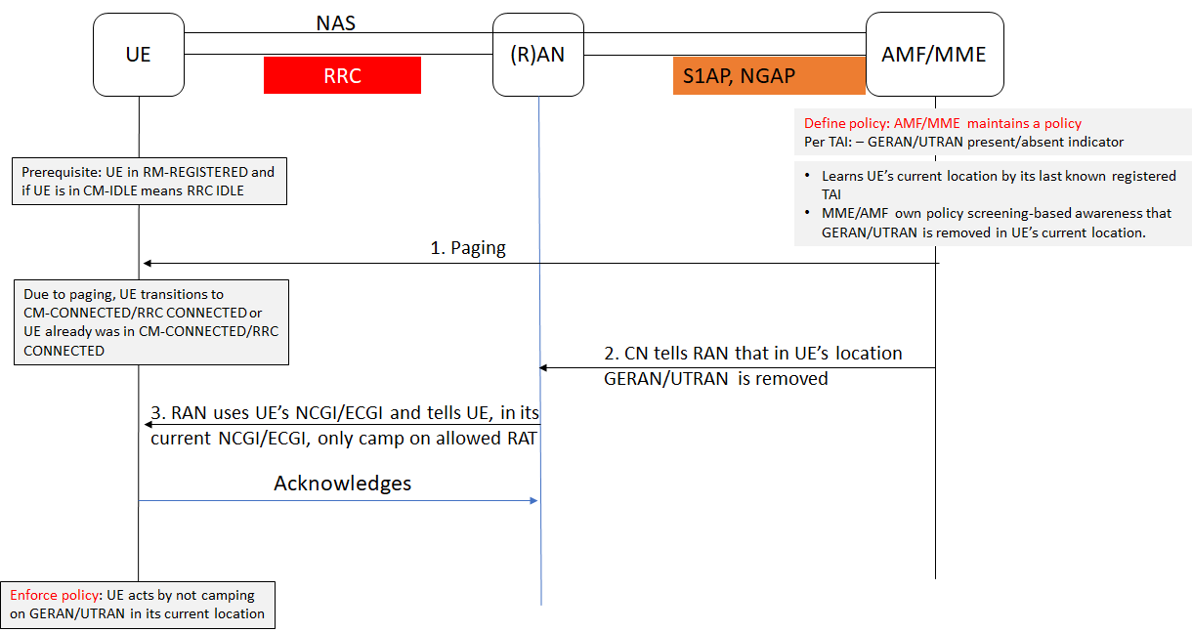
Figure 5.Y.2-2: RAN informs UE of GERAN/UTRAN removal using RRC

Alternatively, as shown in the figure 5.Y.2-3, the CN can pass GERAN/UTRAN removal information in UE's location to RAN (in step 1) for RAN to use System Information (SI) (in step 2) to inform the UE.
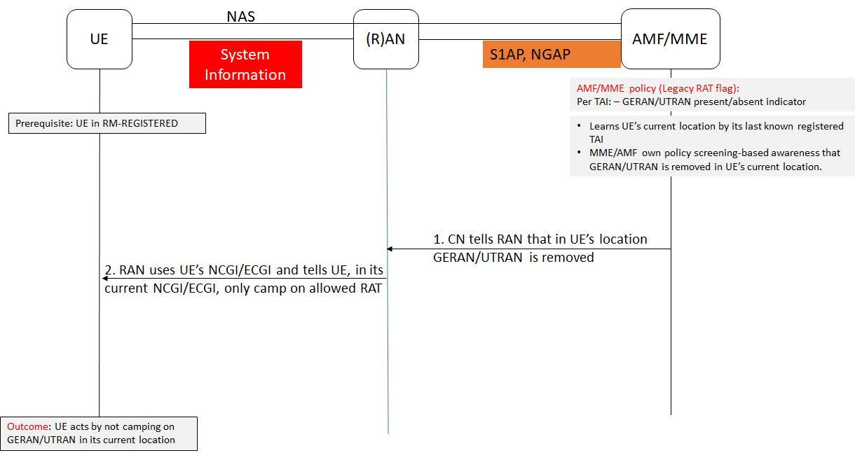
Figure 5.Y.2-3: CN informs UE of GERAN/UTRAN removal via RAN/SI
TAI as AMF/MME sees UE location |  |  | NCGI/ECGI as RAN sees UE location |  |  |  | Policy Check at AMF/MME
PLMN |  | TAC | PLMN |  | NCI/ECI |  | GERAN/UTRAN presence/absent
MCC | MNC |  | MCC | MNC | gNB/eNB id | Cell id | RAT-Indicator
234 | 99 | 1 | 234 | 99 | 123 | 10 | Y
234 | 99 | 2 | 234 | 99 | 456 | 20 | Y
234 | 99 | 3 | 234 | 99 | 789 | 30 | N
208 | 34 | 1 | 208 | 34 | 123 | 40 | Y
208 | 34 | 2 | 208 | 34 | 456 | 50 | Y
240 | 99 | 3 | 240 | 99 | 777 | 60 | Y
Table 5.Y.2- 1: AMF/MME policy table screening UE location

5.Y.3 Evaluation
The solution addresses UEs in CM idle mode and connected mode by network triggered action without relying on UEs to first initiate communication with the network.
The solution addresses security requirements of KI#1 "Bidding down attacks from LTE/NR to decommissioned GERAN/UTRAN", during coexistence of NR/LTE and GERAN/UTRAN, depending on UE's last known location, GERAN/UTRAN may or may not exist in PLMN RAN infrastructure. The solution enables UE to be selective by allowing access to PLMN's own GERAN/UTRAN in locations where it exists, and at the same time enables being restrictive to only access NR/LTE in locations where PLMN has removed its own GERAN/UTRAN.
If the NAS or RRC options are used to communicate information to the UE, the information is protected in NAS and AS because it is sent only after SMC respectively in NAS and AS.
If the System Information is used to inform the UE of PLMN GERAN/UTRAN removal, the System Information itself can be protected using a solution from [x]. The use of SI enables the PLMN network to inform the UE to only access PLMN allowed RATs that could include any desired RAT options.
It is up to operator policy to determine the paging occasions as to when to page UEs in a location where GERAN/UTRAN is removed. The solution does not advocate the use of additional paging but the reuse of existing paging occasions when UEs would have to be paged by the network anyway for existing purposes.
The solution does not address legacy UEs that could only access GERAN and/or UTRAN.
The solution could work in roaming scenarios if the serving PLMN has implemented the CN and RAN procedures of the proposed solution.
Impacted NFs or network entities: AMF, MME, eNB, gNB, ng-eNB
Impacted 3GPP communication protocols/mediums: UCU (for first alternative), NGAP (for second and third alternative), S1AP(for second and third alternative), RRC (for second alternative), SI (for third alternative)

*** End Change 1 ***

*** Start Change 2 ***

2 References
The following documents contain provisions which, through reference in this text, constitute provisions of the present document.
- References are either specific (identified by date of publication, edition number, version number, etc.) or non-specific.
- For a specific reference, subsequent revisions do not apply.
- For a non-specific reference, the latest version applies. In the case of a reference to a 3GPP document (including a GSM document), a non-specific reference implicitly refers to the latest version of that document in the same Release as the present document.
[1] 3GPP TR 21.905: "Vocabulary for 3GPP Specifications".
[2] 3GPP TS 23.502: "Procedures for the 5G System (5GS)".
[3] 3GPP TS 33.501: "Security architecture and procedures for 5G System".
[4] 3GPP TS 23.501: "System architecture for the 5G System (5GS)".
[5] 3GPP TS 23.122: "Non-Access-Stratum (NAS) functions related to Mobile Station (MS) in idle mode".
[6] 3GPP TS 24.501: "Non-Access-Stratum (NAS) protocol for 5G System (5GS)".
…
[x] 3GPP TR 33.809: "Study on 5G security enhancements against False Base Stations (FBS)"
.
*** End Change 2 ***

