3GPP TSG-SA3 Meeting #116 S3-241708
Jeju, South Korea, 20th - 24th May 2024

Source: Ericsson

Title: Solution to prevent bidding down to GERAN/UTRAN by restricting inter RAT handover

Document for: Approval
Agenda Item: 5.6

1 Decision/action requested
It is proposed to approve this solution to address KI#1 in TR 33.701

2 References
NA

3 Rationale
During decommissioning phase when a PLMN gradually removes GERAN/UTRAN radio access types from the infrastructure, the phased approach results into coexistence of 5G NR/LTE and GERAN/UTRAN until GERAN/UTRAN is fully removed from the network.
The proposed solution mitigates risks related to bidding down to GERAN/UTRAN by restricting the inter RAT handover to GERAN/UTRAN if PLMN's GERAN/UTRAN is removed from UE's registered location in the Radio Access Network.

4 Detailed proposal
*** Start Change ***

5.Y Solution #Y: Solution to prevent bidding down to GERAN/UTRAN by restricting inter RAT handover

5.Y.1 Introduction
The proposed solution addresses the security requirement of key issue#1 "Bidding down attacks from LTE/NR to decommissioned GERAN/UTRAN".

5.Y.2 Solution details
The AMF/MME in the Core Network (CN) maintains mapping of RAT per location. For example, this mapping could be a table comprising TAI and RAT information from 5.Y.2-1.
The eNB/gNB/ng-eNB nodes in the Radio Access Network (RAN) enforce the security policy for preventing bidding down.
The proposed solution does not inform about the absence of GERAN/UTRAN Radio Access Technologies (RAT) to UE. Instead, the CN informs the RAN so that the source gNB/ng-eNB/eNB decides not to let the inter RAT mobility related procedures take place in the RAN where the UE is located.
1. The AMF/MME learns about UE's location based on UE's location update procedure.
The CN maintains information about the availability of different RAT per location for example, by a table 5.Y.2-1 that maps UE's location represented by Tracking Area Identity (TAI) with present/absent flag for GERAN/UTRAN.
2. If the GERAN/UTRAN is absent in UE's TAI, the AMF/MME informs eNB/gNB/ng-eNB for eNB/gNB/ng-eNB to decide to not let inter RAT mobility take place in UE's location represented by NCGI/ECGI in RAN.
The AMF/MME uses NGAP/S1AP protocol signaling to pass this information to RAN nodes.
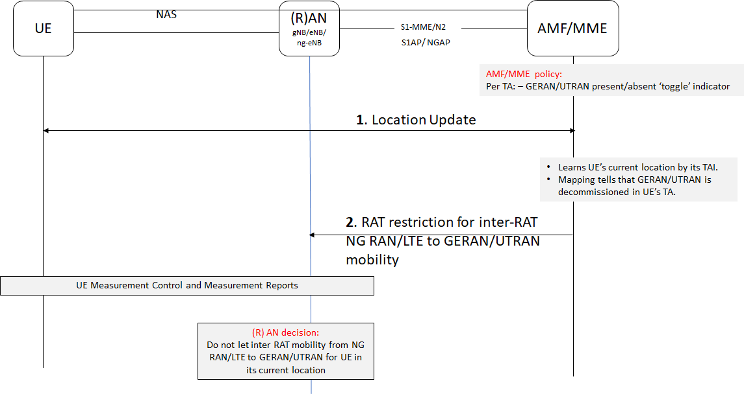
Figure 5.Y.2-1: CN instructs RAN not to let inter RAT mobility happen
TAI as AMF/MME sees UE location |  |  | NCGI/ECGI as RAN sees UE location |  |  |  | Policy Check at AMF/MME
PLMN |  | TAC | PLMN |  | NCI/ECI |  | GERAN/UTRAN presence/absent
MCC | MNC |  | MCC | MNC | gNB/eNB id | Cell id | RAT-Indicator
234 | 99 | 1 | 234 | 99 | 123 | 10 | Y
234 | 99 | 2 | 234 | 99 | 456 | 20 | Y
234 | 99 | 3 | 234 | 99 | 789 | 30 | N
208 | 34 | 1 | 208 | 34 | 123 | 40 | Y
208 | 34 | 2 | 208 | 34 | 456 | 50 | Y
240 | 99 | 3 | 240 | 99 | 777 | 60 | Y
Table 5.Y.2- 1: CN policy table screening UE location

5.Y.3 Evaluation
The solution prevents inter RAT mobility of a UE by keeping RAT bidding down security policy enforcement in the RAN. It's the core network that provides guidance to the RAN to not let inter RAT handover to GERAN/UTRAN take place.
The solution does not require changes to UE. The solution does not solve security requirement of KI#1 for legacy UE that only can access GERAN/UTRAN. Also, legacy UE would not have camped on gNB/ng-eNB/eNB to begin with.
The solution works for UE in CM-CONNECTED/RRC CONNECTED states, but not for UE in RRC IDLE/RRC INACTIVE/CM-IDLE modes where UE triggers mobility by cell (re)selection without involving the network.
The solution ties the UE's location and the available RAT absence absent/presence in an 'allowed list'. Thus, the solution prohibits inter RAT handover to GERAN/UTRAN where PLMN has removed GERAN/UTRAN, while still allowing inter RAT handover elsewhere.
Also, if the RAT is not in the list, the PLMN RAN will not let inter RAT mobility to any other RAT in UE's location. The solution scope could be expanded to non-3GPP RATs such as CDMA, CDMA-2000, W-CDMA, non-3GPP untrusted radio, WiMax etc.
The solution properties allow it to work in roaming scenarios if serving PLMN's CN and RAN interoperate to prevent inter RAT mobility in a location where restricted RAT is not supposed to be operational in UE's reported location.
Impacted network functions/entities: AMF, MME, eNB, gNB, ng-eNB
Impacted 3GPP communication protocols: NGAP, S1AP

*** End Change ***

