3GPP TSG-SA3 Conference Call on 256-bit algorithms S3-2xxxxx

9th, May 2023 (revision of S3-yyxxxx)

Source: CAICT, CATT, China Mobile, Huawei, China Telecom, China Unicom

Title: Information on AEAD mode of ZUC-256

Document for: Discussion and endorsement
Agenda Item:

1 Decision/action requested
SA3 would send an LS, informing ETSI SAGE on the latest information on ZUC-256, and asking SAGE’s advice for 256-NCA3.

2 References
[1] Specification of the 3GPP 256-bit Confidentiality and Integrity Algorithms for the Air Interface. Document 2: Specification of the 256-AEAD1 Algorithm.
[2] AEAD Modes for ZUC Family Stream Ciphers, Hongli Li, Yonghui Wang, Yongbiao Ma, Wenyi Jia, Liang Bai, https://doi.org/10.48550/arXiv.2111.05117.
[3] NIST Special Publication 800-38D, Recommendation for Block Cipher Modes of Operation: Galois/Counter Mode (GCM) and GMAC, November, 2007.

3 Rationale

3.1 Background
In [1], ETSI SAGE gave a unified AEAD structure for security algorithms. In [2], AEAD mode of ZUC-256 algorithm was proposed for years, which is named ZUC-GXM. ZUC-GXM has similar structure with AES-GCM [3].
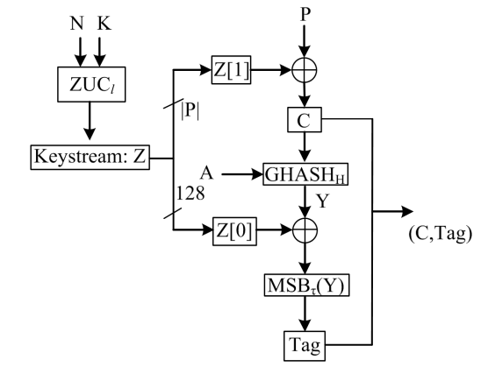
Fig. 1 Structure of AEAD mode of ZUC-256 in [2]
3.2 Comparison
GHASH function of ZUC-256-GXM has the same procedures as 256-AEAD1 as in [1], i.e., Mul_{H} as the loop executes, where “A” represents for the associated data.
The difference between ZUC-256-GXM and 256-AEAD1 can be found and explained as follows:
- Integrity protection key, i.e., H, in process of Mul_{H}, could either be provided by system, or calculated in each PDCP frame.
This feature will bring two benefits: first, MAC calculation can be precalculated partially, which will improve the performance. Secondly, H can be acquired by a transformation of integrity protection key form the key hierarchy, e.g., truncation, thus it brings little affect to the system.
- MulQ [2] is not considered as input of PDCP frame is short.
As in [3], GCM restrict the input length of plaintext, P, as 2³⁹-256 bytes. ZUC-GXM does not adopt MulQ, for the length of a PDCP frame is 9000 Byte at most in 5G, which is far short than 2³⁹-256 bytes.

Observation 1: AEAD mode of ZUC-256 will improve the performance of MAC calculation.
Observation 2: there are two additional options for ZUC-AEAD mode on table: ZUC-256-GXM and 256-AEAD1.

4 Actions
It is proposed to endorse to send an LS to ETSI SAGE, informing SAGE on the AEAD mode of ZUC-256, and requesting SAGE to evaluate:
- Two additional options for ZUC-AEAD mode including ZUC-256-GXM as in [2] and 256-AEAD1 as in [1] can be considered.
- It is believed that using the same framework for SNOW 5G, AES-256 and ZUC-256 would bring benefits.

