3GPP TSG-SA3 Meeting #123 S3-25XXXX

Goteborg, Sweden, 25 – 29 August 2025

Source: Huawei, Hisilicon

Title: Discussion on Security for 6G System

Document for: Discussion
Agenda Item: 6.3

1 Decision/action requested
Discuss the proposal about Security for 6G System

2 References
[1] SP-241391, “New Study on 6G Use Cases and Service Requirements”
[2] SP-250806, “Study on Architecture for 6G System”
[3] RP-251398, “Study on 6G Scenarios and requirements”
[4] SWS-240003_NGMN, “NGMN’s 6G Vision”, https://www.3gpp.org/component/content/article/stage1-imt2030-uc-ws
[5] TR 22.870 Study on 6G Use Cases and Service Requirements

3 Introduction
The work on the requirements and architecture of the 6G networks is progressing in 3GPP SA1, SA2 and RAN. In this contribution, we discuss the need for SA3 to start the corresponding security study. We also provide the timeline and some suggestions for the 6G work management.

4 6G timeline
Rel-20 focuses on two key components: 5G Advanced and 6G studies. Figure 1 shows the 3GPP Rel-20 timeline. Observe that Rel-20 6G part is solely dedicated to 6G studies, while the corresponding normative work is expected for the next release Rel-21.
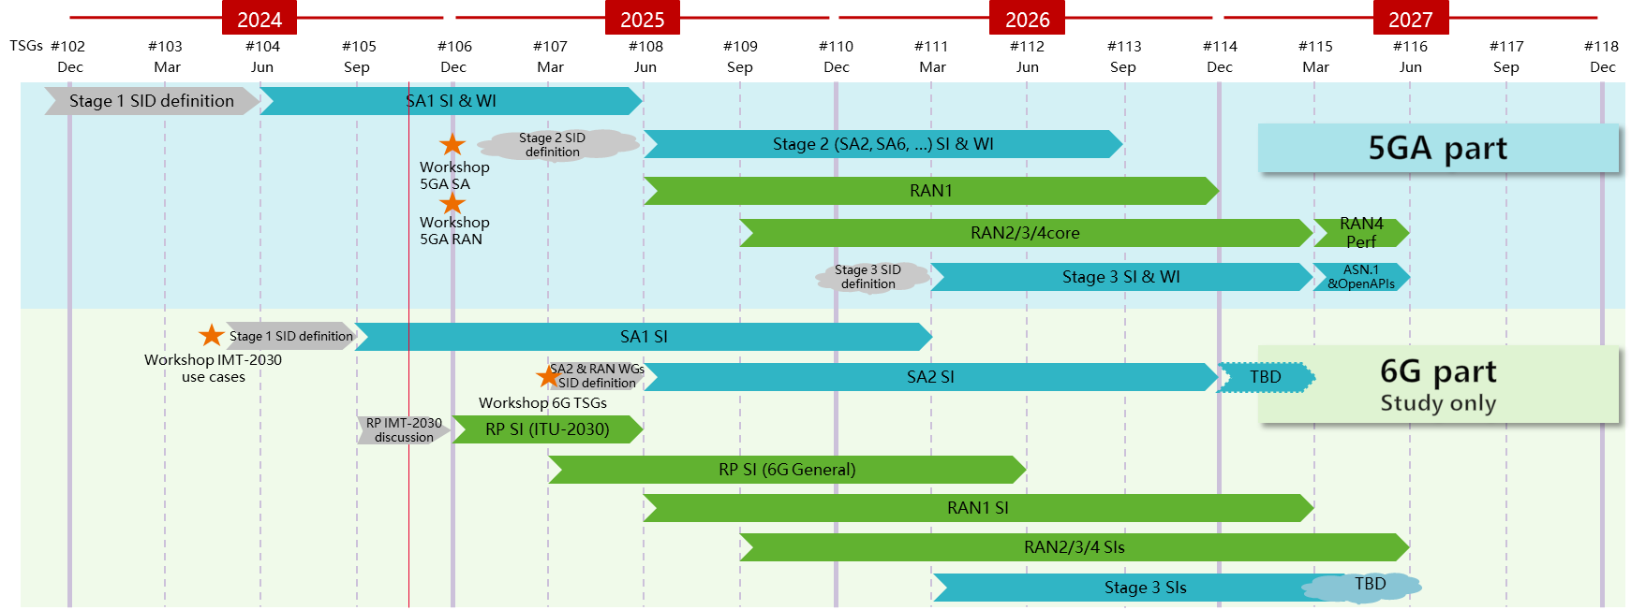
Figure 4-1: Rel-20 Timeline for 5GA and 6G
The 6G studies are currently ongoing in several groups in 3GPP:
- SA1 started first, and is about to complete their study on use cases and service requirements for the 6G networks in March 2026 [1].
- The SA2 study on the architecture for 6G networks [2] has been approved in the latest plenary SA #108. SA2 intends to send their TR for information in September 2026. The completion date has not been determined yet and a check point is planned in December 2025.
- RAN has also initiated a related study on scenarios and requirements for 6G access networks [3]. RAN intends to complete this work in June 2026.
The timelines for SA3/SA4/SA5 are still under discussion. Considering the timeline above, it could be estimated that SA3 can have up to 24 months for the 6G security study taking into account an additional meeting cycle by comparison to other stage 2 groups. In our view, it is crucial to reserve enough time from SA3 agenda for 6G discussions to be able to provide the support that is needed to SA2 and RAN groups on security topics.

5 Objectives for SA3 study
SA1, SA2 and RAN study items already include references to various security related topics. For example, the new 6G RAN design requires the development of related access security mechanism. This could be based on the existing security mechanism or potentially new enhanced ones. Furthermore, SA2 will study the support for control signalling for connectivity services and/or beyond connectivity services with whether and how to enable the introduction of a new non-access stratum functionality. This may warrant the development of new requirements for overall security architecture. Additional security enhancements may also be needed depending on how the 6G Core is designed, e.g., for the SBA framework, network exposure framework, etc.. The 6G system is also expected to support interworking with 5GS and maybe EPS, potentially over different types of accesses. This may introduce new threats that require new mitigations.
6G includes new features as well. For example, AI agents, sensing, computing for UE, core network and application server in 6G, a new data framework. Such features may bring new threats and security requirements, e.g., AI agent related security and privacy, lifecycle data governance, data framework’s own security, and/or enhancement for user consent framework. 6G is expected to ensure secure and reliable AI services while preserving user privacy and data protection at the forefront. All of these evolving new concepts require careful analysis by SA3.
In addition to the dependencies with other 3GPP working groups, SA3 may also consider independent topics and security requirements. In fact, there are external (outside of 3GPP) valuable sources of new potential security requirements such as NGMN Alliance [4]. Other topics include the trust and user privacy aspects of the 6G system. In fact, there is a variety of trusted information that is handled in the 6G networks, e.g., identity information, certificates management for inter-PLMN and intra-PLMN communication, or even for other types of communication such as with service providers or over the top (e.g., apps). There may be a need to design a new framework for multi parties trust for all actors within a 6G network. Meanwhile, as there are several roles for users, it’s very likely the user may hold different identities for serving multiple purposes which is visible dedicatedly to the corresponding service providers, how to manage those user identities and identify them has to be considered in 6G phase.
We envision that the 6G Security work should try to cover all potentially relevant security problems including but not limited to the following.
- The security architecture and authentication framework for the 6G system including device to network communication potentially over different types of accesses, network domain security and privacy.
- AI related security aspects taking into account the introduction of AI agents, a completely novel concept that requires careful analysis by SA3.
- Sensing related security aspects.
- Privacy for all aspects including data collection, distribution, processing, storage, exposure in light of the new data framework to be developed by SA2.
- The overall trust model, a recurrent subject of debate that needs careful reconsideration to take into account various new aspects and features and not only focused on the nature of deployment.
The dependent 6G security SID work tasks could be based on the SA2 ones as follows.
- One main level 1 task for the security design work for the 6G system that could be potentially split into subtasks, e.g., device to network security, network domain security and privacy.
- Other level 1 tasks that map directly to the SA2 ones for the additional features such as AI, data framework, sensing, etc.
For independent 6G security topics, we consider this as business as usual and hence can be treated and managed as any other work item. More precisely, in our view there is no need to have an umbrella 6G security SID that cover all the work related to 6G.

6 Proposal
Take into account the suggestions during the discussion and planning for the 6G work.

