3GPP TSG RAN WG2 Meeting #133 R2-260xxxx
Gothenburg, Sweden, Feb. 9th-13th 2026
Agenda Item: x.x.x
Source: Xiaomi
Title: Report of [POST132][008][6G] UE capability pain points (Xiaomi)
Document for: Discussion and Decision

Introduction
This report provides a summary for the following post-meeting email discussion:
- [POST132][008][6G] UE capability pain points (Xiaomi)
Intended outcome: Identify and capture the pain point issues (including root causes). Identify what RAN2 can focus on and which ones impact other WGs. Find a way to provide examples or demonstrate the identified pain issues to other WGs.
Identify what contributes the most to the overhead/complexity
Deadline: Long

This post meeting email discussion is targeting to have two phases:
Phase 1: Identify pain points and root causes
Comments are welcome to the listed pain points and root causes. Meanwhile, companies are also welcomed to provide examples (e.g., field data, analyzed log, etc) to demonstrate the complexity/overhead. Companies may also add new pain points and root causes into new (sub-)sections if needed. Earlier and interactive inputs are welcomed.
Phase1 Deadline: 19th Dec, 2025
Phase 2: Identify RAN2 focused area and impact to other WGs
Based on inputs during phase 1, phase 2 will categorize pain points and root causes from phase 1 inputs, then identify which one(s) contributes to the overhead/complexity most. RAN2 focused areas and other WGs impacts based on the identified pain points/root causes will also be discussed.
Phase 2 Deadline: 23rd Jan, 2026
Companies providing input to this email discussion are requested to leave contact information below.
Company | Name | Email Address
Xiaomi | Ziyi Li | liziyi5@xiaomi.com
OPPO | Qianxi Lu | qianxi.lu@oppo.com
vivo | Xiang Pan | panxiang@vivo.com

Phase 1 Discussion
This section summarized the pain points and root causes (if any) from contributions submitted to RAN2 #132 meeting.

Problem 1: Capability Signalling Size
Almost all companies acknowledge that the significant signalling size is the key problem/pain point of 5G UE capability. From contributions, several common reasons were mentioned:
- Root cause 1: Significant number of CA and related UE capability parameters; [R2-2508445 (Apple), R2-2508044 (Vivo), R2-2508076 (Xiaomi), R2-2508113 (Oppo), R2-2508616 (Huawei), R2-2508732 (Ericsson), R2-2508868 (Qualcomm), R2-2508876 (Samsung), R2-2508509 (ZTE), R2-2508097 (CATT), R2-2508839 (CMCC), R2-2508209(Sharp)]
- Root cause 2: Multiple band combination list e.g., for regular CA and for UL Tx Switching [R2-2508732 (Ericsson), R2-2508445 (Apple), R2-2508616 (Huawei), R2-2508076 (Xiaomi), R2-2508509 (ZTE)]
- Root cause 3: Same value for capabilities for some/all bands/BCs (e.g., capabilities across all CCs/band/BC); [R2-2508445 (Apple), R2-2508076 (Xiaomi), R2-2508097 (CATT), R2-2508113 (Oppo), R2-2508616 (Huawei), R2-2508732 (Ericsson), R2-2508509 (ZTE)]
- Root cause 4: Overclassified finer granularity [R2-2508616 (Huawei), R2-2508445 (Apple), R2-2508076 (Xiaomi), R2-2508322 (Nokia)]
- Root cause 5: Inefficient BC entry structure [R2-2508732 (Ericsson), R2-2508868 (QC), R2-2508876 (Samsung)]
- Root cause 6: Not well-used FeatureSet and FeatureSetCombination [R2-2508732 (Ericsson), R2-2508445 (Apple), R2-2508044 (vivo), R2-2508868 (QC), R2-2508509 (ZTE), R2-2508668 (NEC)]
- Root cause 7: Pairing between DL and UL cannot be indicated flexibly [R2-2508616 (Huawei), R2-2508509 (ZTE)]
- Root cause 8: Complex/none-forward compatible RF requirements [R2-2508076 (Xiaomi), R2-2508322 (Nokia)]

If this problem is agreeable, please indicate which root cause(s) listed above that can be agreeable, and add new root cause(s) if it is not mentioned above. Please also list the corresponding example(s) for both listed and new root cause(s), rapporteur will consolidate all examples in 2nd phase and facilitate the discussion of identifying which root cause contributes the most. Separate item/row is preferred if multiple root causes are identified:
Company | Please indicate which root cause(s) above is agreeable and input new root cause(s) if any | Example  (e.g., signalling, field data, analysed log, etc)
OPPO | Root cause 2
OPPO | To enhance signaling efficiency, two primary approaches can be considered. First, we can optimize the ASN.1 syntax structure by identifying and eliminating redundant elements (as already been done here in the other root cause). Second, we may apply compression algorithms to the generated capability messages to further reduce their size. Both methods aim to improve overall system performance through more efficient data transmission. | As demonstrated in our previous study (R2-2508113), conventional compression algorithms - including Deflate, LZMA, and PPMD - typically achieve an average compression ratio of approximately 50%, which proves the redundancy in the current capability signaling in the level of ~50%.
vivo | Cause 1 | 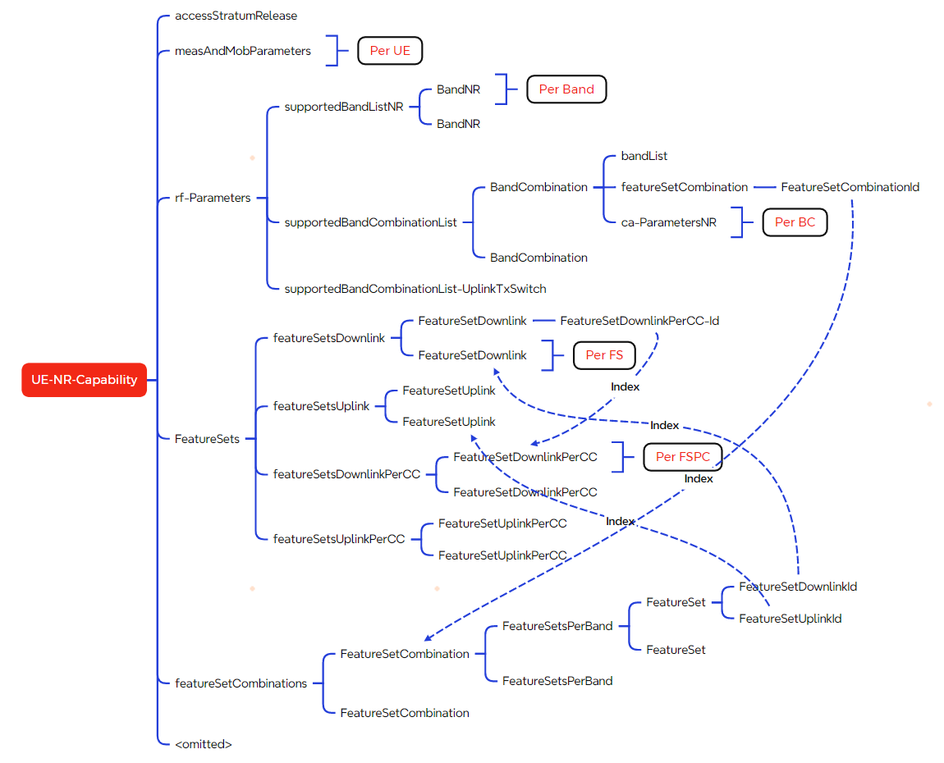  The signaling of UE NR capability is illustrated in the above figure. It can be observed that excessive number of band combinations leads to an almost linear growth in the size of rf-Parameters.  We further analyzed the log of commercial UE and observed that even though the network used a filter to allow the UE to only report BCs that include bands 28, 41, and 79, the UE still reported 21 BCs formed by bands 28, 41, and 79.  Thus, reducing the number of BC could significantly reduce the signaling overhead of capability information.
vivo | Cause 2 | 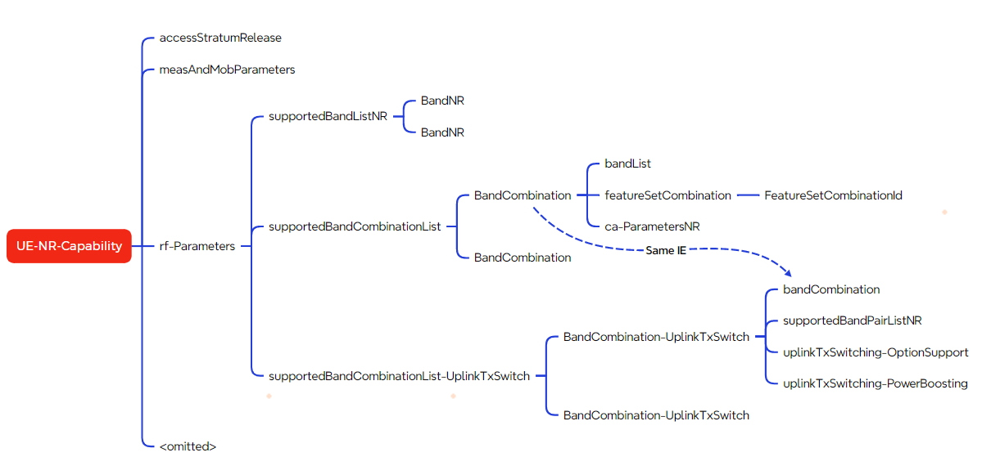  The current relationship between signaling of band combination for CA and ULTxSwitch is shown in the above figure. It can be observed that both BandCombination-UplinkTxSwitch and SupportedBandCombinationList contain the BandCombination IE.  Furthermore, in our logs, we observed that certain parameter values under the same band combination, e.g., ca-BandwidthClassUL, are the same between BandCombination-UplinkTxSwitch and SupportedBandCombinationList.
vivo | Cause 3/ Cause 4 | Based on the analysed log, we observed that mimo-ParametersPerBand includes a large number of capability parameters, while the values of most of these parameters the UE signalled are the same across all the supported bands, e.g., maxNumberConfiguredTCIstatesPerCC;  maxNumberActiveTCI-PerBWP;  pusch-TransCoherence;  periodicBeamReport;  aperiodicBeamReport;  …  We think Cause 4 is similar to Cause 3, i.e., the same value for capabilities for these parameters is due to unnecessary overclassified finer granularity.
vivo | Cause 6 | Based on the analysed log, we observed that the UE reported 21 BCs formed by band 28, 41 and band 79, while no single featureSetCombination was used twice across these combinations.
If companies don’t see the pain point as a problem or an area to be considered in 6G UE capability complexity/overhead reduction, please comment in below the reason and justification.
Company | Comment on Pain Point
OPPO | Regarding Root Cause 1:  While we acknowledge that the BC list (and/or FS/FSC list) contributes significantly to signaling overhead, we don't consider it the fundamental issue. The true root cause lies in the unnecessary reporting of certain information, but it is not the case when UEs do support numerous BCs that are requested for reporting. We suggest R2 monitor R4's progress on the 'band-group' concept as a potential solution.  Regarding Root Cause 3:  The adoption of per-band capability was primarily driven by the ambiguity created by per-UE capability with XDD/FRX differences. As documented in LS R2-2006367, R2 consequently decided to implement the per-band capability approach.  Regarding Root Cause 4:  This issue represents a fundamental trade-off between implementation flexibility and signalling overhead. Given this balance, R2 cannot reasonably provide definitive guidance favouring large granularity capabilities. Each case should be evaluated individually based on its specific requirements.  Regarding Root Cause 5:  As noted in document 8732, a UE supporting multiple bands with various carrier configurations can generate numerous band combination entries. The signaling overhead appears to stem from RF capability requirements for different UL carrier positions and constellation scenarios. However, we have yet to identify specific redundant information that could be reduced, particularly since baseband capability is already compressed using FS/FSC methods.  Regarding Root Cause 6:  We have observed instances of low FS/FSC reusing ratios. Similar to Root Cause 1, without signaling duplication, no significant gains can be expected from the FS/FSC method. Nevertheless, this doesn't diminish the method's potential to reduce overhead when genuine redundancy exists. This again presents a trade-off between implementation flexibility and signalling efficiency.  Regarding Root Cause 7:  This issue is closely tied to UL and DL decoupling progress. We believe it's unrealistic to expect a signaling framework that allows completely arbitrary UL/DL band pairing, as each combination presents unique RF challenges. Therefore, achieving truly flexible DL-UL pairing indications appears impractical.  Regarding Root Cause 8:  While power class and CBW examples are provided - both are known as challenging areas for R4 - we don't yet see how these factors contribute substantially to signaling overhead. At this preliminary stage, it's unclear what feasible actions R4 could take regarding these specific aspects.
vivo | The current definition and description of Problem 1 are too high-level. The listed root causes focus solely on RF capabilities and associated Feature Sets/Feature Set Combinations, but these are not the only reasons leading to significant capability signalling size. For instance, Problem 2 and Problem 4 can also contribute to increased capability signalling size.  To avoid overlapping, it is recommended to refine Problem 1 as: Capability Signalling Size related to RF parameters and featureSet/featureSetCombination.

Problem 2: Inefficient network filtering
Several companies [R2-2508044 (Vivo), R2-2508076 (Xiaomi), R2-2508097 (CATT), R2-2508145 (MTK), R2-2508610 (LG)] think that current network filtering mechanism is not efficient.
- Root Cause 1: Improper/coarse filters (only support RAT/frequency band filtering) and UE may still report capabilities that are not supported by network [R2-2508044 (Vivo), R2-2508097 (CATT), R2-2508610 (LG)]
- Root Cause 2: Network requests a large number of bands in the filter defeating the purpose of the filter [R2-2508145 (MTK)]
- Root Cause 3: UE may still further filter reported capabilities due to limited RRC message size [R2-2508076 (Xiaomi), R2-2508145 (MTK)]
Some companies [R2-2508732 (Ericsson)] also mention some rules/criteria needs to consider when introducing new filters.
If this problem is agreeable, please indicate which root cause(s) listed above that can be agreeable, and add new root cause(s) if it is not mentioned above. Please also list the corresponding example(s) for both listed and new root cause(s), rapporteur will consolidate all examples in 2nd phase and facilitate the discussion of identifying which root cause contributes the most. Separate item/row is preferred if multiple root causes are identified:
Company | Please indicate which root cause(s) above is agreeable and input new root cause(s) if any | Example
vivo | Cause 1 | The UE filtered the band combinations in the supportedBandCombinationList in accordance with this appliedFreqBandListFilter, while UE could report more bands in supportedBandListNR that are not included in the appliedFreqBandListFilter. However, the NW may ignore some of the bands in the supportedBandListNR when configuring the UE.
If companies don’t see the pain point as a problem or an area to be considered in 6G UE capability complexity/overhead reduction, please comment in below the reason and justification.
Company | Comment on Pain Point
OPPO | While precise filtering can effectively reduce signaling overhead, it ultimately requires the UE to submit additional reports when transitioning to network nodes with differing capabilities. In essence, filtering simply divides a single large UE capability report into multiple smaller, incremental reports.  Therefore, filtering must strike a balance - its primary purpose should be to eliminate capabilities that would never be utilized as the UE moves within the PLMN (or at least across a significant large geographic area). It should not attempt to achieve overly precise filtering tailored to the capabilities of a single RAN node.

Problem 3: Impractical RACS
Several companies [R2-2508044 (vivo), R2-2508076 (Xiaomi), R2-2508616 (Huawei), R2-2508868 (QC), R2-2508876 (Samsung), R2-2509032 (DT), R2-2508422 (DCM), R2-2508610 (LG), R2-2508540 (Sony), R2-2508668 (NEC)] thinks 5GNR RACS design is not practical.
- Root Cause 1: Per UE granularity (e.g., difficult to be reused by other UE(s)) [R2-2508044 (vivo), R2-2508076 (Xiaomi), R2-2508540 (Sony)]
- Root Cause 2: Single UE with multiple RACS IDs without knowledge of current UE situation [R2-2508616 (HW), R2-2508868 (QC)]
- Root Cause 3: Optional feature introduced in later release (R16) [R2-2508422 (DCM), R2-2508668(NEC)]
- Root Cause 4: Maintenance burden [R2-2508610 (LG), R2-2508616 (HW)]
- Root Cause 5: Delay and/or duplicated retransmit of full/wide filtered capability during UE mobility resulting from the network vendor change [R2-2508610 (LG), R2-2508868 (QC), R2-2509032 (DT)]

If this problem is agreeable, please indicate which root cause(s) listed above that can be agreeable, and add new root cause(s) if it is not mentioned above. Please also list the corresponding example(s) for both listed and new root cause(s), rapporteur will consolidate all examples in 2nd phase and facilitate the discussion of identifying which root cause contributes the most. Separate item/row is preferred if multiple root causes are identified:
Company | Please indicate which root cause(s) above is agreeable and input new root cause(s) if any | Example
vivo | Cause 1&Cause 4 | We observed that UEs with different versions of one single series, e.g., with/without -pro, have similar but not the same capabilities. As a result, two set of UE capabilities and RACS IDs should be allocated and maintained in NW.  We believe the RACS mechanism can effectively reduce the signaling overhead for capability reporting over the air interface. However, the excessive flexibility in NR UE capabilities makes it difficult for a single set of UE radio capabilities to be reused across multiple UEs. As a result, massive capabilities associated with different UEs will increase the maintenance burden from the network’s perspective.  In addition, although RACS was mainly specified by other WGs, e.g., SA2, the feature was triggered by RAN2’s SI conclusion in R16. We think it’s still make sense for RAN2 to trigger further discussion on 6G RACS in SA2 if the problem is valid.
If companies don’t see the pain point as a problem or an area to be considered in 6G UE capability complexity/overhead reduction, please comment in below the reason and justification.
Company | Comment on Pain Point
OPPO | We concur with the perspective shared by other companies via email that RACS does not constitute an R2 issue. Furthermore, even if RACS were to be ultimately adopted for 6G, its potential impact on the R2 discussions regarding signaling overhead reduction remains unclear to us. This is because, in any case, we must account for scenarios where the network lacks prior knowledge of the RACS identifier.

Problem 4: Unnecessary capability signalling
Several companies [R2-2508876 (Samsung), R2-2508076 (Xiaomi), R2-2509032 (DT), R2-2508422 (DCM), R2-2508903 (AT&T, etc), R2-2508209(Sharp)] mentioned that 5GNR defined a lot of unnecessary capability signalling for massive optional features and its components.
- Root Cause 1: massive optional features [R2-2508876 (Samsung), R2-2508076 (Xiaomi), R2-2509032 (DT), R2-2508422 (DCM), R2-2508903 (AT&T, etc), R2-2508209(Sharp)]
If this problem is agreeable, please indicate which root cause(s) listed above that can be agreeable, and add new root cause(s) if it is not mentioned above. Please also list the corresponding example(s) for both listed and new root cause(s), rapporteur will consolidate all examples in 2nd phase and facilitate the discussion of identifying which root cause contributes the most. Separate item/row is preferred if multiple root causes are identified:
Company | Please indicate which root cause(s) above is agreeable and input new root cause(s) if any | Example
vivo | Cause 1 | The feature groups and components for a specific feature should balance signaling overhead and flexibility.
If companies don’t see the pain point as a problem or an area to be considered in 6G UE capability complexity/overhead reduction, please comment in below the reason and justification.
Company | Comment on Pain Point
vivo | The current definition of Problem 4 is not aligned with the description, as Optional feature groups/components are not unnecessary capability signaling.  To avoid misunderstanding, it is recommended to refine Problem 4 as: unnecessary capability flexibility.

Problem 5: Commercialization challenges
During RAN2 #131bis/#132 meeting and RAN #110 meeting, several commercialization challenges are brought up from 5G UE capability framework and IODT test point of view. Based on the contributions to both RAN2 and RAN meetings, following root causes are summarized:
- Root Cause 1: No differentiation between non-trivial feature(s) and other feature(s). This further leads to under-reporting/finer granularity UE capability reporting used in 5G for the purpose of addressing individual deployment and infra vendors, but increases signalling overhead (as discussed in Problem 1); [RP-253230 (QC)]
- Root Cause 2: Mandatory feature is only mandating user equipment to implement, but not for the network, and further leads to losing tracking of ecosystem supported features in 3GPP. This makes difficult to guarantee the degree of forward compatibility; [RP-253066 (AT&T, etc), R2-2508903 (AT&T, etc)]
- Root Cause 3: Late deployment to wait for ‘slowest’ network vendor before activating a capability in operator’s network, due to no differentiation treatment of different vendors; [R2-2508868(QC), R2-2506988]
- Root Cause 4: Interoperability issue even after IoDT test is done, due to incompatibility to specification, insufficient tests covering the problematic case(s), lack of IoDT between vendors, etc. [R2-2507607 (ZTE), RP-253048(Oppo)]
If this problem is agreeable, please indicate which root cause(s) listed above that can be agreeable, and add new root cause(s) if it is not mentioned above. Please also list the corresponding example(s) for both listed and new root cause(s), rapporteur will consolidate all examples in 2nd phase and facilitate the discussion of identifying which root cause contributes the most. Separate item/row is preferred if multiple root causes are identified:
Company | Please indicate which root cause(s) above is agreeable and input new root cause(s) if any | Example
OPPO | Root cause 2
vivo | - Yes for Cause 2  - Cause 1 is ambiguous as the under-reporting seems duplicated with cause 3.  - No for Cause 3, the operators are expected to complete comprehensive IODT for all network vendors.  - No for Cause 4, avoiding interoperability issues is one of the key motivations of refining the spec and comprehensive IODT tests.  In addition, we understand that Cause 3/4 should be discussed in RANP. | Cause 2: Taking RRC_INACTIVE as an example, support for the RRC_INACTIVE state is mandatory for NR UEs, while this feature has not been widely deployed on the network. As a result, the extra implementation complexity for these features is in vain from UE’s perspective.  From R2’s perspective, we only focus on the spec impact, e.g., capturing some mandatory features of both UE/NW as stage 2 description, which can a reference for RAN5 to define the test use cases.
If companies don’t see the pain point as a problem or an area to be considered in 6G UE capability complexity/overhead reduction, please comment in below the reason and justification.
Company | Comment on Pain Point
OPPO | Regarding RP-253230, our understanding is that the core proposal primarily advocates for establishing basic granularity standards for 6G capability (specifically per-band in P1, per-BC in P2, and per-FS/FSPC in P3). The document also introduces requirements for mandatory network-side capabilities in cases where per-FS or per-FSPC capability proves unfeasible. However, we find the logical connection between these elements somewhat unclear and would appreciate further clarification from the proponents.  Additionally, as outlined in RP-253048, we maintain a negative stance toward the IoDT workaround approach. In particular, we oppose the direction of implementing per-vendor punitive measures, which fall under root causes 3 and 4.

Problem x: (New problem )
Problem description:
Company | Pain Point
Please add root cause(s) and the corresponding example(s). Separate item/row is preferred if multiple root causes are identified:
Company | Root Cause | Example
If companies don’t see the pain point as a problem or an area to be considered in 6G UE capability complexity/overhead reduction, please comment in below the reason and justification.
Company | Comment on Pain Point

Problem x: (New problem )
Problem description:
Company | Pain Point
Please add root cause(s) and the corresponding example(s). Separate item/row is preferred if multiple root causes are identified:
Company | Root Cause | Example
If companies don’t see the pain point as a problem or an area to be considered in 6G UE capability complexity/overhead reduction, please comment in below the reason and justification.
Company | Comment on Pain Point

Phase 2 Discussion
<to be updated based on phase 1 discussion>

Conclusion
<to be updated>

Reference
- R2-2508044 Discussion on 6GR UE capability framework vivo
- R2-2508073 Discussion on UE capability framework Transsion Holdings
- R2-2508076 UE Capability pain points and considerations Xiaomi
- R2-2508097 Considerations on 6GR UE Capability CATT
- R2-2508113 Discussion on 6G UE Capability OPPO
- R2-2508145 UE capability framework considerations for 6GR MediaTek Inc.
- R2-2508209 6GR UE Capability Framework SHARP Corporation
- R2-2508322 6GR UE capability framework Nokia
- R2-2508356 Views on UE capability signaling in 6G Charter Communications, Inc
- R2-2508422 On UE capability framework for 6G NTT DOCOMO INC.
- R2-2508445 Considerations on UE capability framework in 6G Apple
- R2-2508459 Discussion on UE capability aspects in 6G Fujitsu
- R2-2508509 Consideration on 6G UE Capability ZTE Corporation, Sanechips
- R2-2508540 Discussion on 6GR UE capability Sony
- R2-2508610 6G UE Capability Framework LG Electronics Inc.
- R2-2508616 Discussion approach for 6G UE capability Huawei, HiSilicon
- R2-2508622 Considerations on UE capability framework for 6GR Lenovo
- R2-2508624 UE Capability Framework in 6G Ofinno
- R2-2508668 Discussion on fundamentals of UE capability framework NEC
- R2-2508732 Improvements for UE capabilities Ericsson
- R2-2508768 Design of 6GR UE capabilities InterDigital, Inc.
- R2-2508839 Considerations on UE capability framework for 6GR CMCC
- R2-2508868 Considerations on UE capability framework in 6G Qualcomm Incorporated
- R2-2508876 UE capability framework for 6G Samsung
- R2-2508903 A New UE Capability Framework for 6G AT&T, Deutsche Telekom, Ericsson, Nokia, Orange, Panasonic, Spark NZ, Telecom Italia, Telstra, T-Mobile USA, Verizon, Viavi
- R2-2508916 Discussion on UE Capability Framework Futurewei Technologies
- R2-2508937 Consideration on 6GR UE Capability Spreadtrum, UNISOC
- R2-2508939 Consideration on 6G UE capability framework ETRI
- R2-2508963 Discussion on UE capability framework TCL
- R2-2508968 Discussion on IODT problems for 6G UE capability framework KDDI Corporation
- R2-2509032 Discussion on UE capability framework Deutsche Telekom AG
- R2-2509073 Discussion on dynamic UE capability update BT Plc, Ericsson, T-Mobile USA, Deutsche Telekom
- R2-2506988 Considerations on UE capability signalling in 6G Qualcomm Incorporated
- R2-2507607 Consideration on 6G UE Capability ZTE Corporation
- RP-253048 Discussion on Handling of IoDT issues Oppo
- RP-253230 Views on UE capability framework Qualcomm
- RP-253066 A New UE Capability Framework for 6G AT&T, Deutsche Telekom, Ericsson, KT Corp., Nokia, NTT Docomo, Orange, Panasonic, SK Telecom, Spark NZ, Telecom Italia, Telstra, T-Mobile USA, Verizon, Viavi, Vodafone, Xiaomi

