3GPP TSG-RAN WG2 Meeting #131bis R2-250xxxx
Prague, Czechia, 13th – 17th October, 2025

Agenda Item: 8.13.1
Source: OPPO
Title: Report of [Post131][411][Relay] Rel-19 relay 38.351 CR (OPPO)
Document for: Discussion, Decision

Introduction
The following document is to collect open issues for the following email discussion::
- [Post131][411][Relay] Rel-19 relay 38.351 CR (OPPO)
Scope: Update the CR in R2-2505353 in accordance with decisions of RAN2#131.
Intended outcome: Agreed CR in R2-2506323
Deadline: Short (for RP)

Companies are invited to provide feedback on open issue list by: Sept. 19th 10:00 UTC.

Remaining open issues for specification TS 38.351
Companies are invited to describe any other identified open issues not currently included within this document
SRAP-Issue num (Company) | Identified open issues | Suggested change | Rapp comment
SRAP-1(ASUSTeK) | The handling of the last relay operation for identifying SRB0 of the Child UE is not clearly captured in the current running CR clause 5.2.2.0/5.2.2.2. | In clause 5.2.2.0: 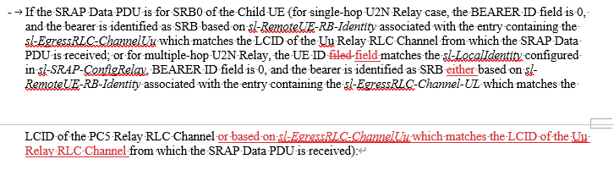  In clause 5.2.2.2:  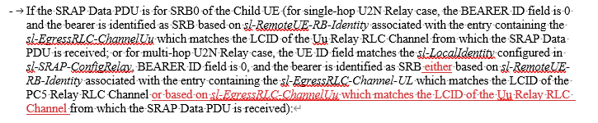  [Rapp] Based on offline comment, the change will be updated as follows:  In clause 5.2.2.0:  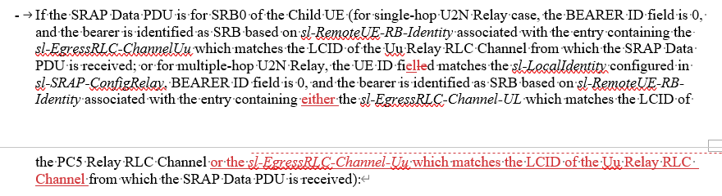  In clause 5.2.2.2:  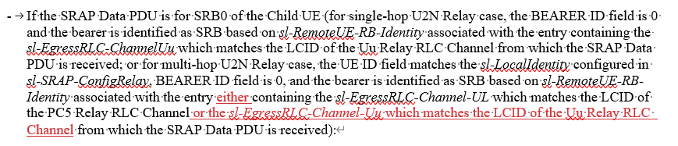 | Agree, will be included in the Rapp CR
SRAP-2 (Huawei) | The egress link determination seems unclear at the relay UE in the procedural text.  The egress link should be determined based on the mapping between the local ID (contained in the SRAP header) and the L2ID of the connected child UE in the downstream.  If we agree for such change here, we will also need to introduce similar change in the RRC spec. | The corresponding change in clause 5.2.2.1 is highlighted:  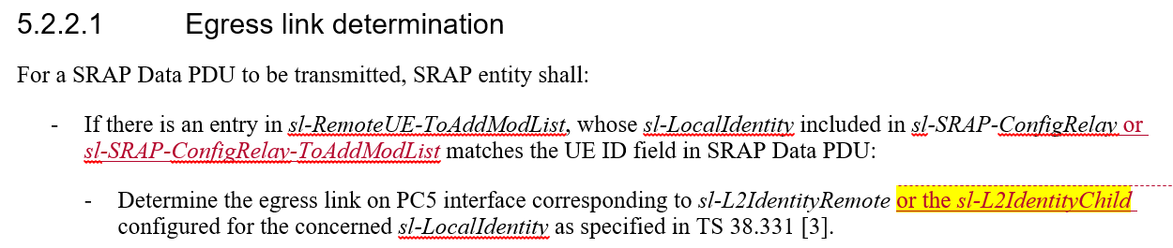 | Thanks, the sl-L2IdentityRemote is the L2ID of the connected child UE in the downstream, so the new IE is not needed.
SRAP-3 (Huawei) | The error handling of SRB0 and SRB1 at the intermediate relay UE (except for the first relay UE).  It is possible that the intermediate relay UE does not receive the RRC reconfiguration when receiving the SRB0/SRB1 message from the connected child UE during the RRC setup procedure/the path switch procedure. In the current spec, the intermediate relay may discard the SRB0/SRB1 message in the above case. We need to consider the above case in the error handling clause. | The corresponding change in clause 5.4 is highlighted:  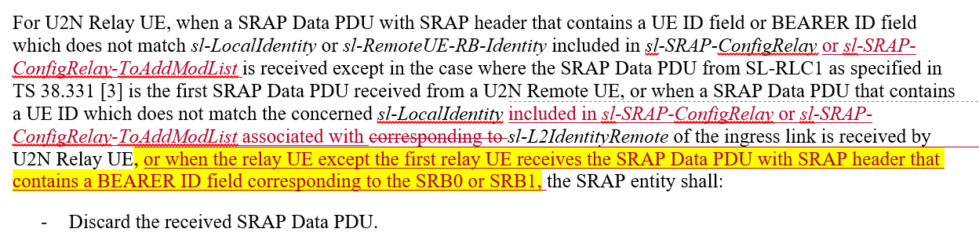 | Thanks, the understanding is the intermediate relay UE is in RRC connected state, which means the network will provide the necessary configurations for the Remote UE’s SRB0/SRB1, based on that understanding, seems no special handling for that case is needed. We can hear the view from other companies.
SRAP-4 (OPPO) | In clause 3.1, the Terms for Last Relay is not aligned with other spec. | Add missing sentence “The child UE is the U2N Remote UE in case of single-hop L2 U2N Relay communication.” | Misc issue, will be included in the Rapp CR
SRAP-5 (OPPO) | In clause 4.2.2, one type in Figure 4.2.2-2 | Add space between “theChild”. | Misc issue, will be included in the Rapp CR
SRAP-6 (OPPO) | In clause 5.2.2.2, based on current procedure, for SRB1 of directly and indirectly Remote UE, it assumed default configuration (SL-RLC1) can be used. But there is no agreement on that. | Considering RAN2 agrees the configuration of indirectly connected remote UE’s SRB0 is dedicated configuration, seems it is reasonable to use dedicated configuration for SRB1 as well instead of use default SL-RLC1 to differentiate the SRB1 from Child UE and other remote UEs.  - As in single-hop U2N Relay mechanism, R2 confirm, for the DL and UL SRB0 of remote UE in multi-hop U2N Relay:  - At the link between remote UE and the first relay UE, reuse the specified PC5 RLC channel (i.e., SL-RLC0);  - At the link between intermediate relay UEs or the link between intermediate relay and the last relay, or the link between the last relay and the network, the RLC channel is configured by the network via dedicated RRC message.  RAN2 to discuss using dedicated RLC channel configuration for SRB1 of indirectly connected remote UE.  If it can be agreed, change as follows: | Considering this issue is not discussed in RAN2, contribution input on the open issue is recommended.
SRAP-7 (OPPO) | In clause 5.2.3, for the receiving operation of U2N Remote UE, sl-EgressRLC-Channel-UL is not applicable here | Remove “or sl-EgressRLC-Channel-UL” | Misc issue, will be included in the Rapp CR
SRAP-8 (OPPO) | In clause 5.2.3.3.2, for BEARER ID shared by SRB and DRB, it should be sl-EgressRLC-Channel-DL to refer | Change “sl-EgressRLC-Channel-UL” to “sl-EgressRLC-Channel-DL” | Misc issue, will be included in the Rapp CR
Based on the above discussion, it is proposed to discuss open issue SRAP-6 in the coming RAN2 meeting, and contribution from companies are welcomed.
- (SRAP-6) RAN2 to discuss the RLC channel configuration to be used for SRB1 in multi-hop U2N Relay:
- Option-1: Similar to SRB0, the default SL-RLC1 can be used on the PC5-hop between remote UE and the First U2N Relay, dedicated RLC channel configuration is used on the other hops.
- Option-2: The default SL-RLC1 can be used on all the hops, Additionally, define the behavior of intermediate relay UEs depending on whether the RLC channel configuration for SRB1 is present or absent.

Conclusions
<To be filled after companies have provided feedback to the proposed resolutions for simple issues only. Please include the number of supporting companies (e.g., 18/20]) in brackets within the proposal>
The following proposals have been provided based on feedback to the above document:

[Proposals for discussion]
<List all proposals which will likely require further online/offline discussion to resolve>
- (SRAP-6) RAN2 to discuss the RLC channel configuration to be used for SRB1 in multi-hop U2N Relay:
- Option-1: Similar to SRB0, the default SL-RLC1 can be used on the PC5-hop between remote UE and the First U2N Relay, dedicated RLC channel configuration is used on the other hops.
- Option-2: The default SL-RLC1 can be used on all the hops, Additionally, define the behavior of intermediate relay UEs depending on whether the RLC channel configuration for SRB1 is present or absent.

References
[1] R2-2506566 Introduction of NR sidelink multi-hop relay in TS 38.351

