3GPP TSG-RAN WG2 #130 R2-250xxxx
xxx, xxx, May 2025

Agenda Item: 8.13.1
Source: OPPO
Title: Remaining SRAP open issues in R19 L2 Multi-hop U2N sidelink Relay
Document for: Discussion, Decision

Introduction
The following document includes a list of open issues according to the following email discussion:
[Post129bis][407][Relay] Rel-19 relay CR to 38.351 (OPPO)
Scope: Update the 38.351 running CR from the baseline of R2-2503077 to take into account decisions of RAN2#129bis.
Intended outcome: Updated CR for RAN2#130
Deadline: Long

Companies are invited to provide feedback on open issue list by: 2rd May 2025

Remaining open issues for specification TS 38.351
Open issue SRAP-1: SRAP configuration of indirectly connected Remote UE
Issue description:
Relevant agreement:
SRAP configuration including remote UE ID and BEARER ID is configured by the network via dedicated RRC signalling as in R17.
For the SRAP configuration at the relay UE (both last relay and intermediate relay UE), rely on network to provide SRAP configuration for at least the directly connected child UEs, based on the L2 IDs of the direct connected child UEs.
For CR drafting, assume as a baseline that the child UE’s SRAP configuration can include entries for indirect child UE with associated local ID for next-hop determination. We will review next meeting if this explicit mapping functionality is needed.
FFS whether to introduce reflective bearer mapping as an optional feature.
Status in running CR：
Based on the above RAN2 agreements, the running CR is drafted according to the baseline solution that the child UE’s SRAP configuration can include entries for indirect child UE with associated local ID. And related Editor’s Notes are added in clause 4.5 and 5.2.2.1 as follows:
EN at clause 4.5:
Editor’s Notes: FFS whether the UE ID for indirectly connected U2N Remote UE is needed.
EN at clause 5.2.2.1:
Editor’s Notes: FFS whether the SRAP configuration list for the indirectly connected Remote UE is needed.
Main points of contention:
How does the reflective bearer mapping mechanism work needs to be further clarified. And whether to introduce reflective bearer mapping as an optional feature.
Possible options:
Option-1: Besides the baseline mechanism specified in the running CR, additional support the reflective bearer mapping as optional feature. For this option, how does the reflective bearer mapping work needs to be clarified.
Option-2: Not to additionally support the reflective bearer mapping.

Open issue SRAP-2: SRAP configuration parameter name
Issue description:
Relevant agreement:
SRAP configuration including remote UE ID and BEARER ID is configured by the network via dedicated RRC signalling as in R17.
For the SRAP configuration at the relay UE (both last relay and intermediate relay UE), rely on network to provide SRAP configuration for at least the directly connected child UEs, based on the L2 IDs of the direct connected child UEs.
For CR drafting, assume as a baseline that the child UE’s SRAP configuration can include entries for indirect child UE with associated local ID for next-hop determination. We will review next meeting if this explicit mapping functionality is needed.
FFS whether to introduce reflective bearer mapping as an optional feature.
Status in running CR：
Editor’s Notes is added in clause 5.2.2.2 as follows:
EN at clause 5.2.2.2:
Editor’s Notes: The IE name e.g., sl-SRAP-ConfigRelayList, sl-EgressRLC-Channel-DL, sl-EgressRLC-Channel-UL, local ID of the directly connected remote UE will be updated to align with RRC specification.
Main points of contention:
Parameter name.
Possible options:
Parameter name will be aligned with RRC specification.

Open issue SRAP-3: Error handling in multi-hop U2N Relay
Issue description:
Relevant agreement:
Agreements:
In multi-hop L2 U2N relay, besides the agreed remote UE ID and BEARER ID, in addition, at least include D/C field in the SRAP PDU header.
In multi-hop L2 U2N relay, for SRAP header, at least support the legacy single-hop U2N SRAP header, i.e., the agreed UE ID field is used for the remote UE local ID (including the case of an intermediate relay UE acting as a remote UE). FFS on whether to have one additional format to include remote UE L2 ID and what use case it is applied for.
Status in running CR：
In R17/18 Relay, the UE identify SRAP data PDU based on the SRAP header and SRAP configuration, the UE will discard the unknown data PDU with unknown UE ID and/or BEARER ID. The current running CR is drafted by following legacy principle. An Editor’s Note is added in clause 5.4 as follows to see whether additional/other error handling cases needed.
EN in clause 5.4:
Editor’s Notes: Handling of unknown, unforeseen, and erroneous protocol data of L2 intermediate U2N Relay (if any delta issue) is to be added.
Main points of contention:
In the baseline procedure, seems the legacy principle can be reused and no delta issue identified. The possible uncertainty is about if parallel RRC setup procedure is supported, the intermediate relay UE may need to handle the unknown SRAP data PDU (e.g., DL SRB0 or UL SRB1) before acquire the SRAP configuration.
Possible options:
Option-1: Don’t support parallel RRC setup procedure with additional SRAP header format at least for DL, so no additional issues for error handling.
Option-2: If parallel RRC setup procedure with additional SRAP header format is supported for DL, the UE will not process error handling until SRAP configuration from the network is obtained.

Open issue SRAP-4: parallel RRC setup procedure with additional SRAP header format
Issue description:
Relevant agreement:
Agreements:
Continue to consider forwarding of SRB0 messages by relay UEs not in RRC_CONNECTED with respect to control plane approach 1.
TPs showing the two approaches for fast forwarding of SRB0 (SRAP header and local ID assignment by RRC signalling) are invited for next meeting (co-sourcing strongly encouraged).
Other approaches are not precluded (contribution-driven) but should be shown at a mature stage considering the time left.
Strive to avoid additional RAN3 impact specific to fast forwarding.
FFS if applicable to DL.
FFS what level of gNB awareness of the path information would be needed.
FFS if fast forwarding is optional/mandatory for UEs to support.
Status in running CR：
The baseline SRAP header format is reused, an Editor’s Note is added in clause 6.2.2 as follows.
EN in clause 5.4:
Editor’s Notes: FFS on whether the SRAP Data PDU format for single-hop U2N relay can already cover multi-hop U2N Relay.
Main points of contention:
Whether/how to support the parallel RRC setup procedure with additional SRAP header format as optional feature. And whether to support only UL or both UL and DL.
Possible options:
Option-1: Don’t support parallel RRC setup procedure.
Option-2: Support parallel RRC setup procedure for UL only.
Option-3: Support parallel RRC setup procedure for both UL and DL.

Other identified open issues
Companies are invited to describe any other identified open issues not currently included within this document
Company | Other identified open issues? (please describe)
Ericsson | Issue - Whether L2 ID of an indirectly connected child UE is needed in the SRAP config  RAN2 has agreed in RAN2#129bis that  For CR drafting, assume as a baseline that the child UE’s SRAP configuration can include entries for indirect child UE with associated local ID for next-hop determination. We will review next meeting if this explicit mapping functionality is needed.  For the above baseline approach, after checking the RRC spec, we think it may be better to also include L2 ID for each indirectly connected child UE. It may be easier to implement in RRC from ASN.1 extension perspective. Since in the current RRC spec,  SL-RemoteUE-ToAddMod-r17 ::= SEQUENCE {  sl-L2IdentityRemote-r17 SL-DestinationIdentity-r16,  sl-SRAP-ConfigRelay-r17 SL-SRAP-Config-r17 OPTIONAL, -- Need M  ...  }  The field sl-L2IdentityRemote-r17 will be always present in the IE.  So, for each relay UE, the relay UE can be configured with SRAP configuration for each child UE separately/independently, regardless of it is directly connected or indirectly connected.  In addition, such alternative may be easier for relay UE to search the matching entry when receiving a SRAP data PDU, the relay UE doesn’t need to perform nested search. In such alternative, we can introduce a new field nextHopL2ID-r19 in SL-RemoteUE-ToAddMod-r17, which is only present for indirectly connected child UE, the egress link for indirectly connected child UE is determined based on nextHopL2ID. Alternatively, no new field is needed, instead, sl-L2IdentityRemote-r17 of each indirectly connected child (remote) UE can be set as the L2ID of the directly connected child, i.e., parent (or grandfather) of the indirectly connected child.  We would like to check if this new alternative is ok to companies.  [OPPO]: The understanding is this new alternative cannot work work since the SL-RemoteUE-ToAddMod is an Add/Mod structure, which means the L2 ID has to uniquely identify a SRAP configuration.  [Ericsson] don’t agree with RAPP.  however, by checking the spec, it says  Else if there is an entry in sl-RemoteUE-ToAddModList, whose sl-LocalIdentity included in sl-SRAP-ConfigRelay or [sl-SRAP-ConfigRelayList] matches the UE ID field in SRAP Data PDU, which includes an sl-RemoteUE-RB-Identity that matches the SRB identity or DRB identity of the SRAP Data PDU determined by the BEARER ID field (For the BEARER ID shared by both SRB and DRB, SRB and DRB are differentiated based on sl-RemoteUE-RB-Identity associated with the entry containing the sl-EgressRLC-ChannelUu which matches the LCID of the Uu Relay RLC Channel or [sl-EgressRLC-Channel-UL] which matches the LCID of the PC5 Relay RLC Channel from which the SRAP Data PDU is received, and for DRB, the DRB identity is BEARER ID plus 1):  It clearly sees that “local ID” is used to locate the SRAP config.  [OPPO]: Thanks for the further discussion. We understand  - the ToAddMod/Release structure issue is defined in TS 38.331 and more related to RRC, in the following copied RRC specification, for the Add/Mod/Release handling, the L2 ID is used to let the UE know which entry is to be reconfigured.  - for the above highlight SRAP specification is it doesn’t mean “local ID” is used to locate each entry the SRAP configuration, but just to say whether there is an entry contains the concerned local ID configuration.  We can further discuss this issue in the coming R2 meeting, and the following EN is added to address this:  Editor's Notes: FFS whether SRAP configuration for each indirectly connected Remote UE is configured repeatedly with the L2·ID of the directly connected child UE (i.e., same L2·ID for multiple entries).  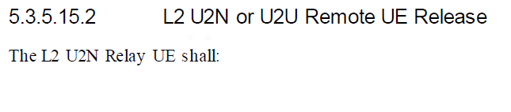  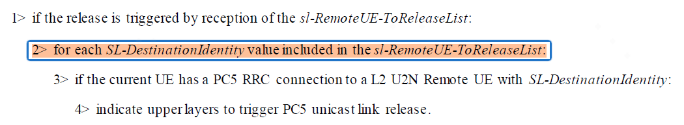  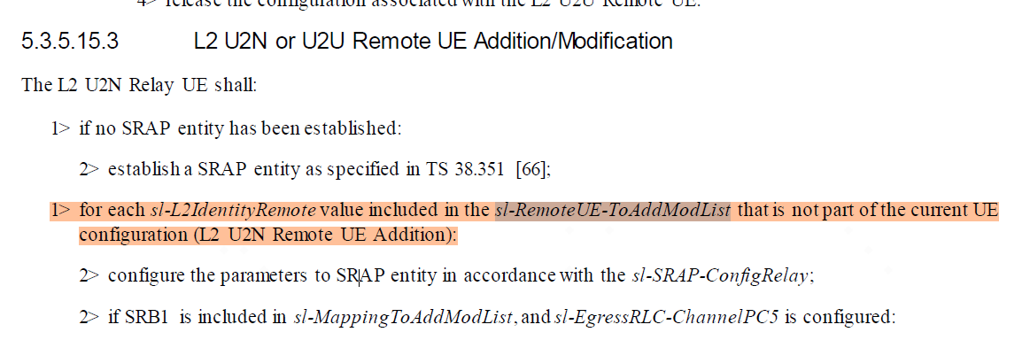
ASUSTeK | In the current Running CR, we have the following paragraph in 5.4 for handling unknown, unforeseen, and erroneous PDU:  For U2N Relay UE, when a SRAP Data PDU with SRAP header that contains a UE ID field or BEARER ID field which does not match sl-LocalIdentity or sl-RemoteUE-RB-Identity included in sl-SRAP-ConfigRelay or [sl-SRAP-ConfigRelayList] is received except in the case where the SRAP Data PDU from SL-RLC1 as specified in TS 38.331 [3] is the first SRAP Data PDU received from a U2N Remote UE, or when a SRAP Data PDU that contains a UE ID which does not match the concerned sl-LocalIdentity corresponding to sl-L2IdentityRemote of the ingress link is received by U2N Relay UE, the SRAP entity shall:  - Discard the received SRAP Data PDU.  In our opinion, the highlight statement is not proper for multi-hop U2N relay because the ingress link, in case of multi-hop U2N relay, refers to the link with the child relay UE instead of the link with the Remote UE (except the first relay UE). A potential TP as below:  For U2N Relay UE, when a SRAP Data PDU with SRAP header that contains a UE ID field or BEARER ID field which does not match sl-LocalIdentity or sl-RemoteUE-RB-Identity included in sl-SRAP-ConfigRelay or [sl-SRAP-ConfigRelayList] is received except in the case where the SRAP Data PDU from SL-RLC1 as specified in TS 38.331 [3] is the first SRAP Data PDU received from a U2N Remote UE, or when a SRAP Data PDU that contains a UE ID which does not match the concerned sl-LocalIdentity corresponding toincluded in sl-SRAP-ConfigRelay or [sl-SRAP-ConfigRelayList] associated with sl-L2IdentityRemote of the ingress link is received by U2N Relay UE, the SRAP entity shall:  - Discard the received SRAP Data PDU.  [OPPO]: Thanks, the running CR is updated accordingly.

Conclusions
<To be filled after companies have provided feedback to the proposed resolutions for simple issues only. Please include the number of supporting companies (e.g., 18/20]) in brackets within the proposal>
The following proposals have been provided based on feedback to the above document:
[Proposals for easy agreement]
<List all proposals with consensus and/or may be easily agreed based on Rapporteur’s opinion>

[Proposals for discussion]
<List all proposals which will likely require further online/offline discussion to resolve>

References
[1] R2_129b_Positioning_Relay_2025-0410-1040
[2] R2_129_Positioning_Relay_2025-02-21-0845_eom

Appendix (Optional)
Agreements in RAN2 #129:
In multi-hop L2 U2N relay, besides the agreed remote UE ID and BEARER ID, in addition, at least include D/C field in the SRAP PDU header.
In multi-hop L2 U2N relay, for SRAP header, at least support the legacy single-hop U2N SRAP header, i.e., the agreed UE ID field is used for the remote UE local ID (including the case of an intermediate relay UE acting as a remote UE). FFS on whether to have one additional format to include remote UE L2 ID and what use case it is applied for.
Agreements in RAN2 #129bis:
The term “U2N relay UE” can include first/intermediate/last relay UEs in multihop, if not otherwise qualified. We can distinguish explicitly when a requirement applies only to single-hop or only to certain multihop roles.
The term “U2N remote UE” can include multihop remote UEs, if not otherwise qualified. We can distinguish explicitly when a requirement applies only to single-hop or only to multihop.
Expand the definitions of “U2N relay UE” and “U2N remote UE” in the CR definition sections to include multihop. This drafting can be done initially in the 38.300 running CR and migrated later into the other CRs.
The existing multihop definitions, e.g., first/intermediate/last relay UE, are kept. FFS if they need debugging (business as usual). The intention is that the first relay UE is an intermediate relay UE, as originally agreed.
The terms “parent” and “child” UE can be used in CR drafting. FFS if they need to be defined, based on how we end up using them.

Continue to consider forwarding of SRB0 messages by relay UEs not in RRC_CONNECTED with respect to control plane approach 1.
TPs showing the two approaches for fast forwarding of SRB0 (SRAP header and local ID assignment by RRC signalling) are invited for next meeting (co-sourcing strongly encouraged).
Other approaches are not precluded (contribution-driven) but should be shown at a mature stage considering the time left.
Strive to avoid additional RAN3 impact specific to fast forwarding.
FFS if applicable to DL.
FFS what level of gNB awareness of the path information would be needed.
FFS if fast forwarding is optional/mandatory for UEs to support.

Reuse the single-hop relay mechanism to support the Local ID allocation for multi-hop relay:
• First relay UE reports the L2 ID of the remote UE to the gNB to request the local ID allocation, the uniqueness of the local ID within the cell is assumed to be guaranteed by the gNB by implementation.
• The remote UE local ID is 8 bits.

As in single-hop U2N Relay mechanism, R2 confirm, for the DL and UL SRB0 of remote UE in multi-hop U2N Relay, SRAP header is present over each hop except the PC5 hop between the remote UE and first relay UE.
As in single-hop U2N Relay mechanism, R2 confirm, for the DL and UL SRB0 of remote UE in multi-hop U2N Relay:
- At the link between remote UE and the first relay UE, reuse the specified PC5 RLC channel (i.e., SL-RLC0);
- At the link between intermediate relay UEs or the link between intermediate relay and the last relay, or the link between the last relay and the network, the RLC channel is configured by the network via dedicated RRC message.
SRAP configuration including remote UE ID and BEARER ID is configured by the network via dedicated RRC signalling as in R17.
For the SRAP configuration at the relay UE (both last relay and intermediate relay UE), rely on network to provide SRAP configuration for at least the directly connected child UEs, based on the L2 IDs of the direct connected child UEs.
For CR drafting, assume as a baseline that the child UE’s SRAP configuration can include entries for indirect child UE with associated local ID for next-hop determination. We will review next meeting if this explicit mapping functionality is needed.
FFS whether to introduce reflective bearer mapping as an optional feature.

From a Remote UE perspective, the dedicated Uu radio bearer mapping configuration at least includes the following information:
• Local identity of the Remote UE
• The Remote UE’s Uu SRB/DRB identity to Egress PC5 RLC channel mapping
From a relay UE perspective (including first/intermediate/last relay UEs), the legacy contents of the SRAP configuration are applied for at least the directly connected child UEs. FFS (depending on outcome of the reflective mapping) if they are also applied for indirectly connected child UEs.

