3GPP TSG-WG2 Meeting #129bis R2-25xxxxx
Wuhan, China, 7th – 11th April 2025

CR-Form-v12.3
CHANGE REQUEST
 | 38.300 | CR |  | rev |  | Current version: | 18.5.0
For HELP on using this form: comprehensive instructions can be found at
http://www.3gpp.org/Change-Requests.

Proposed change affects: | UICC apps |  | ME | X | Radio Access Network | X | Core Network

Title: | Corrections to TS 38.300 on multi-path relay enhancement [N3C_M_Relay]
Source to WG: | CMCC, ZTE, MediaTek, vivo, Huawei, CATT, Meta, Nokia, Nokia Shanghai Bell, Xiaomi, Spreadtrum, UNISOC
Source to TSG: | R2
Work item code: | TEI19 |  |  |  |  |  | Date: |  |  | 2025-04-18
Category: | B |  |  |  |  |  | Release: |  |  | Rel-19
 | Use one of the following categories:  F (correction)  A (mirror corresponding to a change in an earlier release)  B (addition of feature),  C (functional modification of feature)  D (editorial modification)  Detailed explanations of the above categories can  be found in 3GPP TR 21.900. |  |  |  |  |  |  |  | Use one of the following releases:  Rel-8 (Release 8)  Rel-9 (Release 9)  Rel-10 (Release 10)  Rel-11 (Release 11)  …  Rel-16 (Release 16)  Rel-17 (Release 17)  Rel-18 (Release 18)  Rel-19 (Release 19)
Reason for change: |  | Supporting indirect path ehancement for multiple relay UEs via N3C link.
Summary of change: |  | - Add the scenario on indirect path ehancement for multiple relay UEs via N3C link.  - Clarify the mechanism for data split and PDCP duplication in case of multiple relay UEs via N3C.
Consequences if not approved: |  | Can not support indirect path ehancement for multiple relay UEs via N3C link.
Clauses affected: |  | 16.21.1, 16.21.2.2
 |  | Y | N
Other specs |  | X |  | Other core specifications |  |  |  | TS 38.331 CR XX  TS 38.306 CR XX
affected: |  |  | X | Test specifications |  |  |  | TS/TR ... CR ...
(show related CRs) |  |  | X | O&M Specifications |  |  |  | TS/TR ... CR ...
Other comments:
This CR's revision history:

Start of changes

16.21.1 General
In multi-path relay scenario, a MP Remote UE is connected to a single gNB via one direct path and one indirect path while the MP Remote UE is in RRC_CONNECTED state. For the indirect path, both L2 and L3 MP Relay architectures are supported for MP Relay using PC5 interface, and only L2 MP Relay architecture is supported for MP Relay using N3C interface. The L3 MP Relay architecture is transparent to the serving NG-RAN of the MP Relay UE, except for controlling sidelink resources. In the case of MP Remote UE using SL indirect path, mode 1 resource allocation is supported only for intra-DU case, with the SR/BSR and grant sent on the direct path.
In multi-path relay, the interface between MP Remote UE and MP Relay UE can be either PC5 or N3C. When the interface between MP Remote UE and MP Relay UE is N3C interface, the relationship of MP Remote UE and MP Relay UE is pre-configured or static, and it is up to the implementation of the MP Remote UE and MP Relay UE how to pre-configure or make it static. More than one MP Relay UEs can be configured to MP Remote UE via N3C interface.
Multi-path relay supports MP Remote UE and MP Relay UE when they are in the same gNB, and PCell is always on the direct path.
Multi-path relay is supported in the following cell deployment scenarios:
- The MP Relay UE and MP Remote UE are served by the same cell;
- The MP Relay UE and MP Remote UE are served by different intra-frequency cells of the same gNB;
- The MP Relay UE and MP Remote UE are served by different inter-frequency cells of the same gNB.
Multi-path relay is supported in the following sidelink scenarios:
- Sidelink TX/RX and Uu link share the same carrier at the MP Remote UE;
- Sidelink TX/RX and Uu link use different carriers at the MP Remote UE;
- Sidelink TX/RX and Uu link share the same carrier at the MP Relay UE;
- Sidelink TX/RX and Uu link use different carriers at the MP Relay UE.
Next change

16.21.2.2 L2 MP Relay using N3C indirect path
For the multi-path relay using N3C indirect path between the Remote UE and Relay UE(s), at least one MP Relay UE(s) can be configured with MP Remote UE via N3C interface. The protocol stacks for the user plane and control plane of L2 MP Relay architecture are illustrated in Figure 16.21.2.2-1 and Figure 16.21.2.2-2.
In the multi-path relay using N3C indirect path, the SRAP sublayer does not exist on the protocol stack. For the direct path, the Uu SDAP, PDCP, RLC, MAC, PHY and RRC are terminated at gNB and L2 MP Remote UE. While RLC, MAC, and PHY in Uu hop of indirect path are terminated at L2 MP Relay UE and gNB. Without the SRAP sublayer over N3C, an UL PDCP PDU in the L2 MP Remote UE is delivered to RLC entity in the L2 MP Relay UE via N3C link based on UE implementation. It is supported for more than one RB over the Uu link of the L2 MP Relay UE by configuring 1:1 bearer mapping between the Radio bearer in the L2 MP Remote UE and Uu Relay RLC channel in the L2 MP Relay UE. The Uu logical channels for the PDU delivery of the L2 MP Relay UE's local traffic and relay traffic are configured differently. Bearer identification except LCID is not needed in L2 PDU over the Uu link. If split bearer is configured, it is up to MP Remote UE implementation to decide which MP Relay UE is used for transmission of a UL PDCP PDU, when more than one MP Relay UEs are configured to MP Remote UE in N3C interface. If the split bearer is configured and the PDCP duplication is activated, the duplicated PDCP PDUs are delivered via both direct path and indirect path, and it is up to MP Remote UE implementation to decide which MP Relay UE(s) is(are) used for transmission of a UL PDCP PDU when more than one MP Relay UEs are configured to MP Remote UE in N3C interface.

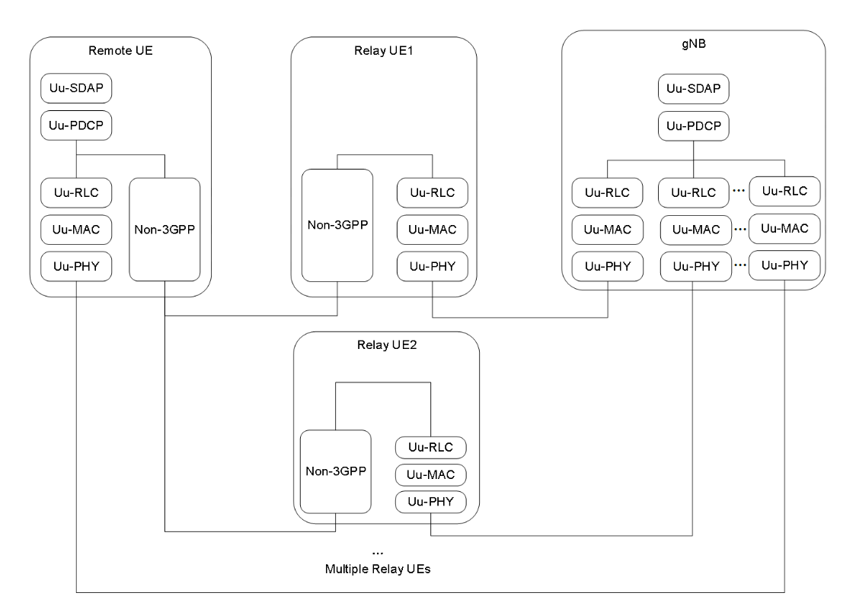
Figure 16.21.2.2-1: User plane protocol stack for L2 Multi-path Relay(s) using N3C indirect path
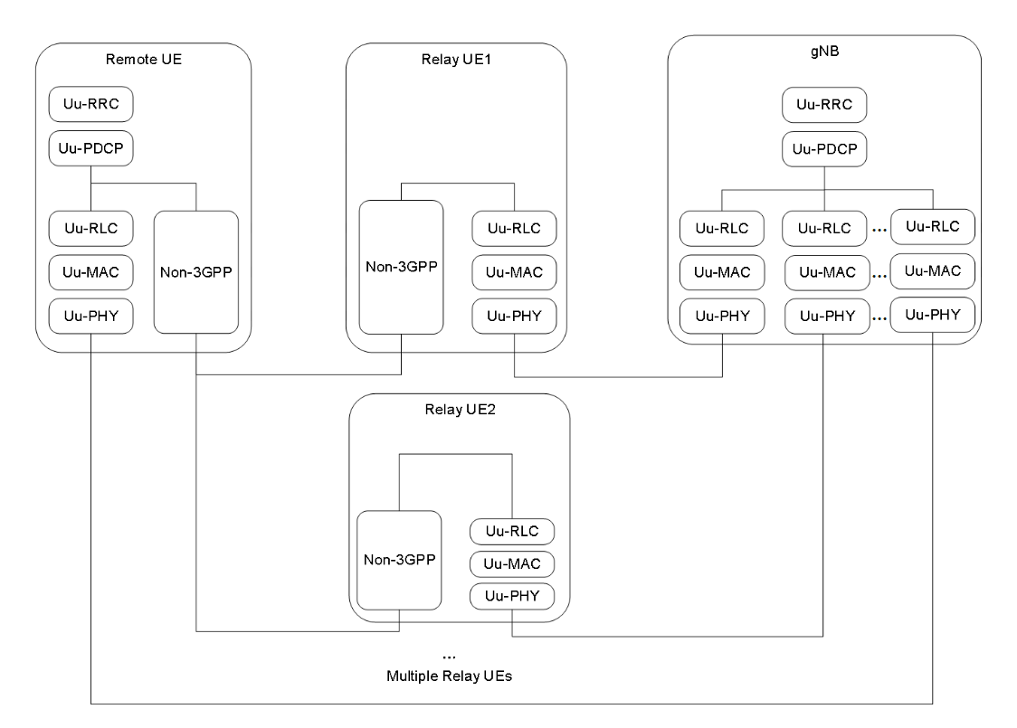

Figure 16.21.2.2-2: Control plane protocol stack for L2 Multi-path Relay(s) using N3C indirect path
End of changes

