**3GPP TSG-RAN WG2#130 R2-25XXXXX**

**Malta, MT, 19th – 23rd May 2025**

**Agenda item:**

**Source:** Ericsson

Title: Summary of [POST129][401][POS] NavIC L1 CR update (Ericsson)

**Document for:**  Discussion, Agreement

Introduction

This document is the report of the following email discussion:

* [POST129][401][POS] NavIC L1 CR update (Ericsson)

Scope: Update the CR in R2-2500108 in line with decisions of this meeting, and check it for final correctness.

Intended outcome: Agreeable CR

Deadline: Very long (to RAN2#130)

1. Contact Information

|  |  |  |
| --- | --- | --- |
| **Company** | **Name** | **Email Address** |
|  |  |  |
|  |  |  |
|  |  |  |
|  |  |  |
|  |  |  |
|  |  |  |
|  |  |  |
|  |  |  |
|  |  |  |
|  |  |  |
|  |  |  |
|  |  |  |
|  |  |  |
|  |  |  |

1. Discussion

Based upon the online discussion in RAN2#129, there are two outstanding issues that we need to sort out.

1. Health Indication of Navigation Data L1 Signals [1,2]
2. Reference Signal for Broadcast Ephemeris [3]

In this email discussion, we discuss the above and gather any further input that is needed to complete the CR.

* 1. Health Indication

The main question is if the below description as provided in R2-2500108-NavIC\_L1\_stage3\_CR\_Updated.docx is correct or needs to be updated.

|  |  |  |
| --- | --- | --- |
| NavIC | L5 health  [38] | L1 health  [xx] |

Some of the companies expressed that the ICD of L1 also contains the health status of L5 signal. However, looking at the relevant section highlighted below, it appears only L1 health status has been captured.

Section – 6.2.1.7 in NavIC L1 SPS ICD: [https://www.isro.gov.in/media\_isro/pdf/SateliteNavigation/NavIC\_SPS\_ICD\_L1\_final.pdf](https://www.isro.gov.in/media_isro/pdf/SateliteNavigation/NavIC_SPS_ICD_L1_final.pdf" \t "_blank)  
Section – 6.2.1.6 in NavIC L5 SPS ICD: [https://www.isro.gov.in/media\_isro/pdf/SateliteNavigation/irnss\_sps\_icd\_version1.1-2017.pdf](https://www.isro.gov.in/media_isro/pdf/SateliteNavigation/irnss_sps_icd_version1.1-2017.pdf" \t "_blank)

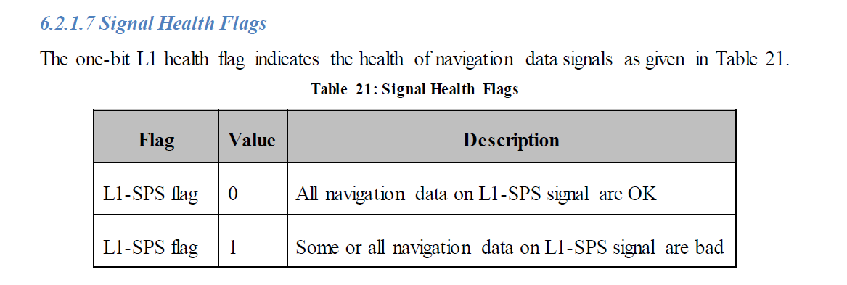

Based upon above, the field description in "R2-2500108-NavIC\_L1\_stage3\_CR\_Updated.docx should be correct.

Companies are requested to provide their opinion on below; on whether they agree to the field description as provided in "R2-2500108-NavIC\_L1\_stage3\_CR\_Updated.docx.

|  |  |  |
| --- | --- | --- |
| **Company** | **Agree/Disagree** | **Remark** |
| Qualcomm |  | If with in "R2-" the document provided in "R2-2500108-NavIC\_L1\_stage3\_CR\_Updated.docx" for this email discussion is meant, agree. |
|  |  |  |
|  |  |  |

* 1. Reference Ephemeris NavIC Signal

The information about which NavIC signal broadcast ephemeris SSR clock and orbit corrections should be added to the NOTE 2 of the IE *GNSS-SSR-OrbitCorrections*.

To follow the example of GPS, QZSS and BDS, the selected signal should be the one with most comprehensive support now and onwards, and also the signal that will be most widely deployed on the satellites of the NavIC system.

The signal expected to be most widely supported by devices, to be most deployed on satellites and will be most future compatible for the NavIC is the L1 signal. Therfore, the Note2 is updated as below

NOTE 2: In the cases that *gnss-ID* indicates 'gps', 'qzss', 'bds' or ‘navic’, the *iod* refers to the NAV broadcast ephemeris (GPS L1 C/A, QZSS QZS-L1, BDS B1I, or NavIC L1 respectively, in table GNSS to iod Bit String(11) relation in IE *GNSS‑NavigationModel).*

However, NavIC L5 existed before Rel-19, thus the choice of NavIC L1 is Non Backward Compatible change and hence further update needs to not break the legacy UEs which may still consider L5 as reference ephimeris. Companies are requested to review the updated CR and if they agree/disagree with the CR and any further comments they have.

|  |  |  |
| --- | --- | --- |
| **Company** | **Agree/Disagree** | **Remark** |
| Qualcomm | Agree in principle with change in "R2-2500108-NavIC\_L1\_stage3\_CR\_Updated.docx" | However, The "NOTE 2" is already in existing specification not fully correct. The "NAV broadcast ephemeris" terminology is only used for GPS and QZSS (where NAV and CNAV data are defined). Either the closing parenthesis should be after "QZSS QZS-L1", or the "NAV broadcast" should be removed. I suggest the latter. E.g.,  NOTE 2: In the cases that *gnss-ID* indicates 'gps', 'qzss', 'bds' or 'navic', the *iod* refers to the broadcast ephemeris for GPS L1 C/A, QZSS QZS-L1, BDS B1I/B3I, or NavIC L5 respectively, in table GNSS to iod Bit String(11) relation in IE *GNSS‑NavigationModel.*  *Thanks: NAV has been removed from Note 2:* |
|  |  |  |
|  |  |  |

* 1. Any Other Comments

|  |  |
| --- | --- |
| **Company** | **Remark** |
| Qualcomm | NeQuickModel2ParameterList-r19 ::= SEQUENCE (SIZE (3)) OF NeQuickModel2ParameterElement-r19  I think we should better use (SIZE (1..3)). A server does not always need to provide the data for all 3 regions.  NavIC neQuick model focuses on 3 sub-regions whose boundaries & parameters are independent and varying as against the Galileo model. This is the primary motivation behind the proposed IE definition to have fixed size 3. |
|  | Editorial:  Table heading in ***NeQuickModel****2****Parameter field descriptions***  This should not be in Italic font.  Fixed |
|  | Editorial:    A space before [xx] can be deleted.  Fixed |
|  | Editorial:    A space before "(IDF)" is missing.  Fixed |
|  | *GNSS-SSR-OrbitCorrections*  The parenthesis in the new NOTE 4 sentence should be removed:  "In the case *gnss-ID* indicates 'navic' and if *refEph* is set to *navicL1*, the *iod* refers to the broadcast ephemeris of NavIC L1 in table GNSS to iod Bit String (11) relation in IE *GNSS‑NavigationModel."*  *Fixed* |

1. Conclusion

The discussion above can be summarized in the form of the below summary and proposal:

Summary:

* No Further change needed for the L1 Signal Health Status
* Addition of NavIC L1 as Reference Ephemeris for *GNSS-SSR-OrbitCorrectionsSet2, GNSS-SSR-ClockCorrectionsSet2* and *GNSS-SSR-URA-Set2*
* Note 2 of *GNSS-SSR-OrbitCorrections* has been updated where “NAV” has been removed NavIC L5 has been added for broadcast ephemeris
* Note 4 *GNSS-SSR-OrbitCorrections* of has been updated with below addition “In the case *gnss-ID* indicates navic and if *refEph* is set to *navicL1*, the *iod* refers to the broadcast ephemeris (NavIC L1 in table GNSS to iod Bit String (11) relation in IE *GNSS‑NavigationModel*).”

1. The CR in R2-25xxxxx is agreed which updates the CR in R2-2500108 with the above summarized updates.

# 4 References

[1] <https://www.isro.gov.in/media_isro/pdf/SateliteNavigation/NavIC_SPS_ICD_L1_final.pdf>

[2] <https://www.isro.gov.in/media_isro/pdf/SateliteNavigation/irnss_sps_icd_version1.1-2017.pdf>

[3] R2-2500972 NavIC broadcast ephemeris to refer to for GNSS SSR corrections Ericsson, Reliance Jio