3GPP TSG-RAN WG2#129-bis R2-25XXXXX
Wuhan, China, April 7 – April 11, 2025

Agenda Item: 8.5.1
Source: Huawei, HiSilicon
Title: Report of [POST129][101][NES] (Huawei)
Document for: Discussion and decision

1 Introduction
This document is the report of the following discussion:
- [POST129][101][NES] (Huawei)
Scope: Capture all agreements in 38.300 running CR.
Intended outcome: Endorsed 38.300 running CR in R2-2501461.
Deadline: Long email discussion (Mar. 21st 10:00 UTC)

Please provide your comments by Thursday March 20th 10:00 UTC to allow 24h for the rapporteur to update the CR before the deadline.

Companies providing input to this email discussion are requested to leave contact information below.
Company | Delegate name | Email address
OPPO | Qianxi Lu | qianxi.lu@oppo.com
Xiaomi | Li Zhao | zhaoli6@xiaomi.com
Samsung | Anil Agiwal | anilag@samsung.com

2 RRC CR for NES
The post-RAN2#129 draft running stage-2 CR for NES enhancements and a document for providing comments are provided in the discussion folder. Please don’t change the CR text or insert comments to the CR file. Please use the table below for comments and wording suggestions for clarity of the CR tdoc. If you want to highlight several issues, please use comment IDs e.g. HW001, HW002, etc. so it is easier for the rapporteur to respond.

Company and comment ID (e.g. HW001) | Section and detailed comments/suggestions | Rapporteur response
OPPO001 | Paging adaptation for cell level energy saving: in order to reduce gNB signalling, the value of N and Ns are extended to concentrate the POs in sparser PFs. The UE supporting paging adaptation shall monitor PDCCH in its NES specific PO.  [OPPO] The yellow terms is not rigorous, since PO for R19 NES UE can be shared with legacy UE, and also R19 UE may also monitor legacy PO if network does not configure R19 PO at all.
OPPO002 | On-demand SSB transmissions facilitated through serving cell indications enable UEs to perform at least SCell time/frequency synchronization, L1/L3 measurements and SCell activation, and are supported for FR1 and FR2 in non-shared spectrum.  [OPPO] Although it is from WID, but rigorously SCell activation include steps like t/f sync and L3 meas, so not a same level concept?
Xiaomi001 | Adaptation of PRACH in time domain is supported for 4-step RACH and CBRA.  [Xiaomi] should be 4-step CBRA as according to the agreement, there is no conclusion on 2-step CBRA.  Also suggest to add a editors’ note whether to support 2-step CBRA and/or CFRA depends on RAN1
Xiaomi002 | This solution is supported in the following scenarios:  - The SCell is configured to a UE but before the UE receives SCell activation command  - When UE receives SCell activation command  [Xiaomi] according to the following RAN1 agreement, only 3A is excluded, whether to support 3B is still FFS. Suggest to add a note to wait for RAN1 conclusion on 3B.  Conclusion  The following combination of scenarios and cases for indicating OD-SSB are not supported in Rel-19  - Scenario #3A and Case #1  - Scenario #3A and Case #2  Above does not impact discussion on SSB periodicity adaptation in time domain
Xiaomi003 | 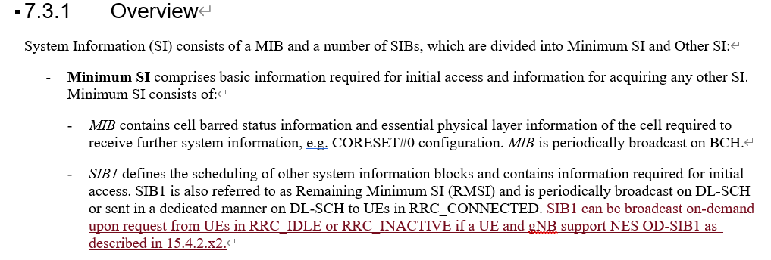  RAN2 agreed that the UE in RRC_CONNECTED can perform on-demand SIB1 procedure for RLD case.  The “RRC_CONNECTE” should be captured.  - Specify the following UE behavior to allow the UEs in RRC_CONNECTED state to acquire OD-SIB1 when T311 is running:  - When T311 is running, the UE can trigger the OD-SIB1 acquisition procedure with stored UL WUS configuration in SIB-X, if it is still valid.  - The legacy cell selection criteria are reused as the trigger condition of OD-SIB1 acquisition.  - The OD-SIB1 acquisition behavior is same as that of RRC_IDLE/IANCTIV UEs.  [Samsung] Agree with Xaomi.
Xiaomi004 | 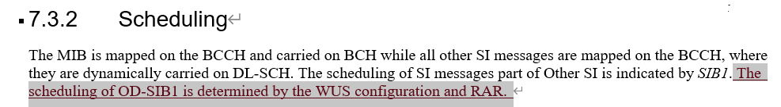  It is too early to capture this sentence due to no agreements and this sentence is also not clear.
Samsung 001 | 5.2.5.5  We need to atleast add that “MIB on PBCH may indicate that SIB1 is not being broadcasted, in which case the UE may transmit SIB1 request if UE has valid SIB1 request configuration.
Samsung 002 | 7.3.1  “SIB1 can be broadcast on-demand upon request from UEs in RRC_IDLE or RRC_INACTIVE if a UE and gNB support NES OD-SIB1 as described in 15.4.2.x2.”  Suggest to remove “ if a UE and gNB support NES OD-SIB1’. It seems not needed.
Samsung 003 | 7.3.1  “SIBxx contains UL-WUS configurations of NES OD-SIB1 cells as defined in TS 38.331 [12].”  First we would like to use terminology which conveys the actual intent/behavior in specification.  What UE sends is a SIB1 request. Its not a UL wakeup signal. So, suggest to change ‘UL-WUS configurations’ to SIB1 request configurations.  It sufficient to say, “SIBxx contains SIB1 request configurations of one or more cells as defined in TS 38.331 [12].”
Samsung 004 | 7.3.1  Figure 7.3.1-1: System Information Provisioning needs to be updated to indicate ‘broadcast on-demand on DL-SCH’ for SIB1
Samsung 005 | 7.3.2  “The scheduling of OD-SIB1 is determined by the WUS configuration and RAR.”  This text is not needed as we do not have corresponding text for SIB1 in legacy.
Samsung 006 | 7.3.2  We need to atleast include the following text:  For UEs in RRC_IDLE, RRC_INACTIVE and RRC_CONNECTED (during the RRC connection re-establishment), a request for SIB1 triggers a random access procedure, in which case MSG1 is used for indicating SIB1 request and the gNB acknowledges the request in MSG2.
Samsung 007 | 9.2.5  “Paging adaptation for cell level energy saving: in order to reduce gNB signalling, the value of N and Ns are extended to concentrate the POs in sparser PFs. The UE supporting paging adaptation shall monitor PDCCH in its NES specific PO.  “  In our view, paging adaptation does not reduce gNB signalling. It avoids network to keep waking up for paging in the entire DRX cycle by configuring PF/POs in the beginning of DRX cycle.
Samsung 008 | 15.4.2.5  “If a cell is activating or going to activate NES OD-SIB1, the cell can allow the access of UEs capable of NES OD-SIB1 but prevent the access of UEs not capable of NES OD-SIB1 based on no SIB1 indication in MIB using FFS as described in clause X.Y.”  Its not clear what activation of NES OD-SIB1 means. Prefer to reword as”  - “If a cell provides SIB1 based on SIB1 request, the cell allows the access of UEs capable of OD-SIB1 but prevent the access of UEs not capable of OD-SIB1 based on ‘no SIB1 indication’ in MIB using FFS as described in clause X.Y.”
Samsung 008 | 15.4.2.x2 On-demand SIB1  Comment 1: Its not clear to use why we need to define “NES OD-SIB1 Cell”. In our view this is not needed.  Comment 2: We do not need to use term ‘UL-WUS’ in specification. We would like to use terminology which conveys the actual intent/behavior in specification. What UE sends is a SIB1 request. Its not a UL wakeup signal. So we prefer to use ‘SIB1 request’ instead of ‘UL WUS’
Samsung 009 | 15.4.2.x2 On-demand SIB1  The text is not accurate (e.g. RRC connected is missing, applicability of SIB1 request configuration etc). Suggest to reword as follows:  To facilitate reduced gNB downlink transmissions, the gNB can provide SIB1 on-demand i.e. upon receiving SIB1 request from UE. On-demand SIB1 is supported for UEs in RRC_IDLE, RRC_INACTIVE and RRC_CONNECTED (during RRC connection re-establishment). A request for SIB1 triggers a random access procedure, in which case MSG1 is used for indicating SIB1 request and the gNB acknowledges the request in MSG2. SIB1 request configuration of one or more cells are included in SIBxx, which can be broadcasted in any cell, including cell’s own SIB1 request configuration. While the UE is camped on a cell, it can use the SIB1 request configuration of another cell from SIBxx valid in the camped cell to acquire SIB1 of that cell for cell reselection or it can apply the SIB1 request configuration of the camped cell from SIBxx valid in the camped cell to acquire SIB1 of the camped cell. For the purpose of on-demand SIB1, the following terms are defined:

