3GPP TSG-RAN2 Meeting #127bis R2-240xxxx

Hefei, China, 14th October 2024 - 18th October 2024

Agenda Item: 8.5.4
Source: OPPO
Title: Summary of [109]
Document for: Discussion, Decision

- Introduction
This is to discuss the offline as follows.
- [POST127][109][NES] (OPPO)
Scope: For each direction (N extension vs PF bundling): 1) List proposed options, 2) Discuss to understand each option better, 3) Down select options, 4) Discuss pros and cons for each direction or down-selected options (with the consideration of UE impacts, system impacts and specification job). F2F offline discussion in Brk3 room. => It is extended to long email discussion to continue detailed analysis of pros and cons for each direction.
Intended outcome: Discussion summary in R2-2407598. => Updated discussion summary
Deadline: Long email discussion.
- Stage-1 Discussion
In this section, the defined scope of the post email discussion is further expanded to dig into details.
2.1 Issue-1: List proposed options
Based on the conclusion from 125bis
For adaptation of paging occasions in time domain, RAN2 to study
a) bundle paging frames and
b) extend the values of N to have increased interval between PFs (e.g. T/64, T/128 ...) and compensating decrease in number of PFs by increasing POs per PF.

For option-a), as discussed during AT-127 [109], there are multiple sub-options of approach a), for which there is one left issue, i.e.,
Proposal 2 For option-a), R2 further discuss whether to allow gaps between bundled PFs.
- Can be discussed as part of long email discussion.
Q1-1: for option-a), do you agree to allow gaps between bundled PFs?
Company | Agree/Disagree | Comment
Nokia | Agree | This is useful to address potential PO overlap of two adjacent PFs.
Lenovo | Disagree | The MAIN intention of this work is to save network energy by allowing it to sleep as much as possible. This is possible by minimizing paging transmissions and by trying to make transmissions in “one shot” as far as possible. The gap will not allow the network RF to go into deeper sleep state, as it would need to wake up soon for the next PF transmission.  In our study, collected from various field logs, in R2-2406890, is clear that on an average network has only about 2 UEs (records) to page in a DRX Cycle. So, just one PF (and one PO) is sufficient. Waking up the network unnecessarily is going against energy saving aim. How many POs in each PF will be there is configurable and also the nrofPDCCH-MonitoringOccasionPerSSB-InPO is configurable.
vivo | No strong view | We understand the gap is needed to avoid PO overlapping between two consecutive PFs. However, the NES mode is likely to be applied when the cell load is low, and thus the chance for potential PO overlapping issue may be little.
CATT | Agree | Share the view with Nokia.it is necessary to avoid the PO overlapping.

For option-a), as discussed during AT-127 [109], there are multiple sub-options, it was a bit difficult to make down-selection between sub-options due to the limited time. So now the attempt as follows to see if any possibility to converge.
Option | Source | Formula | Comment
a-1 | Intel, 6471 | (SFN + PF_offset) mod T = G*(UE_ID mod L) | L: the number of consecutive PFs within a PF bundle (i.e., PF bundle size)  G: the frame gap between consecutive PFs
a-2 | Apple, 6671 | (SFN + PF_offset) mod T = (T div N)*(UE_ID SubGroup_ID mod N)
a-3 | Apple, 6671 | (SFN + PF_offset) mod T = (T div N)*(UE_ID Mod N)
a-4 | CATT, 7004 | (SFN + PF_offset) mod T = G*(UE_ID mod N) | G: the frame gap between consecutive PFs.
a-5 | Vivo, 6723 | (SFN + PF_offset) mod T = SFN [(UE_ID mod N)]
a-6 | Vivo, 6723 | Rel-19 PF = legacy PF +[ (UE_ID mod (N_new/N+factor)) – (factor-1)]
a-7 | Lenovo, 6809 | only one fixed PO is used in a cell specific Paging DRX Cycle | Lenovo: This is also option-b) in our understanding. Please see our responses below.
a-8 | Samsung, 6348 | (SFN +PF_Offset) mod T = (D div N) * (UE_ID mod N). | N (#of PFs in duration D at the beginning of DRX cycle) = D, D/2, D/4, D/8 ,..
Q1-2: For option-a), which sub-option you prefer?
Company | Preferred sub-option | Comment
Nokia | a-1 | We prefer the options, which provide a gap between adjacent PFs. Options a-4 and a-8 also work as long as N can be configured differently from the legacy N for legacy paging. Additionally it might be worthwhile to consider having possibility for two (or more) PF bundles per paging cycle in order ensure sufficient capacity.
Lenovo | a-7 | We think a-7 can also be counted as option-b i.e., extend the values of N to have increased interval between PFs (e.g. T/64, T/128 …T/N). It will lead to just one PF in the DRX cycle. And since this is just “one” PF, in that sense we have successfully bundled the PFs in this “one” PF. So, its technically also option a. The companies worried about “capacity” should show a need first. We do not think that number of UEs are substantially (like 10-fold) increase in Rel. 19.
vivo | a-1/a-3/a-5 | We are OK with a-1/a-3 and the selection between them depends on the conclusion of Q1-1. We would like to also support a-5 (as proponent) as it can indicate the Rel-19 PFs position (e.g., list of SFNs) directly. UE finds the corresponding index of entry in the SFN list based on its UE ID, and then finds the corresponding SFN value based on its index.
CATT | a-4 | It allows gaps between bundled PFs when G >1. And N can be configured differently from the N for legacy paging if separate paging parameters are configured for legacy paging and Rel-19 NES paging adpatation.

On the other hand, there seems no much further details to clarify for option-b).

Overall, it is good to understand if there is any major issue missing, in order to clarify either option.
Q1-3: Besides the issues above, any major issue remains, in order to clarify the key idea for either option-a) or option-b)?
Company | Any major left issue?  Yes/No | Comment
Nokia | Yes | When we have bundled paging occasions then likely we would need to also accommodate PRACH resources so that they are “aligned” with bundle.
Lenovo | No | In Rel. 19 we do not want to have any further enhancements. This is because:  - Network can “spread” paging across cycles, keeping the cycle length short if required. Paging is anyway hit and trial (network does not know where the UE is inside of its RA).  - The field operation must even today be capable to handle 4-5 MO calls being established in the same short time period…even assuming 10 UEs being paged in rf128 paging cycle.
CATT | Yes | In RAN2#125bis, it was agreed:  - From the UE point of view, UE will monitor one PEI/PO every paging DRX cycle, i.e. the UE doesn’t skip PO in paging DRX cycle.  We need to discuss how to ensure UE will monitor one PO every paging DRX cycle with option-b). For example: T is 64 radio frames while N is T/64 is broadcasting system information for option-b). The T of a UE is 32 radio frames as T in the UE is determined by the shortest of the UE specific DRX value configured by RRC (if any), the UE specific DRX value configured by upper layers (if any), and a default DRX value broadcast in system information. Then N is 1/2 for the UE with option-b) which means there may be no PF in every paging DRX cycle. In order to ensure UE monitors one PO every paging DRX cycle, we can clarify that the UE can return to legacy paging mechanism if suitable legacy paging parameters for network power saving are configured or N can be equal to 1 in this case.

2.2 Issue-2: Discuss to understand each option better
It seems the scope is the same as issue-1 above.

2.3 Issue-4: Discuss pros and cons for each direction or down-selected options (with the consideration of UE impacts, system impacts and specification job)
Although this is the last bullet in email scope, it seems helpful to discuss this first, before going to the 3rd bullet here.
From email rapporteur perspective, it seems clearer that option-b) has requires less specification effort since it aims at keeping the legacy formula as it was, and the effort comes from the additional value range for the corresponding parameters. While option-a) would come with a revised formula.
Q2-1: Given that option-b) tends to keep the legacy formula as it was but just extended value range, while option-a) tends to go for a revised formula, do you agree that the specification job for option-b) is less?
Company | Agree/Disagree | Comment
OPPO | Agree
Nokia | Agree
Lenovo | Agree, and… | We would like the solution A-7 to be counted in option-b) as well (or more option-b than a).
CATT | Agree

And then the option-a) would be motivated only if there is a major performance difference. While during AT-127, as clarified and concluded
Figure 1 Option-a) vs. Option-b) in terms of PO location in time domain (discussed in AT-127 [109])
As clarified in 304 as follows:
NOTE 1: A PO associated with a PF may start in the PF or after the PF.
NOTE 2: The PDCCH monitoring occasions for a PO can span multiple radio frames. When SearchSpaceId other than 0 is configured for paging-SearchSpace the PDCCH monitoring occasions for a PO can span multiple periods of the paging search space.
And thus 127 agreed that
Proposal 3 R2 observe that the option-a) and option-b) can be designed to configure the PO:s at same time position.
Q2-2: Given clarification (as concluded in R2#127) that PO does not have to be limited to the time period of the corresponding PF, and thus option-b) can reach same time position for POs, do you think there would be a major difference for the system performance of the two options? If Yes, please clarify the difference in your view.
Company | Any major performance difference? Yes/No? | Comment
OPPO | No | Based on same time position for the PO:s, we have not understood the reason for a performance difference between the two options.
Nokia | No | We have not identified any major difference between options – with appropriate parameter selection they can look rather same.
vivo |  | We have some concern on opt.b for that it may have signalling overhead issue in some cases as it needs more bits in the SI to indicate firstPDCCH-MonitoringOccasionOfPO for additional POs of opt.b. In the table below, we analyze the additional signaling overhead of opt.b compared to opt.a when SCS is 30kHz and T is 320ms for instance.  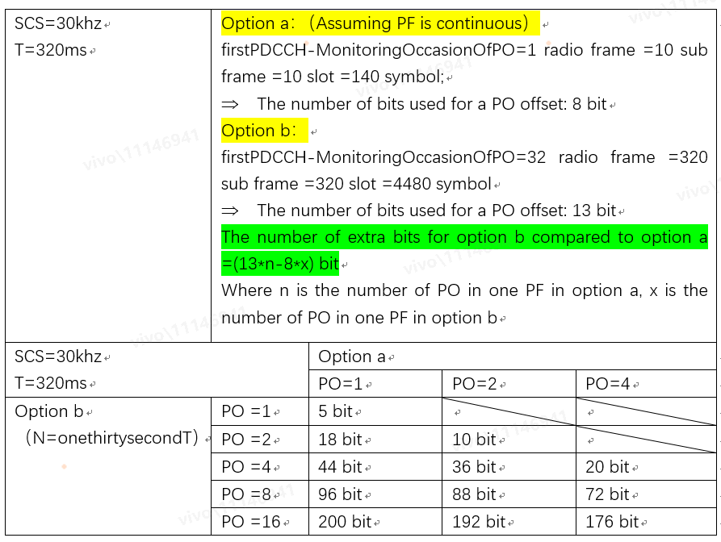
CATT | No

- Stage-2 Discussion
2.4 Issue-3: Down select options
Given the clarification during 127 and the discussion above, it would be helpful to understand companies view, regarding the two options.

- Conclusion
Based on the offline, we reached the following WF

