**3GPP TSG-RAN WG2 Meeting #127 _R2-2406271**

**Maastricht, Netherlands, 19th August – 23th August, 2024**

**Agenda Item: 8.2.1**

**Source: Huawei**

**Title: TP for TR 38.769 update**

**Document for: Discussion and Decision**

# 1 Introduction

This contribution provides the text proposal on the update of TR 38.769 and proposal is TBD:

# 2 Text Proposal for TR 38.769 V0.0.1 (2024-02)

Start of Change

# Introduction

In recent years, IoT has attracted much attention in the wireless communication world. More 'things' are expected to be interconnected for improving productivity efficiency and increasing comforts of life. Further reduction of size, complexity, and power consumption of IoT devices can enable the deployment of tens or even hundreds of billions of IoT devices for various applications and provide added value across the entire value chain. It is impossible to power all the IoT devices by battery that needs to be replaced or recharged manually, which leads to high maintenance cost, serious environmental issues, and even safety hazards for some use cases, for example, wireless sensors in electrical power, and petroleum industries.

Most of the existing wireless communication devices are powered by batteries that need to be replaced or recharged manually. The automation and digitization of various industries opens numerous new markets requiring new IoT technologies of supporting batteryless devices with no energy storage capability or devices with energy storage that do not need to be replaced or recharged manually.

An example type of application is asset identification, which presently has to resort mainly to barcodes and RFID in most industries. The main advantage of these two technologies is the ultra-low complexity and small form factor of the tags. However, the limited reading range of a few meters usually requires handheld scanning which leads to labor intensive and time-consuming operations, or RFID portals/gates which leads to costly deployments. Moreover, the lack of interference management scheme results in severe interference between RFID readers and capacity problems, especially in case of dense deployment. It is hard to support a large-scale network with seamless coverage for RFID.

In contrast, this study investigates solutions for Ambient IoT, a new IoT technology to open new markets within 3GPP systems, whose number of connections and/or device density can be orders of magnitude higher than existing 3GPP IoT technologies, and which can provide complexity and power consumption orders-of-magnitude lower than existing 3GPP LPWA technologies such as NB-IoT and LTE-MTC. TSG RAN has completed a Rel-18 RAN-level SI on Ambient IoT, producing TR 38.848 which provides a terminological and scoping framework for future discussions of Ambient IoT. This has defined representative use cases, deployment scenarios, connectivity topologies, Ambient IoT devices, design targets, and required functionalities; it also conducted a preliminary feasibility assessment.

The SI reported in this present TR is now to investigate solutions in detail at RAN-WG level for Ambient IoT in 3GPP.

# 1 Scope

The overall objective of the SI is to study a harmonized air interface design with minimized differences (where necessary) for Ambient IoT to enable the following devices:

i. ~1 *µ*W peak power consumption, has energy storage, initial sampling frequency offset (SFO) up to 10*X* ppm, neither DL nor UL amplification in the device. The device’s UL transmission is backscattered on a carrier wave provided externally.

ii. ≤ a few hundred *µ*W peak power consumption has energy storage, initial sampling frequency offset (SFO) up to 10*X* ppm, both DL and/or UL amplification in the device. The device’s UL transmission may be generated internally by the device, or be backscattered on a carrier wave provided externally.

Referring to the definitions in [2, TR 38.848], this is done in the context of:

- Deployment scenario 1 (indoor-to-indoor) with Topology 1, and indoor microcell basestation.

- Deployment scenario 2 (indoor-to-outdoor) with Topology 2 and indoor UE as intermediate node under network control, and outdoor macrocell basestation.

The spectrum considered is FR1 licensed spectrum in FDD, which can be in-band to NR, in guard-band to NR, or in standalone band(s). The traffic types considered are DO-DTT and DT, focusing on indoor inventory and indoor command representative use cases. The study also assesses whether the harmonized air interface can address the DO-A use case.

# 2 References

The following documents contain provisions which, through reference in this text, constitute provisions of the present document.

- References are either specific (identified by date of publication, edition number, version number, etc.) or non‑specific.

- For a specific reference, subsequent revisions do not apply.

- For a non-specific reference, the latest version applies. In the case of a reference to a 3GPP document (including a GSM document), a non-specific reference implicitly refers to the latest version of that document *in the same Release as the present document*.

[1] 3GPP TR 21.905: "Vocabulary for 3GPP Specifications".

[2] 3GPP TR 38.848: "Study on Ambient IoT (Internet of Things) in RAN".

# 3 Definitions of terms, symbols and abbreviations

This clause and its three (sub) clauses are mandatory. The contents shall be shown as "void" if the TS/TR does not define any terms, symbols, or abbreviations.

## 3.1 Terms

For the purposes of the present document, the terms given in TR 21.905 [1] and the following apply. A term defined in the present document takes precedence over the definition of the same term, if any, in TR 21.905 [1].

**example:** text used to clarify abstract rules by applying them literally.

**Inventory**: The service provided by the network to discover and acquire the identifier of A-IoT device(s).

**Command**: The service provided by the network to send the operation instruction to the A-IoT device (e.g. read, write, etc.).

## 3.2 Symbols

For the purposes of the present document, the following symbols apply:

<symbol> <Explanation>

## 3.3 Abbreviations

For the purposes of the present document, the abbreviations given in TR 21.905 [1] and the following apply. An abbreviation defined in the present document takes precedence over the definition of the same abbreviation, if any, in TR 21.905 [1].

A-IoT Ambient IoT

DO-A Device-originated autonomous

DO-DTT Device-originated by device-terminated trigger

DT Device-terminated

FR Frequency Range

IoT Internet of Things

LPWA Low-power, wide-area

LTE-MTC Long Term Evolution – Machine Type Communication

NB-IoT Narrowband IoT

RFID Radio frequency identification

SFO Sampling frequency offset

# 4 Evaluation methodology

*Editor’s note: These sub-clauses correspond to Objective 1a, 1b, 1d, respectively.*

## 4.1 Remaining details of RAN design targets

## 4.2 Evaluation assumptions

## 4.3 Link budget template

# 5 Ambient IoT device architectures

## 5.1 ~1 *µ*W devices (Device 1)

## 5.2 ≤few hundred *µ*W devices

### 5.2.1 External carrier wave (Device 2a)

### 5.2.2 Internally-generated carrier wave (Device 2b)

# 6 Solutions for Ambient IoT

## 6.1 Physical layer

## 6.2 Protocol stack and signalling procedures

*Editor’s note: Corresponds to the RAN2 objective in the SID.*

### 6.2.1 General aspects and overall procedure

The study aims that the design on the interface between reader and A-IoT device is common for Topology 1 and Topology 2. Unless explicitly stated, the descriptions in sub-clause 6.2 apply to all A-IoT device types and both Topology 1 and Topology 2.

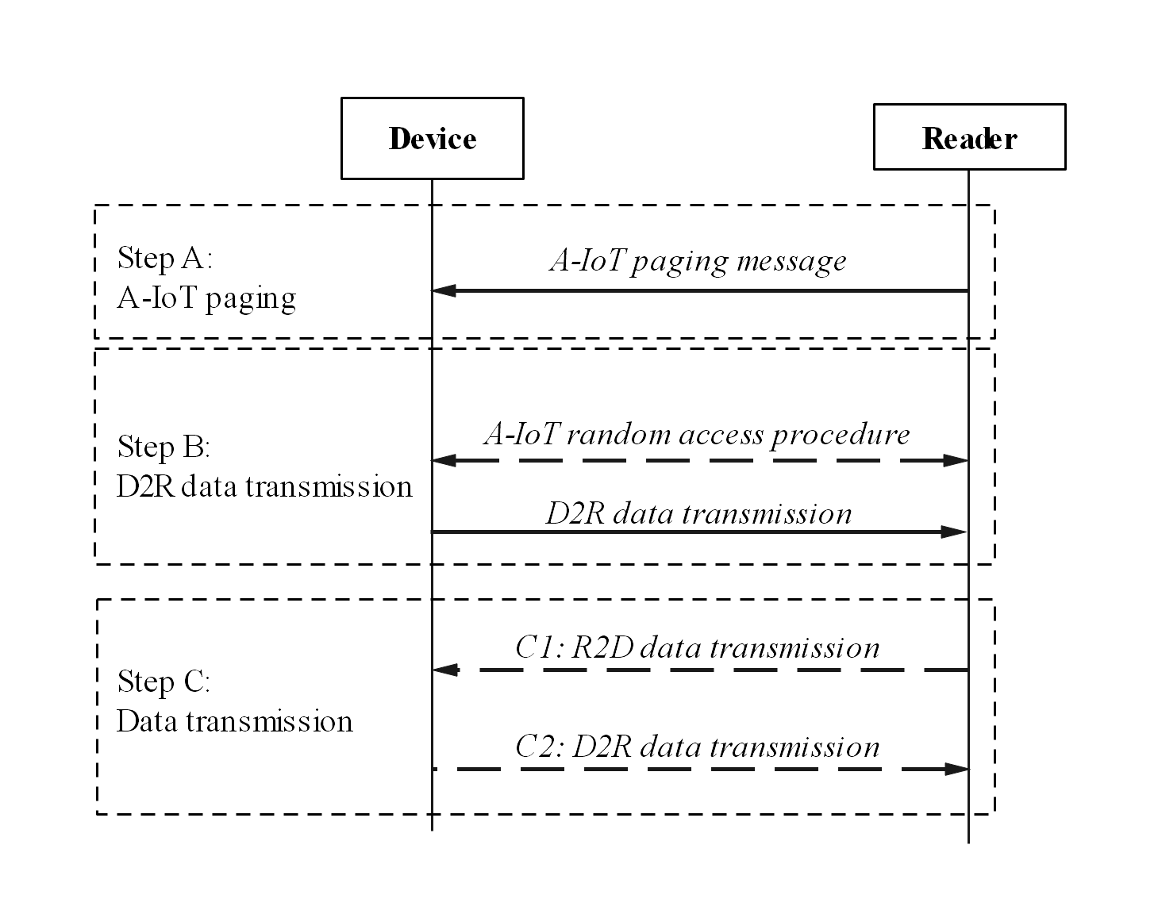

Figure 6.2.1-1 Overall AS procedures between A-IoT device and reader

The overall AS procedures can be formulated as:

* Step A: A-IoT paging. Based on the service request, the reader sends the A-IoT paging message indicating device(s) that need to respond.

NOTE 1: In the sub-clause 6.2, the term of “A-IoT paging message” is equal to the “(initial) trigger message”. For simplification, only the former is used.

* Step B: D2R data transmission. Triggered A-IoT device(s) perform the device ID transmission via the A-IoT random access procedure or without using the A-IoT random access procedure. See sub-clause 6.2.4.
* Step C1: Possible R2D data transmission (e.g. for sending the command).
* Step C2: Possible D2R data transmission (e.g. the corresponding response to command).

Then, above AS procedure can support indoor inventory and indoor command use cases by the following manners:

* For the detailed use case of “inventory-only”, it is supported by the procedure with step A and step B as baseline.
* For the detailed use case of “inventory and command”, it is supported by the procedure with step A, step B, step C1 and step C2, as baseline.

NOTE 2: For the use case of “inventory and command”, it does not imply that the A-IoT paging message includes both the inventory and command and it does not imply the inventory and command are received by the reader at the same time from upper layer.

* For the detailed use case of “command-only”:

- It can be also supported by the baseline procedure with step A, step B, step C1 and step C2.

- In addition, another candidate to support this use case is following, whose feasibility still depends on the conclusion from [SA2 TR 23.700-13] and [SA3 TR 33.713]:

- Step A’: A-IoT paging. Based on the service request, the reader sends the A-IoT paging message including the command, indicating device(s) to process/respond the command.

- Step C2: Possible D2R data transmission (e.g. the device ID or the corresponding response to command), via the A-IoT random access procedure or without using the A-IoT random access procedure.

### 6.2.2 Protocol stack, functionality and data transmission aspects

The AS layer design assumes no support of AS security, unless the study in [SA3 TR 33.713] further concludes differently.

As to the protocol stack for A-IoT interface between A-IoT device and reader, it is assumed:

* RRC layer is not supported;
* SDAP layer is not supported;
* PDCP layer is not supported;
* RLC layer is not supported;
* A-IoT MAC layer is supported;
* A-IoT physical layer is supported.

Editor’s Note: Based on the study of the required functionalities, it is FFS if a new AS protocol on top of A-IoT MAC layer is needed.

As to the A-IoT required functionalities, the following functionalities are supported:

* A-IoT paging (see sub-clause 6.2.3);
* A-IoT random access procedure (see sub-clause 6.2.4);
* Data transmission (see sub-clause 6.2.4);

As to the A-IoT required functionalities, at least the following functionalities are NOT supported (see TS 38.300 for references for any legacy NR functionality):

* RRC states
* RRC connection management
* RRM L3 measurement reporting
* Mobility
* ASN.1 encoding/decoding
* Periodical system information and MIB
* Tracking/RAN area update procedure
* Per-packet QoS and per-QoS flow at AS level
* HARQ
* RLC ARQ/AM
* AS-layer (above physical layer) RLC-like/ARQ-like retransmission
* AS-layer (above physical layer) repetition

NOTE 1: It is not precluded that the reader and A-IoT device send the “payload” again as new transmission from A-IoT MAC perspective.

* Multiple A-IoT logical channels for upper layer data
* Legacy NR SR
* Legacy NR BSR

### 6.2.3 A-IoT paging functionality

In AS layer, the A-IoT paging functionality is to indicate device(s) that need to respond.

As to the A-IoT paging message, the identifier may be required to identify the device/group of devices in this trigger message (e.g. for the case of reaching a single or a group of devices). Following cases are studied:

* The A-IoT paging message containing an identifier of a single A-IoT device
* The A-IoT paging message containing a group ID that maps to multiple A-IoT devices
* The A-IoT paging message that does not contain any identifier, i.e., indicating all A-IoT devices that can receive the A-IoT paging message need to respond
* The A-IoT paging message containing multiple identifiers of A-IoT devices. The need for this use case is still to be confirmed/dependent according to the conclusion in [SA2 TR 23.700-13].

NOTE 1: The details of the above identifier and group ID and also the use case/scenario are studied in [SA2 TR 23.700-13].

As to the A-IoT paging message, it can additionally indicate the information from which the device(s) can determine the resource(s) to be used for D2R response message(s).

For A-IoT device paging functionality, it is understood that the legacy paging message, legacy paging occasion and legacy DRX from NR are not supported (See TS 38.300 for references for any legacy NR functionality). From RAN2 perspective, it is assumed that the A-IoT device can receive as long as there is enough energy.

### 6.2.4 A-IoT random access procedure

A-IoT random access procedure is captured in this sub-clause, which is used for the Ambient IoT device(s) to access the network for data transmission.

The A-IoT random access is triggered by the reader, including triggering the access for a single A-IoT device, group of A-IoT devices, or all A-IoT devices under the coverage of the reader.

The slotted-ALOHA is the baseline for A-IoT random access procedure.

When the A-IoT device is selected to respond in accordance to the sub-clause 6.2.3, the A-IoT device performs the following procedure:

- **Step 1**: Random access type and access occasion/resource determination:

- If the random access is contention-free access:

- selects the indicated D2R occasion/resource;

- skips the contention resolution in Step 2 and performs the Step 3 for data transmission.

- If the random access is contention-based random access:

- performs access occasion/resource determination/selection: [FFS];

- performs the Step 2 for contention resolution.

- **Step 2**: Contention resolution of contention-based random access:

- There are two candidate solutions being studied for the contention resolution, as below:

***Solution 1: A-IoT Msg1 without data***

- A-IoT Msg1: When the A-IoT device identifies the start of its own access occasion, it sends one random ID generated by the A-IoT device to the reader.

NOTE 1: How the random ID is generated by the A-IoT device, e.g. randomly generated or generated based on the device ID, can be further discussed.

Editor’s Note: FFS on size of the random ID.

- A-IoT Msg2: The reader responds with the successfully received random ID.

If the A-IoT device receives the A-IoT Msg2 including a random ID, which is the same as the previously transmitted one in A-IoT Msg1, it considers the contention resolution as successful.

NOTE 2: The A-IoT Msg2 is used for contention resolution, since it is assumed that the size of random ID in A-IoT Msg1 should be sufficient for contention resolution purpose. The A-IoT devices, which select the same access occasion/resource, sending the same value of the random ID in A-IoT Msg1 will be sufficiently low probability case, with the sufficient value range of random ID.

***Solution 2: A-IoT Msg1 with data***

- A-IoT Msg1: When the A-IoT device identifies the start of its own access occasion, it sends the A-IoT Msg1 including the upper layer data, which can be the device ID and/or any other upper layer data.

Editor’s Note: FFS whether the random ID is additionally included in A-IoT Msg1 of solution 2.

- A-IoT Msg2: The reader may respond with the successfully received [FFS information].

If the A-IoT device receives the A-IoT Msg2 including a [FFS information], which is the echo to the previously transmitted one in A-IoT Msg1, it considers the contention resolution as successful.

- **Step 3**: Data transmission:

- After the A-IoT device considers the contention resolution as successful if the contention-based random access is used, or if the contention-free access is used, it may perform the upper layer data transmission with the reader, which can be the device ID and/or any other upper layer data, if any.

Editor’s Note: In Step 3, it is understood that the subsequent R2D transmission after the D2R transmission does not need to be always sent. The usage/presence of this subsequent R2D transmission is to be further studied, e.g. it can be considered later in this study to handle the D2R transmission failure (due to various reasons). This is to be captured after RAN2 makes clear conclusions.

## 6.3 Impacts on CN-RAN interface

*Editor’s note: Corresponds to the first RAN3 objective in the SID.*

## 6.4 RAN architecture aspects

*Editor’s note: Corresponds to the second RAN3 objective in the SID.*

## 6.5 Coexistence of Ambient IoT and NR/LTE

*Editor’s note: Corresponds to the first RAN4 objective in the SID.*

## 6.6 RF requirements study

*Editor’s note: Corresponds to the second RAN4 objective in the SID.*

## 6.7 Characteristics of carrier-wave waveform

## 6.8 Locating Ambient IoT devices

*Editor’s note: Proximity determination may be in a 6.8.x sub-clause, or another arrangement, depending on how the study proceeds.*

# 7 Coverage evaluations

# 8 Conclusions and recommendations

End of Change