Note: Corrections related to TX carrier (re-)selection in Section “5.22.1.11” will be reflected in MAC specification at the next meeting when UE behavior for the issues below becomes clear. Therefore, please do not submit comments about the issues below in this email discussion.
- Issue 1. Procedure’s structure (e.g., procedure order: carrier filtering considering HARQ attribute, of resource pool selection for CBR measurement, carrier selection, resource pool selection for grant creation) for TX carrier (re-)selection
- Issue 2. Whether Procedure “Pool selection for CBR measurement” and procedure “Pool selection for grant creation” are decoupled
- Issue 3. How to consider HARQ attribute in the TX carrier (re-)selection procedure

Company | Clause | Comment | Rapp Response
Sharp | 5.22.1.1  5.22.1.3.1 | 5.22.1.1  In the latest RAN1#115, for NOTE 3A10, the referred WA has been updated, thus, the corresponding updates are needed.  Agreement  Confirm the below working assumption on Type 1 LBT blocking with following modifications.  Working assumption (RAN1#114bis)  For Type 1 LBT block issue (inter-UE case), the following option 2 and option 1 are supported separately based on UE capability  - Option 2: If transmission in slot(s) at least Tproc,0SL before a reserved resource is able to share its initiated COT to the reservation, UE may prioritize/select resource(s) in the slot(s) for transmission.  - (pre)configuring enabling/disabling option 2 is supported  - Option 1:  - UE may avoid selection of N consecutive resource(s) before a reserved resource when the L1 SL priority value for the transmission is higher than the L1 SL priority value of the reserved resource.  - The value of N can be selected from {0, 1, 2}  - The selection of the value of N is up to UE implementation  - UE may avoid selection of M consecutive resource(s) after a reserved resource when the transmitting symbols of the reserved resource overlap with LBT of the selected resource.  - The value of M can be selected from {0, 1, 2}  - M is determined based on UE implementation  - (pre)configuring enabling/disabling option 1 is supported  - Note: both option1 and option2 are optional UE features  5.22.1.3.1  For NOTE 5, from our perspective, it prohibits MAC layers to select NACK-only based HARQ-ACK if the size of the group is not larger than the number of PSFCH resources provided by upper layers. While NOTE 5 seems not prohibiting the “else” branch. Therefore, we think NOTE 5 can be updated as “NOTE 5: UE operating in SL unlicensed does not use negative-only acknowledgement for groupcast HARQ and UE expects the group size is not greater than the number of candidate PSFCH resources.” Furthermore, as one PSSCH transmission is associated with candidate PSFCH resources in N consecutive slots as agreed in RAN1 due to LBT failure and UE transmits PSFCH in a later slot only if all the prior PSFCH occasions fail, we think further clarification e.g. “6> if both a group size and a member ID are provided by upper layers and the group size is not greater than the number of candidate PSFCH resources in a slot associated with this sidelink grant:  7> select either positive-negative acknowledgement or negative-only acknowledgement.” is needed. | NOTE3A10: Corrections reflecting updates will be reflected in the next Rapp version.  5.22.1.3.1, NOTE 5: According to NOTE, the UE does not select NACK only. Additionally, there is no agreement on whether to capture the UE behavior of the suggestion. The agreement in RAN2 is simply to capture the following sentence in the MAC/stage-2 CR.  - "NACK-only is not supported for SL-U"  So I don't think any additional corrections are needed.  5.22.1.3.1: The suggestions below make sense. I will reflect this in the next Rapporteur version.  - “6> if both a group size and a member ID are provided by upper layers and the group size is not greater than the number of candidate PSFCH resources in a slot associated with this sidelink grant:”
Huawei, HiSilicon | 5.22.1.4.1.2 | " RAN2 assumes that V2X layer provides intersection of mapped carrier sets of all possible QoS flow(s) to AS layer. So correction is not needed. ":  There seems misunderstanding on this.  Upper layer provides carriers set for each QoS flow, the upper layer can not know what QoS flow(s) will be mapped into SLRB, so the intersection is handled in AS layer, the intersection is not provided by upper layer. What the upper layer shall do is to make sure there are appropriate number of carriers per QoS flow such that intersection in AS for SLRB is meaningful regarding CA operation.  The carrier set can be configured by upper layers according to TS 38.331 and TS 23.287 (i.e. RRC_CONNECTED case and RAN2 thinks there are no issues here). For RRC_INACTIVE/RRC_ILDE/OOC case (usable carrier set not configured), it should be determined by the intersection handling. | I see your point. In next rapp_version, I will add UE behavior that considers intersection in LCP.
OPPO | 5.22.1.3.1a | 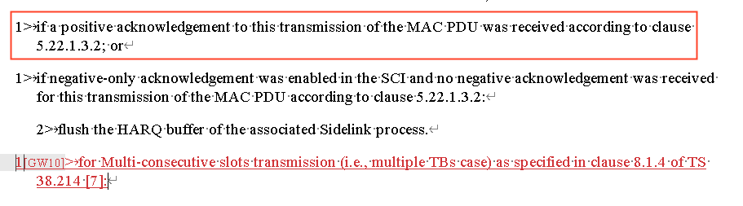  Even though seems the Rapp intention is to use the newly added text to help MCSt to keep performing the Re-Tx, rather than flushing buffer as for legacy cases, the legacy text above (for ACK case) has already flush the buffer? So maybe somehow the MCSt case has to be excluded in the ACK-case If-condition above, to avoid unexpected result? Rely on the Rapp for the detailed wording decision | Thanks for pointing this out and suggestion. Please check the fixes in the next version. Even if I correct it with the suggestion, I'm not sure if I should delete UE behaviour of "3> perform retransmission as specified in clause 5.22.1.1 in the resource(s) of the remaining slot(s) indicated in the sidelink grant as specified in clause 5.22.1.1.".
 | 5.22.1.4.1.2 | 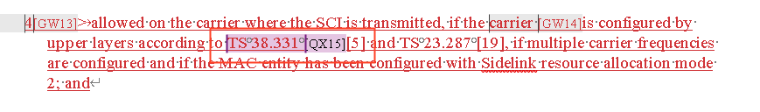  Just for my clarification, is the 38331 indicated carrier also includes the case of PDCP duplication, where the per-LCH carrier set is to be indicated to MAC layer? | That's how I understand it, but am I misunderstanding it?
 | 5.31.2 | A minor issue  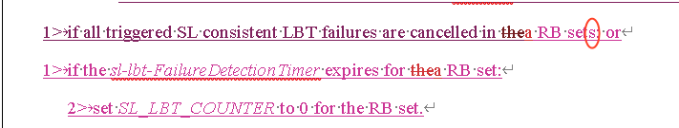  Seems the “s” should be removed, considering the action is for the individual RB-set | Thanks
Apple | 5.22.1.4.1.2 | On below Rapporteur’s comment, we agree with Huawei that this understanding is NOT correct:  “" RAN2 assumes that V2X layer provides intersection of mapped carrier sets of all possible QoS flow(s) to AS layer. So correction is not needed. ":”  As Huawei mentioned, V2X layer provides carriers set for each QoS flow, the V2X layer cannot know what QoS flow(s) will be mapped into SLRB, so the intersection can only be handled in AS layer. Thus, we should capture below RAN2#124 agreement as AS layer operation in this section:  Agreements on QoS flows mapping to carriers:  - Intersection among QoS flow ids belonging to a SLRB is considered in LCP. RAN2 understand NW/upper layer provides appropriate intersections if the service wants CA/PDCP duplication.  As spec change, we suggest to add below NOTE in this section:  NOTE: A LCH is allowed in a carrier based on whether this selected carrier is within a subset of frequencies associated with all the PC5 QoS flows allowed to be mapped to this LCH based on RRC configuration.  Please note that above NOTE has been agreed by majority companies in RAN2#123b post-meeting email discussion#113 (R2-2311791 Summary of [POST123bis][113][V2XSL] QoS flows mapping to carriers (OPPO)). | Same response as the reply to HW’s comment above. And thanks for your suggestion.
Xiaomi | 5.22.1.3.1a | We have similar concern as OPPO. The current structure can not prevent UE from flushing the HARQ buffer. | Thanks. Please check the fixes in the next rapp_version.
 | 5.22.1.4.2 | Is there any agreement for the following new added part?  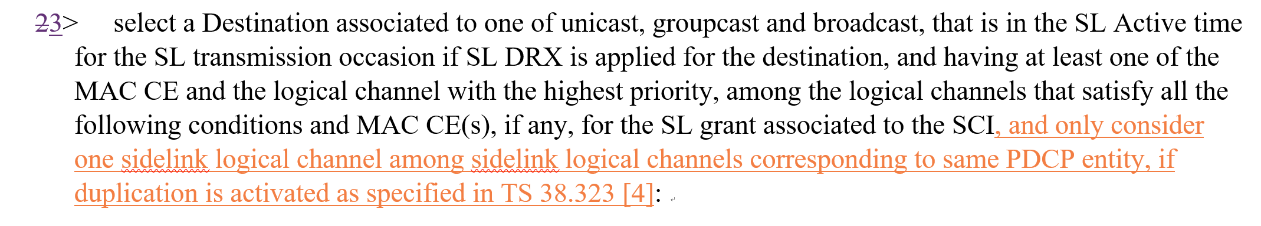 | Text will be removed in next_rapp_version.
 | 6.2.4 | After link establishment, SRB 1/2/3 can be duplicated. So besides SRB3, SRB1/2 should have corresponding LCID for duplication, e.g., 20 for SRB1, 21 for SRB 2 and 22 for SRB3. Duplicated DRB should use 23-38.  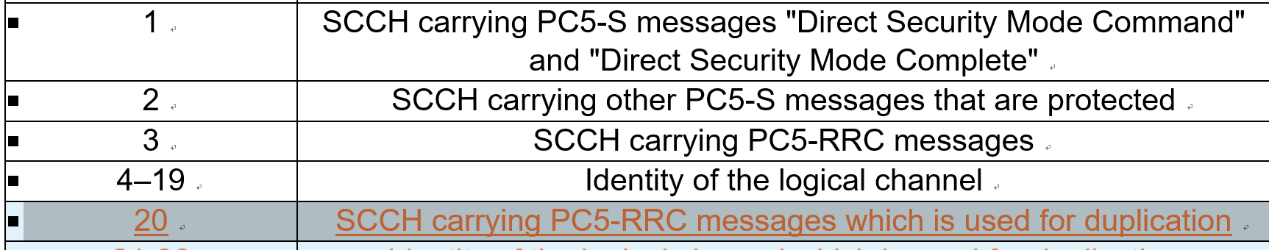 | Thanks. Correction will be reflected in the next rapp_version.
ZTE | 5.22.1.3.1a | Regarding this agreement, and corresponding normative text, we think current wording is not aligned with legacy UE procedure. In current specification, both in Uu and SL, we do not have normative text to describe whether to still perform re-transmission or not. As long as the HARQ buffer is not empty and SL grant available, UE will perform re-transmission. This agreement, we think, is just an high level principle which is not appropriate to be captured into normative text.  #124  MCSt (multiple TB case):  - For remaining slot(s) in case transmission is successful for one TB in MCSt (multiple TB case), the UE still performs retransmission for this TB in the remaining slot(s).  As you can see, current text will flush HARQ buffer in 5.22.1.3.1a and clear re-transmission grant in 5.22.1.1. Therefore, suggest to discuss how to capture this agreement in open issue list.  5.22.1.3.1a:  1> if sl-MaxTransNum corresponding to the highest priority of the logical channel(s) in the MAC PDU has been configured in sl-CG-MaxTransNumList for the sidelink grant by RRC and the number of transmissions of the MAC PDU has been reached to sl-MaxTransNum; or  1> if a positive acknowledgement to this transmission of the MAC PDU was received according to clause 5.22.1.3.2; or  1> if negative-only acknowledgement was enabled in the SCI and no negative acknowledgement was received for this transmission of the MAC PDU according to clause 5.22.1.3.2:  2> flush the HARQ buffer of the associated Sidelink process.  5.22.1.1  1> if a selected sidelink grant is available for retransmission(s) of a MAC PDU which has been positively acknowledged as specified in clause 5.22.1.3.3:  2> clear the PSCCH duration(s) and PSSCH duration(s) corresponding to retransmission(s) of the MAC PDU from the selected sidelink grant. | Same response as the reply to OPPO’s comment above.
Nokia | 5.4.4 | For completeness, suggest to add the red text after ‘if’:  The MAC entity may stop, if any, ongoing Random Access procedure due to a pending SR for SL consistent LBT failure recovery, which has no valid PUCCH resources configured, if one of the following conditions is met: | Thanks.
Nokia | 5.22.1.1/2 | Editorial suggestion to use ‘SL consistent LBT Failure’ to be aligned throughout the specification. | Fixed to ‘SL consistent LBT failure’.
Nokia | 5.22.1.1 | Editorial suggestion to use SL-CSI Reporting instead of ‘SL CSI Reporting’ to be aligned with the rest of the parts in MAC specification. | Thanks
Nokia | 5.22.1.1 | Regarding the below part:  7> when SCS of NR SL is (pre-)configured as $μ=1$, select the time and frequency resources in the first of NR SL slots overlapping with an LTE SL subframe  8> may additionally select the time and frequency resources in the subsequent NR SL slot overlapping with the LTE SL subframe  Question1. Not sure whether 7> should be 7> instead of 6> as the concerned sentence is not really subject to above 6> part.  Question 2. From specification implementation perspective, ‘may’ should not be in the procedural text especially when the whole paragraph starts with ‘the MAC entity shall for each Sidelink process:’ above. It may conflict the UE behavior because the whole paragraph starts with ‘shall’ but here it says may’. Can we have this as a NOTE then? | Regarding the Q1,  I think the current structure is correct because 6> is applied both when SCS is 15KHZ and 30KHZ, and 7> and 8> are applied additionally with 6> when SCS is 30KHZ.  Regarding the Q2, based on several discussions, RAN2 has decided to capture the agreement as normative text. It is not easy to revert this decision in this CR discussion. Additionally, it can be seen in several places that UE implementation behavior is described using “may” in the 3GPP specification.
Nokia | 5.22.1.2 | Regarding the below part:  1> if a MAC PDU is not transmitted (i.e. initial transmission or retransmission) in all of the resources for this MAC PDU that are associated with the sidelink process for Multi-consecutive slots transmission due to the Sidelink LBT failure  ‘NOT + ALL’ may result in interpretation different from the agreement. Suggest changing ‘all’ to ‘any’. | “all” is correct to specify the UE behavior of the RAN2 agreement.
Nokia | 5.221.7 | Regarding the below part:  1> if the SL-CSI reporting has been triggered for a carrier by an SCI and not cancelled:  2> if the sl-CSI-ReportTimer for the triggered SL-CSI reporting is not running:  3> start the sl-CSI-ReportTimer.for the carrier  Not sure if this is the correct behavior. RAN2 agreed that CSI reporting MAC CE can be delivered via any carrier while the MAC CE does not carry any carrier information, meaning that there will be only one CSI reporting ongoing at a time. In that sense, sl-CSI-ReportTimer should be still per UE. It is not clear if rapporteur’s intention here is to maintain the sl-CSI-ReportTimer per carrier, which has not been agreed to our undestanding. | Observation is correct. Correction will be reflected in next Rapp_version.
Ericsson | 5.22.1.7 | I just checked this clause; I fully agree with Nokia. Rapporteur has misinterpreted RAN2 agreement. The whole discussion on CSI report is that, we shall keep the legacy MAC behaviour, i.e., the CSI report timer is maintained per PC5 RRC connection. Since the destination pair only keeps one CSI report triggered at a time, they know which carrier that each CSI report is associated with, therefore, there is no carrier specific operation/no carrier information in the CSI report. Therefore, all “for the carrier” or “of the carrier” need to be removed. | Thanks. Same response as the reply to Nokia’s comment above.
Ericsson | About the term | Unlicensed operation can be updated as “SL operation with shared spectrum channel access”, to be aligned with RRC spec and also the legacy features (e.g., NR-U) | Thanks. I will modify the related text with your suggestion.
Qualcomm | 5.22.1.1 | 3> if sl-lbt-FailureRecoveryConfig is configured in the SL BWP:  4> indicate to the physical layer RB set information for which Sidelink consistent LBT failure was detected as specified in clause 5.31.2.  3> if the TX carrier (re-)selection procedure was triggered in above and one or more carriers have been (re-)selected in the TX carrier (re-)selection according to clause 5.22.1.11:  4> determine the order of the (re-)selected carriers, according to the decreasing order based on the highest priority of logical channels which are allowed on each (re-)selected carrier, and perform the resource selection procedure as specified in this clause for each Sidelink process on each (re-)selected carrier according to the order: | “…failure was detected and not cancelled…”  [Rapp] Thanks.  “…order.” The order here is the decreasing order as described previously.  [Rapp] Correction on TX carrier (re-)selection is not handled in this email discussion. Please see the Rapp NOTE for this email discussion.
Qualcomm |  | 3> if sl-InterUE-CoordinationScheme1 enabling reception/transmission of preferred resource set and non-preferred resource set is not configured by RRC:  4> if transmission based on random selection is configured by upper layers:  5> randomly select the time and frequency resources for one transmission opportunity from the resource pool which occur within the SL DRX Active time, if configured, as specified in clause 5.28.2 of the destination UE selected for indicating to the physical layer the SL DRX Active time above, if configured and the pool(s) in which all RB sets had Sidelink consistent LBT failure detected and not cancelled, according to the amount of selected frequency resources and the remaining PDB of SL data available in the logical channel(s) allowed on the carrier. | …, if configured, and the pool(s) in which all RB sets with had Sidelink consistent LBT failure detected and not cancelled are excluded, if configured,…  [Rapp] Thanks for your suggestion with better wording.  Or use the similar wording in other places: excluding the RB sets detected with C-LBT failure.
Qualcomm |  | 5> if sl-NRPSSCH-EUTRA-ThresRSRP-List is configured by the RRC,  6> randomly select the time and frequency resources for one transmission opportunity from the resources indicated by the physical layer as specified in clause 8.1.4 of TS 38.214 [7], according to the amount of selected frequency resources and the remaining PDB of SL data available in the logical channel(s) allowed on the carrier;  7> when SCS of NR SL is (pre-)configured as $μ=1$, select the time and frequency resources in the first of NR SL slots overlapping with an LTE SL subframe.  8> may additionally select the time and frequency resources in the subsequent NR SL slot overlapping with the LTE SL subframe. | This is applied to $μ=0$, but with the current structure it seems applying to all numerologies.  [Rapp] Please see my response to Nokia's comment regarding this.  “Regarding the Q1,  I think the current structure is correct because 6> is applied both when SCS is 15KHZ and 30KHZ, and 7> and 8> are applied additionally with 6> when SCS is 30KHZ.”
Huawei, HiSilicon | 5.22.1.3.1a | In v06_Rapp, the Option 1 for MCSt is implemented with exceptional condition " except a positive acknowledgement to Multi-consecutive slots transmission (i.e., multiple TBs case) of the MAC PDU;". However there is another condition for "still do the retransmission" in the meeting agreement is "there is remaining slot(s) for the TB receiving ACK". If there is no remaining slot(s), the buffer shall be flushed as in legacy, however this is disabled by the current exception condition for all MCSt cases.  So the exceptional condition shall be " except a positive acknowledgement to Multi-consecutive slots transmission (i.e., multiple TBs case) of the MAC PDU and there is remaining slot(s) for this MAC PDU;".
ZTE |  | WID should be “NR_SL_enh2-Core”
ZTE |  | In LTE V2X, we have following description:  “If duplication is activated as specified in TS 36.323 [4], the MAC entity shall map different sidelink logical channels which correspond to the same PDCP entity onto different carriers in accordance with clause 5.14.1.5, or onto different carriers of different carrier sets (if configured in allowedCarrierFreqList for the corresponding destination). For a given sidelink logical channel, it is up to UE implementation which carrier set to select among the carrier sets configured in allowedCarrierFreqList (if configured) for the corresponding destination.  ”  According to current RRC running CR, two non-overlapping carrier sets is re-used to configure SRB allowed carriers. Therefore, suggest to adopt following description:  “ If duplication is activated as specified in TS 38.323 [*], the MAC entity shall map different sidelink SRB logical channels which correspond to the same PDCP entity onto different carriers of different carrier sets (if configured in SL-SCCH-CarrierSetConfig for the corresponding destination). For a given sidelink SRB logical channel, it is up to UE implementation which carrier set to select among the carrier sets configured in SL-SCCH-CarrierSetConfig (if configured) for the corresponding destination ”
Huawei, HiSilicon | 5.22.1.1 | We understand moving co-channel coexistence description to be under "IUC is not configured by RRC" is based on agreement "SL DRX and IUC is not considered in resource selection of co-channel coexistence of LTE sidelink and NR sidelink until it becomes clear that SL DRX and IUC are supported in co-channel coexistence.". However even before this moving, in resource selection procedure for co-channel coexistence of LTE sidelink and NR sidelink, SL DRX active time and IUC operation has not been considered.  To be future proof and considering split view on DRX/IUC/co-channel coexistence, it is much preferred/safer not to move co-channel coexistence description.

