Note: Corrections related to TX carrier (re-)selection in Section “5.22.1.11” will be reflected in MAC specification at the next meeting when UE behavior for the issues below becomes clear. Therefore, please do not submit comments about the issues below in this email discussion.
- Issue 1. Procedure’s structure (e.g., procedure order: carrier filtering considering HARQ attribute, of resource pool selection for CBR measurement, carrier selection, resource pool selection for grant creation) for TX carrier (re-)selection
- Issue 2. Whether Procedure “Pool selection for CBR measurement” and procedure “Pool selection for grant creation” are decoupled
- Issue 3. How to consider HARQ attribute in the TX carrier (re-)selection procedure

Company | Clause | Comment | Rapp Response
Sharp | 5.22.1.1  5.22.1.3.1 | 5.22.1.1  In the latest RAN1#115, for NOTE 3A10, the referred WA has been updated, thus, the corresponding updates are needed.  Agreement  Confirm the below working assumption on Type 1 LBT blocking with following modifications.  Working assumption (RAN1#114bis)  For Type 1 LBT block issue (inter-UE case), the following option 2 and option 1 are supported separately based on UE capability  - Option 2: If transmission in slot(s) at least Tproc,0SL before a reserved resource is able to share its initiated COT to the reservation, UE may prioritize/select resource(s) in the slot(s) for transmission.  - (pre)configuring enabling/disabling option 2 is supported  - Option 1:  - UE may avoid selection of N consecutive resource(s) before a reserved resource when the L1 SL priority value for the transmission is higher than the L1 SL priority value of the reserved resource.  - The value of N can be selected from {0, 1, 2}  - The selection of the value of N is up to UE implementation  - UE may avoid selection of M consecutive resource(s) after a reserved resource when the transmitting symbols of the reserved resource overlap with LBT of the selected resource.  - The value of M can be selected from {0, 1, 2}  - M is determined based on UE implementation  - (pre)configuring enabling/disabling option 1 is supported  - Note: both option1 and option2 are optional UE features  5.22.1.3.1  For NOTE 5, from our perspective, it prohibits MAC layers to select NACK-only based HARQ-ACK if the size of the group is not larger than the number of PSFCH resources provided by upper layers. While NOTE 5 seems not prohibiting the “else” branch. Therefore, we think NOTE 5 can be updated as “NOTE 5: UE operating in SL unlicensed does not use negative-only acknowledgement for groupcast HARQ and UE expects the group size is not greater than the number of candidate PSFCH resources.” Furthermore, as one PSSCH transmission is associated with candidate PSFCH resources in N consecutive slots as agreed in RAN1 due to LBT failure and UE transmits PSFCH in a later slot only if all the prior PSFCH occasions fail, we think further clarification e.g. “6> if both a group size and a member ID are provided by upper layers and the group size is not greater than the number of candidate PSFCH resources in a slot associated with this sidelink grant:  7> select either positive-negative acknowledgement or negative-only acknowledgement.” is needed.
Huawei, HiSilicon | 5.22.1.4.1.2 | " RAN2 assumes that V2X layer provides intersection of mapped carrier sets of all possible QoS flow(s) to AS layer. So correction is not needed. ":  There seems misunderstanding on this.  Upper layer provides carriers set for each QoS flow, the upper layer can not know what QoS flow(s) will be mapped into SLRB, so the intersection is handled in AS layer, the intersection is not provided by upper layer. What the upper layer shall do is to make sure there are appropriate number of carriers per QoS flow such that intersection in AS for SLRB is meaningful regarding CA operation.  The carrier set can be configured by upper layers according to TS 38.331 and TS 23.287 (i.e. RRC_CONNECTED case and RAN2 thinks there are no issues here). For RRC_INACTIVE/RRC_ILDE/OOC case (usable carrier set not configured), it should be determined by the intersection handling.
OPPO | 5.22.1.3.1a | 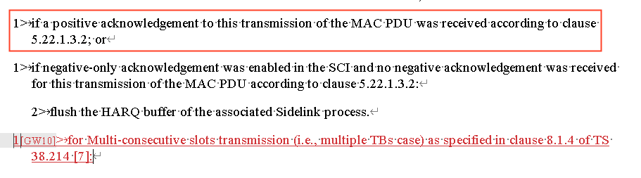  Even though seems the Rapp intention is to use the newly added text to help MCSt to keep performing the Re-Tx, rather than flushing buffer as for legacy cases, the legacy text above (for ACK case) has already flush the buffer? So maybe somehow the MCSt case has to be excluded in the ACK-case If-condition above, to avoid unexpected result? Rely on the Rapp for the detailed wording decision
 | 5.22.1.4.1.2 | 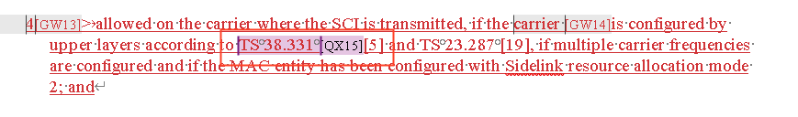  Just for my clarification, is the 38331 indicated carrier also includes the case of PDCP duplication, where the per-LCH carrier set is to be indicated to MAC layer?
 | 5.31.2 | A minor issue  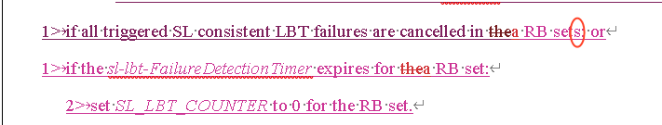  Seems the “s” should be removed, considering the action is for the individual RB-set
Apple | 5.22.1.4.1.2 | On below Rapporteur’s comment, we agree with Huawei that this understanding is NOT correct:  “" RAN2 assumes that V2X layer provides intersection of mapped carrier sets of all possible QoS flow(s) to AS layer. So correction is not needed. ":”  As Huawei mentioned, V2X layer provides carriers set for each QoS flow, the V2X layer cannot know what QoS flow(s) will be mapped into SLRB, so the intersection can only be handled in AS layer. Thus, we should capture below RAN2#124 agreement as AS layer operation in this section:  Agreements on QoS flows mapping to carriers:  - Intersection among QoS flow ids belonging to a SLRB is considered in LCP. RAN2 understand NW/upper layer provides appropriate intersections if the service wants CA/PDCP duplication.  As spec change, we suggest to add below NOTE in this section:  NOTE: A LCH is allowed in a carrier based on whether this selected carrier is within a subset of frequencies associated with all the PC5 QoS flows allowed to be mapped to this LCH based on RRC configuration.  Please note that above NOTE has been agreed by majority companies in RAN2#123b post-meeting email discussion#113 (R2-2311791 Summary of [POST123bis][113][V2XSL] QoS flows mapping to carriers (OPPO)).
Xiaomi | 5.22.1.3.1a | We have similar concern as OPPO. The current structure can not prevent UE from flushing the HARQ buffer.
 | 5.22.1.4.2 | Is there any agreement for the following new added part?  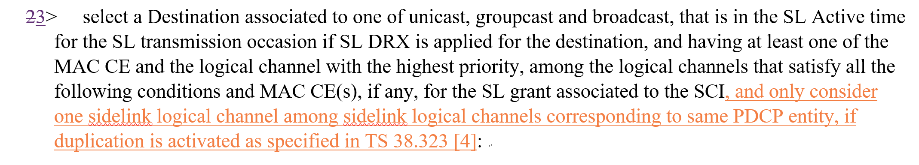
 | 6.2.4 | After link establishment, SRB 1/2/3 can be duplicated. So besides SRB3, SRB1/2 should have corresponding LCID for duplication, e.g., 20 for SRB1, 21 for SRB 2 and 22 for SRB3. Duplicated DRB should use 23-38.  