3GPP TSG-RAN WG2 Meeting #123bis R2-231xxxx
2023 Xiamen, China, October 9th – 13th, 2023

Agenda Item: 7.25.1
Source: Apple
Title: Open issues for SCell FR2 Enhancement (Apple)
Document for: Discussion and Decision

Introduction
On RAN4 WI of FR2 unknown SCell activation enhancement, RAN2 made the following agreement in RAN2#123bis meeting, but how to capture it in spec is still FFS.
RAN2#123bis Agreements:
1. If the network activates multiple SCells within same MAC CE the UE may send only one measurement report.

This document is to collect company’s view on the spec work. If consensus can be reached, the proposals can be reflected in the running CR directly.
- [POST123bis][020][SCell Activation] Running CR (Apple)
Intended outcome: Review running CR to be endorsed in meeting
Deadline: Long

Please provide your comments before October 27th 0100 UTC.

Contact Points
Rapporteur encourages the participating delegates to provide their contact information in this table.
Company | Name | Email Address
Huawei, HiSilicon | Rui Wang | wangrui46@huawei.com
Xiaomi | Shukun Wang | Wangshukun3@xiaomi.com
CATT | Tangxun | tangxun@catt.cn

Discussion

Measurement configuration
Whether the measurement configuration is per CG or per SCell is still FFS.
Editor Note 1: FFS on whether the reporting configuration with the reportType set to reportOnScellActivation is associated with a CG or a SCell (servingCellMO).

Two options may have different spec impact especially in the case of multiple SCell activation in one MAC CE.

Option 1: Measurement configuration is per SCell
- Configuration
    - Understanding
One measurement ID is associated with one report config and one serving MO.
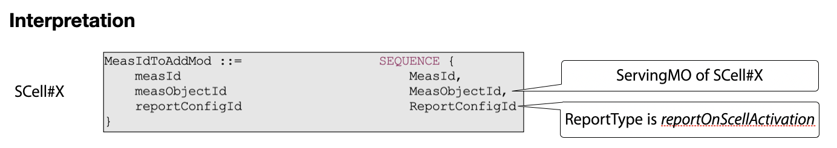
    - Spec impact
There is no impact on the current signalling in running CR.
- Reporting
    - Understanding
When multiple SCells are activated by one MAC CE, it’s possible that multiple measurement reports will be triggered according to current description in running CR.
Therefore, we should clarify in spec that only one measurement report may be transmitted if multiple report can be initiated by one MAC CE, and which measurement report to be sent can be up to UE implementation.
    - Spec impact
One NOTE is added to clarify that only one measurement report can be transmitted by one SCell activation MAC CE. The TP is provided based on the draft CR being reviewed.

5.5.4 Measurement report triggering

5.5.4.1 General
……
If AS security has been activated successfully and if an indication is received by lower layer that an SCell is activated by a MAC CE, the UE shall:
1> for each measId included in the measIdList within VarMeasConfig:
2> if reportType is set to reportOnActivation:
3> if the activated SCell fulfills the measurement requirements as specified in TS 38.133 [14]:
4> include a measurement reporting entry within the VarMeasReportList for this measId;
4> set the numberOfReportsSent defined within the VarMeasReportList for this measId to 0;
5> initiate the measurement reporting procedure, as specified in 5.5.5.
NOTE: If multiple measurement reports may be initiated by one SCell activation MAC CE, only one measurement report is allowed to be transmitted.

Question 1a: For Option 1 (per SCell config), do you agree with understanding and the corresponding spec impact analysis on configuration part?
Configuration:
- Understanding: one measurement ID is associated with one report config and one serving MO;
- Spec impact analysis: no impact on the current signalling in running CR.

Company | Understanding | Spec impact | Comments
Huawei, HiSilicon | Agree | Agree | The existing signaling can already indicate which Scell can trigger the measurement report upon Scell activation by associate the MO of the serving cell and the new report type.
Xiaomi | Agree | Agree
Nokia | Not agree | Agree | Assuming there is only one indication from lower layers per MAC CE then there is no way to trigger more than one report? Thus likely nothing needed?
CATT | Agree | Agree

Question 1b: For Option 1 (per SCell config), do you agree with understanding and the corresponding spec impact analysis on reporting part?
Reporting:
- Understanding: Only one measurement report may be transmitted if multiple report can be triggered by one MAC CE, and which measurement config is used to trigger can be up to UE implementation.
- Spec impact analysis: add a NOTE as above TP for section 5.5.4.1.
NOTE: If multiple measurement reports may be initiated by one SCell activation MAC CE, only one measurement report is allowed to be transmitted.

Company | Understanding | Spec impact | Comments
Huawei, HiSilicon | Agree | Agree | We are ok to capture the UE behaviour (when a MAC CE actives multiple Scell configured with the new reportType, the UE can report only one measurement report) in a NOTE or in normative text.
Xiaomi | Agree | Agree
Nokia | Agree | Not Agree | Not sure why we need a NOTE for this. Assuming there is only one indication from lower layers per MAC CE then there is no way to trigger more than one report? Thus likely nothing needed?
CATT | Agree | Not agree | A Note is not sufficient, specified UE behaviour is better. When a Scell activation MAC CE includes multiple Scells, UE only reports one measurement report which includes measurement results of all activated Scells.

Option 2: Measurement configuration is per CG
- Configuration
    - Understanding
<Measurement object>
One measurement ID is associated with one report config and not associated with any MO. UE ignores the measurement object.
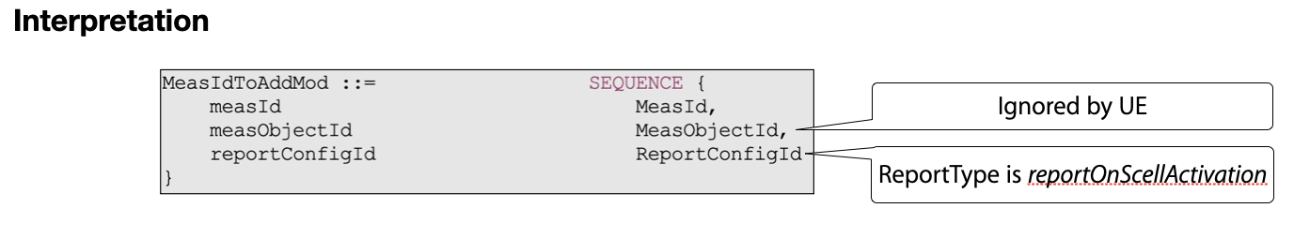
Understanding 1: UE ignores the measurement object in the CG specific measurement configuration.
<Trigger SCell list>
Amongst the multiple SCells in a CG, UE may not support the measurement report on all SCells of the CG, and network may just want to enable it on some specific SCell(s). In order for network to indicate which SCell(s) the new report is applicable for, we need to consider introducing a triggering SCell list in measurement report configuration for such control.
Without the configuration of triggering SCell list, UE has to check all the newly activated SCells based on its capability which will increase the UE burden.
Understanding 2: For SCell level control, new triggering SCell list should be introduced in CG specific measurement configuration.
    - Spec impact
Case a) With SCell level control, new triggering SCell list will be introduced under the report configuration, and the TP is as below.
ReportOnScellActivation-r18 ::= SEQUENCE {
rsType NR-RS-Type,
reportQuantityRS-Indexes MeasReportQuantity,
maxNrofRS-IndexesToReport INTEGER (1..maxNrofIndexesToReport),
includeBeamMeasurements BOOLEAN,
triggeringSCellList SEQUENCE (SIZE (1..maxNrofSCells)) OF SCellIndex OPTIONAL -- Need R
}
Case b) Without SCell level control, there is no further spec impact.

- Reporting
    - Understanding
When multiple SCells are activated by one MAC CE, only one measurement report will be triggered and transmitted according to current description in running CR.
Case a) With SCell level control, UE only triggers the new measurement report when the newly activated SCell is in the trigger SCell list.
Case b) Without SCell level control, UE triggers the new measurement report on all newly activated SCell by each SCell activation MAC CE.
    - Spec impact
Case a) With SCell level control, the TP is provided below based on the draft CR being reviewed.

5.5.4 Measurement report triggering

5.5.4.1 General
……
If AS security has been activated successfully and if an indication is received by lower layer that an SCell is activated by a MAC CE, the UE shall:
1> for each measId included in the measIdList within VarMeasConfig:
2> if reportType is set to reportOnActivation:
3> if the activated SCell is in the triggeringSCellList and fulfills the measurement requirements as specified in TS 38.133 [14]:
4> include a measurement reporting entry within the VarMeasReportList for this measId;
4> set the numberOfReportsSent defined within the VarMeasReportList for this measId to 0;
5> initiate the measurement reporting procedure, as specified in 5.5.5.
Case b) Without SCell level control, there is no spec impact.

Question 2a: For Option 2 (per CG config), do you agree with the following understanding 1 and the corresponding spec impact analysis on configuration part?
Configuration:
- Understanding 1: UE ignores the measurement object in the CG specific measurement configuration.
- Spec impact analysis: no impact on the current signalling in running CR.

Company | Understanding 1 | Spec impact analysis | Comments
Huawei, HiSilicon | Agree | See comments | We understand the intention is to say reusing the existing MeasIdToAddMod can avoid further asn.1 change, apart from the potential change to reportCOnfig, e.g. Scell list, which we agree, but the UE behaviour of how to ignore the measurement object for the measID associated with the new report type should be clearly captured in the spec.
Xiaomi |  |  | I can understanded the intention.  I think we can define a new object as MeasObjectCLI, to inlcude all possible FR2 SCell.  It can ensure the same RRM framework, i.e., one MO + one MR = one Measurment config.
Nokia | possibly not agree |  | UE triggers report per MAC CE activation – not separately per SCells. So we find this bit confusing what is being discussed here.
CATT | Agree | See comments | If we specify that the indication from MAC is for the whole scell activation MAC CE, not in a per Scell way, then there is no further spec impact.

Question 2b: For Option 2 (per CG config), do you support SCell level control and agree with the understanding 2 and spec impact on configuration part?
Configuration:
- Understanding 2: For SCell level control, new triggering SCell list is introduced in CG specific measurement configuration.
- Spec impact analysis: Introduce triggeringSCellList in the report configuration with SCell level control.
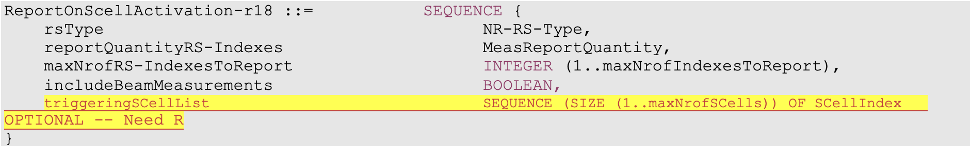

Company | SCell level control | Understanding 2  /Spec impact | Comments
Huawei, HiSilicon | We agree with rapporteur that per Scell config may be useful | See comments | We are wondering whether this Scell list is to be mandatory for the new report type? otherwise, how does the UE undertand which Scell can trigger the new report when the Scell list is absent should be discussed and captured in spec clearly.
Nokia | Not agree | Not agree | We don’t need any extra control here – When MAC CE is received UE reports all the serving cells. This level of control is totally unnecessary.
CATT | Not agree | Not agree | We don’t see a strong motivation to further distinguish which Scell can trigger the early L3 measurement report or not.

Question 2c: For Option 2 (per CG config), if you support SCell level control, do you agree with the following understanding and the spec impact on reporting part?
Reporting:
- Understanding: UE only triggers new measurement report when the newly activated SCell is in trigger SCell list.
- Spec impact: TP is provided below based on the draft CR being reviewed.

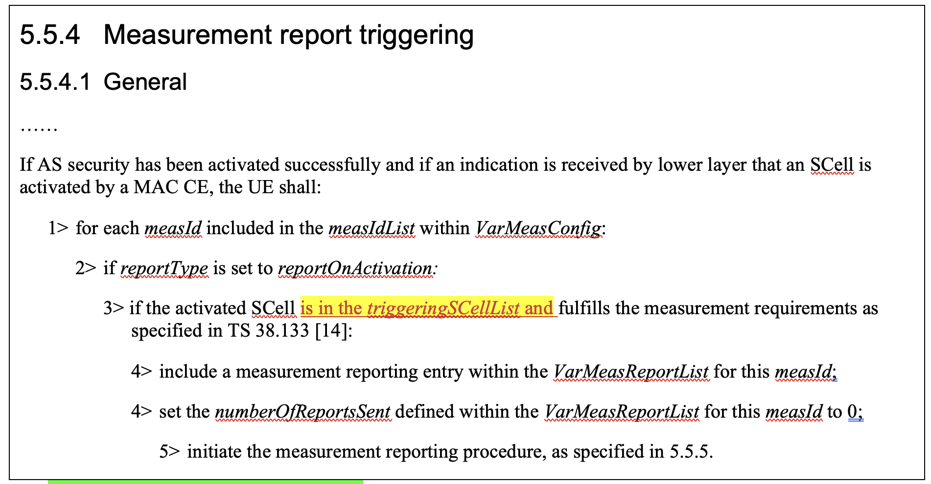

Company | Understanding | Spec impact | Comments
Huawei, HiSilicon | Agree | See comments | Same question as above, whether this Scell list can be absent?

Question 2d: For Option 2 (per CG config), if you donot support SCell level control, do you agree with the following understanding and the spec impact analysis on reporting part?
Reporting:
- Understanding: UE triggers new measurement report on all newly activated SCell by each SCell activation MAC CE.
- Spec impact analysis: no impact on the current signalling in running CR.

Company | Understanding | Spec impact? | Comments
Nokia | Confusing understanding | Agree that no spec impact | When MAC CE is received UE reports all the serving cells – exactly similar to what is currently done for all measurement reporting. UE always reports all serving cells. No need to modify that.
CATT |  |  | Our view is that one Scell activation MAC CE triggers one measurement report.

Preference on the options

Question 3: Which option do you support regarding the measurement configuration?
- Option 1: per SCell configuration
- Option 2: per CG configuration without SCell control
- Option 3: per CG configuration with SCell control (i.e. introduce the triggering SCell list)

Company | Preference | Comments
Huawei, HiSilicon | Option 1 | Option 1 is clean, and can achieve the same goal of option 3 with much less spec impact. To us, option 2/3 let UE ignore the configured measurement object, which is not preferred.
Xiaomi | Option 1 | Prefer option 1 on the table. Or:  Option 4: Define a new object as MeasObjectCLI, to inlcude all possible FR2 SCell. It can ensure the same RRM framework, i.e., one MO + one MR = one Measurment config.
Nokia | Option 2 | Option 2 is current CR – That is preferred. We don’t really see any need for scell specific control. What would be even the usecase. No need to start optimizing this as UE will anyway always report all serving cells.
CATT | Option 2 | The target is to send one L3 measurement report upon the reception of Scell activation MAC CE, so the indication from MAC is per MAC CE, not per Scell, and also there is only one measID for this purpose (UE ignores the measObject, and no need to add a list of Scells in the reportConfig).

Interaction between RRC and MAC

Question 4: Do you think it’s necessary to specify the interaction between RRC and MAC for this measurement reporting?
- Option 1: Not specify it, and it’s up to UE implementation.
- Option 2: Specify it with general description.
Note: if option 2 is your preference, please provide which you prefer to specify in detail.
Company | Preference | Comments
Huawei, HiSilicon | Option 1
Xiaomi | Option 2 | The L2 command, i.e., MAC CE, will trigger a L3 report. The sentense is need to connect L2 procedure and L3 procedure for the whole L3 reporting procedure.  There are also some case in spec:  ===e.g.1: 38.331==  1> if ta-Report is configured with value enabled and the UE supports TA reporting:  2> indicate TA report initiation to lower layers;  ======= e.g.1: 38.321===========  A Timing Advance report (TAR) shall be triggered if any of the following events occur:  - upon indication from upper layers to trigger a Timing Advance report;  ======suggested change in 38.321 for this topic =========  We think it is not clear which layer (RRC or MAC or PHY) can determine the below conditions:  Cond 1: At least one SCell is activated from deactivated state;➔(MAC)  Cond 2: The SCell meeting Cond 1 is unknown FR2 SCell; ➔ (MAC)  Cond 3: The L3 measurement result for FR2 SCell meeting Cod 1/2 after SCell activation command are valid. ➔(RRC)  So at least, the MAC shoud notify RRC about the scell list meeting cond 1  ==========  5.9 Activation/Deactivation of SCells  ==omit some text===  3> (re-)initialize any suspended configured uplink grants of configured grant Type 1 associated with this SCell according to the stored configuration, if any, and to start in the symbol according to rules in clause 5.8.2;  3> trigger PHR according to clause 5.4.6.  2> if an FR2 SCell was deactivated prior to receiving this SCell Activation/Deactivation MAC CE or this Enhanced SCell Activation/Deactivation MAC CE and the FR2 SCell is activated by this MAC CE; and  2> if the FR2 SCell is unknown cell as specified in TS 38.133 [11]; and  3> indicate the measurement report trigger and this FR2 SCell to the upper layers.  1> else if an SCell Activation/Deactivation MAC CE or an Enhanced SCell Activation/Deactivation MAC CE is received deactivating the SCell; or  ============
Nokia | either or | As long as it is clear a single MAC CE used for activation only triggers one indication to RRC to avoid multiple measurement reports to be sent.
CATT | Prefer option 1 | Whether a to-be-activated Scell is a FR2 unknown Scell with available measurement results can be determined by RRC layer, so if the the interaction between RRC and MAC needs to be specified, MAC only needs to indicate a Scell activation MAC CE is received. This can also be handled by UE implementation.

Conclusion
According to the analysis in section 2, we propose that:
.

