3GPP TSG RAN WG2 Meeting #123b R2-230xxxx
Xiamen, China, 9th – 13th Oct., 2023

Agenda item: 7.3.4
Source: Apple
Title: Open issues of running 38.304 CR for NES
WID/SID: Netw_Energy_NR-Core– Release 18
Document for: Discussion and Decision

1 Introduction
This is a summary document on open issues during below running CR discussion:
- [POST123][315][NES] Running CR 38.304 (Apple)
Scope : Review running CR
Outcome: CR to be submitted to next meeting
Deadline: long

2 Open issue list
The collected company comments and running CR of TS 38.304, and CR Rapporteur response can be found in Appendix.
Per the Chair’s guidance, CR rapporteur provide below 2 NES open issues:
- Issue 1: Definition of “NES capable UE” and how to capture it in TS 38.304
- Issue 2: Whether/How to better capture behaviour of cellBarredNES
  - This is a joint issue of running 38.304 CR and 38.331 CR.
  - For example, 2 companies suggested add "This field is ignored by NES capable UEs while cellBarredNES is included in SIB1." under cellBarred bullet, to make UE behavior clearly. However, Rapporteur is not sure whether it will imply new UE behavior like "first read SIB1 for cellBarredNES, and then read MIB for cellBarred” or "first read MIB for cellBarred but just store (not apply), then read SIB1 for cellBarredNES, and finally decide whether to apply cellBarred or not”. So, suggest to list it as an open issue for discussion.
These two issues need to be addressed over the next two meetings from the CR rapporteur perspective. So, In your contributions please focus on solutions for closing these issues.

3 Conclusion
Per the Chair’s guidance, CR rapporteur propose below 2 NES open issues which need to be addressed over the next two meetings. In your contributions please focus on solutions for closing these issues.
- Issue 1: Definition of “NES capable UE” and how to capture it in TS 38.304
- Issue 2: Whether/How to better capture behaviour of cellBarredNES (a joint issue of running 38.304 CR and 38.331 CR).

Appendix (collected comments on running CR discussion)
Company | Detailed comments | Rapporteur response
Huawei | To fully capture the agreement on NES access control we need to align with the “If not present the UE shall follow legacy barring” part.  The NES implementation is different than RedCap and NTN because a NES UE is also a legacy UE. So, the NES UE needs to check SIB1 but if the NES barring bit is not present it needs to follow the MIB barring (which is not the case for NTN and RedCap). One example of implementing it would be to add a condition below the current changes in the proposed CR:  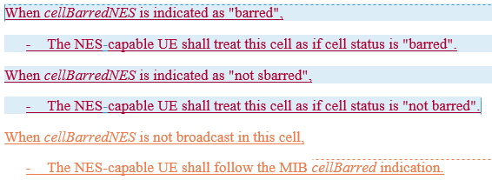 | OK.  I didn't add the suggested condition because I think 38.331 has captured it (so to avoid duplication). But it seems no harm to add it. So, I will implement this change.
Xiaomi | "This field is ignored by UEs supporting NTN while cellBarredNTN is included in SIB1"  => The same wording is neede for NES UE. | Disagree.  According to below agreement, the legacy bit in MIB can be ignored by NES capable UE only when new bit is present (i.e. the UE shall apply legacy bit if new bit is absent)
BT1 | 1. It looks easier to follow same approach as before "This field is only applicable to NES-capable UEs" | OK.  Rapporteur think the main issue is how to define "non NES capable UE", which should be avoided. So, I will implement this change.
BT2 | 2. In addition, we need to capture "If not present the UE shall follow legacy barring". Proposal "If cellBarredNES is not present, NES-capable UEs will follow cellBarred indicated in MIB" | See response to Huawei's comments.
ZTE | We understand the co-existence with other cell bar indicator should also be considered. A NES-capable UE may also support other features, e,g. RedCap, then the cellBarredRedCap1Rx, cellBarredRedCap2Rx should also be considered.  For RedCap UE, the existing principle is that RedCap UE would consider the cell as barred if any of the cellbarred in MIB, cellBarredRedCap1Rx, cellBarredRedCap2Rx in SIB1 is set to barred. And we understand the same principle also applies when the cellBarredNES is introduced and the expected interpretation for the following setting would be as follows (this is a screenshot while the table is copied at the end of this document) :  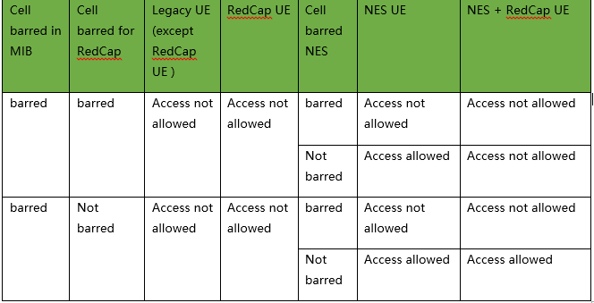  Which means, for NES-capable UE, only the cellBarred in MIB can be ignored, NES-capable UE still need to check other cell bar indication for other features, e.g. RedCap, if it is also a RedCap UE.  To achieve the above understanding, we propose the following change in 304:  - cellBarred (IE type: "barred" or "not barred")  Indicated in MIB message. In case of multiple PLMNs or NPNs indicated in SIB1, this field is common for all PLMNs and NPNs. This field is ignored by UEs supporting NTN while cellBarredNTN is included in SIB1. This field is ignored by NES-capable UE while cellBarredNES is included in SIB1.  When cellBarredNES is indicated as "barred",  - The NES-capable UE shall treat this cell as if cell status is "barred".  When cellBarredNES is indicated as "not barred",  - The NES-capable UE shall treat this cell as if cell status is "not barred".  When cellBarredNES is not broadcast in the cell,  - The NES-capable UE shall follow the MIB cellBarred indication. | Disagree.  Similar to previous discussion on Cell reselection of RAN slicing and HSDN:  - Whether NES UE can also support Redcap (or other technique with barring bit, e.g. NTN) should be discussed in RAN2.  - If the co-existence requirement can be agreed, the barring rules for such UEs needs further RAN2 discussion. We don't think the table is s RAN2 common understanding right now.  So, at this stage, Rapporteur will only capture agreements we made so far:  The NES UE always follows the NES bit used for barring, if present. If not present the UE shall follow legacy barring.  The suggested change basically changed the above agreement.
Nokia | Looks rather fine as is but probably it is best to capture “NES capable” as Editors Note FFS until we know details of what does that mean.  Regarding v4 details: Regarding the added bullet regarding “when cellBarreNES is not broadcast in the cell,” and sub-bullets is not clear. In fact now if one reads the specification NES capable UE will bar the cell always if MIB cellBarred is present. as that is the first bullet and there is nothing about UE ignoring legacy barring if NES barring is present. Thus in fact it would be better to remove those two bullets and add ignoring text in the cellBarred bullet e.g.(additions in yellow):  cellBarred (IE type: "barred" or "not barred")  Indicated in MIB message. In case of multiple PLMNs or NPNs indicated in SIB1, this field is common for all PLMNs and NPNs. This field is ignored by UEs supporting NTN while cellBarredNTN is included in SIB1. This field is ignored by NES capable UEs while cellBarredNES is included in SIB1. | 1. In CR-v3, we have captured such EN at end of this section :)  Editor Note: FFS how to define "NES-capable UE".  2. The normal UE behavior should be: first read MIB for cellBarred and then read SIB1 for cellBarredNES.  However, I think the suggested text seems to imply the UE behavior will be changed to: first read SIB1 for cellBarredNES, and then read MIB for cellBarred  or first read MIB for cellBarred but just store (not apply), then read SIB1 for cellBarredNES, and finally decide whether to apply cellBarred or not.  So, Rapporteur would like to hear more company view.
Qualcomm | For the CellBarredNES to be checked and the new behavior to apply, The MIB cellBarred field has to be indicated as “barred”, otherwise checking the condition is not necessary for the UEand there is a possible error case, so we think the condition should be:  - cellBarredNES (IE type: "barred" or "not barred")  Indicated in SIB1 message. In case of multiple PLMNs or NPNs indicated in SIB1, this field is common for all PLMNs and NPNs. This field is only applicable to NES-capable UEs. This field is ignored if cellBarred is indicated as ‘not barred’.  This also helps with simplifying camping rules for NES-capable UEs as a cell that is not barred in MIB does not need further rules checking. | Disagree  I agree it can simplify rules, but this proposal is exactly OPPO's proposal 3 (R2-2308181) treated online in RAN2#123. It was not agreed because some companies had different view on UE behavior.  You can bring this proposal to upcoming RAN2#123b and try whether it can be agreed.
OPPO | Not quite sure if the change below fully matches the agreement of “The NES UE always follows the NES bit used for barring, if present. If not present the UE shall follow legacy barring.“, since it implies legacy barring equals cellBarred in MIB, without mentioning reserved bit.  On Nokia’s comments, I am not quite sure I got the point, since, based on logic in 38. 304, the case in the first bullet points to the “not barred” case. The cell "barred" case is located after the change for NES.  On Qualcomm’s comments, to be honest, I also feel weird about the case that the legacy UE can access the NES cell but the NES-capable UE cannot. Thus, it makes sense that the NES-capable UE does not need to check cellBarredNES if cellBarred is indicated as “not barred”, otherwise, such UE needs to further check cellBarredNES. While I also understand companies have different views, so we are fine with the current 304 update. | Tend to disagree:  Rapporteur's understanding is "legacy barring" in RAN2#123 agreement is CellBarred in MIB. I think "reserved bit" means bits on NPN, right? Similar to response to ZTE, we can further discuss whether NES can co-exist with other feature (e.g. Redcap, NPN) in future RAN2 meeting. For now, Rapporteur tend to only capture RAN2 agreements made so far.  Other company's view on this issue is appreciated.

Cell barred in MIB | Cell barred for RedCap | Legacy UE (except RedCap UE ) | RedCap UE | Cell barred NES | NES UE | NES + RedCap UE
barred | barred | Access not allowed | Access not allowed | barred | Access not allowed | Access not allowed
 |  |  |  | Not barred | Access allowed | Access not allowed
barred | Not barred | Access not allowed | Access not allowed | barred | Access not allowed | Access not allowed
 |  |  |  | Not barred | Access allowed | Access allowed

