3GPP TSG RAN WG2 Meeting #123b R2-230xxxx
Xiamen, China, 9th – 13th Oct., 2023

Agenda item: 7.3.4
Source: Apple
Title: Collect comments for running CR 38.304 for NES
WID/SID: Netw_Energy_NR-Core– Release 18
Document for: Discussion and Decision

1 Introduction
This document is the report of the following discussion:
- [POST123][315][NES] Running CR 38.304 (Apple)
Scope : Review running CR
Outcome: CR to be submitted to next meeting
Deadline: long

The running 38.304 CR for NES is provided in the discussion folder. Please do not insert / make comments in the CR document, which will be hard for Rapporteur to track and respond your comments. If you have comments, please provide them in the table below. Rapporteur will provide response and decide whether to update CR.

Company | Detailed comments | Rapporteur response
Huawei | To fully capture the agreement on NES access control we need to align with the “If not present the UE shall follow legacy barring” part.  The NES implementation is different than RedCap and NTN because a NES UE is also a legacy UE. So, the NES UE needs to check SIB1 but if the NES barring bit is not present it needs to follow the MIB barring (which is not the case for NTN and RedCap). One example of implementing it would be to add a condition below the current changes in the proposed CR:  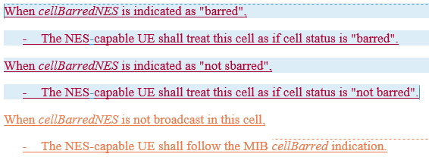 | OK.  I didn't add the suggested condition because I think 38.331 has captured it (so to avoid duplication). But it seems no harm to add it. So, I will implement this change.
Xiaomi | "This field is ignored by UEs supporting NTN while cellBarredNTN is included in SIB1"  => The same wording is neede for NES UE. | Disagree.  According to below agreement, the legacy bit in MIB can be ignored by NES capable UE only when new bit is present (i.e. the UE shall apply legacy bit if new bit is absent)
BT1 | 1. It looks easier to follow same approach as before "This field is only applicable to NES-capable UEs" | OK.  Rapporteur think the main issue is how to define "non NES capable UE", which should be avoided. So, I will implement this change.
BT2 | 2. In addition, we need to capture "If not present the UE shall follow legacy barring". Proposal "If cellBarredNES is not present, NES-capable UEs will follow cellBarred indicated in MIB" | See response to Huawei's comments.
ZTE | We understand the co-existence with other cell bar indicator should also be considered. A NES-capable UE may also support other features, e,g. RedCap, then the cellBarredRedCap1Rx, cellBarredRedCap2Rx should also be considered.  For RedCap UE, the existing principle is that RedCap UE would consider the cell as barred if any of the cellbarred in MIB, cellBarredRedCap1Rx, cellBarredRedCap2Rx in SIB1 is set to barred. And we understand the same principle also applies when the cellBarredNES is introduced and the expected interpretation for the following setting would be as follows (this is a screenshot while the table is copied at the end of this document) :  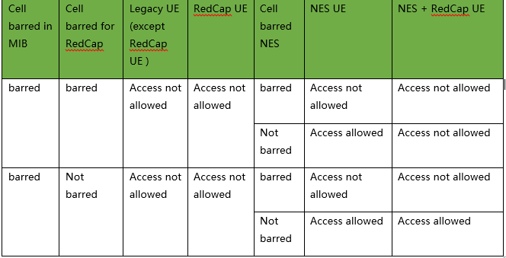  Which means, for NES-capable UE, only the cellBarred in MIB can be ignored, NES-capable UE still need to check other cell bar indication for other features, e.g. RedCap, if it is also a RedCap UE.  To achieve the above understanding, we propose the following change in 304:  - cellBarred (IE type: "barred" or "not barred")  Indicated in MIB message. In case of multiple PLMNs or NPNs indicated in SIB1, this field is common for all PLMNs and NPNs. This field is ignored by UEs supporting NTN while cellBarredNTN is included in SIB1. This field is ignored by NES-capable UE while cellBarredNES is included in SIB1.  When cellBarredNES is indicated as "barred",  - The NES-capable UE shall treat this cell as if cell status is "barred".  When cellBarredNES is indicated as "not barred",  - The NES-capable UE shall treat this cell as if cell status is "not barred".  When cellBarredNES is not broadcast in the cell,  - The NES-capable UE shall follow the MIB cellBarred indication. | Disagree.  Similar to previous discussion on Cell reselection of RAN slicing and HSDN:  - Whether NES UE can also support Redcap (or other technique with barring bit, e.g. NTN) should be discussed in RAN2.  - If the co-existence requirement can be agreed, the barring rules for such UEs needs further RAN2 discussion. We don't think the table is s RAN2 common understanding right now.  So, at this stage, Rapporteur will only capture agreements we made so far:  The NES UE always follows the NES bit used for barring, if present. If not present the UE shall follow legacy barring.  The suggested change basically changed the above agreement.

Cell barred in MIB | Cell barred for RedCap | Legacy UE (except RedCap UE ) | RedCap UE | Cell barred NES | NES UE | NES + RedCap UE
barred | barred | Access not allowed | Access not allowed | barred | Access not allowed | Access not allowed
 |  |  |  | Not barred | Access allowed | Access not allowed
barred | Not barred | Access not allowed | Access not allowed | barred | Access not allowed | Access not allowed
 |  |  |  | Not barred | Access allowed | Access allowed

