3GPP TSG RAN WG2 Meeting #123b R2-230xxxx
Xiamen, China, 9th – 13th Oct., 2023

Agenda item: 7.3.4
Source: Apple
Title: Collect comments for running CR 38.304 for NES
WID/SID: Netw_Energy_NR-Core– Release 18
Document for: Discussion and Decision

1 Introduction
This document is the report of the following discussion:
- [POST123][315][NES] Running CR 38.304 (Apple)
Scope : Review running CR
Outcome: CR to be submitted to next meeting
Deadline: long

The running 38.304 CR for NES is provided in the discussion folder. Please do not insert / make comments in the CR document, which will be hard for Rapporteur to track and respond your comments. If you have comments, please provide them in the table below. Rapporteur will provide response and decide whether to update CR.

Company | Detailed comments | Rapporteur response
Huawei | To fully capture the agreement on NES access control we need to align with the “If not present the UE shall follow legacy barring” part.  The NES implementation is different than RedCap and NTN because a NES UE is also a legacy UE. So, the NES UE needs to check SIB1 but if the NES barring bit is not present it needs to follow the MIB barring (which is not the case for NTN and RedCap). One example of implementing it would be to add a condition below the current changes in the proposed CR:  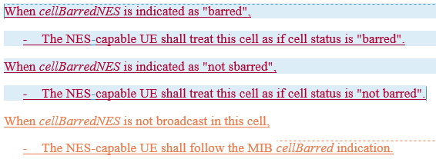 | OK.  I didn't add the suggested condition because I think 38.331 has captured it (so to avoid duplication). But it seems no harm to add it. So, I will implement this change.
Xiaomi | "This field is ignored by UEs supporting NTN while cellBarredNTN is included in SIB1"  => The same wording is neede for NES UE. | Disagree.  According to below agreement, the legacy bit in MIB can be ignored by NES capable UE only when new bit is present (i.e. the UE shall apply legacy bit if new bit is absent)
BT1 | 1. It looks easier to follow same approach as before "This field is only applicable to NES-capable UEs" | OK.  Rapporteur think the main issue is how to define "non NES capable UE", which should be avoided. So, I will implement this change.
BT2 | 2. In addition, we need to capture "If not present the UE shall follow legacy barring". Proposal "If cellBarredNES is not present, NES-capable UEs will follow cellBarred indicated in MIB" | See response to Huawei's comments.

