3GPP TSG-RAN WG2 Meeting #123 DocNumber
Toulouse, France, August 21st - 25th, 2023

Agenda: 7.25.4
Source: Ericsson
Title: Report of [Post123][102]NTN Self Ev] CPUP latency (Ericsson)
Document for: Discussion, decision

1 Introduction
ITU-R has defined requirements for the satellite component of IMT-2020 [1]. The set of requirements and the corresponding evaluation guidelines are based on the terrestrial procedure, to which 3GPP has submitted TR 37.910 [2]. Similar to the terrestrial case, the requirements include a CP and UP latency targets which have been set to 40 ms and 10 ms, respectively [1], to take into account the longer propagation delay inherent to satellite communications.
The purpose of this email discussion is to align the views on parameters for evaluating user plane and control plane latency in order to prepare the evaluation report that will be captured in TR 37.911 [3]. In addition, a text proposal to TR 37.911 [3] is provided as an attachment to capture the agreements taken so far by RAN2 regarding the mobility interruption evaluation. The study aims to have a final submission package ready by RAN#102, that is before ITU-R WP4B submission deadline (end of December 2023) [4].
- [Post123][102]NTN Self Ev] CP/UP latency (Ericsson)
Scope: discuss the actual numbers for CP/UP latency and potentially draft a corresponding TP
Intended outcome: email discussion summary
Deadline: Long

2 Remaining issues
During RAN2#123, the following relevant agreements were taken:
- At the moment, RAN2 assumes the best-case scenario even though RAN2 understands that it might not be a common scenario in some cases. Additional scenarios can be considered during the self evaluation work
- RAN2 assumes that both UE and gNB are located at the satellite’s nadir, i.e., elevation angles are 90 degrees, for the calculation of round trip delay (RTD).
- Given the assumptions of Proposal 1, feeder and service link delays are included in the propagation delay computation (RTD).
- For the mobility interruption evaluation, RAN2 assumes that for now it is sufficient to consider beam-based mobility in NTN.
- From RAN2 perspective, satellite on-board delay can be considered negligible.
- RAN2 assumes the CP procedure defined in Figure 1 as the baseline for the CP evaluation.
- For the best-case scenario, RAN2 assumes a lossless scenario (p=0) for the User plane evaluation / RAN2 will not consider retransmissions.
- RAN2 assumes the following for the evaluation of CP and UP latency:
  - NR FDD
  - Only NTN bands are considered (n255, n256).
  - UE capabilities 1 & 2
  - Resource type mapping A &B
  - SCS 15 kHz for the baseline scenario. FFS other supported scenarios (e.g., 30 kHz).

2.1 CP latency
As agreed in RAN2#123, the following control plane procedure is the baseline for the evaluation of IMT-2020 requirements.
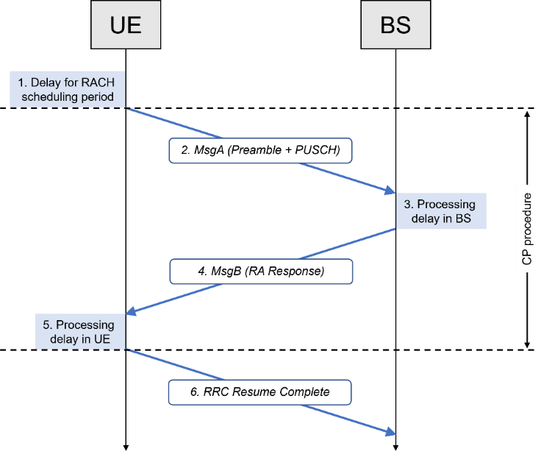

Q1. Which delay assumptions are applicable to NR NTN? Please fill in the last column “company comments” with suggestions and the respective justification.
Step | Description | CP latency for UL data transfer | Company comments
1 | Delay due to RACH scheduling period (1TTI) | 0
2.1 | Transmission of MsgA
2.1.1 | Transmission of RACH Preamble | Length of the preamble according to the PRACH format
2.1.2 | Transmission interval | 1 ms | THALES : Need to precise what is heard by ”Transmission interval” of MsgA in a Note. Should it depend to the SCS selected ?
2.1.3 | Transmission of PUSCH payload (RRCResumeRequest) | Ts (the length of 1 slot / non-slot)
2.2 | Propagation delay UE -> BS | RTD/2
3 | MsgA detection and processing delay in gNB (preamble, L2, RRC) | 3 ms | [Rapp] Same as for reception of Msg3 in NR TN
4 | Transmission of MsgB
4.1 | Transmission of MsgB (RA response and RRCResume) | Ts (the length of 1 slot / non-slot)
4.2 | Propagation delay BS -> UE | RTD/2
5 | Processing delay in UE of RRC Resume including RA response | 7 ms | [Rapp] Same as for reception of Msg4 in NR TN
6 | Transmission of RRC Resume Complete and data | 0
Notes:
1. For step 1, the procedure for transition from a most “battery efficient” state has yet not begun, hence this step is not relevant for the latency of the procedure which is illustrated by a '0' in the above.
2. For step 2.1.1, the length of the preamble associated with the PRACH format is specified in TS 38.211 [6].
3. For step 3, the processing delay in gNB (preamble, L2 and RRC) has been reduced to 3 ms. The delays due to inside-gNB or inter-gNB communication are not included in Step 3. Such delays may exist depending on deployment but are not within the scope of this evaluation.
4. For step 5 for UL data transfer, the processing delay in the UE (L2 and RRC) is considered, i.e., from reception of RRC Connection Resume including the RA response to the reception of UL grant. The transmission of UL grant by gNB and processing delay in the UE (processing of UL grant and preparing for UL tx) are also considered. The RRCConnectionResume message only includes MAC and PHY configuration. No DRX, SPS, or MIMO re-configuration will be triggered by this message. Further, the UL grant for transmission of RRC Connection Resume Complete and the data is transmitted over common search space with DCI format 0.
5. For step 6, the beginning of this subframe is considered to be "the start of continuous data transfer", hence this step is not relevant for the latency of the procedure which is illustrated by a '0' in the above.

2.2 UP latency DL
Q2. Which delay assumptions are applicable to NR NTN? Please fill in the last column “company comments” with suggestions and the respective justification. Note that for the UP evaluation RAN2 has agreed not to consider retransmissions.
ID | Component | Notations | Value | Company comments
1.1 | BS processing delay | t_{BS,tx}  The time interval between the data is arrived, and packet is generated. | T_{proc,2}/2, with d_{2,1}= d_{2,2}=0. (T_{proc,2} is defined in Section 6.4 of TS38.214) (NOTE1) | [Rapp] d2,3 can be removed as it seems not to be defined in TS 38.214.
1.2 | DL frame alignment (transmission alignment) | t_{FA,DL}  The time interval between packet generation and the next Tx opportunity. | T_{FA}  T_{FA} is the frame alignment time within the current DL slot.
1.3 | TTI for DL data packet transmission | t_{DL_duration} | Length of one slot (14 OFDM symbol length) or non-slot (4/7 OFDM symbol length), depending on slot or non-slot selected in evaluation.
1.4 | One-way propagation time BS -> satellite -> UE | t_{prop} | RTD/2
1.5 | UE processing delay | t_{UE,tx}  The time interval between PDSCH reception and decoding of the data. | T_{proc,1}/2 (T_{proc,1} is defined in Section 5.3 of TS38.214), d_{1,1}=0 | [Rapp] d_{1,2} can be removed as it seems not be defined in TS 38.214.
Note:
1. The value is used for evaluation only; gNB processing delay may vary depending on implementation.

2.3 UP latency UL
Q3. Which delay assumptions are applicable to NR NTN? Please fill in the last column “company comments” with suggestions and the respective justification. Note that for the UP evaluation RAN2 has agreed not to consider retransmissions.
ID | Component | Notations | Value | Company input
1.1 | UE processing delay | t_{UE,tx}  The time interval between data arrival and packet generation. | T_{proc,2}/2, with d_{2,1} = d_{2,2} = 0.  T_{proc,2} is defined in Section 6.4 of TS 38.214. | [Rapp] d2,3 can be removed as it seems not to be defined in TS 38.214.
1.2 | UL frame alignment (transmission alignment) | t_{FA,UL}  The time interval between packet generation and the next Tx opportunity. | T_{FA}  Length of one slot, since T_{FA} is bounded by the slot duration.
1.3 | TTI for UL data packet transmission | t_{UL_duration} | Length of one slot (14 OFDM symbol length) or non-slot (4/7 OFDM symbol length), depending on slot or non-slot selected in evaluation.
1.4 | One-way propagation time UE -> satellite -> BS | t_{prop} | RTD/2
1.5 | BS processing delay | t_{BS,rx}  The time interval between PUSCH reception and decoding of the data. | T_{proc,1}/2, with d_{1,1} = 0.  T_{proc,1} is defined in Section 5.3 of TS 38.214. (Note 1) | [Rapp] d_{1,2} can be removed as it seems not be defined in TS 38.214.
Note:
1. The value is used for evaluation only; gNB processing delay may vary depending on implementation.

2.4 LS to RAN1
During the F2F discussion, a few companies highlighted that some of the values used in the control plane and user plane evaluation would benefit from a confirmation by RAN1 (e.g., MsgA detection and processing delay in gNB). Given the aim to finish the evaluation by RAN#102 in December, rapporteur understand the intention of the proponent companies while wants to highlight the tight timeline for elaborating, sending and receiving a potential LS.
Q4. Should RAN2 send an LS to RAN1 to confirm the delay values associated with the above control and user plane evaluations? If Yes, please write in the comments column which specific delay values need to be confirmed.

Company | Yes/No | Comments
THALES | No | The assumptions agreed for RAN2 at the RAN2#123 takes baseline configurations of the different procedures (Step-2 RACH,…) and does not require more inputs from RAN1 for latency analysis.
Qualcomm | See comments | Probably yes as we should target to complete this in the next meeting and, we could inform RAN1, probably they can also check.  We also suggest considering table with example values for the considered scenario, like below, but we can consider only the M = 14, SCS 15kHz and p = 0 parameters.  Table 5.7.1.1.1-2 DL user plane latency for NR FDD (ms)  DL user plane latency – NR FDD UE capability 1 UE capability 2  SCS SCS  15 kHz 30 kHz 60 kHz 120 kHz 15 kHz 30 kHz 60 kHz  Resource mapping Type A M=4 (4OS non-slot) p=0 1.37 0.76 0.54 0.34 1.00 0.55 0.36  p=0.1 1.58 0.87 0.64 0.40 1.12 0.65 0.41  M=7 (7OS non-slot) p=0 1.49 0.82 0.57 0.36 1.12 0.61 0.39  p=0.1 1.70 0.93 0.67 0.42 1.25 0.71 0.44  M=14 (14OS slot) p=0 2.13 1.14 0.72 0.44 1.80 0.94 0.56  p=0.1 2.43 1.29 0.82 0.51 2.00 1.04 0.63  Resource mapping Type B M=2 (2OS non-slot) p=0 0.98 0.56 0.44 0.29 0.49 0.29 0.23  p=0.1 1.16 0.67 0.52 0.35 0.60 0.35 0.28  M=4 (4OS non-slot) p=0 1.11 0.63 0.47 0.31 0.66 0.37 0.27  p=0.1 1.30 0.74 0.56 0.36 0.78 0.45 0.32  M=7 (7OS non-slot) p=0 1.30 0.72 0.52 0.33 0.93 0.51 0.34  p=0.1 1.49 0.83 0.61 0.39 1.08 0.59 0.40

4 Conclusions

5 References
- R1-2304123, Feature lead summary #4 on evaluation methodology for IMT-2020 Satellite, RAN1.
- ITU-R M.2514, "Vision, requirements and evaluation guidelines for satellite radio interface(s) of IMT-2020".
- TR 37.911, Study on self-evaluation towards the IMT-2020 submission of the 3GPP Satellite Radio Interface Technology, Release 18, June 2023.
- RP-230736, Study on Self-Evaluation towards the 3GPP submission of a IMT-2020 Satellite Radio Interface Technology, Ericsson, Qualcomm, Thales, MediaTek Inc., RAN#99, Rotterdam, The Netherlands, March 2022.

