3GPP TSG-RAN WG2 #123 R2-23XXXXX
Toulouse, France, August 21 – 25, 2023

Agenda Item: X.Y.Z
Source: Ericsson
Title: Outcome of [Post122][059][AIML]
Document for: Discussion

1 Introduction
The scope of the discussion is given by the following email thread:
- [Post122][059][AIML] TR text proposal (Ericsson)
Scope: Assemble agreed figure, tables etc into a TR baseline TP. Identify discussion points that seems essential to progress RAN2 TP in the near term
Intended outcome: Agreeable TP,
Deadline: Long
The main purpose of this document is to address the discussion related to the functional framework, specifically regarding the data/information flows (i.e., arrows) which we did not have time to discuss online.
If you have not already done so, please refer to the separate document (i.e., RAN2’s TP to the TR) before proceeding with this document. Please note that an Annex has been included in that document listing all RAN2 agreements. The Rapporteur has highlighted those that are captured as TP.
Additionally, please provide any further details you believe are worth addressing in this email discussion as input to Q2 (see below).

Deadline for comments: Thursday Aug 10th, 2023, 1000 UTC
Inactive periods and other planning comments:
July 1st – 30th 3GPP Inactive Period
August 10 1000 UTC Deadline Long Email Discussions
August 11 1000 UTC Submission Deadline RAN2#123

Below you can find the list of participating companies and their respective responsible delegates.
Company | Delegate name | Email address
Ericsson | Felipe Arraño Scharager | felipe.arrano.scharager@ericsson.com
vivo | Boubacar Kimba | kimba@vivo.com
Xiaomi | Xing Yang | Yangxing1@xiaomi.com

2 Discussion

2.1 On the functional framework
The following was agreed during RAN2#122:
Functional Arch
- Intention is to cover functional arch in general, e.g. covering both be model based and/or functionality based LCM
- “Model Storage” in the figure is only intended as a reference point (if any) for protocol terminations etc for model transfer/delivery etc. It is not intended to limit where models are actually stored. Add a note for this.
- Remove “Model” in Model Managemt and Model Inference and for the actions/the arrow form Management to Inference (to reduce the risk for misunderstanding).
- Management may be model based management, or functionality based management. Add a mote for this.
- With the modifications above Figure 2 from R2-2305327 is agreed

Figure 2 from R2-23053207 can be seen below:
Figure 2: Functional architecture of AI for air interface

As per the agreements above, the Rapporteur has captured the following Figure in RAN2’s (currently discussed) text proposal for TR 38.843:
Figure 4.4-1: Functional framework for AI/ML for NR Air Interface
Please be aware of the following changes to the names of the data/information flows (i.e., arrows):
- The arrow from Management to Inference has been renamed as “Management Instruction”,
- The arrow from Management to Model Training has been renamed “Monitoring output”,
- The arrow from Inference to Management has been renamed to “Inference Output”.
Arguments to these changes are provided as input to Q1 below.
Question 1:
Companies are invited to provide their views on the functional framework in the Figure above (Figure 4.4.-1). Try focusing on the data/information flows (i.e., the arrows), as the main blocks/functions have already been discussed and agreed online. Hence, try answering: should an arrow be optional? Should we rename them? Should we add/remove some? etc...
Note: As per RAN2’s agreement the Rapporteur’s intention is to update the TR’s Figure that will be submitted to RAN2#123 according to the outcome of the discussion below.
Company | Views
Ericsson | On the arrow’s names:  We think that we should rename the following arrows as follows:  Model selection/(de)activation/switching/fallback Management Instruction  Monitoring output Inference output  Performance Feedback / Retraining Request Monitoring output  For the first one, there is a need to generalize what this is intended for.  Further, on the other ones, please look that monitoring data goes into management, then the outcome of management should be “monitoring output”, and the outcome of inference should be “inference output”.  Note that for the “Performance Feedback / Retraining Request”, the Model Training function should be the one to decide whether retraining is needed based on the monitoring output (i.e., not the Management function deciding this).  On the presence/optionality of arrows and functions (blocks):  - (arrow) Model Transfer/Delivery Request:  We are not entirely sure why the management function should be in charge of this. In principle, the management entity should simply provide the outcomes of certain model performances. Hence, we are inclined not to proceed with this model (update) request.  Additionally, since we agreed that “Model Storage” is only intended as a reference point, we could also use dashed lines for all arrows from/to the “Model Storage” block (eventually the block itself could also be dashed).
vivo | First:  We think we should decouple the TR update and whether to rename the arrows in the figure. That is, the TR update should just focus on the current RAN2 agreements. And separately we can discuss whether to rename the arrows. If RAN2 agree to do the update, we still have RAN2#123 post meeting for TR update. There is no rash to do this in the current TR update discussion.  Second:  On: Model selection/(de)activation/switching/fallback → Management Instruction:  We think using “Instruction” may be confusing. We do not see the necessity to introduce a new terminology for current model management procedure related to selection/(de)activation/switching/fallback .  On Performance Feedback / Retraining Request → Monitoring output  Retraining Request can be based on monitoring output, but not every monitoring output would require retraining request. So, whether or not there is need to retrain a model should be decided at management entity. If we agree to rename, as proposed by Rapp, that means the model retraining decision would be totally left to model training entity. That is not RAN2 current agreement.
Xiaomi | On the arrow name  The functionality of the arrows should be aligned among all the arrows in the diagram. Now it seems that the arrows have different meaning in the diagram. Some arrows represent the contents to be exchanged between two blocks. For example, the arrow between data collection and model training/ management/inference. While, some other arrows represent involved process between blocks. For example, the arrow between management and model inference. In our view, it is more general to make one arrow represent involved procedure. Considering this aspect, the text of arrow between data collection and model training/management/model inference and the text of arrow between model training and model storage can be updated to reflect involved procedure.  On the arrow addition  The functionality/model identification process is one important aspect in the whole LCM. This procedure may be reflected in the diagram. Management is responsible to manage the model or functionality identification. After the model is trained, then related functionality identification or model identification can be performed if needed. Hence, an arrow representing the model/functionality identification can be added between the model training and management.  On the arrow removal  The management need to acquire performance monitoring inputs. In the fig, there are two arrows from data collection and inference. However, we understand the data collection shall support both legacy metrics and AI related metrics. Therefore, seems the arrow from model inference to management is unnecessary and can be removed. It is already covered by the arrow between data collection and management since the collected monitoring data could also include the output of the inference.  On the optionality of arrow  We are not sure whether the arrow from management to model training is always mandatory. Seems the only use case of such arrow is to retrain the model. However, we understand the model training may be out of 3GPP, which means the training may be independent from the performance monitoring. Therefore, we suggest to make this arrow optional.  Also agree with Ericsson, the model storage related arrow can be optional since the model storage itself is optional.  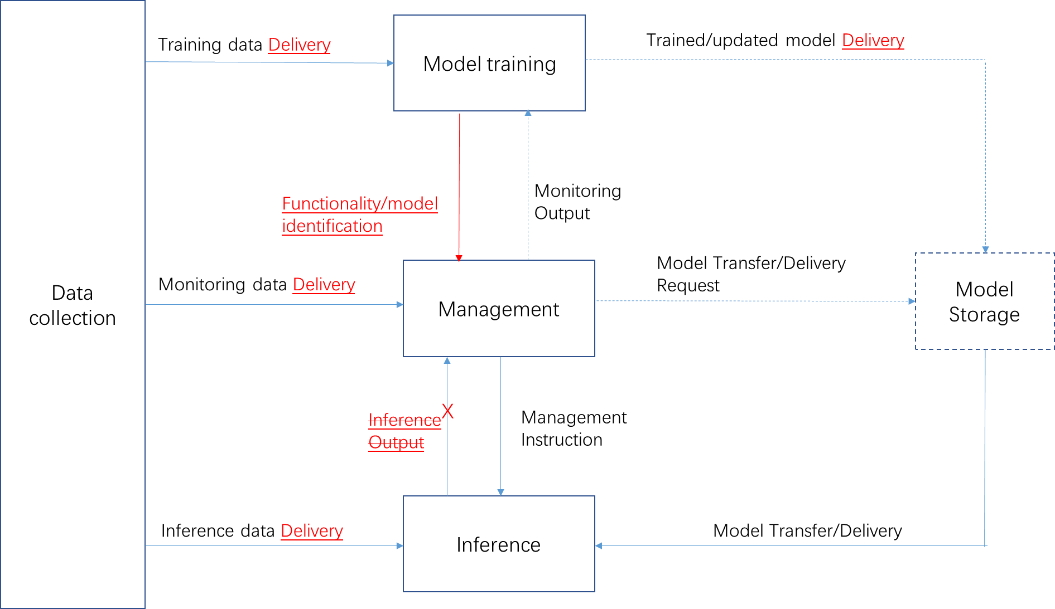
[Rapporteur’s Summary]: To be added…
- According to companies’ inputs...
- RAN2 to …
Question 2:
Companies are invited to provide additional comments with respect to RAN2’s TP for the TR. Is there something missing? Is there any other topic that should be addressed by this email discussion? etc…
As per what the Chair has described as scope for this email discussion, companies are also invited to provide views on discussion points that appear essential to progress RAN2’s TP in the near term. Please note that the Rapporteur has already added Editor’s Notes to the TR (highlighting some topics that need further study or/discussion/progress in RAN2).
Company | Views
Ericsson | We have tried to stress some points in the TP which RAN2 should start discussing in the near term, these include:  - (Prioritize discussion on) Mechanisms to report updates on applicability of models/functionalities  - UE capability reporting considerations (note that RAN1 have agreed some things on this matter, and we believe that RAN2 should have a saying as well).
vivo | For 4.2, the EN about functionality and capability sees not needed as further discussion and clarification will be captured in sections 7.3.1.1 and 7.3.1.4.  For 7.3, all the descriptions related to the assumptions in the LS to RAN1 should be rephrased as ‘RAN2 assumes…’. Besides, suggest adding an EN for the RRC state of data collection:  Editor’s note: Analysis and potential enhancement of the data collection when UE in the non-connected state can be revisited when needed.  For 7.3.2/3/4 “…be initiated by either the …” We think “decided” or “decided/initiated” may be more precise.  For 7.3.4, the original assumption is 'For model monitoring at NW side, performance metrics can be generated by UE/gNB and terminated at LMF.‘ However, the current TP added the restriction ' For monitoring at the network side of UE-sided model‘. We suppose the gNB is not able to generate performance metrics for UE-sided model, and suggest removing ' of UE-sided model‘.

- According to companies’ inputs...
- RAN2 to …
[Rapporteur’s Summary]: To be added…

3 Conclusion
In the previous sections we made the following observations:
Observation 1 According to companies’ inputs...
Observation 2 According to companies’ inputs...

Based on the discussion in the previous sections we propose the following:
Proposal 1 RAN2 to …
Proposal 2 RAN2 to …

4 References
- R2-23XXXXX, “R2 input to TR 38.343”, Ericsson, RAN2#123, August 2023, Toulouse, France

