3GPP TSG-RAN WG2 Meeting#121bis-e R2-23xxxxx
Electronic Meeting, 17 – 26 April, 2023

Agenda Item: 8.11.2.1
Source: Apple
Title: Report of [Post121][607][eMBS] UP issues for Multicast in RRC Inactive (Apple)
Document for: Discussion and Decision

Introduction
This document captures the outcome of the following email discussion:
- [Post121][607][eMBS] UP issues for Multicast in RRC Inactive (Apple)
Scope: Based on the companies’ contributions identify and discuss the potential UP issues that need to be resolved to support Multicast in RRC Inactive. Identify potential impact on RAN2 UP specifications and impact to other WGs, e.g. RAN1, RAN3.
Outcome: Report
Deadline: Long

Please provide your comments before 04/05/2023 23:59 UTC.

Discussion
Rapporteur encourages the participating delegates to provide their contact information in this table.
Company | Contact: Name (E-mail)
ZTE | QI Tao (qi.tao3@zte.com.cn)

CFR configuration
In Rel-17, the multicast CFR configuration and broadcast CFR configuration are different.
- Multicast CFR is configured within the UE dedicated BWP for RRC_CONNECTED UE;
- Broadcast CFR is configured with the BW fully overlapping with CORESET0 and with the same numerology as CORESET0 as indicated in the following 3 cases (i.e. case A/C/E) in Figure 1. the configuration is used for MTCH and MCCH transmission to UE in all RRC states.
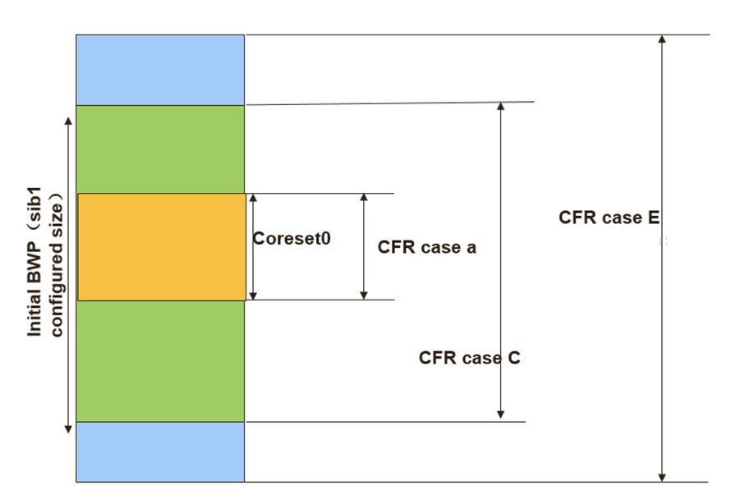
Figure 1: CFR cases for MBS broadcast [12]
For multicast reception in RRC_INACTIVE in Rel-18, RAN2 has agreed to introduce new SIB and new MCCH to provide the multicast configuration for multicast reception in RRC_INACTIVE. If R17 broadcast CFR design (3 cases) can be reused for multicast reception, RRC_INACTIVE UEs can receive SIBs/paging and MBS multicast without BWP switching.

Q1: [CFR] Do you agree to follow R17 MBS broadcast CFR principle to provide multicast CFR configuration in RRC_INACTIVE?
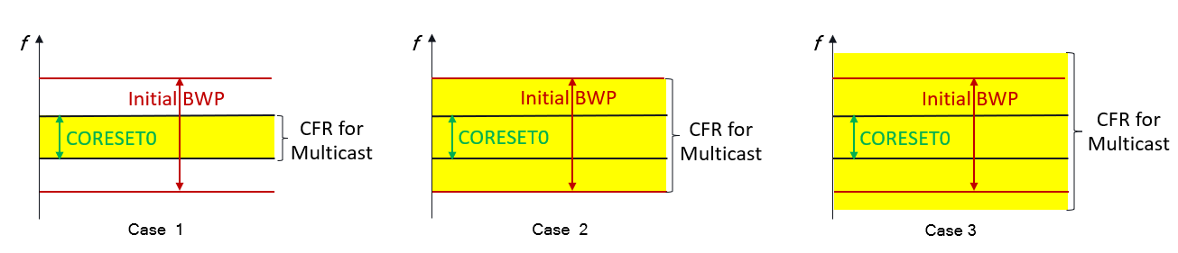
Figure 2: CFR for Rel-18 Multicast reception in RRC_INACTIVE [15]

Company | Yes or No | Comment if any
ZTE | Would love to.. but | There is at least one issue if we follow the restrictions of CFR for Rel-17 BC:  - for Rel-17 Multicast, we don't have any limitation as of any case above, the SCS might not even be the same as the initial BWP for the broadcast, theoretically. What if UE was configured otherwise, do they need to be re-configured, all at once, at the moment network enables the multicast reception in RRC_INACITVE?  Other than that, the following question may need some further discussion in later stage.  - does broadcast and multicast for RRC_INACTIVE UEs use the same CFR configuration? it seems unnecessary. how to guide UE mobility from other cell to get the PTM config in multicast MCCH shall be discussed.  - does all multicast received in RRC_INACTIVE use the same CFR? And for a certain multicast service, is the same CFR configuration used in RRC_INACTIVE and RRC_CONNECTED state? Probably so, but there no need to limit network implementation.  - Is the same CFR configuration for both multicast MCCH and MTCH? Better not. We shall have capability limited UE in mind, e.g., MCCH can be of narrower band, and MTCH of per service.  - etc..

MAC related issues

HARQ operation and scheduling DCI
In Rel-17, the DCI format and HARQ operation used for MBS multicast and broadcast are different.
 | MBS multicast (MTCH) | MBS broadcast (MTCH) and MCCH
DCI format | - DCI format 4_1/4_2 | - DCI format 4_0
Applicable RRC states | - RRC_CONNECTED | - All RRC states
HARQ operation | - NW provides HARQ scheduling information (i.e., NDI, HARQ process number, HARQ feedback resources and timing, etc).  - HARQ process ID is explicitly indicated in DCI.  - Support NDI based HARQ retransmission. | - NW does not indicate HARQ process ID.  - UE selects the HARQ process ID by itself.  - NDI based HARQ retransmission is not supported.
Beam for transmission | - The TCI state for PDSCH and the TCI state for PDCCH are UE specific TCI state, which is based on UE specific beam management.  - The DCI format 4_2 for multicast MBS contains the TCI state for PDSCH reception;  - The DCI format 4_1, the same TCI state as TCI state for unicast PDCCH will be used. | - The transmission is via beam sweeping based on SSB index.

DCI Format 4_0 | DCI Format 4_1 | DCI Format 4_2
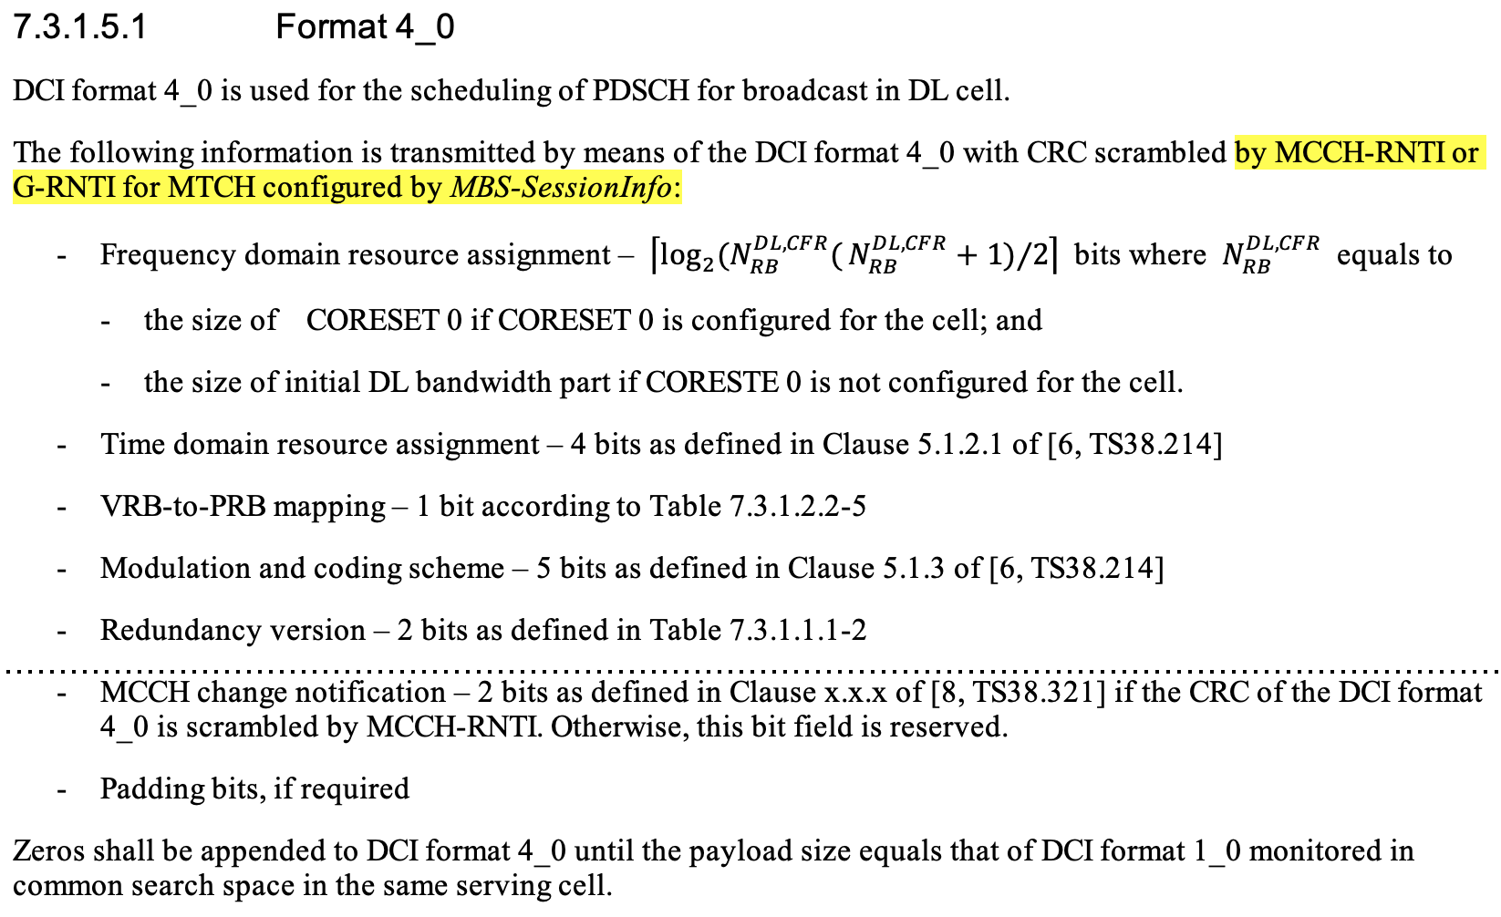 | 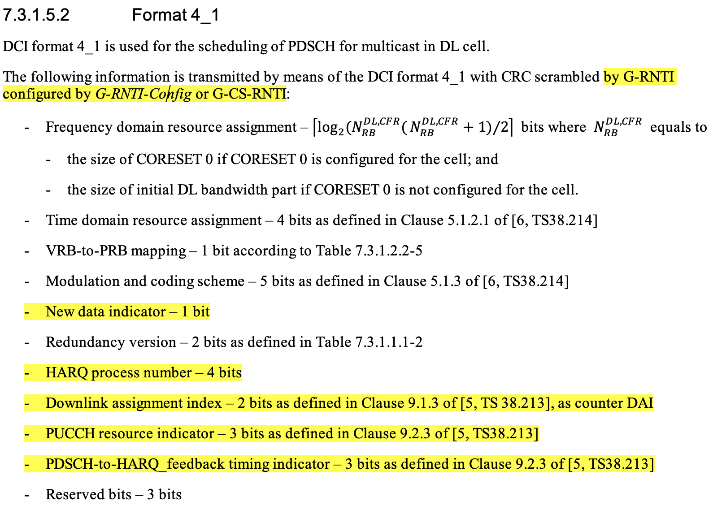 | 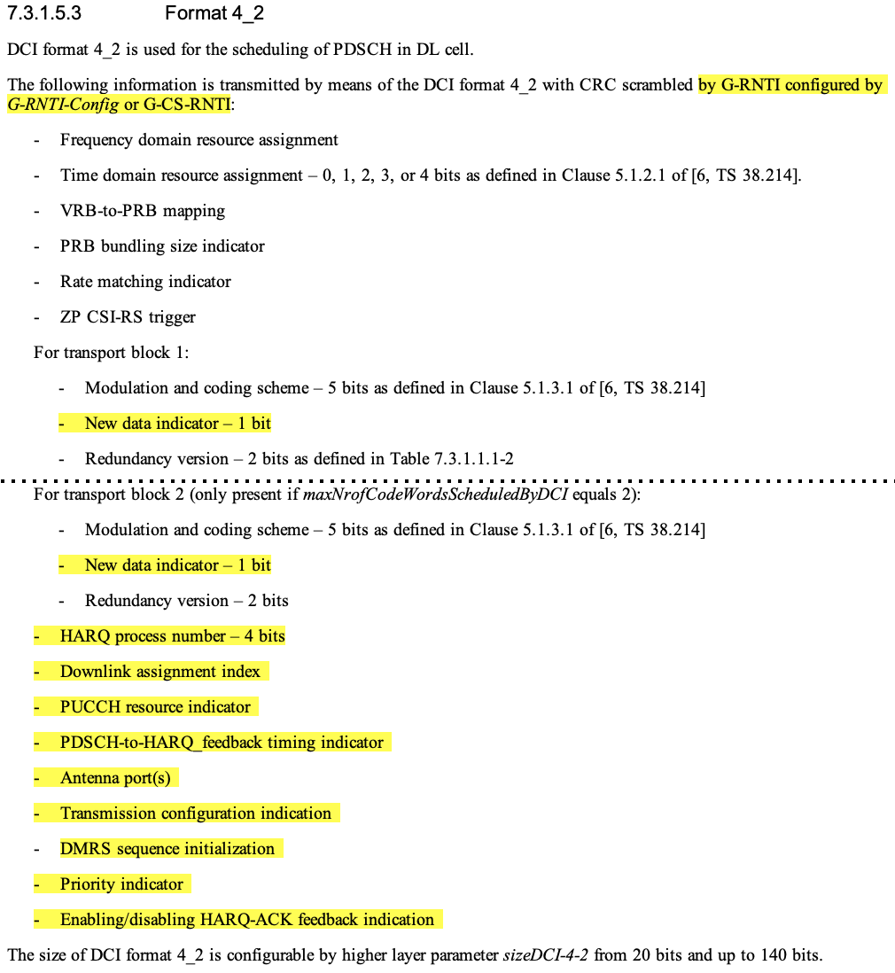

As we agreed in RAN2#119 meeting as below, the baseline is to use the same PDCCH/PDSCH resource for the multicast for both RRC_INACTIVE and RRC_CONNECTED UEs.
- The following is taken as baseline: we assume the same PDCCH/PDSCH resources (e.g. resources used for MTCH) can be used for all UEs (including UEs in CONNECTED and/or INACTIVE states) for receiving the same multicast session. Different configuration/resources are not precluded as well. FFS what exactly can be common and what not (e.g. HARQ, SPS etc.) and what is needed in addition (to legacy PTM config).

Following R17 PDCCH design on MBS multicast in RRC_CONNECTED, DCI format 4-1/4-2 will be considered for the multicast to RRC_INACTVE UE. But looking into the fields in DCI format 4-1/4-2, for the multicast reception in RRC_INACTIVE, whether the fields related to the following functions are needed or not are still open for discussion:
- 1) HARQ feedback
- 2) HARQ operation
- 3) Beam information.

<HARQ feedback>
In RAN2#119 meeting, RAN2 agreed that HARQ feedback and PTP are not supported for multicast reception in RRC_INACTIVE.
- HARQ feedback and PTP are not supported for multicast reception in RRC_INACTIVE.

Therefore, HARQ feedback resources and timing information in the DCI is not used for multicast transmission to RRC_INACTIVE UEs. In other words, if DCI format 4-1/4-2 is used for MBS multicast in RRC_INACTIVE, UE ignores the HARQ feedback related fields.

Q2: [HARQ FB] Do you agree that HARQ feedback related information in the DCI is not needed for multicast transmission to RRC_INACTIVE UE?
- If DC format 4-0 or new DCI format is used, NW doesnot provide the feedback info in DCI;
- If DCI format 4-1/4-2 is used, NW provides the feedback info in DCI but UE ignores it.

Company | Yes or No | Comment if any
ZTE | Yes but | We prefer to reuse at least DCI format 4-1 and FFS 4-2, for a certain multicast, the same DCI shall be used for all UEs (in RRC_CONNECTED or UE in RRC_INACTIVE states, and UE from Rel-17).  - the UE behaviour on how to ignore certain bits in DCI will be defined in physical layer, i.e., RAN1 shall be aware of this. We can do this together with the Beam related issue, in a single LS to RAN1.  And whether network enables HARQ Feedback for UEs in RRC_CONNECTED, we can keep it open for now.

<HARQ operation>
About the necessity to carry the HARQ process ID and NDI fields in DCI for multicast reception in RRC_INACTIVE, it depends on which HARQ operation we would like to support. There are two options on the HARQ operation:
- Option 1: Same as MBS broadcast
- UE select the HARQ process ID for multicast transmission by itself.
- NDI based HARQ retransmission is not supported.
- HARQ process ID and NDI in the DCI are not indicated.
- Option 2: Same as MBS multicast in RRC_CONNECTED state
- NW explicitly indicates the HARQ process ID for multicast transmission.
- NDI based HARQ retransmission is supported.
- HARQ process ID and NDI in the DCI are indicated.

Q3: [HARQ] Which option of the HARQ operation do you support for multicast reception in RRC_INACTIVE?
- Option 1: Same as MBS broadcast.
- Option 2: Similar as MBS multicast in RRC_CONNECTED state.
Company | Option | Comment if any
ZTE | 2 | this follows Q2 on which DCI format to go.

<Beam information>
About the beam information carried in DCI for multicast transmission in RRC_INACTIVE, since UE specific beam management is not supported for RRC_INACTIVE UE, network can only support the multicast transmission in RRC_INACTIVE via beam sweeping based on SSB index like boradcast MBS.

Q4: [Beam] Do you agree that the multicast transmission RRC_INACTIVE is performed via beam sweeping based on SSB index like broadcast MBS (i.e. beam information is not need in DCI)?
Company | Yes or No | Comment if any
ZTE | Yes | Network has to blindly broadcast the data as in Rel-17 BC by beam sweeping.

Q5: [DCI] Do you think we should request RAN1 to confirm whether it is feasible to reuse the same DCI format of R17 multicast (i.e. DCI format 4-1/4-2) for dynamic scheduling of multicast in RRC INACTIVE?
Company | Yes or No | Comment if any
ZTE | Yes | As in Q2, there will be re-defining of UE behaviour if we follow the same DCI format 4-1 or 4-2, and RAN1 may need to further check if there will be other issues:  - is it possible to configure RRC_CONNECTED UEs with Rel-17 multicast way, and configure UE in RRC_INACTIVE with common signaling in MCCH, to enable them to receive the same PDSCH resources?  But do we really need 4-2? We don't need separate beam for PDCCH/PDSCH (as in 4-0), either other features (port, priority, etc.).

SPS
In RAN2#119 meeting, RAN2 agreed that HARQ feedback and PTP are not supported for multicast reception in RRC_INACTIVE. But whether to support SPS for multicast reception in RRC_INACTIVE is still open.
- HARQ feedback and PTP are not supported for multicast reception in RRC_INACTIVE.

In Rel-17, to support SPS for multicast in RRC_CONNECTED, UE is required to support the following aspects:
- Support SPS configuration via UE dedicated RRC signaling.
In Rel-17, DL MBS SPS is configured by dedicated RRC signaling on serving cell per BWP.
- Support L1 signaling for SPS activation and deactivation mechanism.
In Rel-17, for DL MBS SPS, a DL assignment is provided by PDCCH with G-CS-RNTI, and UE store or clear it based on L1 signalling indicating SPS activation or deactivation.
- Support L1 signaling for SPS HARQ retransmission mechanism.
In Rel-17, for DL MBS SPS, a DL assignment is provided by PDCCH with G-CS-RNTI is to explicitly indicate the HARQ retransmission.
- Support DCI format 4-1/4-2.
In Rel-17, DCI format 4-1/4-2 is configured for the PDCCH for SPS activation/deactivation and SPS HARQ retransmission.
- Support to use specific HARQ process for MBS SPS transmission.
In Rel-17, for DL MBS SPS, the HARQ process used for the SPS config is explicitly indicated in SPS-config. UE can support multiples SPS configurations.
If SPS is supported for multicast in RRC_INACTIVE state, enhancements are needed from the above aspects.

Q6: [SPS] Do you support SPS for multicast reception in RRC_INACTIVE?
Company | Yes or No | Comment if any
ZTE | No | How to enable/disable SPS, with the risk that UE may lose such indication, will be a problem. We can simply follow BC in Rel-17, i.e., no SPS.

Q7: [SPS] If your answer to Q6 is YES, what do you think of the SPS operation for multicast reception in RRC_INACTIVE?
Company | How to SPS operation (e.g. from the 5 aspects listed above?)

DRX
For multicast reception in RRC_INACTIVE, since HARQ feedback and PTP are not supported, in DRX operation, RRC_INACTIVE UE does not need to start drx-HARQ-RTT-TimerDL-PTM and drx-RetransmissionTimerDL. Therefore, the DRX operation for multicast in RRC_INACTIVE is same as the DRX for MBS broadcast. About the spec impact, the simple way is to extend the DRX for MBS broadcast (section 5.7a in MAC) to cover DRX for MBS multicast reception in RRC_INACTIVE.
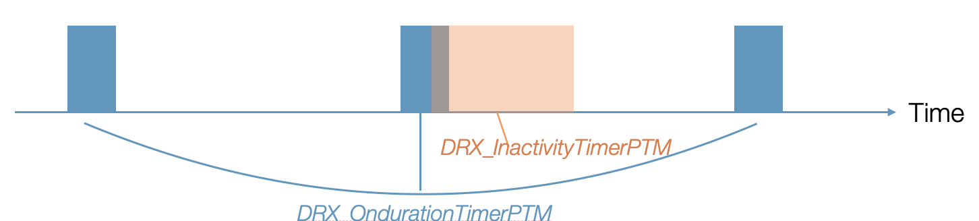
Figure 3: DRX operation for MBS broadcast

Q8: [DRX] Do you agree that the DRX operation for multicast reception in RRC_INACTIVE reuses MBS broadcast DRX design?
Company | Yes or No | Comment if any
ZTE | no | or we follow multicast framework, while always considering the re-tx is disabled?

LCID
In Rel-17, the LCID space used for MBS broadcast and MRB multicast is different.
- Multicast MRB and unicast DRB share the common LCID space.
- Broadcast MRB/MCCH and unicast DRB use the different LCID spaces.
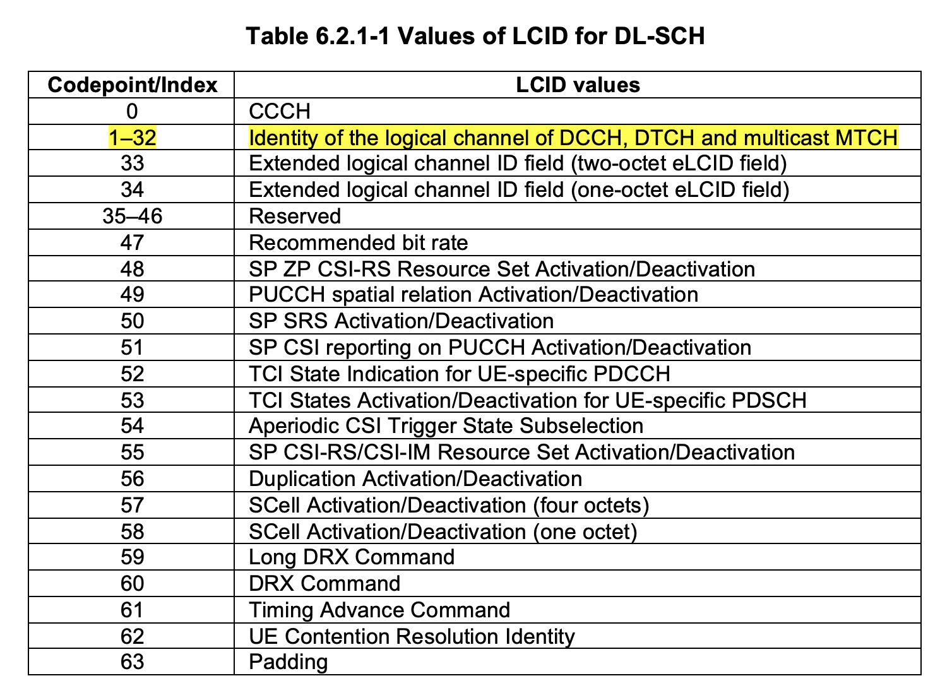
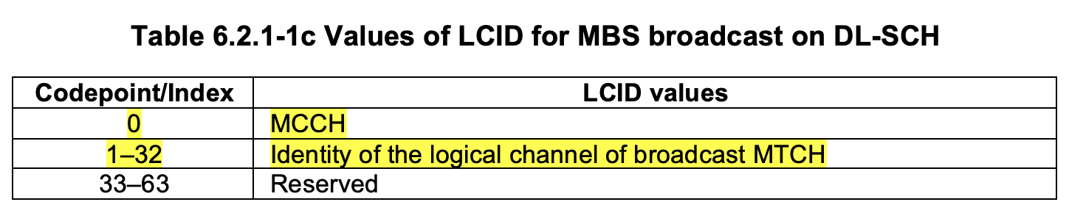

For multicast reception in RRC_INACTIVE in Rel-18, for the same multicast session, the RLC and PDCP configuration of the multicast MRB should be same (at least for the same cell) for RRC_CONNECTED and RRC_INACTIVE UEs. Since the LCID is provided in RLC configuration, the LCID configuration for multicast MRB should follow the same rule as that in R17 multicast configuration in CONNECTED state, i.e. using the common LCID space with unicast DRB.

Q9: [LCID-MTCH] Do you agree that the common LCID space is used for multicast MRB and unicast DRB regardless of UE RRC state (i.e. no change on the LCID table for MTCH)?
Company | Yes or No | Comment if any
ZTE |  | it is too complicated and we need more time on this..

For MCCH, RAN2 agreed to introduce the new MCCH for multicast in INACTIVE, I think it’s straightforward to introduce the new LCID and new RNTI for the multicast MCCH channel transmission.
- We introduce a new MCCH logical channel for multicast in INACTIVE (different from broadcast MCCH)

Q10: [LCID-MCCH] Do you agree to introduce a new LCID in Table 6.2.1-1c for multicast MCCH?
NOTE: TP is provided as below for example.
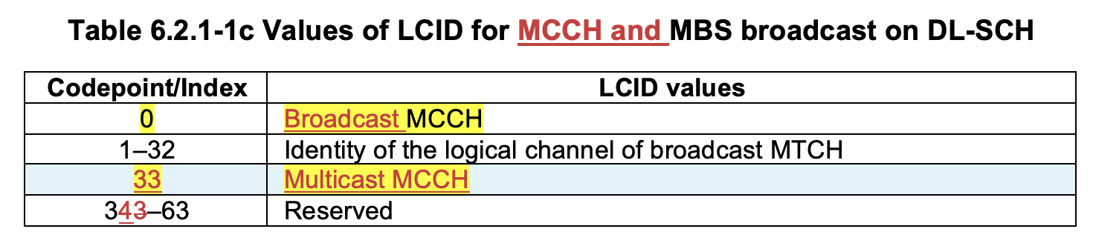
Company | Yes or No | Comment if any

Q11: [RNTI-MCCH] Do you agree to introduce a new RNTI in Table 7.1-1 for multicast MCCH?
NOTE: TP is provided as below for example.
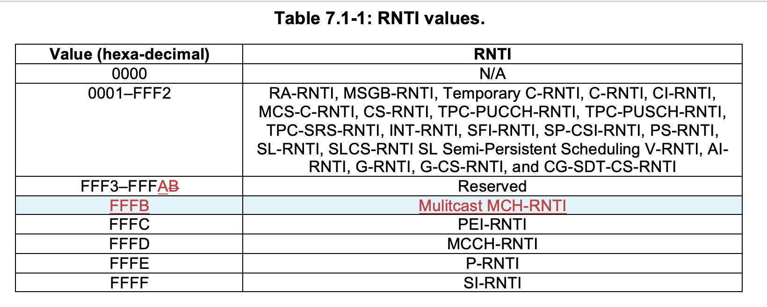
Company | Yes or No | Comment if any

L2 handling during RRC state transition
The following is the current spec description on L2 handling during the RRC state transition from RRC_CONNECTED to RRC_INACTIVE.
For the MBS multicast in Rel-17, when UE enters RRC_INACTIVE, UE will stop the related MAC timer , flush the soft buffers for the DL HARQ process being used for MBS multicast, and suspend the multicast MRB.
5.3.8.3 Reception of the RRCRelease by the UE
The UE shall:
==omit some text==
1> if the RRCRelease includes suspendConfig:
2> reset MAC and release the default MAC Cell Group configuration, if any;
2> apply the received suspendConfig except the received nextHopChainingCount;
==omit some text==
2> suspend all SRB(s) and DRB(s) and multicast MRB(s), except SRB0;
2> indicate PDCP suspend to lower layers of all DRBs and multicast MRBs;
==omit some text==
2> indicate the suspension of the RRC connection to upper layers;
2> enter RRC_INACTIVE and perform cell selection as specified in TS 38.304 [20];
5.12 MAC Reset
If a reset of the MAC entity is requested by upper layers or the reset of the MAC entity is triggered due to SCG deactivation as defined in clause 5.29, the MAC entity shall:
==omit some text==
1> if upper layers indicate SCG deactivation and bfd-and-RLM with value true is configured for the deactivated SCG:
2> stop (if running) all timers except beamFailureDetectionTimer associated with PSCell and timeAlignmentTimers.
1> else:
2> stop (if running) all timers, except MBS broadcast DRX timers;
==omit some text==
1> flush the soft buffers for all DL HARQ processes, except for the DL HARQ process being used for MBS broadcast;
1> for each DL HARQ process, except for the DL HARQ process being used for MBS broadcast, consider the next received transmission for a TB as the very first transmission;

In Rel-18, if UE is configured with multicast reception in RRC_INACTIVE, when UE enters RRC_INACTIVE, UE should not stop the multicast MRB, and in MAC layer UE should not stop multicast related MAC timers used in RRC_INACTIVE. About whether to flush the soft buffers for the multicast reception, it depends on whether we would like to support HARQ continuation for MBS multicast during RRC state transition.

Q12: [ST-MRB] For multicast reception in RRC_INACTIVE, do you agree that UE doesnot suspend the multicast MRB when entering RRC_INACTIVE state?
Company | Yes or No | Comment if any
ZTE | not sure | What if UE is already receiving the MRB of an active multicast session and is being released?

Q13: [ST-MAC Timer] For multicast reception in RRC_INACTIVE, do you agree that UE doesnot stop the MAC timers used for multicast reception in RRC_INACTIVE (i.e. drx-onDurationTimerPTM or drx-InactivityTimerPTM) when entering RRC_INACTIVE state?
Company | Yes or No | Comment if any
ZTE | not sure | same as above.

Q14: [ST-HARQ] For multicast reception in RRC_INACTIVE, do you support HARQ continuation for MBS multicast reception (i.e. not flushing the soft buffer used for MBS multicast) during the RRC state transition?
Company | Yes or No | Comment if any
ZTE | not sure | same as above.

L2 handling during RRC_INACTIVE mobility

In Rel-17, PDCP COUNT continuity is supported for multicast reception during handover. For multicast reception in RRC_INACTIVE in Rel-18, PDCP COUNT continuity should be also supported during INACTIVE mobility. As indicated in [12], if PDCP COUNT of source cell and target cell cannot be synchronized in network side, network will explicitly inform UE to re-initialize the PDCP parameters by providing the initialRX-DELIV from the target cell.

Q15: [Mobility] For multicast reception in RRC_INACTIVE, do you agree that UE does not need to re-establish PDCP entity (i.e. re-initiate the PDCP variables) of the multicast MRB if PDCP COUNT can be sync between source and target cell during INACTIVE mobility?
Company | Yes or No | Comment if any
ZTE | No | 1 - considering current spec is written in a such flexible manner, we propose that we shall consider the baseline or the common case shall be the PDCP SN is not synced.  2 - and UE might not be able to know whether it is synced.  3 - the safe way is re-establish everything upon cell re-selection.  // And we do have a concern on how the PDCP shall be initialized, based on UE implementation as BC, or based on the network provided initial value? Then does network need to update the MCCH every time as such value is always being updated? We dont think so.

Q16: [Mobility] For multicast reception in RRC_INACTIVE, do you agree that NW explicitly informs UE to re-establish PDCP entity (i.e. re-initialize the PDCP variables) of a cell the UE reselects to (in case PDCP COUNT is not sync between source and target cell)?
Company | Yes or No | Comment if any
ZTE | No | a network itself does not know whether a neighbour node is synced with him or not.  as in Q15, we can simply assume they are not synced.

Others

Q17: If companies have any UP issues which are not listed as above, please add the issues in the following table.
Company | Comment if any
vivo | - Whether PDSCH aggregatiopn is supporte (HARQ related)?  - Whether separate CSS for R18 multicast MCCH/MTCH is supported (CFR configuration related)?
ZTE | as in Q15, how is PDCP initialized may be worth some further check.

Conclusion
Based on the above discussion, we propose that:

Reference
[1] RAN2#121 MBS session notes
[2] R2-2300286 Discuss on PTM configuration for multicast in RRC INACTIVE MediaTek inc.
[3] R2-2300335 PTM configuration and mobility aspects for multicast reception in RRC_INACTIVE Qualcomm
[4] R2-2300178 Discussions on PTM Configuration and Mobility CATT, CBN
[5] R2-2300100 Discussion on multicast reception in RRC_INACTIVE state OPPO
[6] R2-2300243 Discussion on Mixed Approach from PHY Aspect vivo Mobile Com. (Chongqing)
[7] R2-2300283 Analysis of MCCH for sending PTM configuration TD Tech, Chengdu TD Tech
[8] R2-2300672 Discussion on PTM configuration and mobility NEC Corporation
[9] R2-2300735 PTM Configuration and Mobility for INACTIVE Multicast Reception Apple
[10] R2-2300876 PTM configuration aspects and mobility Nokia, Nokia Shanghai Bell
[11] R2-2300947 PTM configuration and mobility for multicast reception in RRC_INACTIVE Lenovo
[12] R2-2301162 PTM configuration and mobility for multicast reception in RRC_INACTIVE Huawei, HiSilicon
[13] R2-2301843 PTM Configuration delivery for multicast reception in RRC_INACTIVE ZTE, Sanechips
[14] R2-2300877 Notifications and RRC state transitions Nokia, Nokia Shanghai Bell
[15] R2-2300252 HARQ operation during RRC state transitions for multicast reception NEC
[16] R2-2301236 Discussion on notification for RRC_INACTIVE multicast reception Ues CMCC
[17] R2-2301587 Notification and RRC state transition aspects on multicast reception in RRC INACTIVE Kyocera
[18] R2-2301038 Available multicast CFR in RRC_INACTIVE LG Electronics Inc.
[19] R2-2301070 Ensuring desired level of reliability for an MBS session in RRC_INACTIVE InterDigital Inc.

Annex: RAN2 Agreements

RAN2#121 Agreements
Multicast reception in RRC_INACTIVE
- PTM configuration aspects and mobility
- UE shall join in the multicast session before receiving multicast in RRC INACTIVE.
- If network finds it useful, the PTM configuration for the (single) serving cell can be configured to UE before the session activation, and UE stores the configuration. When session is activated, UE can receive multicast in INACTIVE state by applying the configuration without going back to RRC_CONNECTED, if not updated by MCCH after being configured.
- When network configures UE to receive multicast in INACTIVE state, RRCRelease message with suspendconfig can be used to deliver the PTM configuration. Other dedicated RRC messages will not be used to provide PTM configuration for MBS multicast for INACTIVE.
- We introduce a new MCCH logical channel for multicast in INACTIVE (different from broadcast MCCH)
- Multicast MCCH configuration is provided via new SIB.
- Optionally, Multicast MCCH configuration for the serving cell can also be provided in dedicated signalling. Understanding is we are not optimizing mobility case because of this.
- Serving cell will not provide the PTM configuration of neighbour cells from other gNBs.
- FFS whether the network can provide PTM configuration for intra-gNB cells.

Shared processing for MBS broadcast and Unicast reception
- Indicate the capability of receiving MBS broadcast from a non-serving cell. FFS whether the granularity is at FeatureSetDownlink or FeatureSetDownlinkPerCC level.
- FFS Whether to include additional information in MII can be controlled by the network. Should consider whether this would be two-step procedure or one-step procedure (e.g. having more info in SIB1)

RAN2#120 Agreements
Multicast reception in RRC_INACTIVE
- PTM configuration and PTM reconifguration during mobility
- We will have a mixed approach and we start with the following:
    - When NW configures UE to continue the multicast reception in INACTIVE state, NW provides the PTM configuration for the activated multicast session via the RRC dedicated signalling, at least for the serving cell (FFS other cases).
    - MCCH is used in case there is a need to indicate a PTM configuration in case there is a need for change in PTM config or during mobility beyond serving cell / gNB. FFS session status change and other indications.
    - We assume that the UE can only receive multicast service after it joined the session.
    - FFS whether MCCH configuration is initially provided to the UE via dedicated signalling.

RAN2#119bis Agreements
Multicast reception in RRC_INACTIVE
- The following general description is taken as baseline for PTM configuration delivery Option 1:
(1-a) PTM configuration(s) (i.e., configurations used for multicast reception in RRC_INACTIVE) of one or more multicast sessions for at least one cell are provided via dedicated RRC signaling to a UE.
(1-b) The RRC message for this includes RRCReconfiguration and/or RRCRelease and/or RRCResume (details FFS)
(1-c) UE stores the received configurations while it is in RRC_INACTIVE, and if there is a need to update some or all the configurations, the UE is notified of such changes and may trigger RRC connection resume to obtain the updated configurations. In case of mobility in RRC_INACTIVE, the UE triggers RRC connection resume if the configuration of the session is not available for the new cell.

- The following general description is taken as baseline for PTM configuration delivery Option 2:
(2-a) PTM configurations (i.e., configurations used for multicast reception in RRC_INACTIVE) are provided via an MCCH-like channel (same or different as used for MBS broadcast), and information regarding MCCH scheduling is provided via SIB, FFS dedicated signalling
(2-b) UE can receive such configurations when it is in RRC_INACTIVE, FFS whether it is allowed/needed to also receive when UE is in RRC_CONNECTED
(2-c) If there is a need to update some or all the received configurations, UE does not need to resume RRC connection but is notified of such changes (e.g. via MCCH DCI) and obtains the updated configurations via MCCH.
- Dedicated RRC signalling (i.e. RRC release message with suspendConfig) is used for switching a multicast receiving UE from RRC_CONNECTED to RRC_INACTIVE and continue multicast reception (details FFS).
- For both option 1 and option 2, as a baseline, group paging can be used to switch UEs receiving multicast from RRC_INACTIVE to RRC_CONNECTED, and UEs continue the multicast reception in CONNECTED. FFS if there is any potential issue if Rel-17 group paging is reused. FFS if there are other cases when UE triggers resume. FFS if MCCH can also be used in case of option 2.
- Rel-18 UE in INACTIVE can be informed when the session is activated (Details FFS).
- As a baseline, group paging can be used to inform Rel-18 UE(s) about the session activation (Details FFS, e.g., UE behavior when receiving such group notification).
- If a UE is in RRC_INACTIVE and is configured to receive a multicast session in RRC_INACTIVE, the UE may be notified when the multicast session is deactivated. FFS how (e.g., informed via group paging, MCCH, or other ways).
- Rel-17 mechanism (NAS-based indication) is applicable for multicast session release. FFS if any enhancement is needed.
- FFS how UE determines whether it can receive the multicast session in RRC_INACTIVE or not when the session is activated, taking into account the following solutions (can further update the descriptions if needed, and several solutions may be needed, some solutions may apply only for certain configuration options)
1. When the multicast session is activated, UE can receive the multicast session in RRC_INACTIVE if the PTM configuration used in RRC_INACTIVE for the session is available to the UE and the UE has joined the session already (e.g., configuration provided to UE via dedicated RRC signaling or via MCCH), otherwise it goes back to RRC_CONNECTED to receive the multicast session.
2. When the multicast session is activated, UE is indicated by group paging whether it can receive the multicast session in RRC_INACTIVE or not (detailed signaling FFS).
3. UE is configured "whether it can receive the multicast session in RRC_INACTIVE" by dedicated signaling before UE is released. When the multicast session is activated, UE stays in RRC_INACTIVE or resumes RRC connection accordingly (detailed signaling FFS).

- If option 1 is supported for PTM configuration
As a baseline, group paging may be used to inform the UE when network changes the PTM configurations, and UE upon reception triggers RRC connection resume procedure to obtain the updated configurations (details of group paging can be FFS).
FFS whether and how to solve the issue in signalling/system load when a large number of UEs in the cell need PTM configuration update.

- FFS if there is an issue that a UE can obtain all the PTM configurations for a multicast service via Option 2 without/before joining the multicast session on the condition that security is enabled by service layer. And if yes FFS how to solve the issue (e.g., dedicated configuration + MCCH).

Shared processing for MBS broadcast and Unicast reception
- For shared processing we adopt the following as a baseline:
1) new IE is added in system information to control whether MBSInterestIndication for shared processing can be sent or not;
2) MBSInterestIndication message content and related procedure is updated for shared processing.
- New IE to control whether MBSInterestIndication for shared processing can be sent or not is added to SIB1.

- In MBSInterestIndication, for a broadcast service that the UE is receiving or is interested to receive, at least the following information can be signalled: broadcast frequency, subcarrier spacing, and bandwidth. FFS details/exact parameters and other information. FFS in which scenarios the UE reports this information (e.g. intra-PLMN case, inter-PLMN case)
- FFS whether UE capability is needed to enable shared processing.

RAN2#119 Agreements
Multicast reception in RRC_INACTIVE
- General assumptions, scenarios
- In Rel-18, multicast reception for UEs in INACTIVE supports at least the following scenarios, with the assumption that the UE already has a valid PTM configuration:
- Scenario 1: a UE has been receiving multicast in CONNECTED, and it enters INACTIVE and continues the multicast reception.
- Scenario 2: a UE has joined a multicast session and has been directed to INACTIVE, the UE starts to receive the multicast session
FFS for state changes, e.g. due to service being not provided in INACTIVE anymore etc.

- It is up to gNB to decide whether a multicast session may be received by UE(s) in INACTIVE. FFS what information gNB may be provided to form such decision (related to SA2 discussion).
- It is supported that gNB transmit one multicast session to both UEs in CONNECTED and INACTIVE in the same cell. FFS how the gNB configures this.
- It is assumed the network can choose which UEs receive in RRC INACTIVE and which in RRC Connected and can move UEs between the states for Multicast service reception.
- The following is taken as baseline: we assume the same PDCCH/PDSCH resources (e.g. resources used for MTCH) can be used for all UEs (including UEs in CONNECTED and/or INACTIVE states) for receiving the same multicast session. Different configuration/resources are not precluded as well. FFS what exactly can be common and what not (e.g. HARQ, SPS etc.) and what is needed in addition (to legacy PTM config).

- PTM configuration for RRC_INACTIVE
- For PTM configuration delivery, RAN2 further investigates the following solutions:
Option 1: Dedicated signalling
Option 2: Solution based on SIB+MCCH
We do not preclude some “mix” of the options
- HARQ feedback and PTP are not supported for multicast reception in RRC_INACTIVE.

- Mobility support
- Multicast service continuity after cell reselection in RRC_INACTIVE state (i.e. without resuming RRC connection) will be supported (if the configuration of the new cell is available for the UE). FFS whether there are cases where the UE needs to resume the connection. FFS RAN3 impacts due to inter-gNB mobility.
- Upon cell reselection to neighbour cells during active multicast session, if the configuration of the session is not available for the new cell for UEs in INACTIVE, then the UE is required to resume RRC connection to get the Multicast MRB configuration.

Shared processing for MBS broadcast and Unicast reception
- RAN2 focuses on solutions taking multi-Rx UEs (i.e. no specific enhancements for 1Rx UEs).

