3GPP TSG-RAN WG2 #121-bis-e R2-23XXXXX

Online, 17 – 26 April, 2023

Agenda Item: 8.xx.x

Source: Huawei, HiSilicon

Title: Outcome of [POST121][312][NES] DTX/DRX - Configuration/ activation/ deactivation and alignment (Huawei)

Document for: Discussion and decision

# 1 Introduction

This document is the report of the following discussion:

* [POST121][312][NES] DTX/DRX - Configuration/activation/deactivation and alignment (Huawei)
  + - Scope: Provide and summarize companies' views on:
      * Configuration of Cell DTX/DRX
      * Activation/deactivation of Cell DTX/DRX
      * Alignment between Cell DTX/DRX and UE C-DRX.
    - Intended outcome: Report to the next meeting (with agreeable proposals)

The intention of this document is to invite companies to share their views regarding configuration, activation, deactivation and alignment of Cell DTX/DRX. Taking these into account, the Rapporteur of the discussion provides a set of proposals to be further discussed during RAN2#121-bis-e.

**Deadline for comments: Wednesday, April 5th 2023, 10:00 UTC**

Companies providing input to this email discussion are requested to leave contact information below.

|  |  |  |
| --- | --- | --- |
| **Company** | **Delegate name** | **Email address** |
| Apple | Peng Cheng | pcheng24@apple.com |
|  |  |  |
|  |  |  |
|  |  |  |
|  |  |  |
|  |  |  |
|  |  |  |
|  |  |  |
|  |  |  |
|  |  |  |

# 2 Discussion on open issues

The rapporteur identifies the following open issues to be discussed:

* Methods of configuring Cell DTX/DRX (not including joint/separate configuration and single/multiple configuration, as they have already been discussed and progressed online)
* Methods of activating and deactivating of Cell DTX/DRX
* Alignment between Cell DTX/DRX and UE C-DRX

RAN2 achieved the following agreements on Cell DTX/DRX during the RAN2#121 meeting [3]:

**Agreements**

1. There will be no impact to RACH, paging, and SIBs in idle/inactive for both gNB and Rel-18 and legacy UEs
2. Rel-18 NES capable CONNECTED UE(s) can perform RACH and receive SIBs in non-active duration of cell DTX and/or DRX (i.e., same behavior for cell DTX and cell DRX). No further enhancements for CBRA and CFRA will be pursued.
3. Pattern configuration for cell DRX/DTX is common for Rel-18 UEs in the cell. FFS whether we have DTX UE specific inactivity timer. FFS on configuration signaling and stage 3.
4. Confirm study item agreement that we can have separate DTX and DRX configuration. We will focus on designing DTX/DRX for at least single configuration. FFS whether multiple configuration of cell DTX or DRX will be supported.

The TR 38.864 [2] captured the following with regards to configuration and activation of Cell DTX/DRX, and C-DRX alignment:

|  |
| --- |
| Cell DTX/DRX is applied to at least UEs in RRC_CONNECTED state. A periodic Cell DTX/DRX (i.e., active and non-active periods) can be configured by gNB via UE-specific RRC signalling per serving cell. Below examples on Cell DTX/DRX behaviour during non-active periods are assumed to be possible options, and the UE behaviour/impact will be studied:  - Example 1: gNB is expected to turn off all transmission and reception for data traffic and reference signal during Cell DTX/DRX non-active periods.  - Example 2: gNB is expected to turn off its transmission/reception only for data traffic during Cell DTX/DRX non-active periods (i.e., gNB will still transmit/receive reference signals)  - Example 3: gNB is expected to turn off its dynamic data transmission/reception during Cell DTX/DRX non-active periods (i.e., gNB is expected to still perform transmission/reception in periodic resources, including SPS, CG-PUSCH, SR, RACH, and SRS).  - Example 4: gNB is expected to only transmit reference signals (e.g., CSI-RS for measurement).  The study focus on UE behavior when at any point in time the cell activates a single DTX/DRX configuration. It is up to NW whether legacy UEs can access cells with Cell DTX/DRX.  The Cell DTX/DRX mode can be activated/de-activated via dynamic L1/L2 signalling and UE-specific RRC signaling. Both UE specific and common L1/L2 signalling can be considered for activating/deactivating the Cell DTX/DRX mode.  Cell DTX and Cell DRX modes can be configured and operated separately (e.g., one RRC configuration set for DL and another for UL). Cell DTX/DRX can also be configured and operated together. At least the following parameters can be configured per Cell DTX/DRX configuration: periodicity, start slot/offset, on duration. Details related to UE behaviour can be discussed during WI phase. Whether to support multiple Cell DTX/DRX configurations can be discussed later in the WI phase.  It is beneficial to align UE DRX with Cell DTX and DRX alignment among multiple UEs. The alignment mechanism can be discussed during the WI phase.  From RAN2 perspective, Cell DTX/DRX is feasible. |

## 2.1 Configuration of Cell DTX/DRX

Are the Cell DTX/DRX parameters signalled to the UEs.

The UE can derive the Cell DTX/DRX configuration from various sources. Based on RAN2#120 contributions and TR 38.864 the Rapporteur identified the following options:

* **Option 1:** Explicit Cell DTX/DRX configuration signalled to the UEs, detailed in questions 2-4.
* **Option 2:** No explicit Cell DTX/DRX configuration, meaning that Cell DTX/DRX has no spec impact [5]

**Question 1:** *Which option do you support?*

|  |  |  |
| --- | --- | --- |
| **Company** | **Answer** | **Comments** |
| Apple | Option 1 | 1. From technique perspective, we are not sure how option 2 can work without spec impact. According to option 2 of P5 of [5], our understanding of the solution is:   1. "Mute" all or some periodic occasions of semi-static/periodic UL/DL transmission (e.g. CG, SPS, SR). 2. Refrain dynamic PDSCH/PUSCH by aligned UE CDRX.   For 1), we are not sure how to efficiently mute periodic occasions only for some time interval without spec impact. If it is done via RRC configuration / reconfiguration of CG/SPS/SR, it will incur extra high gNB power consumption caused by sending UE dedicated RRC signalling for each boundary of the non-active interval.  For 2), we think the key issue is that UE CDRX is per MAC entity, which means the same UE CDRX pattern is applied for all serving cells in CA. So, it will put a restriction on Cell DTX/DRX (i.e. only same DG refraining pattern in all serving cells is allowed). Since different serving cell may have different NES requirement, we think this restriction doesn't make sense.  2. Option 1 is captured in SI conclusion after extensive discussion. However, Option 2 was even not discussed in SI phase. We prefer to respect SI conclusion. |
|  |  |  |
|  |  |  |
|  |  |  |
|  |  |  |

How the Cell DTX/DRX parameters are signalled.

**Question 2:** If your answer to Q1 is Option 1, *do you agree to reconfirm the agreement from SI that it is done via RRC dedicated signalling (“periodic cell DTX/DRX pattern is configured by UE-specific RRC”)? If not, please comment on your preferred option.*

|  |  |  |
| --- | --- | --- |
| **Company** | **Answer** | **Comments** |
| Apple | Yes | As far as we know, NES gain can be maximized only if the gNB can sleep for a long time (i.e. we should avoid dynamic gNB on-off in short interval). Periodic pattern via RRC configuration is born to serve this purpose. |
|  |  |  |
|  |  |  |
|  |  |  |
|  |  |  |

Parameters to be configured to the UE.

**Question 3:** If your answer to Q1 is Option 1, *do you agree to confirm the SI outcome that the Cell DTX/DRX configuration contains at least: periodicity, start slot/offset and on-duration?*

|  |  |  |
| --- | --- | --- |
| **Company** | **Answer** | **Comments** |
| Apple | Yes | We think it is straight forward.  Meanwhile, we suggest to confirm we can reuse the formula of UE CDRX to calculate starting time of active duration, i.e. [(SFN × 10) + subframe number] modulo (*Periodicity*) = *StartOffset.* We think it will be helpful to discuss alignment between Cell DTX/DRX and UE CDRX. |
|  |  |  |
|  |  |  |
|  |  |  |
|  |  |  |

Cell DTX/DRX UE specific inactivity timer was discussed during RAN2#121 and left FFS [3]. The Rapporteur would like to gather companies’ view on this topic.

**Question 4:** *Do you support adding to the list from Question 3 a Cell DTX/DRX inactivity timer (cell active time duration extension mechanism)?*

|  |  |  |
| --- | --- | --- |
| **Company** | **Answer** | **Comments** |
| Apple | No  (leave it to the discussion of FFS of RAN2#121) | As Rapporteur mentioned, we have discussed this issue in RAN2#121 and captured an FFS for it:   1. Pattern configuration for cell DRX/DTX is common for Rel-18 UEs in the cell. FFS whether we have DTX UE specific inactivity timer. FFS on configuration signaling and stage 3.   During the online discussion, this issue was controversial. Meanwhile we think how DTX UE specific inactivity timer work is not clear. For example:   1. Does it means the cell active time (common to all UEs in the cell) can be extended just because one particular UE has pending traffic? 2. If Yes to 1), does gNB need to reconfigure Cell DTX/DRX pattern to notify all UEs in the cell? 3. If both Cell DTX and UE DRX are configured, how does it work together with inactivity timer of UE CDRX?   Thus, we think it is premature to discuss configuration issue in this email discussion when its mechanism/feature is even not clear. Since an FFS has been captured, we believe companies will bring their solutions/analysis in their contributions. So, we see no necessity to discuss it here in a hurry. |
|  |  |  |
|  |  |  |
|  |  |  |
|  |  |  |

*[Rapporteur’s summary and proposals]*

## 2.2 Activating and deactivating of Cell DTX/DRX

A following issue is how to activate/deactivate the Cell DTX/DRX configuration. The SI phase identified the following options: dynamic L1/L2 signalling and UE-specific RRC signalling [2].

In our understanding, the “RRC signalling” in the TR 38.864 means that the Cell DTX/DRX is activated/deactivated implicitly for single configuration, i.e. activated once configured, and deactivated once de-configured. If there are multiple configurations configured by RRC, there is a need of explicit activation/deactivation of one of the parameter sets.

We see the following options for Cell DTX/DRX activation/deactivation:

* **Option 1:** Activated/deactivated by dynamic L1 or L2 signalling (in this option please state which one do you prefer)
* **Option 2:** Activated/deactivated implicitly, i.e. activated immediately once configured by RRC and deactivated once the RRC configuration is released
* **Option 3:** Both

**Question 5:** Please indicate your preference on how the Cell DTX/DRX configuration is activated/deactivated. If you see a need you can propose other options.

|  |  |  |
| --- | --- | --- |
| **Company** | **Answer** | **Comments** |
| Apple | Option 3 | For Option 2 (RRC only), as we replied in Q2, it should be baseline because a periodic pattern with long non-active duration can maximize NES gain.  For Option 1:   * We see some benefit of cell common or UE group common L1 signalling. Our consideration is that it can reduce the signalling overhead of sending UE dedicated RRC message to reconfigure Cell DTX/DRX. * For UE dedicated L1 or L2 signaling, we think it doesn't make sense because the dynamic switch of gNB ON-OFF pattern can't help save gNB power consumption. |
|  |  |  |
|  |  |  |
|  |  |  |
|  |  |  |

If L1/L2 signalling is to be pursued, another issue is whether the L1 signalling can be UE specific or cell common, as indicated in the TR [2]. Note that we have already agreed in RAN2 #121 that pattern configuration for cell DRX/DTX is common for Rel-18 UEs in the cell. Also, in the rapporteur’s understanding, the cell common signalling is only for L1, not for L2.

**Question 6:** *Do you see a need of cell level common L1 signalling for activating/deactivating the cell DTX/DRX pattern in addition to UE specific signalling?*

|  |  |  |
| --- | --- | --- |
| **Company** | **Answer** | **Comments** |
| Apple | Yes with wording change.. | As we mentioned in Q5, We see some benefit of cell common L1 signaling. Our consideration is that it can reduce the signalling overhead of sending UE dedicated RRC message to reconfigure Cell DTX/DRX to each UE. And the saving of overhead/message number towards UE) will also transform to NES gain.  We think the question may be confusing what is "*in addition to UE specific signalling*": is it RRC signaling or UE dedicated L1 signaling? We believe it should be RRC signaling. So, we suggest below change:  *Do you see a need of cell level common L1 signalling for activating/deactivating the cell DTX/DRX pattern in addition to ~~UE specific signalling~~RRC signaling?* |
|  |  |  |
|  |  |  |
|  |  |  |
|  |  |  |

*[Rapporteur’s summary and proposals]*

## 2.3 Alignment between Cell DTX/DRX and UE C-DRX

The alignment of UE C-DRX with Cell DTX and DRX was deemed beneficial in the TR 38.864 [2]. The mechanism will be discussed during the WI phase.

The alignment needs to be specified as per WID [1] objective 2:

|  |
| --- |
| 2. Specify enhancement on cell DTX/DRX mechanism including the alignment of cell DTX/DRX and UE DRX in RRC_CONNECTED mode, and inter-node information exchange on cell DTX/DRX [RAN2, RAN1, RAN3]  • Note: No change for SSB transmission due to cell DTX/DRX.  • Note: The impact to IDLE/INACTIVE UEs due to the above enhancement should be avoided. |

In order to specify the alignment RAN2 needs to have a common understanding of what the alignment of Cell DTX/DRX and UE C-DRX means.

In the rapporteur’s understanding, an aligned UE C-DRX configuration with Cell DTX means that the on-duration of C-DRX falls within Cell DTX active time. As highlighted in [4] the active duration of UE C-DRX can be extended by the UE DRX inactivity timer, therefore it is impossible to ensure that active duration of Cell DTX is always overlapping with UE C-DRX active time (T2 in the figure below). But it is possible to ensure that the on-duration of UE C-DRX is within the Cell DTX active time and this is proposed by the rapporteur.

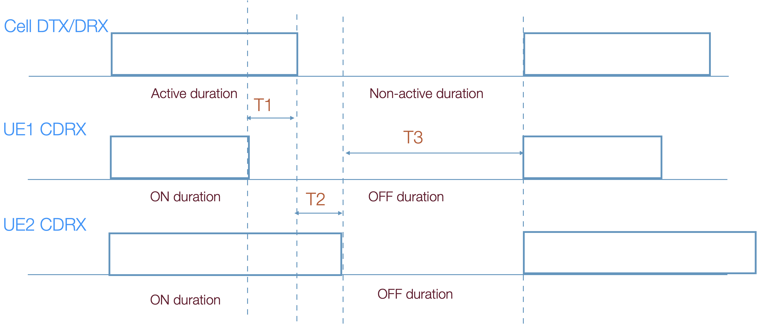

Fig. 1. Illustration of issue scenarios of Cell DTX and UE CDRX alignment [4]

**Question 7:** *Do companies agree to the following statement:*

“An aligned UE C-DRX configuration with Cell DTX means that the on-duration of C-DRX falls within Cell DTX active time.” This definition includes all cases regardless if the periodicity and on-duration are the same or different across the cell, and starting time of UE C-DRX on-duration is the same as cell DTX active duration or not.

|  |  |  |
| --- | --- | --- |
| **Company** | **Answer** | **Comments** |
| Apple | Yes | We think Rapporteur suggested statement is reasonable. |
|  |  |  |
|  |  |  |
|  |  |  |
|  |  |  |

**Question 8:** *Which option of NW-UE alignment do you prefer:*

* **Option 1:** As long as the on-duration of C-DRX falls within Cell DTX active time, the aligned C-DRX of different UEs can vary in offset, periodicity or on-duration [9] as in Fig. 2.



Fig. 2. Different UE DRX patterns aligned with a certain Cell DTX (if Cell DTX is activated).

* **Option 2:** In addition to the on-duration of C-DRX falling within Cell DTX active time, the alignment between cell DTX/DRX and UE C-DRX also requires the starting time of UE C-DRX active duration to be the same as cell DTX active duration (i.e. there is a NES specific start offset).

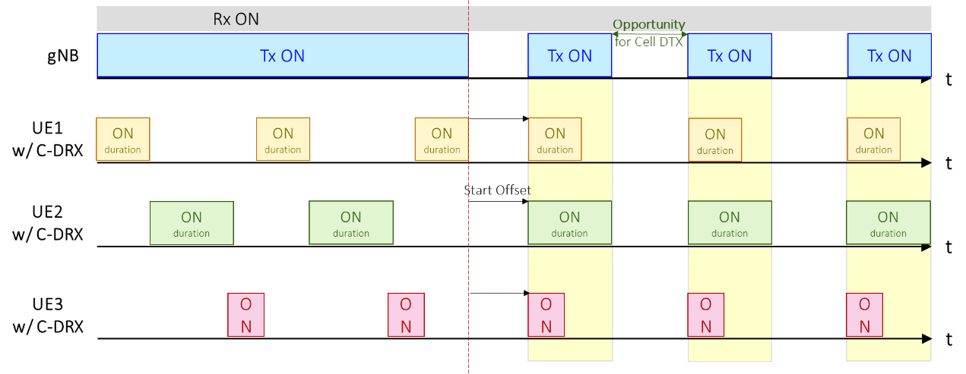

Fig. 3: C-DRX start offset alignment among multiple UEs [23]

* **Option 3:** There is only a single UE C-DRX pattern in a cell which is fully aligned with cell DTX (i.e. exactly the same on/off configurations for the cell and all UEs in this cell).

|  |  |  |
| --- | --- | --- |
| **Company** | **Answer** | **Comments** |
| Apple | Option 2 | We believe Option 2 can maximize NES gain because the same starting time of active duration can make the UEs to finish their transmissions as early as possible, so that gNB can enter non-active duration early.  For option 1, the distributed on-durations of different UEs will make gNB have to keep waking up to wait the last UE's ON-duration finished, and correspondingly gNB has to configure a long active duration of Cell DTX. It is bad for gNB power saving. As example, in below figure, if UE1 and UE2's on-duration are distributed, the active duration of Cell DTX has to be configured to end in T2 to wait UE 2's on-duration finished. However, if UE2's on-duration starts from T0, the Cell DTX active duration can be reduced to end in T1.    For option 3, we don't see the point to make this strong restriction on alignment:   * Different UE may have different traffic requirements. It doesn't make sense to mandate all UEs to have same ON-OFF pattern. * Because we have inactivity timer for UE CDRX anyway, the totally equal on/off duration may also result in the situation of Figure.1. |
|  |  |  |
|  |  |  |
|  |  |  |
|  |  |  |

**Question 9:** *Do you agree to leave the alignment mechanism up to NW implementation? If not please state the possible spec impact in the comments.*

|  |  |  |
| --- | --- | --- |
| **Company** | **Answer** | **Comments** |
| Apple | No | 1) It is too early to conclude no spec impact. We think we should first make the alignment mechanism clear, and then discuss whether it has spec impacts or not.  2) In Rapporteur's Figure 1, the UE behaviour in duration T1 and T2 are not clear. For the moment, it is hard to say whether the UE will always follow legacy UE CDRX behaviour (i.e. without spec change) because we don't even conclude UE behaviour in Cell DTX (and whether the restriction on UE reception in Cell DTX is more strict than UE CDRX). |
|  |  |  |
|  |  |  |
|  |  |  |
|  |  |  |

*[Rapporteur’s summary and proposals]*

# 3 Conclusion

Based on the discussion in the previous sections we propose the following:

**Proposal 1** abc.

**Proposal 2** def.

# 4 References

1. RP-223540, “New WID: Network energy savings for NR”, Huawei
2. 3GPP TR 38.864 V1.0.0, “Study on network energy savings for NR (Release 18)”
3. R2-2301903, “Report from Session on NES, UAV, Small Data, Rel-15-17 UP, Rel-17 Small Data, IIoT/URLLC, and RACH partitioning”, Session Chair (InterDigital)
4. R2-2300701, “Discussion on Cell DTX / DRX”, Apple
5. R2-2300539, “Cell DTX-DRX Mechanism”, Qualcomm Incorporated
6. R2-2300632, “Cell DTX/DRX mechanism”, InterDigital
7. R2-2301399, “Further aspects on cell DTX/DRX”, Ericsson
8. R2-2301515, “Further details on Cell DTX/DRX”, Nokia, Nokia Shanghai Bell
9. R2-2300230, “Discussion on cell DTX/DRX”, Huawei, HiSilicon
10. R2-2300247, “Cell DTX and DRX support”, NEC
11. R2-2300378, “Considerations on Cell DTX/DRX”, KDDI Corporation
12. R2-2300444, “Initial discussion on DTX-DRX mechanism”, vivo
13. R2-2300456, “Discussion on DTX DRX mechanism”, OPPO
14. R2-2300491, “Alignment to Cell DRX”, Lenovo
15. R2-2300492, “Alignment to Cell DTX”, Lenovo
16. R2-2300611, “Considerations of Cell DTX and DRX”, Intel
17. R2-2300819, “Discussion on Cell DTX/DRX”, CATT
18. R2-2301064, “Discussion on cell DTX and DRX mechanism for NES”, ZTE Corporation, Sanechips
19. R2-2301230, “Discussion on network DTX/DRX”, CMCC
20. R2-2301550, “Discussion on DTX/DRX for NES”, Samsung
21. R2-2301733, “Discussion on DTX/DRX mechanism”, LG Electronics Inc.
22. R2-2301776, “Discussion for Cell DTX/DRX”, NTT DOCOMO, INC.
23. R2-2301854, “Further discussion on Cell DTX/DRX”, MediaTek Inc.
24. R2-2301882, “Cell DTX and DRX”, Fraunhofer IIS