3GPP TSG-RAN WG2 #113bis-e Tdoc R2-xxxxxx
Electronic meeting, 2021-04-12 – 2021-04-20

Agenda Item: x.x.x.x
Source: Ericsson
Title: Summary of [Post113-e][055][IoT NTN] Performance evaluation [Ericsson]
Document for: Discussion, Decision

1 Introduction
In RAN#86, a SI was approved to determine and evaluate the minimum necessary specifications to introduce NB-IoT/LTE-M support for non-terrestrial networks (NTN). The description for the SI was updated in RAN#90 [5] and it was agreed to use the existing work on NR NTN captured in TR 38.821 [1] as a baseline.
This document concerns the following e-mail discussion:
- [Post113-e][055][IoT NTN] Performance Evaluation (Ericsson)
Scope: First round of discussion on performance evaluation, paging performance and connection density. Determine what should be captured in the TR. Can discuss pre-assumption, e.g. traffic model etc. Note that there are no specific requirements, so the objective is to assess performance for sanity check and to avoid surprises rather than doing a detailed comparative analysis. To the extent available, can include performance results numbers.
Intended outcome: Report
Deadline: Friday March 26th 11:00 UTC

The purpose of this e-mail discussion is to kick off a first round discussion on performance evaluation, paging performance and connection density in IoT NTN. The goal is to establish a common understanding on the assumptions, e.g., traffic model, methodology and metrics to be used to assess the performance and determine what should be captured in the TR.

The discussion is structured in two sections:
- Paging capacity evaluation
  - Introduce/summarize how paging capacity was evaluated in TR 38.821 for NR NTN.
  - Discussion on what sort of assumptions, e.g., traffic model, methodology and metrics should be used specifically when NB-IoT and LTE-M devices in NTN are considered to assess the paging capacity.
  - Determine what should be captured in the TR.
- Connection Density evaluation
  - Introduce/summarize connection density evaluations for IMT-2020 and the assumptions, methodology and metrics for LTE-M and NB-IoT.
  - Discussion on what sort of assumptions, e.g., traffic model, methodology and metrics should be used specifically when NB-IoT and LTE-M devices in NTN are considered to assess the connection density.

3 Paging capacity evaluation

3.1 Methodology
The paging capacity was assessed for NR NTN in Section 7.3.3 in [1]. The assessment was made considering the parameters that affect the paging performance. This, for instance, includes the number of paging frames and the number of paging occasions that can be configured in NR. These figures were then used along with a specific paging configuration and a specific mobile terminated traffic arrival rate to compute the paging channel load, which would essentially be the needed paging channel load divided by the available paging capacity given the configuration. The supported UE density, given an arrival session rate, was also evaluated.

------------------------------------TR 38.821------------------------------------

7.3.3.1 Paging Capacity
Following parameters should be considered for calculation of paging capacity
- Paging Frames (PF) per second: $N_{PF}$
- Paging Occasions (PO) per PF: $N_{POperPF}$
- Maximum number of paging records in paging message: $N_{UEperPO}$
- User density (UEs/km²)
- Satellite beam diameter: in km
- NO_Traffic: fraction of UEs in the cell with network originated traffic
- Arrival session or call rate: average requested paging occasions per hour and per UE
- Number of cells in per tracking area: M

7.3.3.1.1 Paging capacity of non-multibeam cell
In a non-multibeam scenario 4 out of 10 subframes per PF can be used for paging that is there can be at most 4 PO per PF. A paging message can only be sent in a PO. The paging message can at most include 32 paging records in the paging message where each paging record includes the UE identities of the UEs being paged. The theoretical paging capacity as maximum number of UEs paged per second in an NR non-multibeam cell is thus limited by:
$Supported Paging Capacity per second=N_{PF}×N_{POperPF}×N_{UEperPO}$.

As each RF can be configured to be a PF, the resulting maximum paging capacity with 100 PF per second is thus $\text{4 × 100 = 400}$ PO per second. This implies that theoretically, an NR cell can page $\text{32 × 400 = 12 800}$ UEs per second, or equivalently, more than 46 Million UEs per hour $\text{(12 800 × 60 × 60)}$.
The supported paging capacity should be compared with the required paging per cell, which can be calculated as:
$$Expected arrival rate per cell per second= A x UE density x arrival session rate$$
If the tracking area is larger than one cell and the base station needs to blindly page all the UEs that it want to reach in all cells, then in the worst case the required arrival rate would be:
$$Expected arrival rate per TA per second= M x A x UE density x arrival session rate$$

The paging capacity should also be considered together with the cell’s capacity to support UEs accessing the cell. After being paged, the UE accesses the cell using a random-access procedure which starts by the UE transmitting a random-access preamble on the physical random-access channel (PRACH). PRACH capacity is calculated in Section X.
------------------------------------TR 38.821------------------------------------

For both NB-IoT and LTE-M, there are several differences compared to NR NTN; the maximum number of paging records in a paging message is different, one needs to consider the repetitions required for M/NPDCCH that schedules the paging message and M/NPDSCH that carries the paging message with respect to different enhanced coverage levels and the possibility to allocate narrowbands/paging carriers which enhances the capacity utilizing Frequency Division Multiplexing. The mobile terminated traffic model is also important here and one should keep in mind that paging messages may need to be retransmitted due to decoding failures or UE not being present in that particular cell or tracking area.
We assume that a paging capacity evaluation similar to what has been captured in TR 38.821, will be considered as a baseline in this study item. In the questions below, the intention is to first confirm this understanding to find out whether such assumption is shared and to discuss what else needs to be considered regarding the traffic model, methodology and metrics specially for NB-IoT and LTE-M devices.

Question 1: Do you confirm that the baseline for the methodology is the evaluation method used in TR 38.821? Please comment especially if you think otherwise and/or different methodologies need to be used for NB-IoT or LTE-M.

Company | Yes/No | Comments
OPPO | Yes | We agree to use paging capacity evaluation method captured in TR38.821 as baseline.
Gatehouse | Yes
Nokia | Yes.But | In case of NB-IoT/eMTC the paging capacity also depends on the maximum repetitions configured for the paging search space. This also depends on the maximum coverage extension to be supported in the cell. Number of paging frames per DRX cycle needs to ensure non-overlapping of search spaces. So there will be dependency on Rmax and number of PF.  Each Radio Frame cannot be assumed as PF in NB-IOT and eMTC due to above impact.  On the expected arrival rate, MT traffic profile of UE defined in TR48.210 should be considered for IoT, to check the required number of NB-IoT non-anchor carriers to meet the connection density and capacity.  The soft-switch option of multiple tracking area may also impact the paging load. The estimation of paging based on arrival rate need to consider the duplication of packets over two cells at least for the first paging based on last connected cell. Further paging messages may need to be sent over overlapping tracking areas also. Impact of the soft-switch option on paging strategy and impact on increase in paging load should be considered.
Qualcomm | Yes | The methodology used in TR 38.821 can be baseline.
MediaTek | Yes | TR 38.821 can be considered as the baseline.
ZTE | Yes, but | We agree to use paging capacity evaluation method captured in TR 38.821 as baseline. We also think the mentioned differences make sense and need more consideration. For example:  - We agree with above comments that repetitions have impacts on the paging capacity. But maybe no new metric is needed for this and we can just assume some kind of sparse PO resources configuration.  - Multiple narrowbands/paging carriers also need to be considered and this can compensate the impacts of less paging records in a paging message.  - For “Expected arrival rate per TA per second”, we think only evolution on “M=1” may be not enough. Such TA size may cause frequent TAU procedure which in turn leads to higher UE power consumption. As the concern for UE power saving in IoT over NTN is much greater than that in NR NTN, we suggest to also consider the case where M is greater than 1.  - Moreover, cell size and options for mapping between cell and satellite beams need more consideration.  - We think satellite beam diameter of 1700km in Set 4 need to be taken into account.  - RAN2 may determine whether both options a) same PCI for several satellite beams and b) one PCI per satellite beam can be considered or only b) is considered?
Ericsson | Yes | The methodology is valid also for LTE-M and NB-IoT in a non-terrestrial network
CATT | Yes | The evaluation method used in TR 38.821 can be the baseline.

Question 2: Are there any additional aspects that need to be considered in particular when evaluating the paging capacity for NB-IoT/LTE-M devices with respect to such evaluation in NR NTN? e.g., # of repetitions required, CE levels, paging narrowbands or carriers etc. Please comment on the details if you think so and indicate any aspect if it is specific for NB-IoT or LTE-M.

Company | Yes/No | Comments
OPPO | Yes | For both NB-IoT and eMTC, paging narrowbands number or carrier number should be taken into account, and the supported paging capacity should be expressed as  $Supported Paging Capacity per second={N_{carrier}×N}_{PF}×N_{POperPF}×N_{UEperPO}$.  where the $N_{carrier}$ is the paging narrowbands number for eMTC and carrier number for NB-IoT.  Regarding the paging repetition number, it may affect the value of $N_{PF}$ and $N_{POperPF}$ .
Gatehouse | Yes | Agree with OPPO on that multiple (anchored) carriers can be used for paging. Additionally, in for NB-IoT, repetitions will have a negative effect on the paging capacity. IoT devices will be likely equipment with lesser antenna (and thus lower gain, more loss, lesser SNR)
Nokia | Yes | See above.
Qualcomm | Yes | We also think the paging capacity should take into account the worst repetition level allowed in the cell and paging narrow bands/carriers.  For NB-IoT, we can assume equal distribution of weight for NB-IoT paging carrier.
MediaTek | Yes | We agree with Oppo.
ZTE | Yes | As mentioned in comments for Q1, we generally agree with OPPO on the consideration on paging narrowbands/carriers. Moreover, considering that different carriers, especially anchor carrier and non-anchor carriers, may have different available resources, a simple coefficient may be needed when multiplying the number of carriers (whether it’s same as the weight can be further considered).  Also, some kind of sparse $N_{PF}$ and $N_{POperPF}$configuration may be needed for this evaluation.
Ericsson | Yes | Agree that number of repetitions required, CE levels and paging narrowbands/carriers need to be considered.
CATT | Yes | The value of $N_{PF}$, $N_{POperPF}$,$N_{UEperPO}$ in LTE are different from NR. $N_{PF}$ x $N_{POperPF}$ is the Number of paging frames per DRX cycle with defaultPagingCycle. The maxPageRec in LTE is 16 while $N_{UEperPO}$.is 32 in NR.  BTW, the formula in TR $Expected arrival rate per TA per second= M x A x UE density x arrival session rate$ should be updated as below:  $$Expected arrival rate per TA per second= M × A × UE density × arrival session rate$$

In TR 38.821 [1] two different paging traffic models are used; 1 page per UE per hour and 1 page per UE per 24 hours.
Question 3: Do you agree that the paging traffic models used in TR 38.821 are assumed when evaluating the paging capacity for NB-IoT and LTE-M in IoT NTN scenarios? Please comment especially if you think otherwise and provide your suggestion on the paging traffic models that should be assumed,

Company | Yes/No | Comments
OPPO | Yes
Gatehouse | Yes, but | It might be necessary to evaluate also the moving beam scenario, and not only fixed beam
Nokia | No | For NB-IoT/eMTC , the traffic model assumes specific distribution of arrival rate across the idle mode users. For MT traffic also the same distribution is assumed. Percentage of users for MT was assumed as 50%. But this can be modified depending on actual scenario. Ref TR45.820. In our view the paging traffic model defined in TR for CIoT study should be assumed for IoT-NTN rather than this model.  Inputs from satellite service providers on the use-cases which requires MT traffic can be considered to define modified traffic model. Otherwise terrestrial IoT traffic model to be assumed.
Qualcomm | No | For more accurate evaluation, we should consider Table E.2-1 in TR 45.820 that is specifically defined for IoT application. This can be used for paging as defined in “E.2.3 Network Command”.
MediaTek | Yes
ZTE | Yes | As mentioned in TR 45.820, split of inter-arrival time periodicity for MAR periodic (UL) is: 1 day (40%), 2 hours (40%), 1 hour (15%), and 30 minutes (5%). For typical DL traffic model, e.g., network command, the distribution of the periodic inter-arrival time is the same as for MAR periodic model.  So from IoT perspective, 1 page per UE per hour and 1 page per UE per 24 hours seem suitable and enough as the most typical cases for evaluation.
Ericsson |  | We are open to use the paging traffic models captured in either TR 38.821 or TR 45.820 (please see below).  Characteristic  Application payload size distribution Pareto distribution with shape parameter alpha = 2.5 and minimum application payload size = 20 bytes with a cut off of 200 bytes i.e. payloads higher than 200 bytes are assumed to be 200 bytes.  Periodic inter-arrival time Split of inter-arrival time periodicity for MAR periodic is: 1 day (40%), 2 hours (40%), 1 hour (15%), and 30 minutes (5%)
CATT | Yes

Question 4: What metrics need to be considered when evaluating the paging capacity for NB-IoT and LTE-M? e.g., paging capacity requirement. Please indicate the metrics, if any, in case it is specific for NB-IoT or LTE-M.

Company | Comments
Gatehouse
Nokia | The paging load in terms number of paging per second should be considered in deriving the paging capacity.  KPI for individual UE should be the paging latency and lost messages for given paging capacity and traffic model. Latency for paging response also can be considered as KPI. But this needs to take the RACH capacity also into consideration.
Qualcomm | The cell size should also be considered on evaluating the paging capacity. Current PRACH format may not work if cell size is very large.
MediaTek | Latency does not matter for delay tolerant IoT data. We need to only evaluate if the paging capacity meets the expected traffic requirements.
ZTE | We suggest to focus on the similar metrics as that in NR, e.g., Paging channel loads and Supported UE densities.  We think paging latency may be not so critical and evaluation on paging lost may be difficult as more assumption/information from core network may be needed.  It has been agreed RACH capacity would be evaluated by RAN1, so we can just wait for RAN1 progress.
Ericsson | It would be good to have metrics that reflect the trade-offs between the resources allocated for paging, time to reach an IoT device once the paging request is received and the impact on other IoT devices due to false-paging.

Question 5: Please comment if there are any other aspects/questions that would be good to discuss regarding the evaluation for paging capacity.

Company | Comments
Nokia | Estimation of number of paging carriers required for large NTN cell to meet the minimum performance requirements should be one of the objectives of the outcome.  Impact of paging capacity due to NTN cell mobility if any can be further discussed.  Impact of introduction of (G)WUS on paging capacity could be one aspect for further consideration.  Considering the larger coverage area and high user density use of GWUS is preferred and it can be assumed in the evaluation if required.

4 Connection density evaluation
During the study on self-evaluations towards 5G, evaluations were performed to confirm that 3GPP technologies fulfil the IMT-2020 requirements for 5G [3]. In particular, one requirement for the massive MTC use case was that the 5G standard(s) should support a device density of at least 10⁶ devices/km² where 99% of the users have successfully delivered a 32-byte packet within 10s.
In this section we will describe a methodology that can be used to evaluate the IMT-2020 requirement on connection density for LTE-M and NB-IoT based NTN and discuss specific scenarios to be used with the methodology.

4.1 Connection density evaluation for IMT-2020
In [3], two different methods are described: the full buffer system level simulation and the non-full buffer system level simulation. In the full buffer simulation, ideal resource allocation is assumed, and the system access procedures are disregarded.
In the non-full buffer simulation, there is a more detailed level of modelling by including the system access procedures (idle to connected mode procedures being either RRC resume or EDT), the scheduling procedures (scheduling request, N/MPDCCH scheduling N/PUSCH/PDSCH) as well as release procedures. Thus, the QoS requirement means that the UE shall perform access procedures (random access procedures as well as needed configuration) and then deliver the payload within 10 seconds.
For both evaluation methods, the Urban Macro – mMTC test environment is used where an ISD of 500 meters and 1732 meters are considered.

4.2 Connection density evaluation for IoT NTN
In this section we propose the methodology that can be used when evaluating connection density in NTN scenarios. Detailed system level evaluation methodology is introduced in TR 38.821 [1]. Several simulation assumptions such as the ones for satellite antennae, EIRP, transmit gain and satellite antenna placements can be inherited directly. For simplicity we suggested considering one scenario for LEO and one for GEO.
One aspect that can be problematic for connection density evaluation is the number of cells/spotbeams that are used. TR 38.821 [1] describes beam layouts and the number of spotbeams to evaluate as shown in Figure 1 below, where it is noted that wrap-around is not used. Thus, for a frequency reuse factor (FRF) of 1, an additional 2 tiers of beams are introduced to account for no wrap-around, meaning 61 cells need to be simulated but only the statistics of the inner 19 cells are used. Similarly, for a frequency reuse factor (FRF) of 3, 128 cells need to be simulated with only the inner 19 cells are used.
Since the 99th percentile needs to reach 10 seconds to determine the achievable connection density, the number of users required in the system level evaluation may be very large.

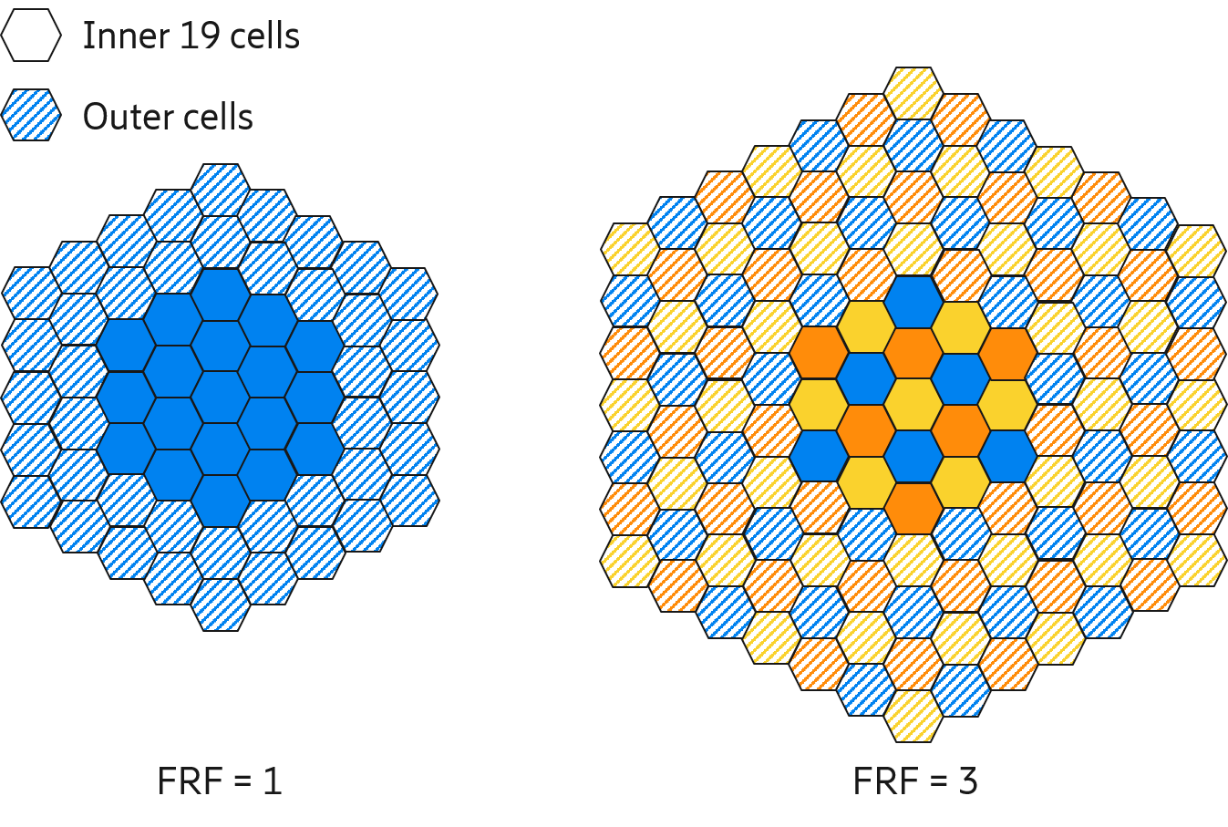
Figure 1. Illustrations of the additional tiers of beams to be wrapped around based on the FRF configurations [1].

For non-full buffer simulation methodology where the system access procedures are simulated, we suggest limiting the number of required cells. One approach is to reduce the number of simulated cells to 19 and then remove the outer layer to only collect statistics from the inner cells to avoid the effects of the outer cells not having any adjacent interferers. This can be seen in Figure 2.

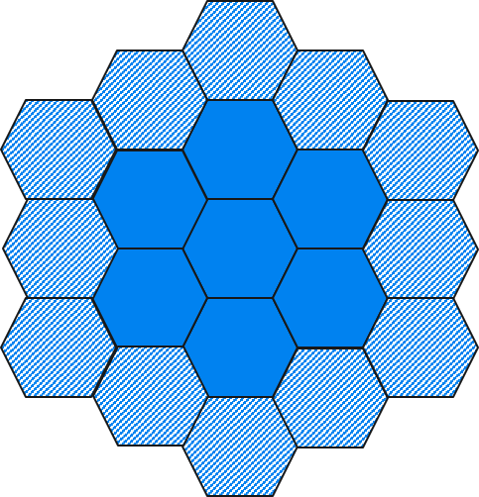
Figure 2. 19-cell layout with only inner layers considered.

Regarding which type of access procedure is used, i.e., either RRC Resume or EDT should be simply stated.
A further evaluation option could be to include the time for the UE to perform its GNSS time-to-first-fix.

Question 6: Do you agree that the methodologies described in 4.1 and 4.2. above can be considered as the baseline? Please comment especially if you think otherwise and/or different methodologies need to be used for NB-IoT or LTE-M.

Company | Yes/No | Comments
OPPO |  | We think the same topology given in figure 1 above could be used in IoT over NTN, we wonder why to reduce the cell number.
Gatehouse | Yes | Agreed to minimize cells for simulation purposes
Nokia | TBD | The use of full buffer evaluation for IoT traffic needs to be further checked, because it is not likely IoT traffic will lead to a full buffer scenario. Here RAN1 inputs will also be beneficial.  Regarding the cell layout and whether interference is to be evaluated based on middle cell, and the number of tiers for interference will also be good to confirm with RAN1.  Finally, it will be good to ask RAN1 about the impact of elevation angle, because the propagation distance and probability of blockage will increase with lower elevation angle, leading to use of repetitions.
Qualcomm |  | Each cell may operate as multiple beams. Simply, cell-level calculation per satellite can be done.  Similar to paging capacity evaluation, for more accurate evaluation, we should consider Table E.2-1 in TR 45.820 that is specifically defined for IoT application.  We may also need to consider the UL and DL traffic for the connection density evaluation.
MediaTek | Yes | We agree with the rapporteur to minimize cells for simulation purposes.
ZTE | TBD | We have high level doubt on necessity of this Connection density evaluation:  - Since there is already an overall UE density per km² with value of 400 in Table B.2-1 in the draft TR 36.763, we are not clear whether it’s still necessary to evaluate the requirement of device density of at least 10⁶ devices/km²?  - Moreover, in the discussion for paging capacity evaluation, we assume the 400 UE density per km² will be applied. Then if we have some new evaluation on this connection density, do we need to re-evaluate the paging capacity?  Back to Question 6, we have sympathy with Nokia’s comments and also think more things need to be determined by RAN1.  Moreover, the cases related to Set 4 may be special, e.g., having the issue of discontinuous coverage. It may be better to ask RAN1 whether such cases also need consideration.
Ericsson | Yes | The methodologies described above can be captured We are open to consider the alternatives.
CATT | Yes, but | Agreed to minimize cells for simulation purposes. But we are wondering why IoT device to perform its GNSS time-to-first-fix is discussed in connection density evaluation.

4.2.1 LEO scenario
For the LEO scenario, we suggest evaluating the connection density performance for IoT NTN under one of the scenarios from TR 38.821. Table 6.1.1.1-9 defines a set of cases from which Case 9 appears to be the most relevant from the perspective of IoT NTN. Case 9 is a LEO scenario at 600km altitude, S-band, 90-degree elevation angle with 1:1 frequency reuse. Furthermore, RAN1 has agreed a set of IoT NTN -specific link budget items in [4] for the UE characteristics. The combined parameters from TR 38.821 and [4] are shown in Annex A.

Question 7: Do you agree that Case 9 from TR 38.821 is used for the LEO scenario when evaluating the connection density performance for IoT NTN? Please comment especially if you think otherwise and/or different case(s) need to be used for NB-IoT or LTE-M.

Company | Yes/No | Comments
OPPO | Yes
Gatehouse | Yes | Agree to use Case 9 based on set-1 in the TR38.821 document. In our understanding, this would represent a best-case scenario for a connection density perspective, compared to the other sets of parameters (set-2, set-3 and set-4) addressed in the IoT NTN SI.
Nokia | No | RAN1 has made an agreement on satellite parameters for link budget evaluation: set1-4. At least one set of parameters could be considered, potentially with different satellite beam width, which may impact on the UE/connection number in the coverage.
Qualcomm | No | We think there is no need to be specific to such one scenario as cell size and time remained in connected mode would be considered.
MediaTek | Yes | Agree to use Case 9 based on set-1 in the TR38.821 document.
ZTE | TBD | We have similar view as Nokia and Qualcomm.  We think firstly the Table 6.1.1.1-9 may need to be extended to reflect all the possible cases related to Set 1~Set 4. And then we (maybe RAN1) can choose the most relevant case(s) for further evaluation.
Ericsson | Yes | Case 9 can be a starting point. RAN1 has included several other cases, such as the ones for cube-sat. Other scenarios can also be considered.
CATT | Yes | Agree in principle and will consider the assumption from RAN1.

4.2.2 GEO scenario
Similarly, for GEO scenario, we suggest evaluating the connection density performance for IoT NTN under one of the scenarios from TR 38.821. Table 6.1.1.1-9 defines a set of cases from which Case 4 appears to be the most relevant from the perspective of IoT NTN. Case 4 is a GEO scenario with 45-degree elevation angle at the central beam, S-band with 1:1 frequency reuse. Furthermore, RAN1 has agreed a set of IoT NTN -specific link budget items in [4] for the UE characteristics. The combined parameters from TR 38.821 and [4] are shown in Annex B.

Question 8: Do you agree that Case 4 from TR 38.821 is used for the GEO scenario when evaluating the connection density performance for IoT NTN? Please comment especially if you think otherwise and/or different case(s) need to be used for NB-IoT or LTE-M.

Company | Yes/No | Comments
OPPO | Yes
Nokia | Yes, but | RAN1 has agreed satellite parameter sets 1-3 for GEO, which can be considered.
Qualcomm | No | See our response in Q7.
MediaTek | Yes
ZTE | TBD | Same comments as that for Question 7.
Ericsson | Yes | Case 4 can be a good starting point and to our knowledge there has not been any new scenarios for GEO proposed in RAN1.
CATT | Yes | Agree in principle and will consider the assumption from RAN1.

Question 9: Please comment if there are any other aspects/questions that would be good to discuss regarding the evaluation for connection density performance.

Company | Comments

5 Other evaluations
In sections 3 and 4 evaluations for paging capacity and connection density performance are described.

Question 10: Please comment if there are any other evaluations that would be good to consider for NB-IoT and LTE-M in IoT NTN.

Company | Comments
Nokia | Random access capacity would be important to evaluate, taking into account large RTT of NTN scenario.

6 Conclusion
In the previous sections we made the following observations:
Observation 1 An Observation with automatic numbering. Assign this type by pressing Alt-O. A list of all Observations can be found in the Conclusion section.

Based on the discussion in the previous sections we propose the following:
Proposal 1 A Proposal with automatic numbering. Assign this type by pressing Alt-P. A list of all Proposals can be found in the Conclusion section.

References
- 3GPP TR 38.821, Solutions for NR to support non-terrestrial networks (NTN), Release 16 (V16.0.0), 2019-12
- 3GPP TR 38.811, Study on New Radio (NR) to support non-terrestrial networks, Release 15 (V15.2.0), 2019-09
- 3GPP TR 37.910, Study on self-evaluation towards IMT-2020 submission, Release 16 (V16.1.0), 2019-09
- R1-210xxxx, Draft Report of 3GPP TSG RAN WG1 #104-e v0.3.0, Online meeting, 25th January – 5th of February 2021, accessed March 2021.
- RP-202689, Study on NB-IoT/eMTC support for Non-terrestrial Network, RAN#90, Dec 2020.
- TR 38.821, Solutions for NR to support Non-terrestrial Networks (NTN), 3GPP, V16.0.0, Jan 2016.
- 3GPP TR 38.913, “Study on scenarios and requirements for next generation access technologies,” version 16.0.0, July 2020.
- ITU-R, Report ITU-R M.2412-0, “Guidelines for evaluation of radio interface technologies for IMT-2020”, October 2017.
- R2-1901404, IoT Device Density Models for Various Environments, Vodafone, RAN2#105, Athens 2019.

Contact delegates
Delegate | Company | Email
Emre A. Yavuz | Ericsson | emre.yavuz@ericsson.com
Haitao Li | OPPO | lihaitao@oppo.com
Robert van der Pool | Gatehouse | rvp@gatehouse.com
Ting Lu | ZTE | lu.ting@zte.com.cn

Annex

A. LEO IoT NTN IMT-2020 connection density scenario
The combined satellite scenario for evaluating the IMT-2020 connection density under LEO scenario is as below.
Satellite characteristics:
Satellite orbit |  | LEO-600
Satellite altitude |  | 600 km
Satellite antenna pattern |  | Section 6.4.1 in [2]
Payload characteristics for DL transmissions
Equivalent satellite antenna aperture (Note 1) | S-band  (i.e. 2 GHz) | 2 m
Satellite EIRP density |  | 34 dBW/MHz
Satellite Tx max Gain |  | 30 dBi
3dB beamwidth |  | 4.4127 deg
Satellite beam diameter (Note 2) |  | 50 km
Payload characteristics for UL transmissions
Equivalent satellite antenna aperture (Note1) | S-band  (i.e. 2 GHz) | 2 m
G/T |  | 1.1 dB K⁻¹
Satellite Rx max Gain |  | 30 dBi
For Notes see [1].

The UE characteristics(based on [1] and RAN1 agreements in [4]):
Characteristics | Handheld
Frequency band | S band (i.e. 2 GHz)
Antenna type and configuration | (1, 1, 1) with omni-directional antenna element
Polarisation Loss | 3 dB
Rx Antenna gain | 0 dBi per element
Antenna temperature | 290 K
Noise figure | 9 dB
Tx transmit power | (PC5) 100 mW (23 dBm)
Tx antenna gain | 0 dBi per element

Beam layout characteristics:
Beam layout definition | Baseline: Hexagonal mapping of the beam bore sight directions on UV plane defined in the satellite reference frame.  Only the 3dB beam width parameters should be used. The beam diameter and beam spacing values can be computed directly from the 3 dB beam width assumptions and should be considered as informative.
Number of beams | Baseline: 19-beam layout
UV plane illustration (extracted from [19]) | 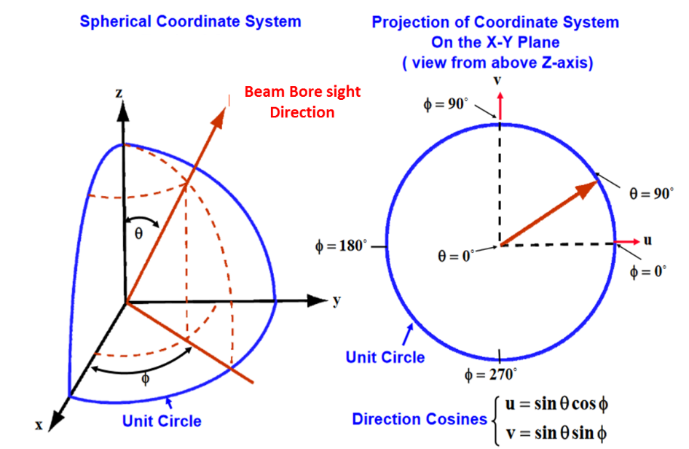
UV plane convention | U axis is defined as the perpendicular line to the satellite-earth line on the orbital plane as illustrated here after :  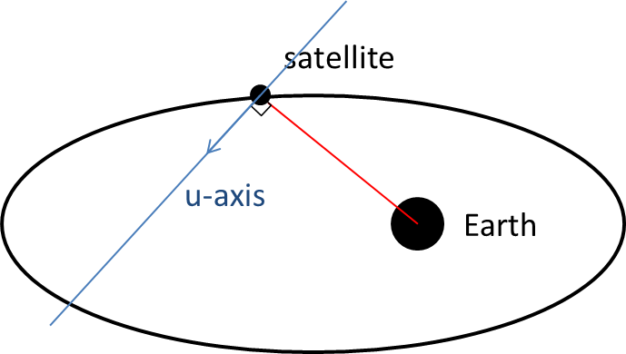  The straight line being orthogonal to UV plane is pointing towards the Earth centre.  UV coordinates of the nadir of the reference satellite is (0,0)
Adjacent beam spacing on UV plane | Baseline: Adjacent beam spacing computation based on 3dB beam width of the satellite antenna pattern :  ABS = sqrt(3) x sin(HPBW/2 [rad])
Central beam bore sight direction definition | Central beam center is considered at nadir point

Miscellaneous parameters:
Frequency band | S-band (i.e. 2 GHz)
Maximum Bandwidth per beam (DL + UL) | To be stated for LTE-M/NB-IoT.
Satellite antenna pattern | See section 6.4.1 in [2]: Bessel function
Satellite polarization configuration | Circular
Beam layout definition | For singles satellite simulation : See Table 6.1.1.1-4
Frequency re-use factor | 1:1
Polarization re-use | Disabled
Channel model | Large scale model of [2] (Note 2)
Deployment scenarios | Base-line : Rural
Propagation conditions | Line of sight
UEs outdoor/indoor distribution | 100% outdoor distribution for UEs
UEs coverage distribution | Randomly uniform.
UE configuration | Handheld (optional for scenario A)
UE orientation | Ideal Tracking serving beam;
Handover Margin | 0 dB
UE attachment | RSRP
For Notes see [1]

B. GEO IoT NTN IMT-2020 Connection density Scenario
The combined scenario for evaluating the IMT-2020 under GEO scenario.
Satellite characteristics:
Satellite orbit |  | GEO
Satellite altitude |  | 35786 km
Satellite antenna pattern |  | Section 6.4.1 in [2]
Payload characteristics for DL transmissions
Equivalent satellite antenna aperture (Note 1) | S-band  (i.e. 2 GHz) | 22 m
Satellite EIRP density |  | 59 dBW/MHz
Satellite Tx max Gain |  | 51 dBi
3dB beamwidth |  | 0.4011 deg
Satellite beam diameter (Note 2) |  | 250 km
Payload characteristics for UL transmissions
Equivalent satellite antenna aperture (Note1) | S-band  (i.e. 2 GHz) | 22 m
G/T |  | 19 dB K⁻¹
Satellite Rx max Gain |  | 51 dBi
For notes see [1].

The UE characteristics(based on [1] and agreements [4]):
Characteristics | Handheld
Frequency band | S band (i.e. 2 GHz)
Antenna type and configuration | (1, 1, 1) with omni-directional antenna element
Polarisation Loss | 3 dB
Rx Antenna gain | 0 dBi per element
Antenna temperature | 290 K
Noise figure | 9 dB
Tx transmit power | 100 mW (23 dBm)
Tx antenna gain | 0 dBi per element

Beam layout characteristics:
Beam layout definition | Baseline: Hexagonal mapping of the beam bore sight directions on UV plane defined in the satellite reference frame.  Only the 3dB beam width parameters should be used. The beam diameter and beam spacing values can be computed directly from the 3 dB beam width assumptions and should be considered as informative.
Number of beams | Baseline: 19-beam layout considering wrap-around mechanism (i.e. 18 beams surrounding the central beam and allocated on 2 distinct “tiers”)
UV plane illustration (extracted from [19]) | 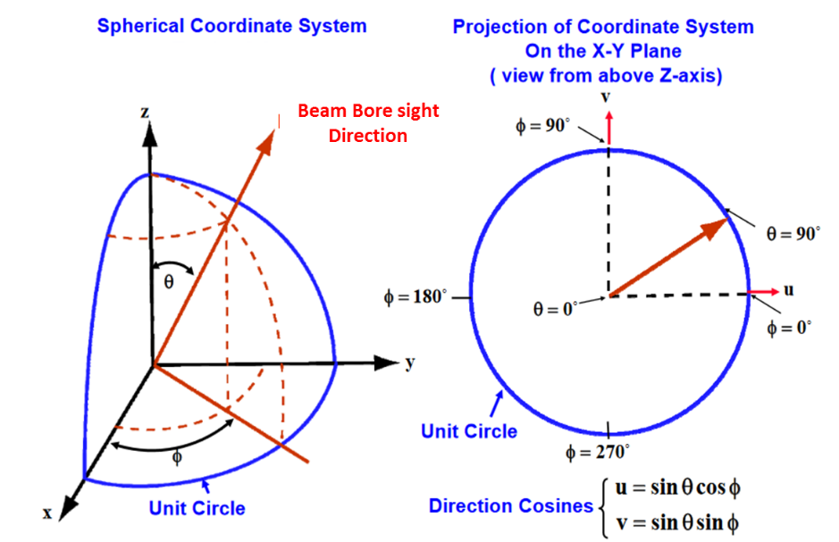
UV plane convention | U axis is defined as the perpendicular line to the satellite-earth line on the orbital plane as illustrated here after :  The straight line being orthogonal to UV plane is pointing towards the Earth centre.  UV coordinates of the nadir of the reference satellite is (0,0)
Adjacent beam spacing on UV plane | Baseline: Adjacent beam spacing computation based on 3dB beam width of the satellite antenna pattern :  ABS = sqrt(3) x sin(HPBW/2 [rad])
Central beam bore sight direction definition | Case 2 : Central beam boresight direction computed based on elevation angle target

Miscellaneous parameters:
Frequency band | S-band (i.e. 2 GHz)
Maximum Bandwidth per beam (DL + UL) | To be stated for LTE-M/NB-IoT.
Satellite antenna pattern | See section 6.4.1 in [2]: Bessel function
Satellite polarization configuration | Circular
Beam layout definition | For singles satellite simulation : See Table 6.1.1.1-4
Frequency re-use factor | 1:1
Polarization re-use | Disabled
Channel model | Large scale model of [2] (Note 2)
Deployment scenarios | Base-line : Rural  Additional deployment scenario results can be provided
Propagation conditions | Line of sight
UEs outdoor/indoor distribution | 100% outdoor distribution for UEs
UEs coverage distribution | Randomly uniform
UE configuration | Handheld
UE orientation | VSAT and Others: Ideal Tracking serving beam;  Handheld: Random
Handover Margin | 0 dB
UE attachment | RSRP
For Notes see [1].

